MSS - Brute Force
Unoptimized Brute Force – Not Useful
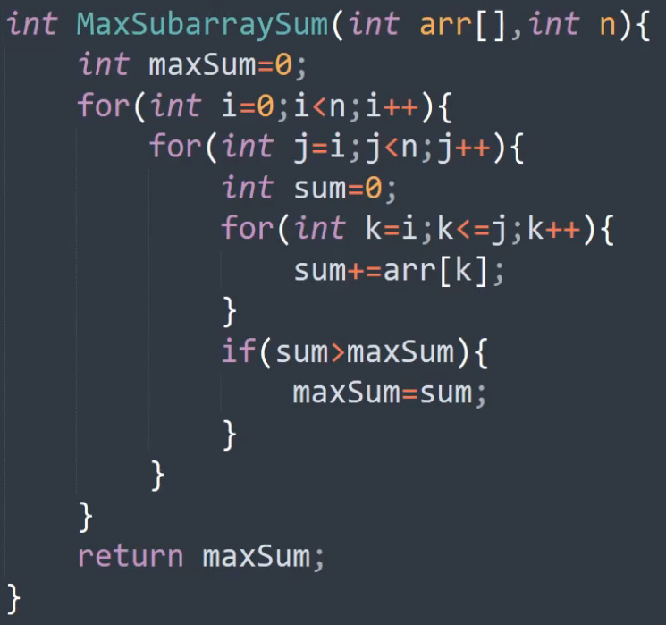
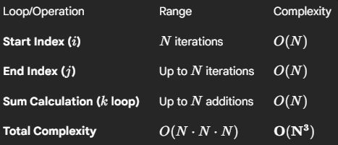
For fixed size sub array:
Optimized Brute Force
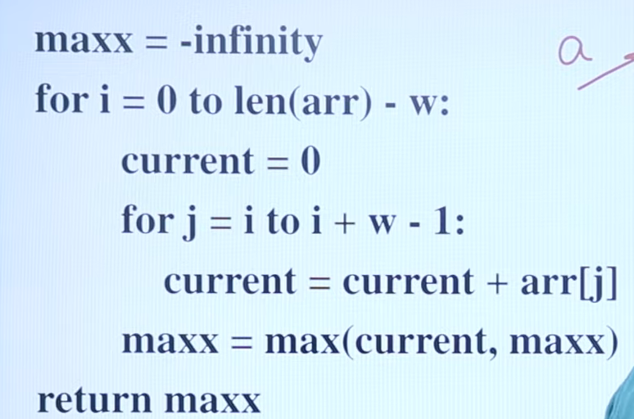
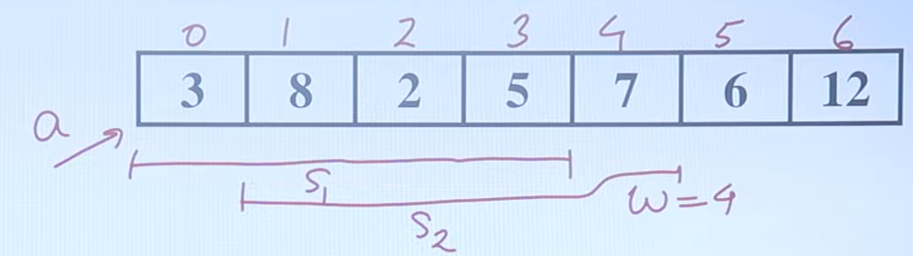
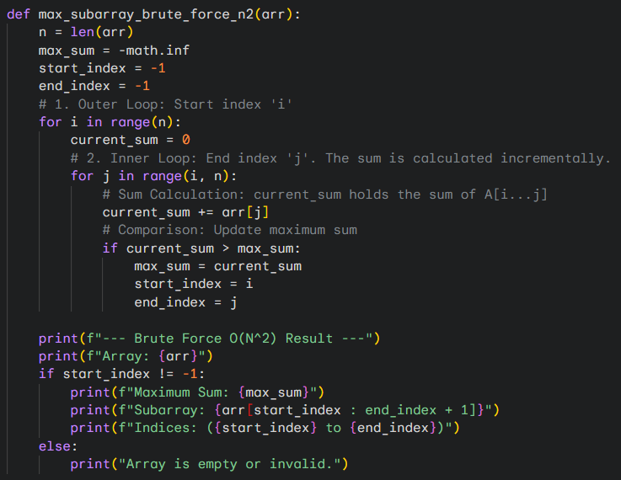
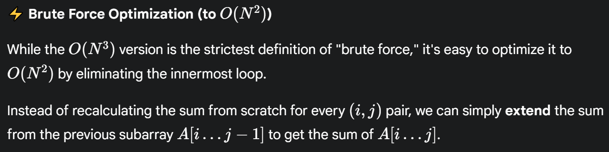
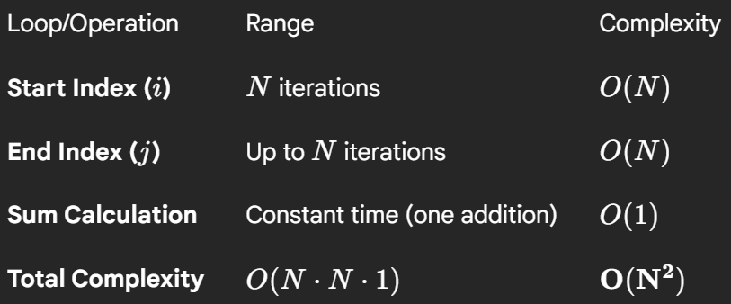
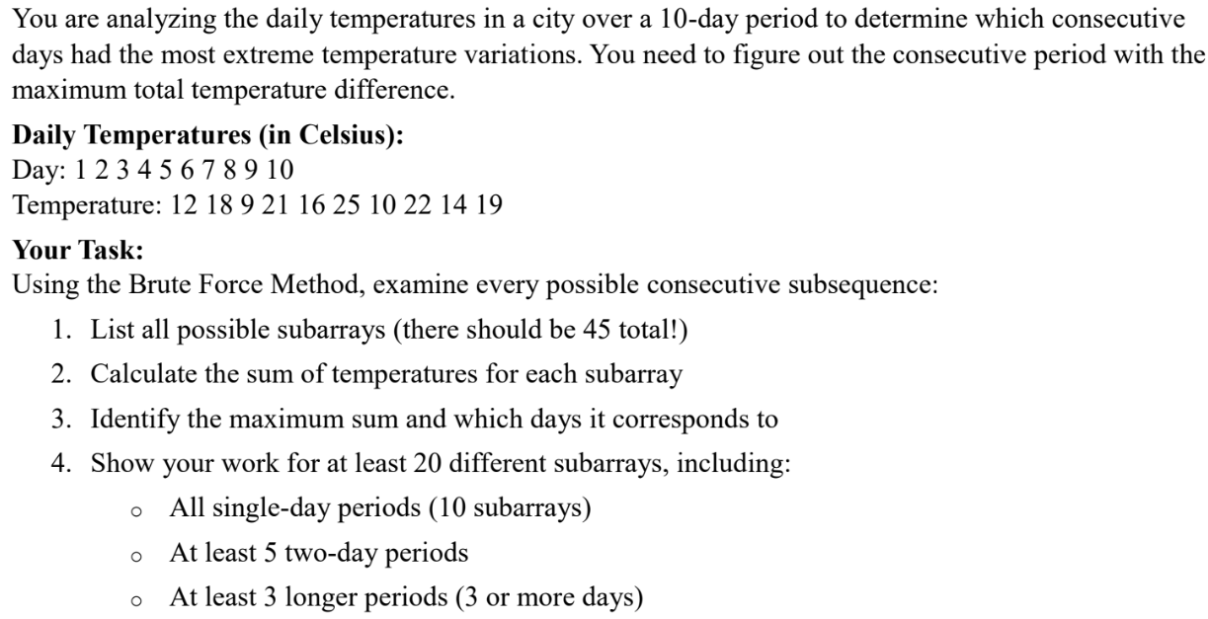
For an array of N=10 elements, the total number of contiguous subarrays is N(N+1)/2 = 10(11)/2 = 55. (10+9+8+...+1=55). We will check all 55 possibilities, demonstrating at least 20 in the table below.
Start Day (i) | End Day (j) | Subarray (Days) | Subarray A[i…j] | Current Sum | max_sum Update? | New max_sum
Start i=1 | (Previous Sum: 0)
1 | 1 | 1 | [12] | 0+12→12 | YES | 12
1 | 2 | 1-2 | [12, 18] | 12+18→30 | YES | 30
1 | 3 | 1-3 | [12, 18, 9] | 30+9→39 | YES | 39
1 | 4 | 1-4 | [12, 18, 9, 21] | 39+21→60 | YES | 60
1 | 5 | 1-5 | [12, 18, 9, 21, 16] | 60+16→76 | YES | 76
1 | 6 | 1-6 | [12, 18, 9, 21, 16, 25] | 76+25→101 | YES | 101
1 | 7 | 1-7 | [12, 18, 9, 21, 16, 25, 10] | 101+10→111 | YES | 111
1 | 8 | 1-8 | [12, 18, 9, 21, 16, 25, 10, 22] | 111+22→133 | YES | 133
1 | 9 | 1-9 | [12, 18, 9, 21, 16, 25, 10, 22, 14] | 133+14→147 | YES | 147
1 | 10 | 1-10 | [12, 18, 9, 21, 16, 25, 10, 22, 14, 19] | 147+19→166 | YES | 166
Start i=2 | (Previous Sum: 0)
2 | 2 | 2 | [18] | 0+18→18 | NO | 166
2 | 3 | 2-3 | [18, 9] | 18+9→27 | NO | 166
2 | 4 | 2-4 | [18, 9, 21] | 27+21→48 | NO | 166
2 | 5 | 2-5 | [18, 9, 21, 16] | 48+16→64 | NO | 166
2 | 6 | 2-6 | [18, 9, 21, 16, 25] | 64+25→89 | NO | 166
2 | 7 | 2-7 | [18, 9, 21, 16, 25, 10] | 89+10→99 | NO | 166
2 | 8 | 2-8 | [18, 9, 21, 16, 25, 10, 22] | 99+22→121 | NO | 166
2 | 9 | 2-9 | [18, 9, 21, 16, 25, 10, 22, 14] | 121+14→135 | NO | 166
2 | 10 | 2-10 | [18, 9, 21, 16, 25, 10, 22, 14, 19] | 135+19→154 | NO | 166
Start i=3 | (Previous Sum: 0)
3 | 3 | 3 | [9] | 0+9→9 | NO | 166
3 | 4 | 3-4 | [9, 21] | 9+21→30 | NO | 166
3 | 5 | 3-5 | [9, 21, 16] | 30+16→46 | NO | 166
3 | 6 | 3-6 | [9, 21, 16, 25] | 46+25→71 | NO | 166
3 | 7 | 3-7 | [9, 21, 16, 25, 10] | 71+10→81 | NO | 166
3 | 8 | 3-8 | [9, 21, 16, 25, 10, 22] | 81+22→103 | NO | 166
3 | 9 | 3-9 | [9, 21, 16, 25, 10, 22, 14] | 103+14→117 | NO | 166
3 | 10 | 3-10 | [9, 21, 16, 25, 10, 22, 14, 19] | 117+19→136 | NO | 166
Start i=4 | (Previous Sum: 0)
4 | 4 | 4 | [21] | 0+21→21 | NO | 166
4 | 5 | 4-5 | [21, 16] | 21+16→37 | NO | 166
4 | 6 | 4-6 | [21, 16, 25] | 37+25→62 | NO | 166
4 | 7 | 4-7 | [21, 16, 25, 10] | 62+10→72 | NO | 166
4 | 8 | 4-8 | [21, 16, 25, 10, 22] | 72+22→94 | NO | 166
4 | 9 | 4-9 | [21, 16, 25, 10, 22, 14] | 94+14→108 | NO | 166
4 | 10 | 4-10 | [21, 16, 25, 10, 22, 14, 19] | 108+19→127 | NO | 166
Start i=5 | (Previous Sum: 0)
5 | 5 | 5 | [16] | 0+16→16 | NO | 166
5 | 6 | 5-6 | [16, 25] | 16+25→41 | NO | 166
5 | 7 | 5-7 | [16, 25, 10] | 41+10→51 | NO | 166
5 | 8 | 5-8 | [16, 25, 10, 22] | 51+22→73 | NO | 166
5 | 9 | 5-9 | [16, 25, 10, 22, 14] | 73+14→87 | NO | 166
5 | 10 | 5-10 | [16, 25, 10, 22, 14, 19] | 87+19→106 | NO | 166
Start i=6 | (Previous Sum: 0)
6 | 6 | 6 | [25] | 0+25→25 | NO | 166
6 | 7 | 6-7 | [25, 10] | 25+10→35 | NO | 166
6 | 8 | 6-8 | [25, 10, 22] | 35+22→57 | NO | 166
6 | 9 | 6-9 | [25, 10, 22, 14] | 57+14→71 | NO | 166
6 | 10 | 6-10 | [25, 10, 22, 14, 19] | 71+19→90 | NO | 166
Start i=7 | (Previous Sum: 0)
7 | 7 | 7 | [10] | 0+10→10 | NO | 166
7 | 8 | 7-8 | [10, 22] | 10+22→32 | NO | 166
7 | 9 | 7-9 | [10, 22, 14] | 32+14→46 | NO | 166
7 | 10 | 7-10 | [10, 22, 14, 19] | 46+19→65 | NO | 166
Start i=8 | (Previous Sum: 0)
8 | 8 | 8 | [22] | 0+22→22 | NO | 166
8 | 9 | 8-9 | [22, 14] | 22+14→36 | NO | 166
8 | 10 | 8-10 | [22, 14, 19] | 36+19→55 | NO | 166
Start i=9 | (Previous Sum: 0)
9 | 9 | 9 | [14] | 0+14→14 | NO | 166
9 | 10 | 9-10 | [14, 19] | 14+19→33 | NO | 166
Start i=10 | (Previous Sum: 0)
10 | 10 | 10 | [19] | 0+19→19 | NO | 166

MSS – Divide & Conquer
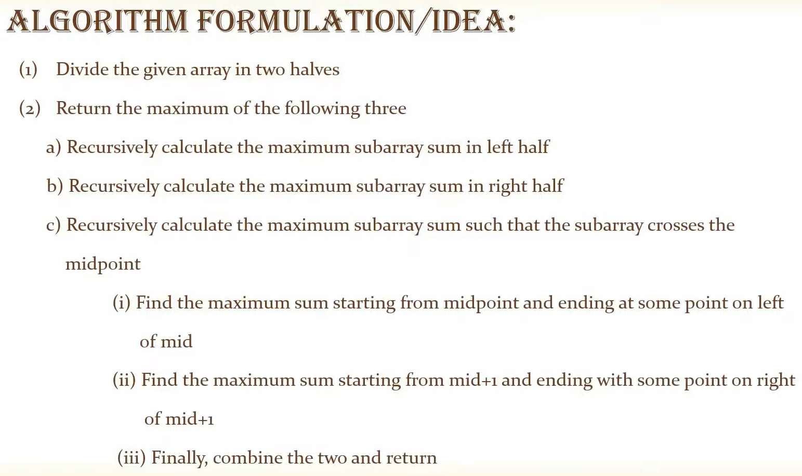
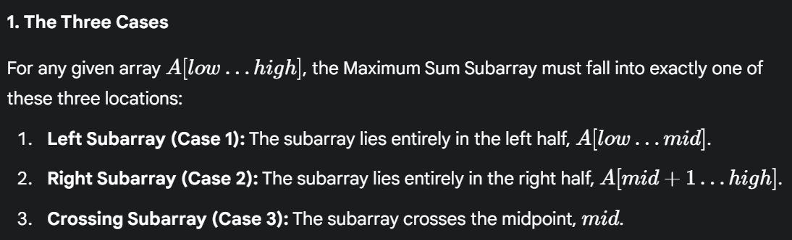
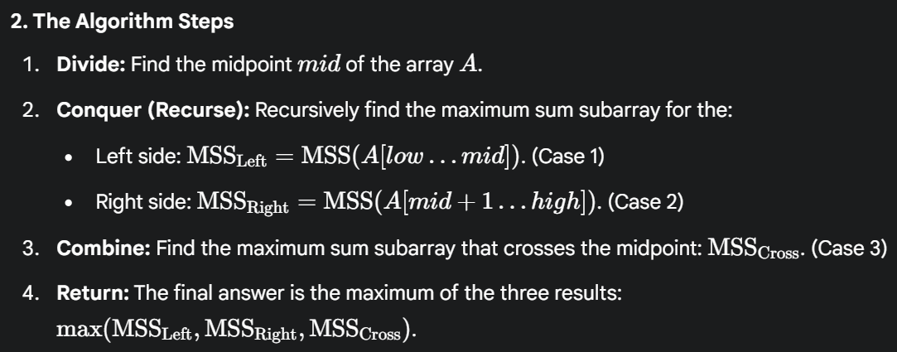
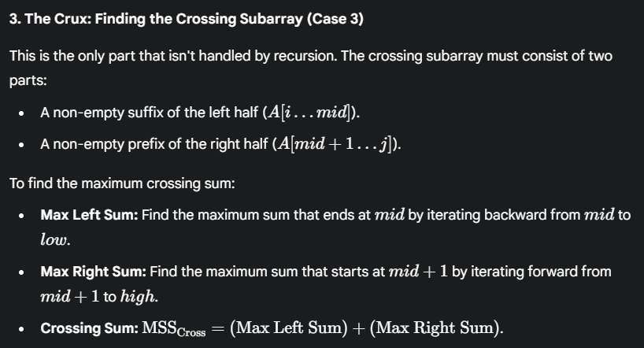
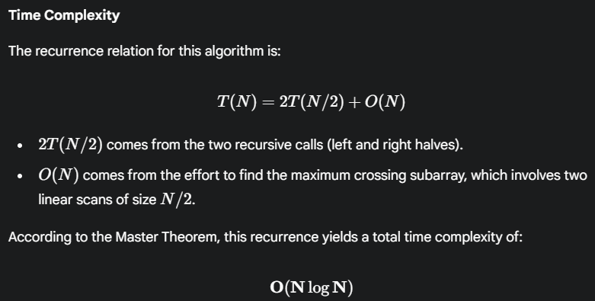
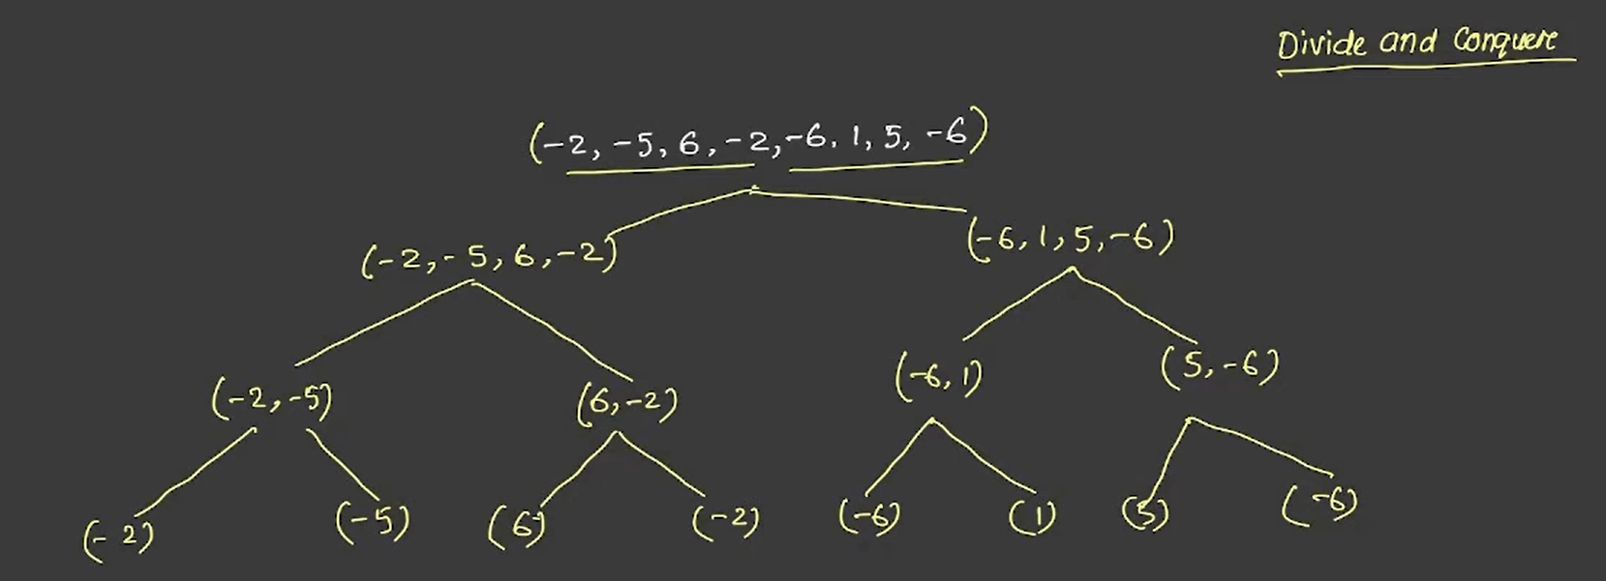
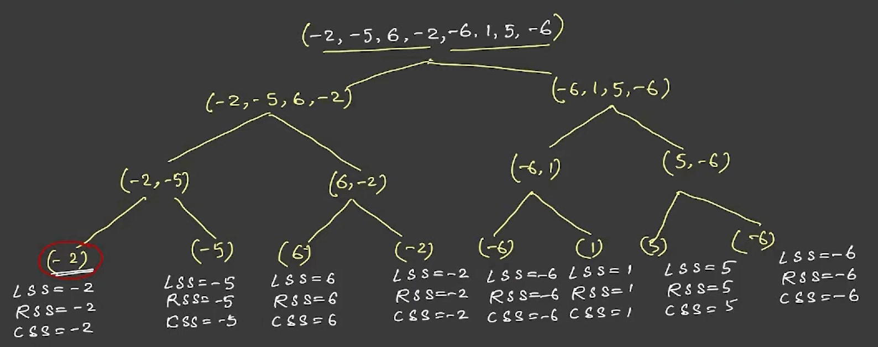
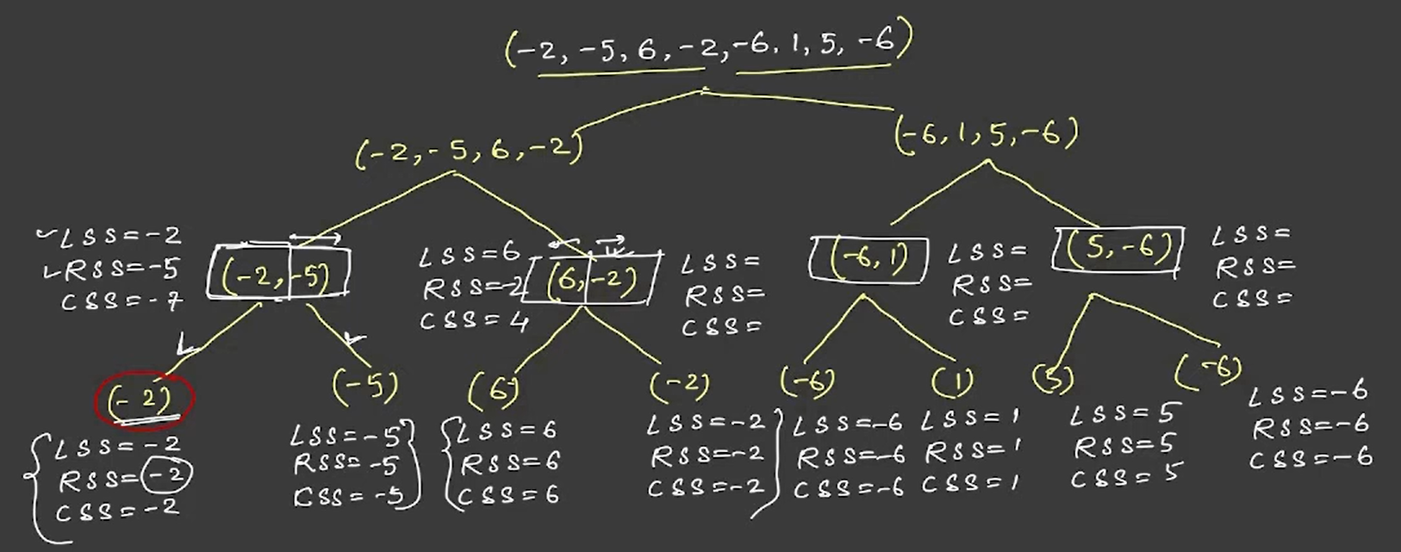
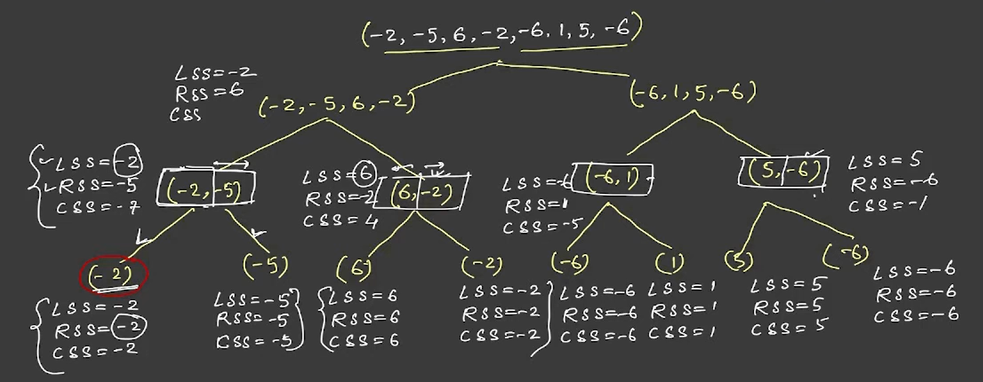
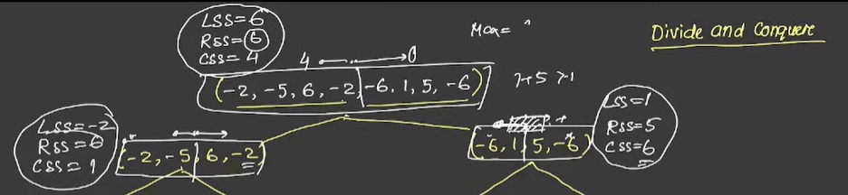

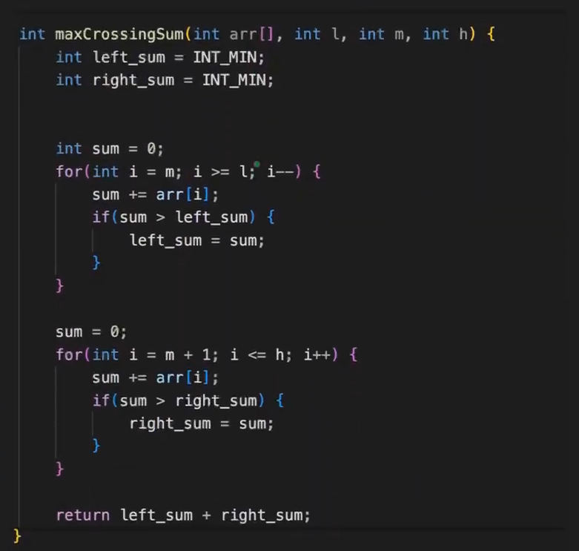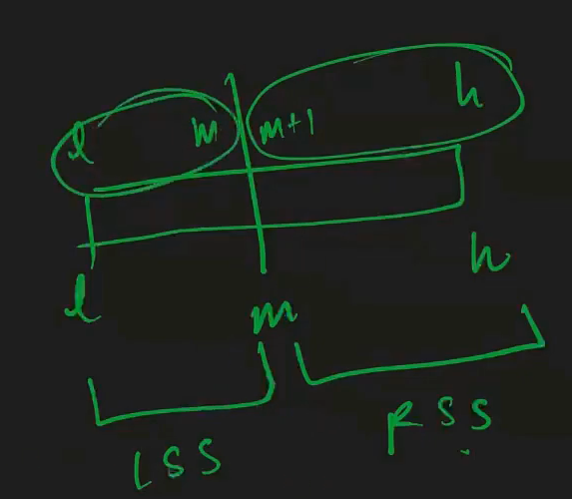
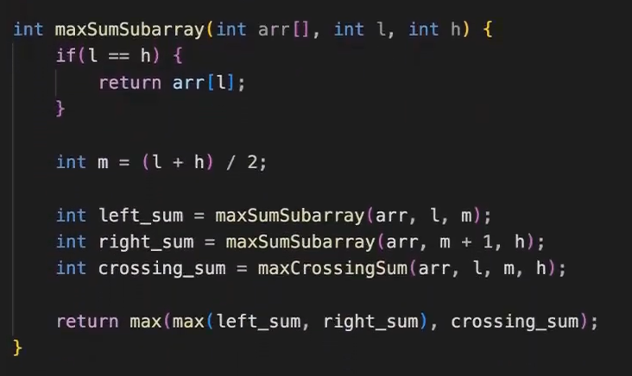
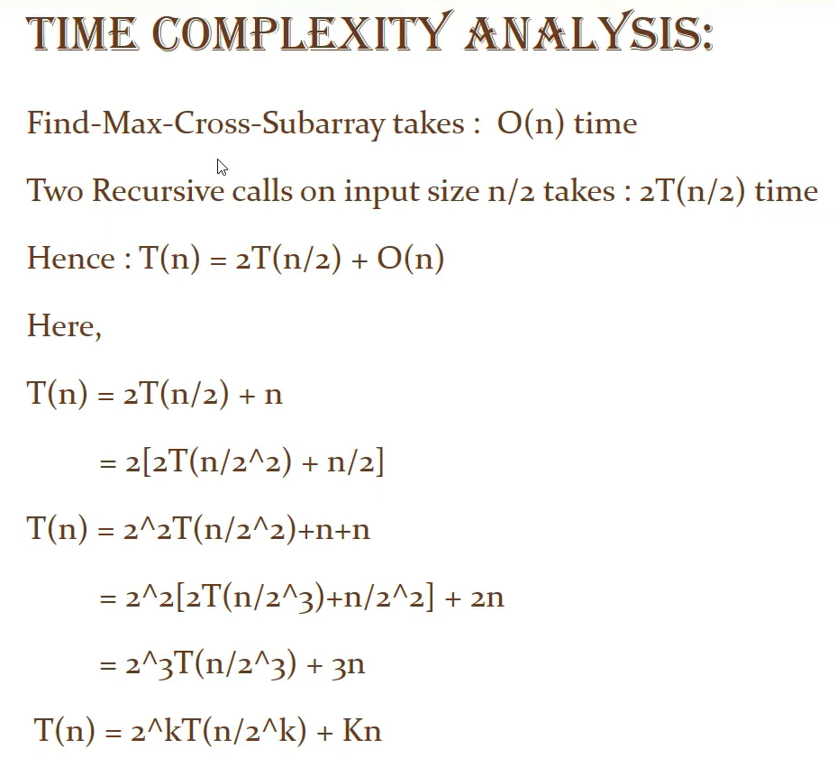
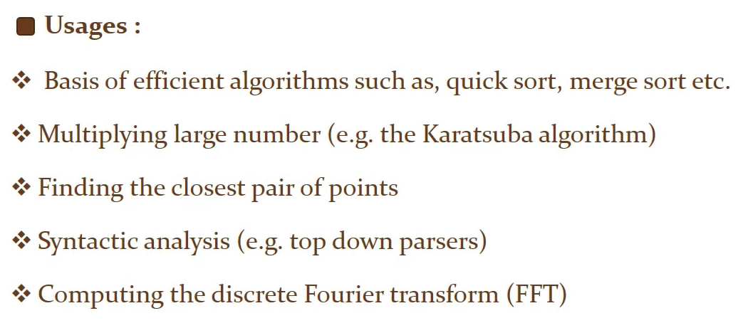

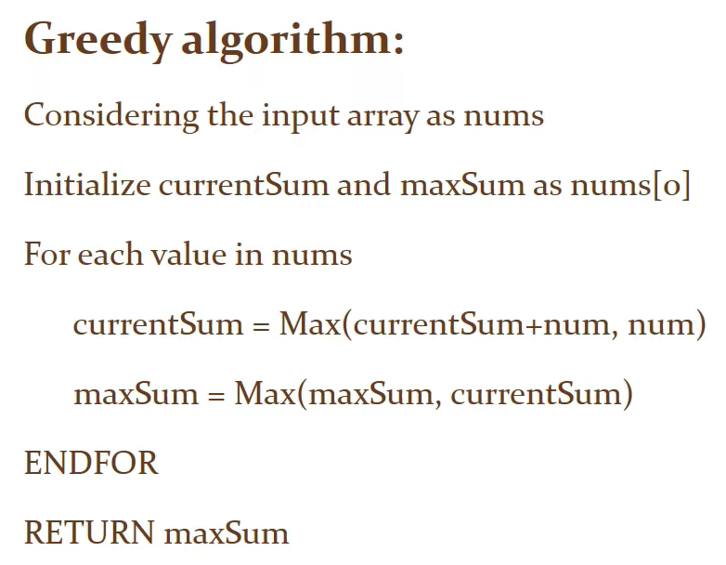
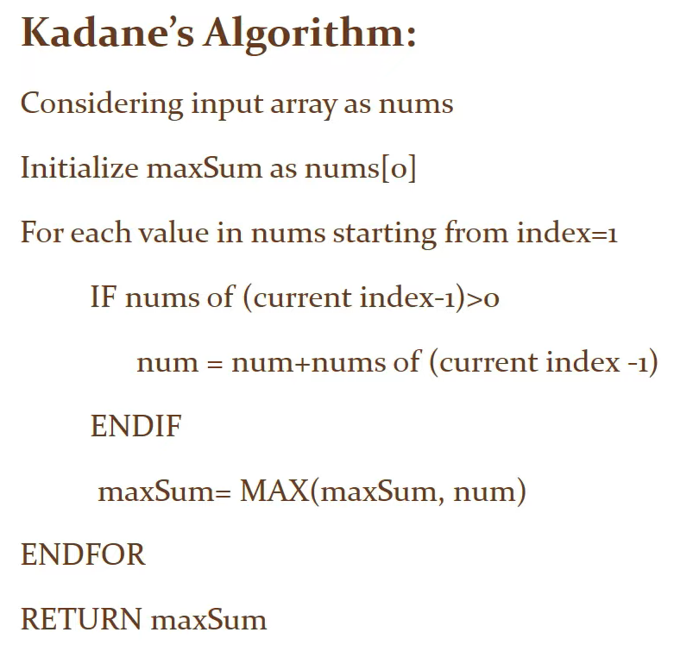
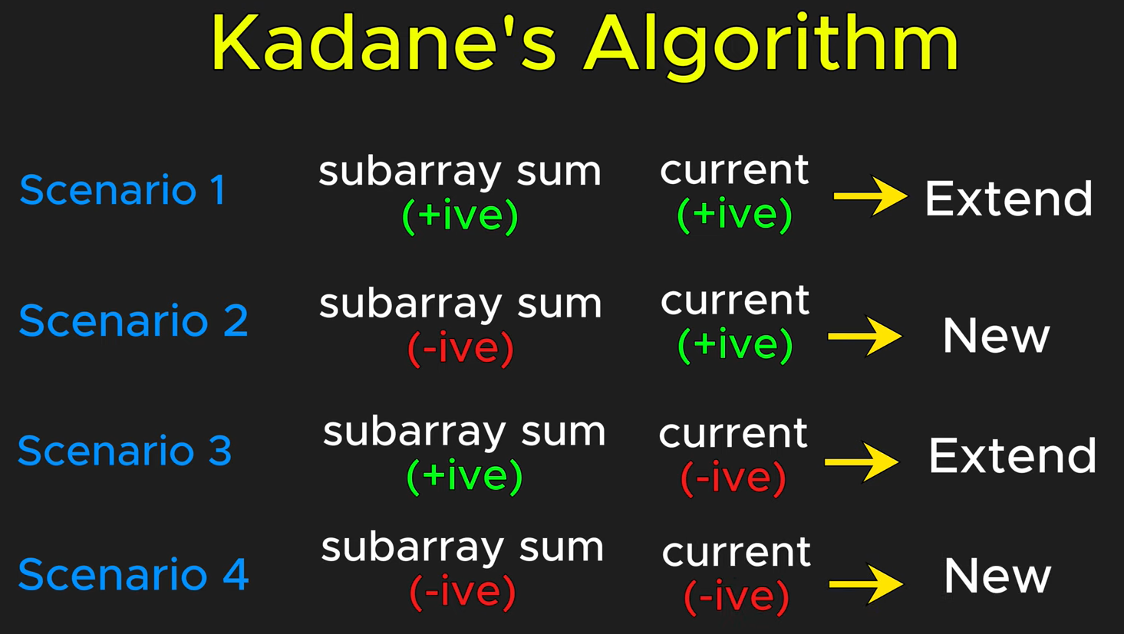
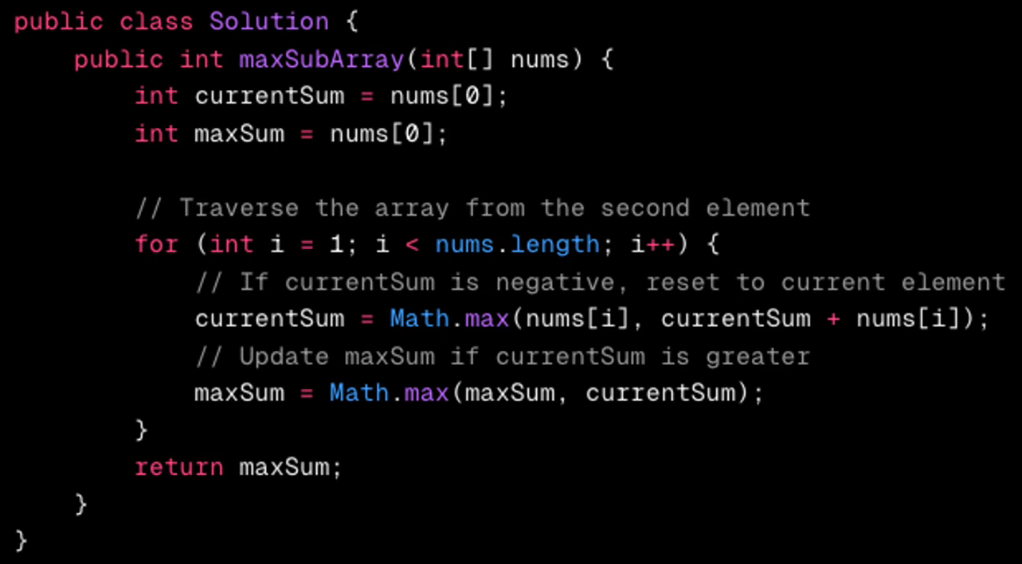
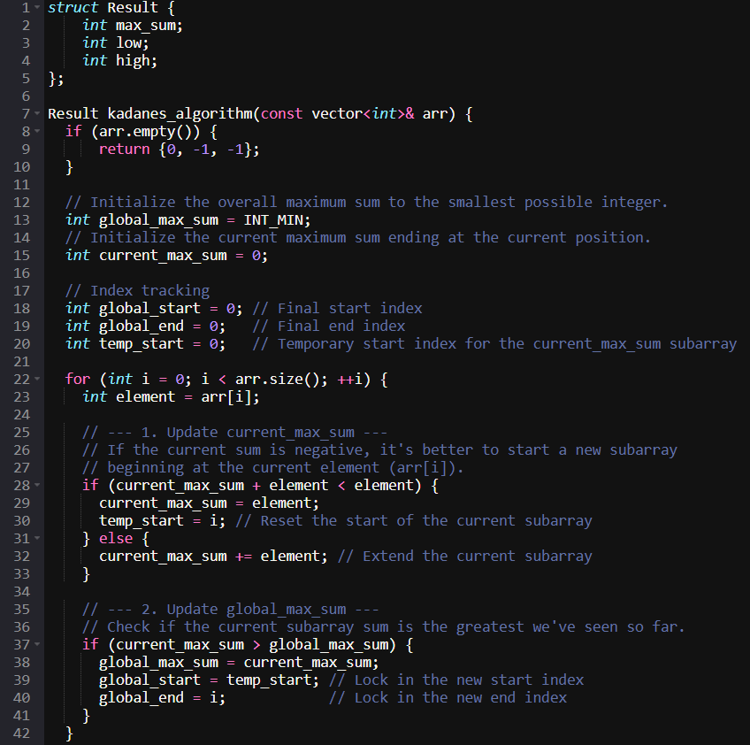
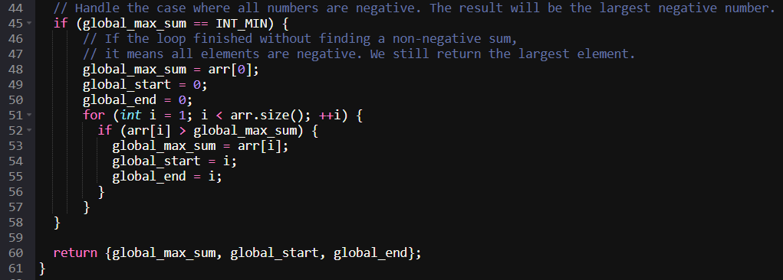
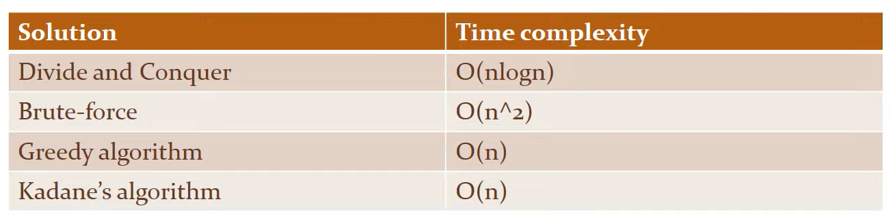
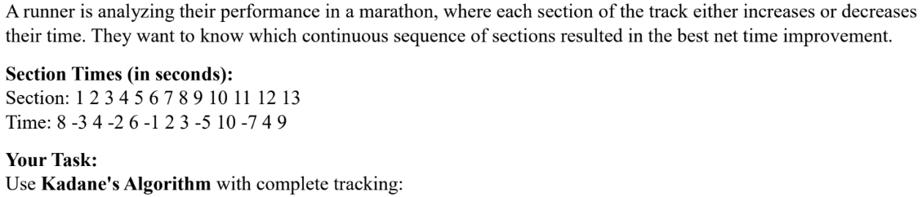
Sec # | Time (A[i]) | Current Sum (Prev Csum​) | Calculation: max(A[i],Csum​+A[i]) | New Csum​ | Decision & Rationale | Max Sum Gsum​ | Start/End of Best Sequence
1 | 8 | 0 | max(8,0+8)=8 | 8 | Start New: Initial section always starts the first sequence. | 8 | 1 / 1
2 | -3 | 8 | max(−3,8−3)=5 | 5 | Continue: 5>−3. The previous positive sum (8) is large enough to overcome the negative time and is worth keeping. | 8 | 1 / 1
3 | 4 | 5 | max(4,5+4)=9 | 9 | Continue: 9>4. Keep extending. Update Gsum​ (9 > 8). | 9 | 1 / 3
4 | -2 | 9 | max(−2,9−2)=7 | 7 | Continue: 7>−2. The net sequence sum is still positive and high (9), so we keep extending despite the small loss. | 9 | 1 / 3
5 | 6 | 7 | max(6,7+6)=13 | 13 | Continue: 13>6. Keep extending. Update Gsum​ (13 > 9). | 13 | 1 / 5
6 | -1 | 13 | max(−1,13−1)=12 | 12 | Continue: 12>−1. Keep extending. | 13 | 1 / 5
7 | 2 | 12 | max(2,12+2)=14 | 14 | Continue: 14>2. Keep extending. Update Gsum​ (14 > 13). | 14 | 1 / 7
8 | 3 | 14 | max(3,14+3)=17 | 17 | Continue: 17>3. Keep extending. Update Gsum​ (17 > 14). | 17 | 1 / 8
9 | -5 | 17 | max(−5,17−5)=12 | 12 | Continue: 12>−5. Keep extending, as the current loss is outweighed by the gain from Sections 1-8. | 17 | 1 / 8
10 | 10 | 12 | max(10,12+10)=22 | 22 | Continue: 22>10. Keep extending. Update Gsum​ (22 > 17). | 22 | 1 / 10
11 | -7 | 22 | max(−7,22−7)=15 | 15 | Continue: 15>−7. Keep extending. | 22 | 1 / 10
12 | 4 | 15 | max(4,15+4)=19 | 19 | Continue: 19>4. Keep extending. | 22 | 1 / 10
13 | 9 | 19 | max(9,19+9)=28 | 28 | Continue: 28>9. Keep extending. Update Gsum​ (28 > 22). | 28 | 1 / 13

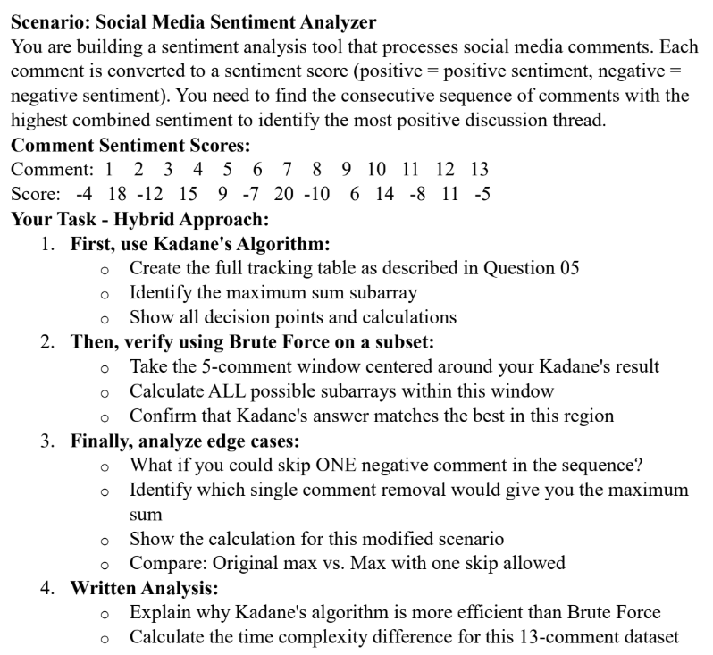
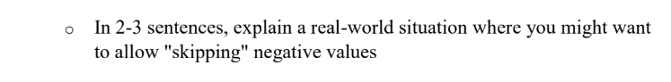
Cmt # | Score (A[i]) | Prev Csum​ | Calculation: max(A[i],Csum​+A[i]) | New Csum​ | Decision & Rationale | Max Sum Gsum​ | Best Sequence Range
1 | -4 | 0 | max(−4,−4)=−4 | -4 | Start New: Initial comment sets the baseline. | -4 | 1 / 1
2 | 18 | -4 | max(18,14)=18 | 18 | Start Fresh: Starting fresh at 18 is much better than carrying the −4 loss (18>14). Update Gsum​ (18 > -4). | 18 | 2 / 2
3 | -12 | 18 | max(−12,6)=6 | 6 | Continue: 6>−12. The strong positive sentiment (18) is worth carrying despite the large negative dip. | 18 | 2 / 2
4 | 15 | 6 | max(15,21)=21 | 21 | Continue: 21>15. Keep extending. Update Gsum​ (21 > 18). | 21 | 2 / 4
5 | 9 | 21 | max(9,30)=30 | 30 | Continue: 30>9. Keep extending. Update Gsum​ (30 > 21). | 30 | 2 / 5
6 | -7 | 30 | max(−7,23)=23 | 23 | Continue: 23>−7. Absorb the deficit. | 30 | 2 / 5
7 | 20 | 23 | max(20,43)=43 | 43 | Continue: 43>20. Keep extending. Update Gsum​ (43 > 30). | 43 | 2 / 7
8 | -10 | 43 | max(−10,33)=33 | 33 | Continue: 33>−10. Absorb the large deficit. | 43 | 2 / 7
9 | 6 | 33 | max(6,39)=39 | 39 | Continue: 39>6. Keep extending. | 43 | 2 / 7
10 | 14 | 39 | max(14,53)=53 | 53 | Continue: 53>14. Keep extending. Update Gsum​ (53 > 43). | 53 | 2 / 10
11 | -8 | 53 | max(−8,45)=45 | 45 | Continue: 45>−8. Absorb the deficit. | 53 | 2 / 10
12 | 11 | 45 | max(11,56)=56 | 56 | Continue: 56>11. Keep extending. Update Gsum​ (56 > 53). | 56 | 2 / 12
13 | -5 | 56 | max(−5,51)=51 | 51 | Continue: 51>−5. Absorb the deficit. | 56 | 2 / 12

Kadane's Result
The maximum combined sentiment is 56, corresponding to the sequence from Comment 2 to Comment 12.

2. Brute Force Verification (Subset)
The Kadane's result is the sequence from Comment 2 to Comment 12. For verification, let's select a 5-comment window centered around the middle of the full array (Comment 7): Comments 5 through 9.
Verification Window (B): Comments 5 to 9
B = [9, -7, 20, -10, 6]
We calculate the sum of all possible continuous subarrays within this 5-comment window.
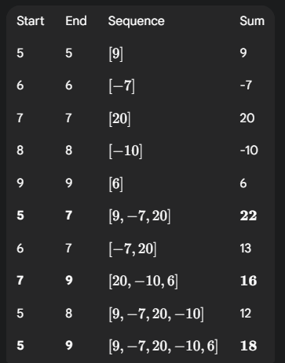
Brute Force Max in Subset: The maximum sum in the verification window (Comments 5-9) is 22 (from Comments 5-7: [9, -7, 20]).
Since Kadane's Algorithm calculated a global maximum of 56 (Comments 2-12), and the Brute Force result of 22 is only the maximum within the small window, this confirms that the global maximum found by Kadane's is significantly better than any contiguous sequence in the smaller region.

