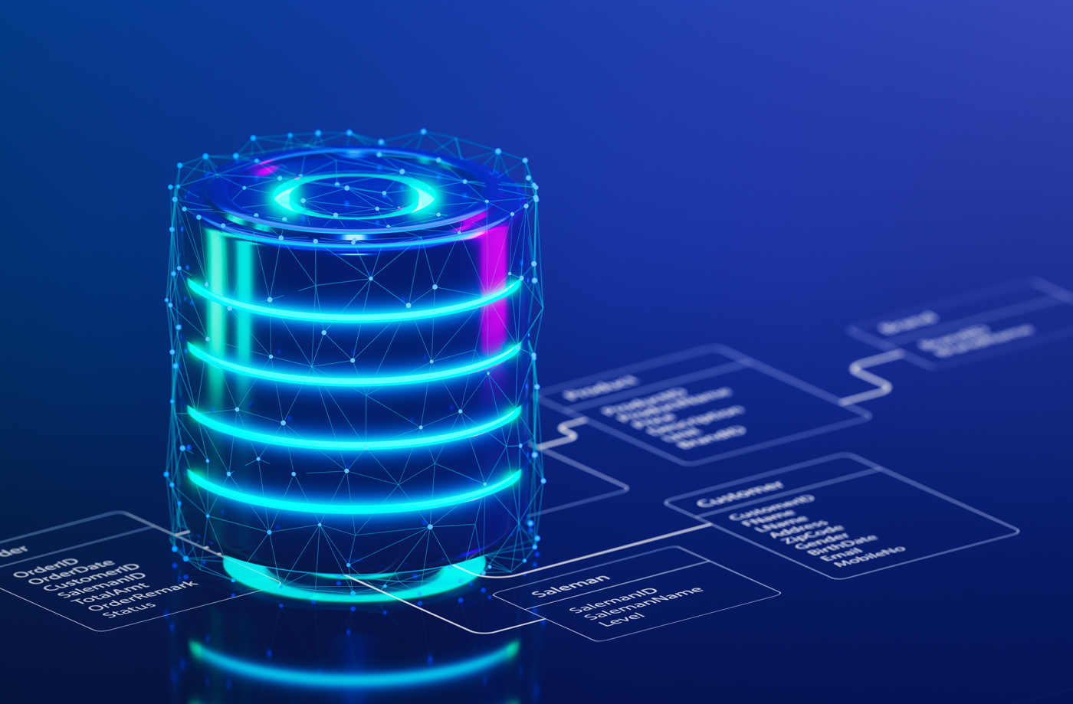

|  |  |
| --- | --- |
| **Name:** | **Waleed Afzal** |
| **Roll No:** | **23P-0566** |
| **Section:** | **4C** |
| **Lab:** | **DBMS** |
| **Number:** | **#14** |

**TASKS:**

**TASK#01:**

**TASK#02:**

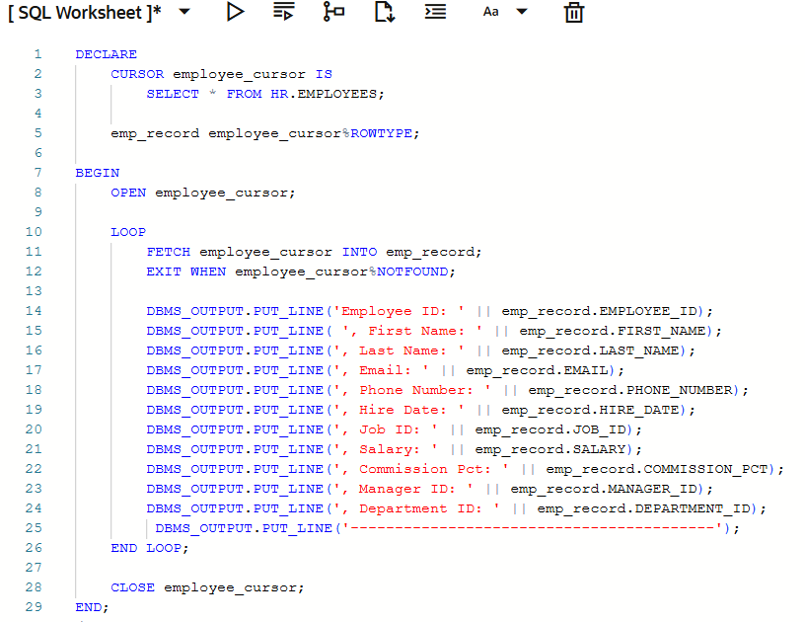

**TASK#03:**

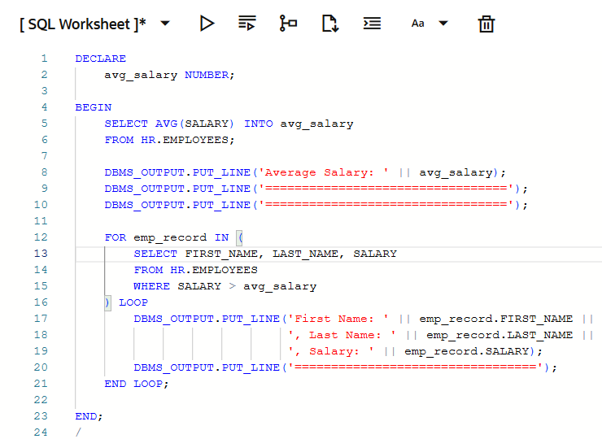

**TASK#04:**

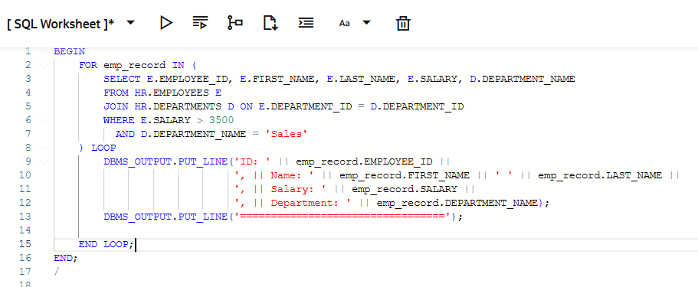

**TASK#05:**

