**1. What is Decision Making?**

* **Definition**: Decision making is the process of choosing the best solution from available alternatives to solve a problem or achieve a goal.
* **Example**: A manager deciding whether to launch a new product or improve an existing one.

**2. Types of Decisions**

**a. Programmed Decisions (For Structured Problems):**

* **Definition**: Routine, repetitive decisions that follow a set of rules or procedures.
* **Example**: A retail store automatically reorders stock when inventory levels drop below a certain point.

**b. Non-Programmed Decisions (For Unstructured Problems):**

* **Definition**: Unique, complex decisions that require custom solutions.
* **Example**: A company deciding to enter a new market or launch a new product.

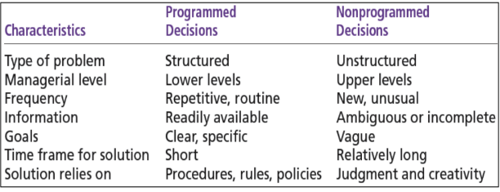

**3. Decision-Making Conditions**

**a. Certainty:**

* **Definition**: All information is available, and outcomes are predictable.
* **Example**: Ordering raw materials from a trusted supplier with guaranteed delivery times.

**b. Risk:**

* **Definition**: Outcomes are uncertain, but probabilities can be estimated based on past data.
* **Example**: Investing in a new advertising campaign with a 70% chance of increasing sales.

**c. Uncertainty:**

* **Definition**: Outcomes are unpredictable due to lack of information.
* **Example**: Expanding into a new international market with unknown customer preferences.

**4. Decision-Making Models:**

**I) Rational Decision-Making Model**

**Definition**: A logical, step-by-step approach to making decisions that maximize outcomes.

* **Steps**:
  1. Define the problem.
  2. Identify decision criteria (e.g., cost, quality, time).
  3. Weigh the criteria (e.g., cost is more important than time).
  4. Generate alternatives.
  5. Evaluate alternatives.
  6. Choose the best alternative.
* **Example**: A manager selecting the best supplier by comparing prices, quality, and delivery times.

**II) Bounded Rationality (Simon Model)**

* **Definition**: Managers make decisions based on limited information and time, aiming for a "good enough" solution rather than the perfect one.
* **Example**: A manager hiring the first qualified candidate instead of interviewing all applicants.

**III) Intuitive Decision Making**

* **Definition**: Making decisions based on experience, feelings, and quick judgment.
* **Example**: A manager deciding to launch a product based on their gut feeling about market trends.

**IV) Political Decision-Making Model**

* **Definition**: Decisions are influenced by negotiations, alliances, and power dynamics within the organization.
* **Example**: A manager building support among team members to approve a new project.

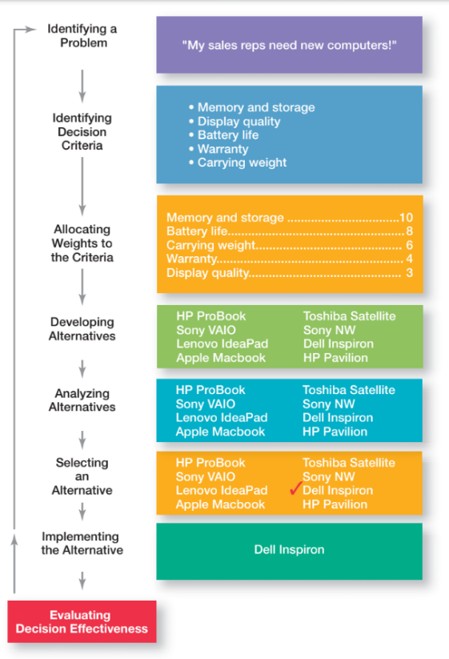**Decision-Making Process**

**1. Identify the Problem**

* **Description:** Clearly define the issue or challenge that requires a decision.
* Realize that your current laptop is outdated and no longer meets your work and personal needs.

**2. Identify Decision Criteria**

* **Description:** Determine the factors and requirements that will influence the decision.
* List factors that are important for your new laptop, such as budget, performance (processor speed, RAM), battery life, weight, display quality, and brand reliability.

**3. Weight the Criteria**

* **Description:** Assign a relative importance (or weight) to each criterion based on its significance to the overall decision.
* Assign a level of importance to each factor—for example, performance might be rated highest, followed by battery life and budget, while weight and display quality also hold significance.

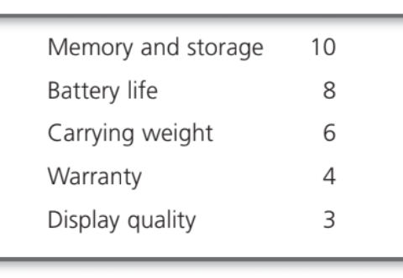

4. **Develop Alternatives**

* **Description:** Generate a range of possible solutions or courses of action to address the identified problem. The alternatives are only listed, not evaluated just yet. Give each alternative some values after doing research.
* Research and compile a list of available laptop models that meet your initial criteria. This might include models from various brands like Dell, HP, Lenovo, and Apple. This shows the assessment of the eight alternatives using the decision criteria, and not the weighting.

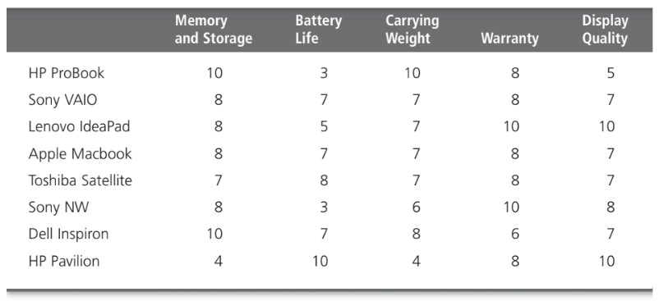

**5. Analyze Alternatives**

* **Description:** When you multiply each alternative value by the assigned weight, you get the **weighted Alternatives**. The total score for each alternative, then, is the sum of its weighted criteria.
* Compare each laptop’s specifications to see how well they align with your weighted criteria.

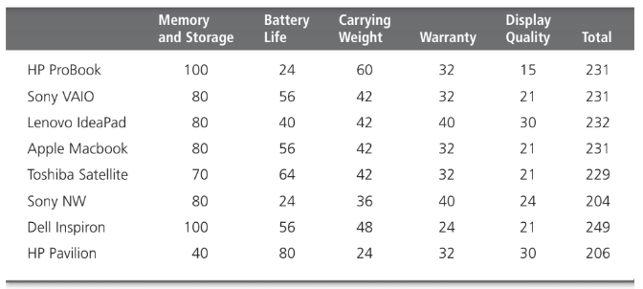

**6. Select the Best Alternative**

* **Description:** Choose the solution that best aligns with the weighted decision criteria and offers the most benefits while minimizing drawbacks.
* Choose the best alternative or the one that generated the highest total in Step 5.

**7. Implement the Alternative**

* **Description:** Put the chosen solution into action by developing an implementation plan, allocating resources, and assigning responsibilities.
* Purchase the selected laptop through a reputable retailer or online store, ensuring that all necessary accessories and warranty options are included.

**8. Evaluate Decision Effectiveness**

* **Description:** Monitor and review the results of the implemented decision to determine if it has resolved the problem and met the objectives.
* After using the new laptop for a few months, review its performance, durability, and overall satisfaction. Determine if the laptop meets your needs or if adjustments (like additional software or support) are required.

**Practice Questions:**

**Scenario 1: Choosing New Project Management Software**

**Identifying the Problem**: "Our current project management software is outdated."

**Identifying Decision Criteria**: The criteria for decision-making are:

* User-friendliness
* Cost
* Features
* Customer support
* Integration with other tools

**Allocating Weights to the Criteria**: Weights assigned to each criterion are:

* User-friendliness: 10
* Cost: 8
* Features: 7
* Customer support: 5
* Integration with other tools: 4

**Developing Alternatives**: The alternatives considered are:

* Software A
* Software B
* Software C
* Software D

**Analyzing Alternatives**: Evaluate each software based on the criteria.

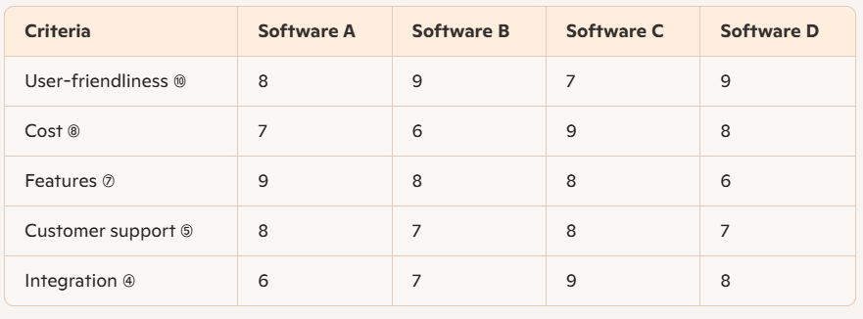

**Selecting an Alternative**: Calculate the total score for each software:

* Software A: (8x*10) + (7x*8) + (9x*7) + (8x*5) + (6x4) = 80 + 56 + 63 + 40 + 24 = 263
* Software B: (9x*10) + (6x*8) + (8x*7) + (7x*5) + (7x4) = 90 + 48 + 56 + 35 + 28 = 257
* Software C: (7x*10) + (9x*8) + (8x*7) + (8x*5) + (9x4) = 70 + 72 + 56 + 40 + 36 = 274
* Software D: (9x*10) + (8x*8) + (6x*7) + (7x*5) + (8x4) = 90 + 64 + 42 + 35 + 32 = 263

Software C has the highest score of **274**.

**Implementing the Alternative**: Deploy **Software C** within the company.

**Evaluating Decision Effectiveness**: Assess if Software C meets the company's needs through feedback from users and performance metrics.

Decision-making styles and value orientations based on two primary dimensions: **Tasks/Technical Concerns** and **People/Social Concerns**.

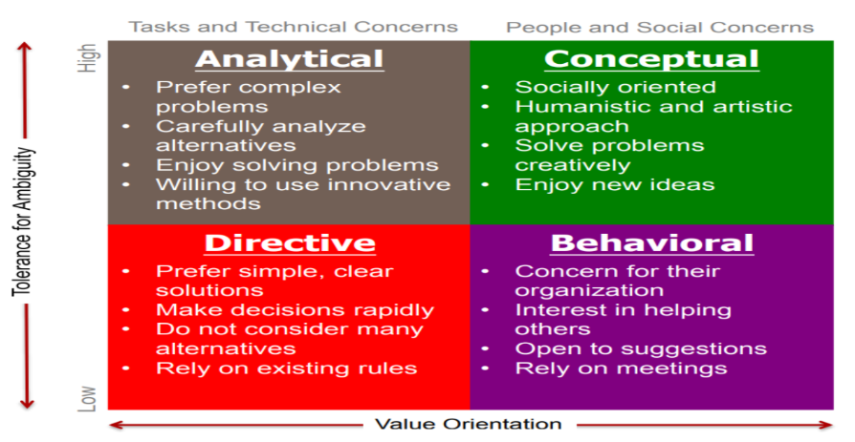

* **Analytical**

This style involves gathering and analyzing large amounts of data from various sources to make decisions based on technical outcomes.

* **Directive**

This style involves making quick decisions based on past experiences and established procedures. It's effective in stable environments with predictable outcomes.

* **Conceptual**

This style involves thinking outside the box and being creative and innovative. It's often characterized by a willingness to take risks and explore new ideas.

* **Behavioral**

This style involves trying to avoid conflict and being concerned with acceptance by others.

**Qualities of Good Decisions**

* **Clear Objectives:** Goals are well-defined.
* **Thorough Information:** Decisions are based on solid data and research.
* **Multiple Alternatives:** Various options are considered.
* **Rational Analysis:** Choices are made logically and align with strategic goals.
* **Risk Management:** Potential risks are assessed and planned for.
* **Feasible Implementation:** There's a clear plan to execute the decision.
* **Adaptability:** Decisions are reviewed and adjusted based on feedback.

**Qualities of Bad Decisions**

* **Unclear Objectives:** Goals are ambiguous or poorly defined.
* **Insufficient Information:** Decisions lack proper data and research.
* **Limited Options:** Few alternatives are considered.
* **Biased Reasoning:** Choices are driven by emotions or biases rather than logic.
* **Poor Risk Assessment:** Potential risks are ignored or underestimated.
* **Weak Implementation:** No clear execution plan is in place.
* **Inflexibility:** Decisions are not revisited or adjusted despite new information.

**Managers often make bad decisions because**

* **Incomplete Information:** Decisions are based on limited or inaccurate data.
* **Cognitive Biases:** Overconfidence and groupthink can cloud judgment.
* **Time Pressure:** Tight deadlines lead to rushed, poorly analyzed choices.
* **Ambiguous Goals:** Unclear objectives create confusion about priorities.
* **Organizational Politics:** Internal conflicts and agendas distort objective decision-making.

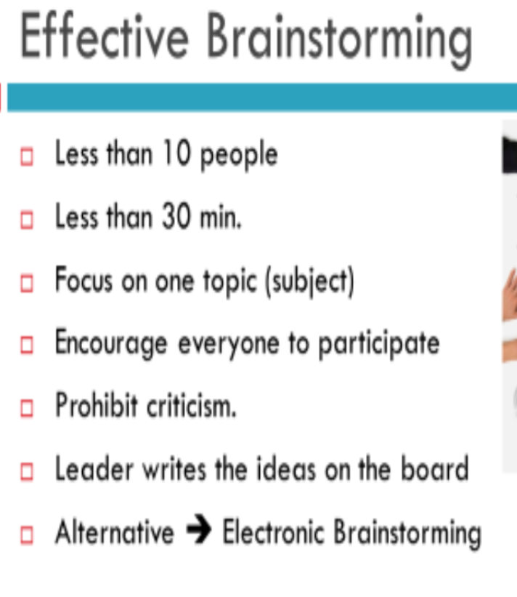

**Coalition**

In management, a coalition is a group of people within an organization who come together to achieve a common goal or influence decision-making.