**1. Why Do Managers Plan?**

Planning is a critical function of management. Here’s why managers plan:

**a. Provides Direction:**

* Planning gives employees a clear understanding of what the organization wants to achieve and what they need to do to contribute to those goals.
* **Example**: If a company’s goal is to increase sales by 20%, employees know they need to focus on marketing, customer service, and product quality.

**b. Reduces Uncertainty:**

* Planning helps managers anticipate changes and prepare for them, reducing the impact of uncertainty.
* **Example**: A company might plan for economic downturns by saving funds or diversifying its product line.

**c. Minimizes Waste and Redundancy:**

* Planning ensures resources are used efficiently by identifying and eliminating unnecessary activities.
* **Example**: A manufacturing company might plan to reduce waste by optimizing its production process.

**d. Establishes Goals for Control:**

* Planning sets goals that can be used to measure performance during the controlling process.
* **Example**: If a company plans to reduce costs by 10%, it can later check if this goal was achieved.

**2. Types of Goals**

Goals are the desired outcomes an organization aims to achieve. There are different types of goals:

**a. Financial Goals:**

* Goals related to the financial performance of the organization.
* **Example**: Increasing revenue, achieving profitable investments, or reducing costs.

**b. Stated Goals:**

* Official goals that an organization declares to its stakeholders. These may not always reflect what the organization actually pursues.
* **Example**: A company might state its goal is to become the market leader in sustainable energy by 2025, but its real focus might be on maximizing profits.

**c. Real Goals:**

* The goals an organization actually pursues, as reflected in the actions of its members.
* **Example**: A university might claim to limit class sizes **(stated)**, but in reality, it focuses on increasing enrollment to boost revenue **(real)**.

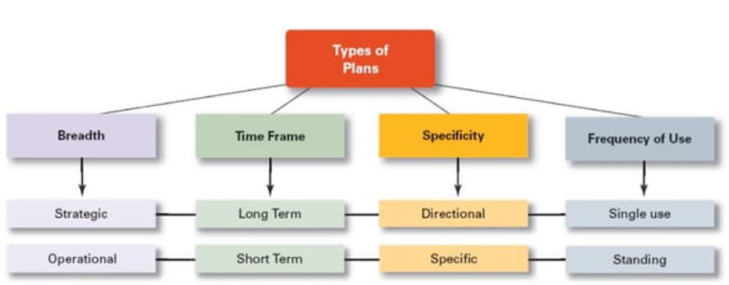

**3. Types of Plans**

Plans are the blueprints for achieving goals. They can be categorized as follows:

**a. Strategic Plans:**

* Long-term plans that provide direction for the entire organization. These are set by **Top-level Management**.
* **Example**: A company’s strategic plan might include expanding into international markets over the next 5 years.

**b. Tactical Plans:**

* Medium-term plans that outline how strategic plans will be implemented. These plans are set and carried out by **Middle-level Management**.
* **Example**: A tactical plan might involve launching a new product line, requiring coordination across departments like R&D, marketing, and sales.

**c. Operational Plans:**

* Short-term, action-driven plans that detail daily activities. These plans are set and carried out by **Front-line Management** i.e. office managers, team leaders, and supervisors.
* **Example**: A team leader creating a shift schedule for employees or assigning tasks for the day.

**4. Time Frame of Plans**

Plans can be classified based on their time frame:

**a. Long-Term Plans:**

* Plans with a time frame of more than 3 years.
* **Example**: A company planning to build a new factory in 5 years.

**b. Short-Term Plans:**

* Plans covering 1 year or less.
* **Example**: A monthly sales target for a retail store.

**c. Intermediate Plans:**

* Plans that fall between short-term and long-term, typically 1 to 3 years.
* **Example**: A 2-year plan to improve employee training programs.

**5. Specificity of Plans**

Plans can be specific or directional, depending on the level of uncertainty:

**a. Specific Plans:**

* Clearly defined plans with no room for ambiguity.
* **Example**: A plan to increase work output by 8% over 12 months, with detailed steps and timelines.

**b. Directional Plans:**

* When **uncertainty** is high and managers must be flexible in order to respond to unexpected changes, directional plans are preferable.
* Directional plans are **flexible plans** that set out general guidelines. They provide focus but don’t lock managers into specific goals or courses of action.
* **Example**: A plan to improve customer satisfaction without specifying exact methods or timelines.

**6. Frequency of Use**

Plans can be single-use or ongoing:

**a. Single-Use Plans:**

* One-time plans designed for unique situations.
* **Example**: A project plan for building a new office or a budget plan for a specific event.

**b. Standing Plans:**

* Ongoing plans that provide guidance for repeated activities.
* **Example**: Organizational policies, such as a company’s code of conduct or employee leave policy.

**7. Traditional Goal Setting**

* Goals are set at the top level of the organization and passed down to lower levels.
* Goals are then broken into sub-goals for each organizational level.
* Assumes the top management **knows best** because they can see the “big picture.”
* Goals are intended to direct, guide, and constrain from above.
* Goals lose clarity and focus as lower-level managers attempt to interpret and define the goals for their areas of responsibility.
* **Example**: The president tells the vice president of production what he expects manufacturing costs to be for the coming year and tells the marketing vice president what level he expects sales to reach for the year. These goals are passed to the next organizational level and written to reflect the responsibilities of that level, passed to the next level, and so forth. Then, at some later time, performance is evaluated to determine whether the assigned goals have been achieved.

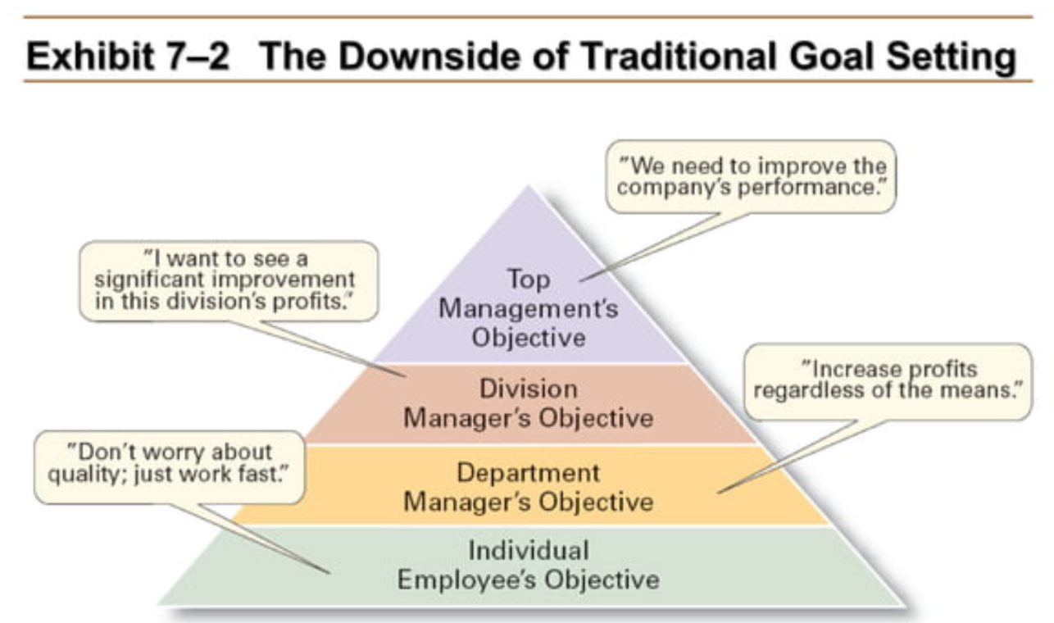

**8. Management by Objectives (MBO)**

Itis a strategic approach to enhance the performance of both the individual and the organization where **managers and employees** work together to identify goals, set objectives, and then use those objectives to evaluate performance and provide feedback. It is a technique which involves setting specific, measurable, achievable, relevant, and time-bound (SMART) **objectives for employees**.

**Steps in MBO**:

* 1. **Define Organizational Goals:**
* Top-level management sets broad strategic goals that align with the company’s vision and mission. These goals provide direction for departments and employees.
  1. **Define Employee Objectives:**
* Once organizational goals are established, individual objectives are set for each employee. These objectives should be specific, measurable, achievable, relevant, and time-bound (SMART).
* Managers and employees collaborate to ensure individual goals align with organizational priorities.
* Employees are encouraged to take ownership of their objectives.
  1. **Continue Monitoring Performance and Progress:**
* Performance is Regularly monitored to track individual progress towards their objectives. This allows for timely adjustments and interventions if necessary.
  1. **Providing Feedback:**
* Constructive feedback is provided to employees on their performance. This feedback helps them understand their strengths and weaknesses and identify areas for improvement.

**5. Evaluate Performance (Appraisal) & Reward Achievements:**

* Evaluate employee performance at the end of the set period based on predefined objectives. Employees who meet or exceed objectives may receive appraisal as rewards, recognition, or promotions.

**9. Steps in Goal Setting**

1. **Review the Mission**: Align goals with the organization’s purpose.
2. **Evaluate Resources**: Ensure goals are achievable with available resources.
3. **Set Goals**: Define specific, measurable, and time-bound goals.
4. **Communicate Goals**: Share goals with everyone involved.
5. **Review Results**: Check if goals are being met and make adjustments if necessary.

**10. Means-Ends Chain (MEC)**

A cognitive framework that helps understand consumer decision-making by connecting product attributes (the "means") to personal values (the "ends") through perceived consequences. It's a hierarchical model that uses "laddering" to explore these connections.

* **Attributes (Means)**

These are the tangible or intangible features of a product or service (e.g., price, quality, design).

* **Consequences**

These are the functional or psychological outcomes that consumers perceive from using a product or service (e.g., convenience, satisfaction, status).

* **Values (Ends)**

These are the underlying motivations and goals that consumers have (e.g., security, freedom, self-esteem).

* **Laddering**

A technique used to explore the connections between attributes, consequences, and values by asking "why" questions to uncover deeper motivations.

Example:

* **Product:** A car
* **Attribute:** Fuel efficiency
* **Consequence:** Lower fuel costs
* **Value:** Financial security

**Contingency Planning (Before a problem occurs)**

**Definition:**  
Contingency planning is the process of preparing for **potential future events or risks** that might disrupt normal operations.

**Key Features:**

* Focuses on "what-if" scenarios (e.g., economic downturn, loss of a key supplier).
* Helps organizations **stay prepared** for uncertainties.
* Plans are **proactive** and developed **before** problems occur.

**Example:**  
A company might create a backup supplier list in case their main supplier fails to deliver materials.

**Purpose:**  
To ensure the organization can **continue operations** smoothly despite disruptions.

**Crisis Planning (During/after a problem occurs)**

**Definition:**  
Crisis planning involves preparing for **sudden and unexpected emergencies** that could threaten the organization’s survival or reputation.

**Key Features:**

* Focuses on **serious threats** (e.g., data breaches, PR disasters, natural disasters).
* Involves creating **emergency response protocols** and **communication strategies**.
* Often includes a **crisis management team** trained to handle high-pressure situations.

**Example:**  
A social media company creates a crisis communication plan to handle backlash from a data leak.

**Purpose:**  
To **minimize damage** and respond **quickly and effectively** during a crisis.

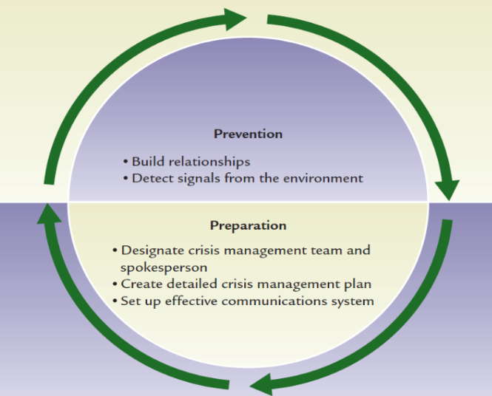

**Stages of Crisis Management**

1. **Prevention**

* Build trusting relationship with key stakeholders
* Open communication

1. **Crises Preparation**

* Crisis Management Team
* Crisis Management Plan
* Establish an Effective Communications System (Command Center)

**Scenario Building**

* **Definition:** Involves analyzing current trends to visualize future possibilities and prepare for uncertainties.
* **Process:** Managers consider potential future scenarios, ranging from optimistic to pessimistic, to prepare for various outcomes.

**Example:**

* **Financial Forecasting:** Banks use scenario modeling to predict the impact of economic changes on asset values, interest rates, and market conditions, aiding in portfolio management and risk assessment

**Questions:**

**1. Why Do Managers Plan?**

**Scenario**: A small bakery is struggling to compete with larger chains. The owner decides to create a plan to improve the business.  
**Question**: How can planning help the bakery owner?

* **Answer**: Planning can help the bakery owner by:
  + **Providing Direction**: Setting clear goals, such as increasing sales by 20% in the next year.
  + **Reducing Uncertainty**: Anticipating challenges like rising ingredient costs and planning how to address them.
  + **Minimizing Waste**: Identifying inefficiencies, such as excess inventory, and reducing waste.
  + **Establishing Goals for Control**: Setting measurable goals (e.g., reducing costs by 10%) to track progress.

**2. Types of Goals**

**Scenario**: A tech company announces its goal to become the leader in sustainable technology by 2030. However, employees notice that the company is focusing more on short-term profits.  
**Question**: What type of goal is the company’s announcement, and what is the real goal?

* **Answer**:
  + **Stated Goal**: The company’s announcement to become a leader in sustainable technology by 2030.
  + **Real Goal**: The company is actually focusing on short-term profits, as reflected in its actions.

**3. Types of Plans**

**Scenario**: A car manufacturer wants to launch a new electric vehicle (EV) in the next 3 years.  
**Question**: What types of plans should the company create, and how do they differ?

* **Answer**:
  + **Strategic Plan**: A long-term plan to become a leader in the EV market by 2030.
  + **Tactical Plan**: A medium-term plan to develop the new EV, including R&D, marketing, and production timelines.
  + **Operational Plan**: A short-term plan for daily activities, such as assigning tasks to engineers and setting production schedules.

**4. Time Frame of Plans**

**Scenario**: A university wants to improve its global ranking.  
**Question**: What types of plans (based on time frame) should the university create?

* **Answer**:
  + **Long-Term Plan**: Increase research output and international collaborations over the next 5 years.
  + **Intermediate Plan**: Hire 20 new faculty members in the next 2 years.
  + **Short-Term Plan**: Organize a conference on global education trends within the next 6 months.

**5. Specificity of Plans**

**Scenario**: A retail store wants to improve customer satisfaction.  
**Question**: Should the store create a specific plan or a directional plan, and why?

* **Answer**:
  + **Specific Plan**: If the store knows exactly what needs to be done (e.g., reduce checkout time to under 5 minutes), it should create a specific plan with clear steps and timelines.
  + **Directional Plan**: If the store is unsure about the best approach, it can create a flexible plan with general guidelines (e.g., improve customer service through training and feedback).

**6. Frequency of Use**

**Scenario**: A company is organizing a one-time charity event and also wants to improve its daily operations.  
**Question**: What types of plans should the company create for these activities?

* **Answer**:
  + **Single-Use Plan**: A detailed plan for the charity event, including budget, schedule, and tasks.
  + **Standing Plan**: Ongoing policies and procedures to improve daily operations, such as a customer service policy or employee training program.

**7. Traditional Goal Setting**

**Scenario**: A company’s CEO sets a goal to increase annual revenue by 15%. This goal is passed down to department heads, who then set goals for their teams.  
**Question**: What is the potential downside of this approach?

* **Answer**: The downside is that goals may become less clear or realistic as they are passed down. For example, a sales team might set unrealistic targets to meet the CEO’s goal, leading to stress and poor performance.

**8. Management by Objectives (MBO)**

**Scenario**: A software company wants to improve employee performance using MBO.  
**Question**: What steps should the company follow to implement MBO?

* **Answer**:
  1. **Review the Mission**: Ensure goals align with the company’s mission (e.g., “to innovate and deliver high-quality software”).
  2. **Evaluate Resources**: Set realistic goals based on available resources (e.g., budget, staff).
  3. **Set Goals**: Define specific, measurable goals (e.g., “launch 2 new software products in the next year”).
  4. **Communicate Goals**: Share goals with all employees and explain their role in achieving them.
  5. **Review Results**: Regularly check progress and adjust goals as needed.

**9. Steps in Goal Setting**

**Scenario**: A startup wants to set goals for its first year of operations.  
**Question**: What steps should the startup follow to set effective goals?

* **Answer**:
  1. **Review the Mission**: Align goals with the startup’s mission (e.g., “to provide affordable tech solutions”).
  2. **Evaluate Resources**: Ensure goals are realistic given the startup’s limited budget and staff.
  3. **Set Goals**: Define specific, measurable goals (e.g., “acquire 1,000 customers in the first year”).
  4. **Communicate Goals**: Share goals with the team and explain how each member contributes.
  5. **Review Results**: Track progress monthly and adjust goals if necessary.

**Questions:**

**Scenario 1: Strategic Planning for a Startup**

**Scenario Description:** A startup, "GreenTech Innovations," is developing a new line of eco-friendly products. The founders want to create a strategic plan to guide the company's growth over the next three years. They aim to become a leading provider of sustainable solutions in their industry.

**Question 1:** How can GreenTech Innovations use the SMART criteria to set strategic goals for their product development and market expansion?

**Answer:** GreenTech Innovations can set SMART goals as follows:

* **Specific:** Develop three new eco-friendly products and expand into two new regional markets.
* **Measurable:** Aim for a 30% increase in revenue from new products and a 20% market share in the new regions within three years.
* **Achievable:** Conduct market research to identify high-demand eco-friendly products and invest in sustainable production technologies.
* **Relevant:** Expanding the product line and market reach aligns with the company's mission to promote sustainability.
* **Time-bound:** Achieve these goals within three years.

**Question 2:** What contingency plans should GreenTech Innovations consider to prepare for potential challenges in their strategic plan?

**Answer:** GreenTech Innovations should consider the following contingency plans:

* **Supply Chain Disruptions:** Establish relationships with multiple suppliers to ensure a steady flow of materials.
* **Regulatory Changes:** Stay informed about upcoming environmental regulations and adapt products to meet new standards.
* **Market Fluctuations:** Develop flexible pricing strategies and diversify product offerings to cater to changing consumer preferences.

**Scenario 2: Crisis Planning in a Financial Institution**

**Scenario Description:** A financial institution, "SecureBank," is preparing for potential crises that could disrupt its operations. The bank wants to ensure it can maintain services and protect its assets during unexpected events.

**Question 1:** What are the essential stages of crisis planning that SecureBank should implement?

**Answer:** SecureBank should implement the following stages of crisis planning:

* **Prevention:** Build trust with stakeholders and maintain open communication to address potential issues proactively.
* **Crisis Preparation:** Establish a Crisis Management Team, develop a Crisis Management Plan, and set up an effective communication system (Command Center).
* **Response and Recovery:** Prepare protocols for responding to crises, such as IT failures or financial crises, and plan for recovery to resume normal operations swiftly.

**Question 2:** How can SecureBank use scenario building to prepare for potential financial crises?

**Answer:** SecureBank can use scenario building by:

* **Identifying Key Risks:** Analyze potential financial risks, such as market crashes or liquidity issues.
* **Developing Scenarios:** Create scenarios ranging from optimistic to pessimistic outcomes, considering factors like interest rate changes and economic downturns.
* **Preparing Responses:** Develop strategies for each scenario, including liquidity management, risk mitigation, and customer communication plans.

**Scenario 3: Innovative Planning in a Tech Company**

**Scenario Description:** A tech company, "InnoVate Solutions," wants to foster innovation and push its teams to achieve excellence. The management is considering setting stretch goals to motivate employees and drive growth.

**Question 1:** How can InnoVate Solutions set stretch goals to encourage innovation and excellence?

**Answer:** InnoVate Solutions can set stretch goals by:

* **Defining Ambitious Targets:** Set goals that are significantly higher than current performance levels, such as aiming to double the number of innovative projects within a year.
* **Making Goals Clear and Compelling:** Ensure goals are well-communicated and inspire employees to think creatively.
* **Providing Resources and Support:** Offer the necessary resources, training, and support to help employees achieve these ambitious goals.

**Question 2:** What potential challenges might InnoVate Solutions face when implementing stretch goals, and how can they be addressed?

**Answer:** Potential challenges include:

* **Employee Burnout:** Stretch goals may lead to increased stress and burnout. This can be addressed by providing support systems and encouraging work-life balance.
* **Resistance to Change:** Employees may resist the push for higher performance. This can be mitigated by involving employees in goal-setting and providing clear rationales for the goals.
* **Resource Constraints:** Achieving stretch goals may require additional resources. The company should ensure adequate funding and support for innovative projects.

**Scenario 4: Planning for a Turbulent Environment**

**Scenario Description:** A logistics company, "SwiftLogistics," operates in an industry prone to disruptions such as transportation issues and labor strikes. The company wants to ensure it can maintain operations during turbulent times.

**Question 1:** How can SwiftLogistics implement contingency planning to prepare for potential disruptions?

**Answer:** SwiftLogistics can implement contingency planning by:

* **Identifying Critical Risks:** Analyze potential disruptions like transportation issues, labor strikes, and IT failures.
* **Developing Alternative Plans:** Create plans for alternative transportation routes, backup suppliers, and redundant IT systems.
* **Training and Communication:** Train employees on contingency procedures and establish clear communication protocols for crisis situations.

**Question 2:** How can SwiftLogistics use scenario building to anticipate and prepare for future challenges?

**Answer:** SwiftLogistics can use scenario building by:

* **Analyzing Trends:** Monitor industry trends and economic indicators to anticipate potential disruptions.
* **Creating Scenarios:** Develop scenarios that consider various disruption levels, from minor delays to major crises.
* **Preparing Responses:** Outline strategies for each scenario, including resource allocation, communication plans, and operational adjustments.