**The Meaning of Control**

**Controlling** is the process of **measuring performance**, **comparing it with set objectives**, and **taking corrective action** when needed to ensure that organizational goals are achieved.

OR

**Organizational control** is the systematic process through which managers **regulate organizational activities** to make them consistent with **expectations** established in plans, targets, and **standards of performance**.

**Importance of Control in Management**

**1. A Critical Link Back to Planning**

Control is like a GPS that helps make sure you're still on the right route that was planned.

* Even if the plan is great, without control, things can go off-track.

**2. Keeping Plans on Track**

Control helps **track progress** and alerts managers if things are not going as expected.

* It answers: Are we meeting our goals? If not, what can we fix?
* It connects planning with real performance and **helps guide future decisions**.

**3. Empowering Employees**

Control systems give feedback, which helps employees understand how they are performing.

* When employees know what’s expected and how they’re doing, they take more responsibility and stay motivated.
* It also allows managers to recognize and reward good performance.

**4. Protecting the Workplace**

Control helps maintain **order, safety, and discipline** in the workplace.

* It ensures that rules and policies are being followed.
* Helps **minimize risks**, theft, accidents, or any kind of workplace disruption.

**The Planning–Controlling Link**

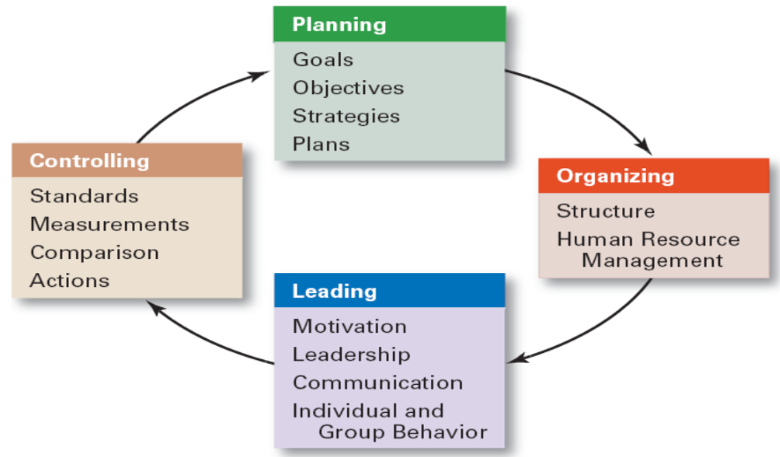

**The Control Process**

**1. Measuring Actual Performance**

* This step is about **checking what’s really happening**.
* Managers collect data on employee output, sales, costs, quality, etc.

**2. Comparing Performance Against Standards**

* Now, we **compare** the real results with the **planned goals** or **standards**.
* Ask: Is the performance above, below, or at the expected level?

**3. Taking Corrective Action**

* If there is a gap between actual and expected performance, managers take steps to fix it.
* This could involve:
  + Training employees
  + Fixing a process
  + Updating equipment
  + Or even revising unrealistic standards

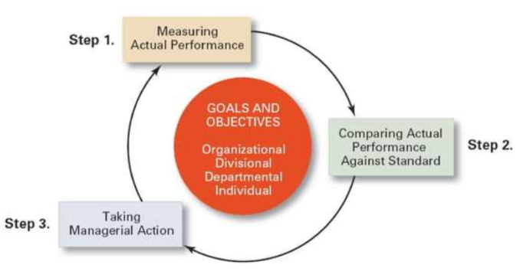

**Measuring: Sources of Information**

**👀 1. Personal Observation**

* Managers watch the work directly.
* Example: A manager walks around the shop floor to see if employees are following safety procedures.
* ✅ Real-time and firsthand.
* ❌ Time-consuming and might be biased.

**📊 2. Statistical Reports**

* Data presented in numbers, charts, or graphs.
* Example: Sales reports, production totals, or defect rates.
* ✅ Objective and great for spotting trends.
* ❌ Lacks detail about the "why" behind numbers.

**🗣️ 3. Oral Reports**

* Verbal updates from employees or teams.
* Example: Daily team huddle or a phone update.
* ✅ Quick and interactive.
* ❌ Not always accurate or recordable.

**📄 4. Written Reports**

* Detailed reports submitted in writing.
* Example: A weekly progress report or project update email.
* ✅ Clear, permanent, and easy to analyse.
* ❌ Slower and may take time to prepare.

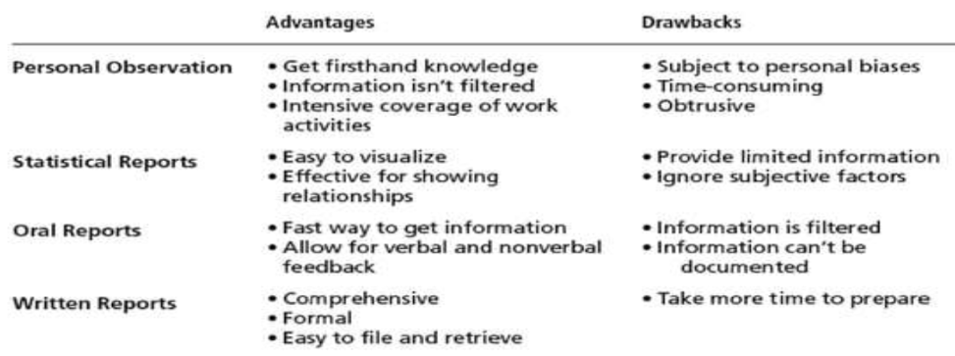

**Comparing**

We’re comparing:

* **Actual Performance** (what really happened) with **Standard** (what was supposed to happen)

**1. Degree of Variation**

* How much difference is there between the actual result and the expected standard?
* Example: If the budget for sales was $100,000 and actual sales were $90,000, the variation is **$10,000 below** the standard.

**2. Significance of Variation**

* Not all differences matter — some may be **small or expected**.
* Managers decide **if the variation is serious enough** to take action.

**3. Size and Direction**

* **Size**: Is the variation **big or small**?
* **Direction**: Is performance **better (over)** or **worse (under)** than the target?

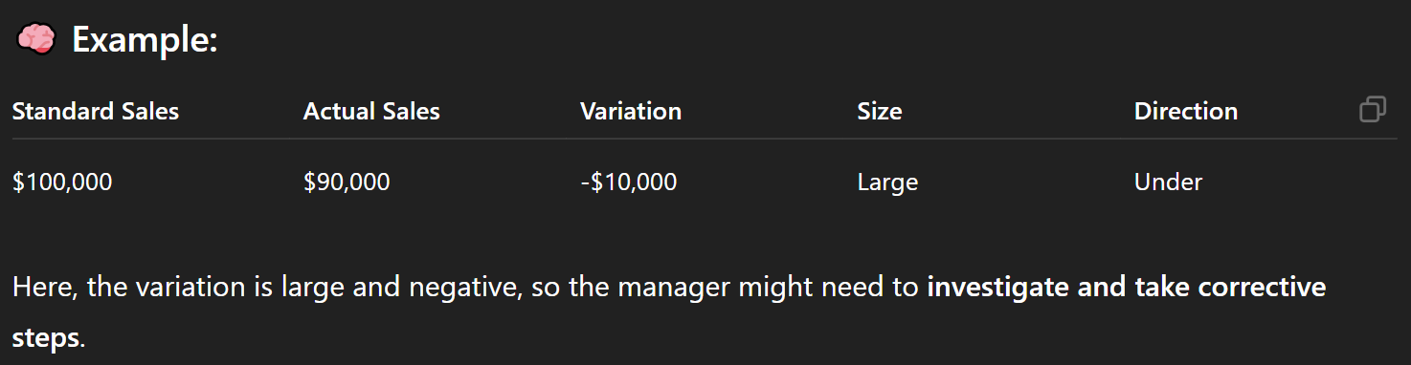

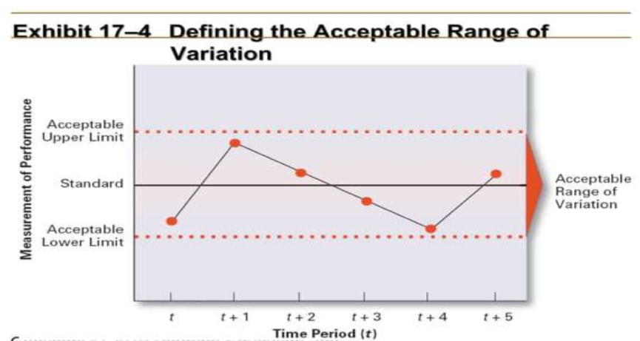

**Taking Managerial Action(s)**

After comparing actual performance to the standard, if there’s a significant gap, **managers must decide what to do**. This step is about **fixing problems or adjusting goals** to keep performance on track.

**1. Doing Nothing**

* If the difference (or deviation) between actual and expected performance is **very small or insignificant**, managers may decide to ignore it.
* Example: If monthly sales are off by only 1%, it might be ignored.

**2. Correcting Actual Performance**

This means taking action **to fix the current problem**.

**a) Immediate Corrective Action**

* Used when something goes wrong that needs **quick attention**.
* Example: A machine breaks down during production — fix or replace it immediately.

**b) Basic Corrective Action**

* Go deeper and **find the root cause** of the problem.
* Then, fix that root cause so the problem doesn’t happen again.
* Example: If sales are dropping due to poor customer service, train employees rather than just offering discounts.

**Examples:**

* Retraining employees
* Updating procedures or manuals
* Changing workflows or systems
* Redesigning jobs or responsibilities
* Altering compensation or motivation schemes
* Firing employees (in serious cases)

**3. Revising the Standard**

Sometimes, the **problem isn't with performance**, but with the **standard itself**.

**a) When to revise:**

* If the target was **unrealistic** (too high or too low).
* If conditions have **changed** (e.g., new tech, economic shifts).

**b) What to do:**

* Adjust the goal to make it more **realistic, fair, and achievable**.
* This helps maintain **motivation and fairness**.

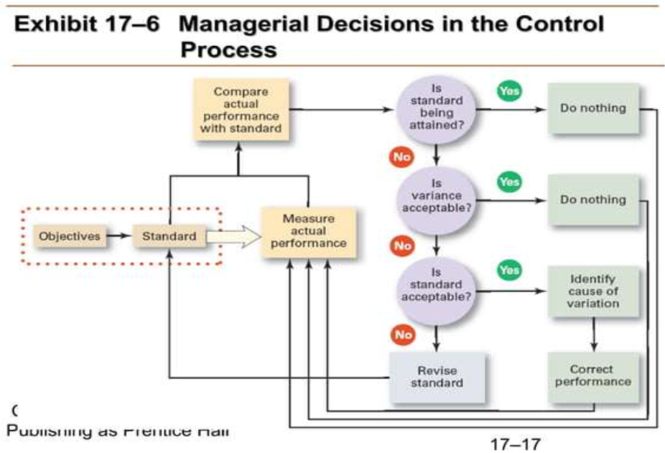

**Controlling for Organizational Performance**

**Performance**

* **Performance** is the **end result of an activity**.

**Organizational Performance**

* It is the **combined result of all the activities** carried out in the organization.
* It includes how well strategies are executed, how efficient processes are, and how employees work together.

**Organizational Performance Measures**

**Organizational Productivity**

* **Productivity** = **Output ÷ Input**
  + It tells **how efficiently** an organization turns **resources into results**.

**Output:**

* The **goods or services** produced.
* Can also mean **sales** or **revenue** earned.

**Input:**

* The **resources used**, such as:
  + Materials
  + Labor (employee time/effort)
  + Facilities (buildings, equipment)
  + Money

**Organizational Effectiveness**

It is a **measure of two key things**:

1. **Are the goals of the organization appropriate and relevant?**
2. **Is the organization achieving those goals successfully?**

For managers, **organizational effectiveness** is the **bottom line**.  
It influences all major decisions such as:

1. **Setting goals**
   * What are we trying to achieve?
   * Are the goals realistic and aligned with the company’s vision?
2. **Designing strategies and work activities**
   * What plans and processes will help reach those goals efficiently?
3. **Coordinating employee efforts**
   * How can we organize people and tasks so everyone contributes to the goal?

**Example:**

**Goal:** A company wants to become the market leader in electric bikes.

* If the company **sets the right strategies**, like:
  + Investing in R&D
  + Marketing to the right audience
  + Building a strong distribution network
* And if it **achieves high sales and customer satisfaction**, then it's **organizationally effective**.

But if the goal is **unclear** or **strategies fail**, it leads to **poor effectiveness**.

**Tools for Controlling Organizational Performance**

Managers use **three types of control** to guide and monitor activities at different stages.

**A. Feedforward Control – *Before the activity***

Feedforward control focuses on **preventing problems** by controlling inputs **before** the process starts.

**"Preventing the problem before it happens."**

**📘 Examples:**

* Training employees before starting a job.
* Hiring only qualified and trained employees.
* Quality checks of raw materials before production.

**✅ Purpose:**

* Ensures the right resources and conditions are in place.
* Helps avoid mistakes early.

**B. Concurrent Control – *During the activity***

Concurrent control takes place **while the activity is happening**. It monitors ongoing work to make real-time corrections.

**"Fixing the problem as it happens."**

**📘 Examples:**

* Monitoring employees on the factory floor.
* Supervisors guiding workers during tasks.
* Software that detects errors during data entry.

**✅ Purpose:**

* Prevents small issues from becoming bigger problems.
* Ensures quality and efficiency during the process.

**C. Feedback Control – *After the activity***

Feedback control focuses on **the results**. It happens **after** the task is completed to learn what went right or wrong.

**"Learning from the outcome."**

**📘 Examples:**

* Financial audits and performance reviews.
* Customer feedback after product delivery.
* Analysing sales data at the end of the quarter.

**✅ Purpose:**

* Helps managers understand effectiveness.
* Improves future planning and decisions.

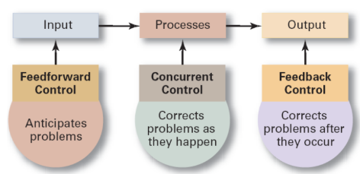

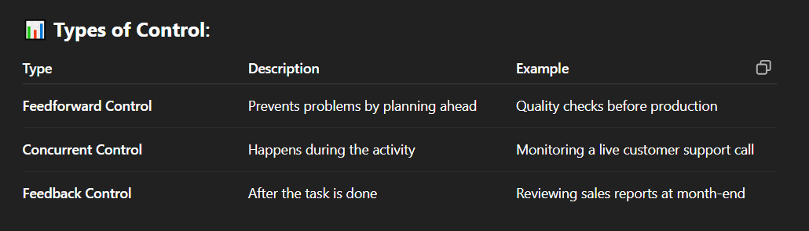

**Tools for Measuring Organizational Performance**

Organizations need tools to track their performance, identify problems, and make strategic decisions. These tools help evaluate how well the organization is doing in achieving its goals.

**1. Balanced Scorecard (BSC)**

🔹 A strategic tool used to **measure performance from multiple angles**, not just financial.

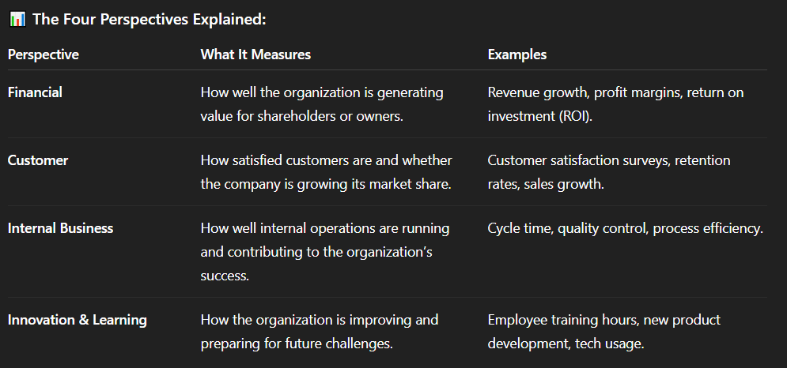

**✅ Benefits of Balanced Scorecard:**

* **Aligns Strategic Objectives with Operations:** It helps organizations align their strategic objectives with their daily operations.
* **Communicates Strategy and Goals:** The BSC helps communicate the organization's strategy and goals clearly to all stakeholders.
* **Identifies Areas for Improvement:** By comparing actual performance against targets, the BSC helps identify areas where improvements are needed.

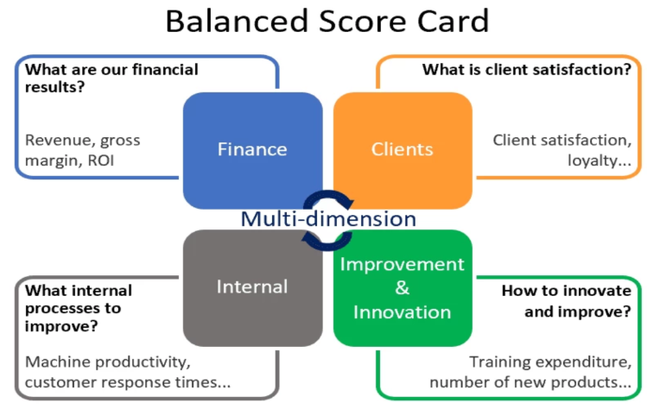

**2. Software Scorecard**

🔹 This is the **digital version** of the Balanced Scorecard.

**🔧 Features:**

* Automatically collects and reports performance data.
* Visual dashboards and charts for easy understanding.
* Real-time monitoring of key performance indicators (KPIs).
* Can be customized for departments, teams, or individuals.

**✅ Benefits:**

* Saves time and increases accuracy.
* Improves decision-making with up-to-date data.
* Enhances communication between departments.

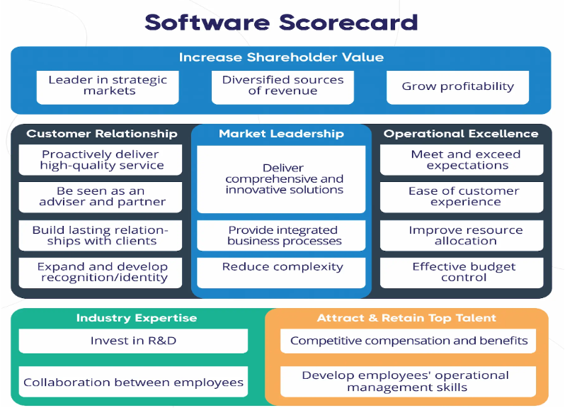

**3. Application to Budgeting (Budgetary Control)**

Budgeting is the process of planning how an organization will **earn and spend money** over a specific period. It involves **creating financial plans (budgets)** and comparing them with **actual performance** to make informed decisions.

**📈 Components:**

* **Revenue Forecasts**: Predicting how much money the organization will earn.
* **Expense Estimates**: Planning how money will be spent.
* **Variance Analysis**: Identifying the gap between **planned vs actual** performance.

**✅ Benefits of Budgetary Control:**

* Helps in financial planning and resource allocation.
* Ensures departments stay within financial limits.
* Tracks overspending or underspending.
* Aligns financial resources with strategic goals.

**Methods of Control**

**Financial Controls**

Financial controls are:

* **Rules and procedures** organizations use to manage money wisely.
* They help make sure **financial resources are used properly**, stay **within budget**, and support the **organization’s goals**.

📌 **Purpose**: To monitor and guide how the company earns, spends, saves, and invests money.

**1. Key Tool: Financial Statements**

Financial statements give a **snapshot of a company’s financial health**. These include:

* **Income Statement** – shows profit or loss over time.
* **Balance Sheet** – shows what the company owns (assets) and owes (liabilities).
* **Cash Flow Statement** – shows how cash is moving in and out.

**2. Financial Analysis**

Financial analysis is the process of:

* **Studying financial reports** to understand how well the business is doing.
* **Comparing results** to previous periods, company goals, or other companies (industry benchmarks).

🔍 **Managers use financial analysis to:**

* Make better decisions.
* Find problems early.
* Improve performance.

**3. Types of Financial Ratios (Used in Financial Analysis):**

1. **Liquidity Ratios**
   * Measure the company's **ability to pay short-term bills**.
   * Example: *Current Ratio* = Current Assets / Current Liabilities
2. **Activity Ratios**
   * Show how well the company **uses its assets to generate sales or cash**.
   * Example: *Inventory Turnover* = Cost of Goods Sold / Average Inventory
3. **Leverage Ratios**
   * Indicate how much of the business is **funded by debt**.
   * Example: *Debt-to-Equity Ratio* = Total Debt / Shareholder's Equity
4. **Profitability Ratios**
   * Measure how well the company is generating **profit from sales or investments**.
   * Example: *Net Profit Margin* = Net Income / Revenue

**🔷 1. Hierarchical Control (Traditional / Top-down approach)**

This is the **classical method** of control in organizations, where **managers and top executives** control employees through **strict rules and structures**.

**🔹 Key Features:**

* **Monitoring through rules and policies**: Employees are expected to follow detailed instructions and company rules.
* **Supervision is heavy**: Managers closely watch what employees do.
* **Written documentation**: There are manuals, SOPs (Standard Operating Procedures), and written policies for every process.
* **Reward and punishment**: Rewards are given for following rules; punishments are given for breaking them.
* **Formal systems**: Everything is structured—there’s a clear chain of command.

**🔸 Example:**

In a traditional bank, employees must follow strict rules for every customer transaction, dress code, and reporting system. Managers monitor daily performance through reports and surveillance.

**🔷 2. Decentralized Control (Modern / Trust-based approach)**

This is a **more flexible, people-centered** method of control. Instead of focusing on rules and direct supervision, control is based on **shared values, mutual trust, and team spirit**.

**🔹 Key Features:**

* **Values and culture-driven**: Employees are guided by a strong organizational culture rather than rules.
* **Self-management**: Teams and individuals are given freedom to make decisions on their own.
* **Trust and responsibility**: Employees are trusted to do their work without constant supervision.
* **Informal control**: Culture, teamwork, open communication, and peer influence keep employees aligned with goals.
* **Adaptability and innovation**: Encourages creativity, flexibility, and learning.

**🔸 Example:**

In a tech company like Google, employees have flexibility in how they work. There may be fewer rules, but a strong company culture encourages responsibility, innovation, and collaboration.

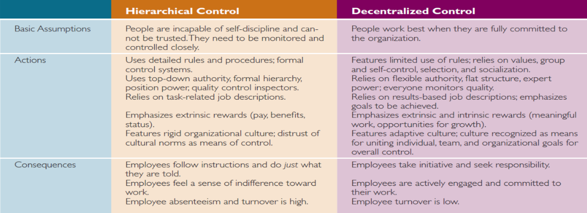

**Total Quality Management (TQM)**

**TQM** is a **management philosophy** focused on embedding **quality** into **every part of an organization’s processes**, from top management to front-line employees. The aim is to **continuously improve performance**, **meet customer expectations**, and **deliver zero-defect products or services**.

**Core Focus Areas of TQM:**

**1. Teamwork**

* Employees at all levels work together.
* Teams solve quality issues collectively.
* Encourages open communication and collaboration.

**2. Collaboration**

* Departments and functions cooperate, not compete.
* Suppliers, customers, and employees collaborate to improve quality.

**3. Identifying Improvements**

* Employees are encouraged to find and suggest ways to make processes better.
* Small changes over time lead to big improvements.

**🎯 Main Goal of TQM: Zero Defects**

* TQM aims for **perfection**—no errors in products, processes, or services.
* While achieving zero defects is tough, it promotes a **mindset of excellence and accountability**.

**🛠️ TQM Tools and Techniques:**

**1. Quality Circles**

* Small groups of employees from the same area who meet regularly.
* Identify, analyze, and solve work-related problems.
* Example: A group of customer service staff meeting weekly to reduce customer complaints.

**2. Benchmarking**

* Comparing your company’s performance with **best-in-class** companies (industry leaders).
* Learn and adopt their best practices.
* Example: A hospital comparing its patient care process with that of a top-ranked medical center.

**3. Six Sigma**

* A **data-driven** approach to eliminate defects.
* Aims for near-perfect performance (3.4 defects per million opportunities).
* Uses a step-by-step method called **DMAIC**: Define, Measure, Analyze, Improve, Control.

**4. Reduced Cycle Time**

* Making processes **faster and more efficient**.
* Eliminating unnecessary steps and waste.
* Example: Reducing the time it takes to process an online order from 3 days to 1 day.

**5. Continuous Improvement (Kaizen)**

* Always seeking small, ongoing improvements rather than big one-time changes.
* Every employee is responsible for finding ways to improve their work.

**Benchmarking**

It is the process of **comparing your organization’s performance, processes, or practices** against the **best in the industry** (or even outside your industry).

It helps organizations **identify performance gaps**, learn from others, and make improvements to **become more competitive and efficient**.

A **benchmark** is a **standard of excellence**—a model or point of reference used to:

* **Measure performance**
* **Set goals**
* **Identify how to do things better**

Think of it as the **ideal performance level** you want to reach.

**🎯 Purpose of Benchmarking**

Benchmarking helps an organization:

* Discover what top performers are doing right
* Understand **why** they’re successful
* Learn how to **adapt and implement** similar methods
* Drive **continuous improvement**
* Close performance **gaps**

**🛠️ Benchmarking as a Control Tool**

Benchmarking is not just about comparison—it's a **control mechanism**:

* It tells you **how far behind or ahead** you are.
* Helps **set performance targets**.
* Identifies **specific actions** needed to improve.
* Encourages **accountability**.