**1. Definition and Importance of Leadership**

**Leadership** is the ability to inspire, guide, and influence teams toward achieving common goals.

* **Importance for Organizations**:
  + Provides **direction** and **vision** for employees.
  + Boosts **employee morale** and **productivity**.
  + Encourages **innovation** and **adaptability** in changing environments.

**Contingency Theories of Leadership:**

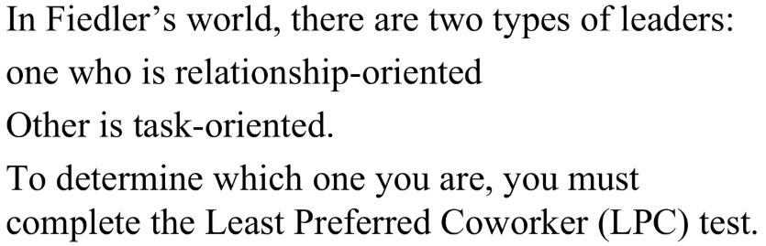**Fielder Contingency Model:** states that there is no one “best” leadership style for any project. Instead, the best leadership style can only be determined by the leader’s inherent strengths and how they work with the team and situation at hand.

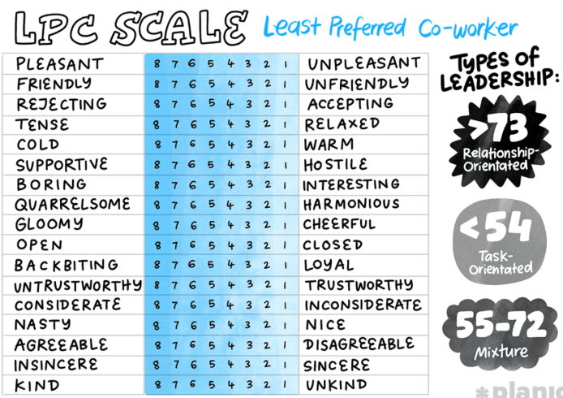

**According to Fiedler, there are two primary leadership styles:**

1. **Relationship-Oriented Leader:** This leader prioritizes positive interpersonal relationships with their team. They are identified by a higher score on the Least Preferred Co-worker (LPC) test, which measures how favorably a leader views their least preferred coworker. A high LPC score (typically >73) indicates a relationship-oriented style.

***Example:***Consider a marketing team brainstorming ideas for a new advertising campaign. The team has a good working relationship (Good Leader-Member Relations ), but the task of generating creative and innovative ideas is inherently unstructured and open-ended (Low Task Structure ). The marketing director has moderate position power – they can guide but prefer to foster creativity rather than dictate (Moderate Position Power ). In this scenario, a **relationship-oriented leader** would thrive. They would focus on facilitating open communication, encouraging diverse ideas, mediating disagreements constructively, and building team cohesion. They might say, "Let's throw out all our craziest ideas, no bad suggestions here! What are your initial thoughts, Sarah? John, what's your take on that?" Their emphasis on supportive behavior helps the team navigate the ambiguity of the task and leverage their collective creativity.

1. **Task-Oriented Leader:** This leader focuses primarily on accomplishing tasks and achieving goals. They are identified by a lower score on the LPC test, where a low LPC score (typically <54) indicates a task-oriented style.

***Example***: Imagine a highly skilled and experienced software development team working on a project with clear requirements and a well-defined process (High Task Structure). The team members trust and respect their project manager deeply (Good Leader-Member Relations ), and the manager has full authority to make decisions and allocate resources (Strong Position Power ). In this scenario, a **task-oriented leader** would be highly effective. They can focus purely on optimizing the workflow, setting aggressive deadlines, and ensuring efficient execution, knowing that the team is capable and aligned. They might say, "Let's push to get this module coded by end of day" rather than spending time on team-building exercises, as the conditions are ideal for direct task focus.

The theory emphasizes that leadership effectiveness depends on matching the leader's style to the favorableness of the situation. The favorableness of a situation is determined by three factors:

**1. Leader-Member Relations:** This refers to the level of trust and confidence the team has in their leader. The more trust the team has, the more likely the leader will succeed. Without trust, motivating and engaging team members and achieving objectives is hard.

* **Good Leader-Member Relations Example:** Imagine a long-standing project team where the leader has consistently supported their team members, provided clear guidance, and celebrated their successes. When the leader introduces a challenging new project, the team readily accepts their direction and feels comfortable approaching them with concerns or new ideas. There is a high level of mutual respect and friendship within the team.
* **Poor Leader-Member Relations Example:** Consider a new leader who has recently taken over a team with a history of mismanagement and unfulfilled promises from previous leaders. The team members are skeptical, question the leader's decisions, and are hesitant to share information or take the initiative. Despite the leader's efforts, there's an underlying tension and lack of trust, making it difficult to gain their full cooperation and commitment.

**2. Task Structure:** This relates to the type of task the team is completing and whether it is clear and structured or vague and unstructured.

* **High Task Structure Example:** A manufacturing assembly line where each worker has a very specific, repeatable set of steps to perform to build a product. The process is standardized, and there are clear guidelines and quality control checks at each stage. The outcome is predictable, and deviations are easily identified.
* **Low Task Structure Example:** A research and development team tasked with inventing a completely new product to solve an emerging market need. There are no existing blueprints or established processes. The team must experiment, brainstorm, and iterate on ideas, with a high degree of uncertainty about the final solution or the path to get there.

**3. Leader’s Position Power:** This refers to the authority a leader has over their team. If a leader can reward them, punish them, or tell them what to do, their position power is high.

* **Strong Position Power Example:** A military commanding officer who has the authority to issue orders, assign duties, promote or demote personnel, and administer disciplinary actions. Their decisions are expected to be followed without question due to their rank and formal authority.
* **Weak Position Power Example:** A team leading a volunteer organization. While they guide the team, they have no formal authority to hire, fire, or directly reward members. They rely heavily on their persuasive skills, personal influence, and the volunteers' commitment to the cause to get tasks accomplished.

**Hersey and Blanchard's Situational Leadership Theory (SLT):**

Hersey and Blanchard's Situational Leadership Theory (SLT) is a model that suggests effective leadership isn't about one fixed style. Instead, it's about choosing the right leadership style based on how ready or mature your followers are for a specific task.

The main idea is that leaders should adjust their approach depending on two things about their followers:

1. **Acceptance:** This means whether followers are willing to accept or reject the leader's guidance. If followers accept the leader, it's easier for the leader to be effective.
2. **Readiness:** This is how much followers have the **ability** (knowledge, skills) and **willingness** (confidence, motivation) to complete a specific task. As followers become more skilled and confident, leaders should gradually give them more control and less direct supervision.

**🡪 SLT describes four leadership styles and four levels of follower readiness:**

**Four Leadership Styles:**

**S1: Telling (High Task, Low Relationship):** What it means: The leader gives very specific instructions and closely watches performance. They tell people exactly what to do, how to do it, and when to do it.

*Simple Wording: "Just do exactly what I tell you."*

**S2: Selling (High Task, High Relationship) / Coaching or Explaining:** What it means: The leader still makes the decisions and provides clear instructions, but they also explain why tasks need to be done a certain way. They provide support and encourage followers to understand and agree with the plan.

*Simple Wording: "I'll tell you what to do, but I'll also explain why and listen to your questions."*

**S3: Participating (Low Task, High Relationship):** What it means: The leader provides less direct instruction but offers a lot of support. They share ideas with the group and work together with team members to make decisions. The focus is on collaboration and empowering the team.

*Simple Wording: "Let's work together to figure this out. I'm here to support you."*

**S4: Delegating (Low Task, Low Relationship):** What it means: The leader provides very little direction or support. They hand over the responsibility for decisions and carrying out tasks to the group members, who are expected to handle things independently.

*Simple Wording: "You're capable. You handle it."*

**Follower Readiness Levels**

These levels describe how ready a follower is for a specific task:

* **R1: Low Readiness**
  + **What it means:** The follower is unable (lacks skills or knowledge) and unwilling (lacks confidence or motivation) to perform the task, or is insecure.
  + ***Simple Wording:*** *"Doesn't know how to do it and isn't confident or willing."*
* **R2: Moderate Readiness**
  + **What it means:** The follower is unable (lacks skills or knowledge) but willing (motivated and confident) to perform the task.
  + ***Simple Wording:*** *"Willing but doesn't know how yet."*
* **R3: Moderate Readiness**
  + **What it means:** The follower is able (has skills and knowledge) but unwilling (lacks confidence or motivation) to perform the task, or is insecure.
  + ***Simple Wording:*** *"Knows how to do it but isn't confident or willing."*
* **R4: High Readiness**
  + **What it means:** The follower is able (has skills and knowledge) and willing (motivated and confident) to perform the task.
  + ***Simple Wording:*** *"Knows how to do it and is confident and willing."*

**Contemporary Leaderships:**

* Leadership evolves with organizational needs and environmental context (technology, economy, labor, social/cultural values).
* **Humility:** A contemporary trait, being modest and dedicating success to others.

**Transactional Leadership:**

* Upholds the status quo, uses rewards and punishments to motivate.
* Emphasizes structure, organization, supervision, performance, and outcomes.
* **Characteristics:** Clarifies tasks, initiates structure, provides awards, improves productivity, hardworking, focuses on management.
* **Use:** Effective in highly structured organizations (e.g., military) requiring strict rules, and for achieving immediate results/deadlines.
* ***Example***: A retail manager offering bonuses for hitting monthly sales

**Transformational Leadership:**

* Focuses on helping group members support one another, providing guidance and inspiration.
* **Goals**: Inspire growth, promote loyalty, instill confidence.
* **Characteristics:** Innovative, recognizes follower needs, inspires followers, creates a better future, promotes significant change.
* **Use:** Useful during organizational change (adapting to new markets, tech) and when innovation is crucial.

***Example***: Elon Musk’s vision for SpaceX motivates teams to innovate relentlessly

**Charismatic Leadership:**

* Characterized by a leader's magnetic personality and ability to inspire through charm and communication.
* **Use:** Particularly useful during times of crisis or uncertainty to provide hope, direction, and rally support.
* ***Example***: Martin Luther King Jr.’s charisma united people during the civil rights movement

**Visionary Leadership:**

Visionary leadership is a style characterized by a leader's ability to create and articulate a clear and compelling vision of the future. This leadership style is often associated with inspiring and motivating team members to work towards a common goal.

**Example**: "Steve Jobs envisioned a world transformed by technology, inspiring innovation and empowering teams to create revolutionary products."

**Team Leadership:**

* **Characteristics**: Patience to share info, trust in others, ability to delegate, understanding when to intervene.
* **Job**: Facilitating team process, coaching, handling disciplinary issues, reviewing performance, training, communication.
* **When to Use**: When high expertise is needed from multiple sources, in decentralized organizations, or with self-managed teams.

**LEVEL 5 Leadership:**

Level 5 Leadership is the highest tier in a hierarchy of leadership capabilities, characterized by a unique combination of **personal humility** and **intense professional will**. Leaders at this level channel their ambition into the organization’s success rather than personal glory.

**The 5-Level Hierarchy (Jim Collins’ Model)**:

1. **Level 1: Highly Capable Individual (Bottom Level)**
   * *Skills*: Contributes talent and work ethic.
   * *Example*: A skilled engineer completing tasks efficiently.
2. **Level 2: Contributing to Team Member**
   * *Skills*: Collaborates effectively with others.
   * *Example*: A project coordinator ensuring team alignment.
3. **Level 3: Competent Manager**
   * *Skills*: Organizes people and processes to meet goals.
   * *Example*: A department head managing workflows.
4. **Level 4: Effective Leader**
   * *Skills*: Drives clear vision and high performance.
   * *Example*: A visionary director boosting company revenue.
5. **Level 5: Executive Leader (Top Level)**
   * *Skills*: Combines humility + will to achieve **enduring greatness**.
   * *Example*: A leader transforming a good company into an industry legend.

**Servant Leadership:**

* Philosophy where leaders prioritize serving others over accruing power.
* Focus on growth and well-being of others.
* Connects followers' higher motives to organizational mission.
* Often seen in nonprofit organizations.

**Authentic Leadership:**Leaders are seen as genuine and "real."

Practice transparent behavior to build relationships, achieve goals, and inspire teams.

Empower and inspire others with their openness and authenticity

**Interactive Leadership:**Interactive Leadership is a **participative, relationship-oriented** style where leaders actively engage with their team members, encourage open communication, and foster a culture of shared decision-making. Unlike top-down leadership, interactive leaders **empower employees**, value their input, and create an inclusive work environment.

**Example**: "Sheryl Sandberg fosters collaboration and open communication at Facebook, empowering teams to innovate and succeed together."

**Laissez Faire Leadership:***(French for "let do" or "allow to act")*

Laissez-faire leadership is a **delegative, non-authoritarian** style where leaders provide minimal direct supervision, allowing team members substantial autonomy in decision-making and task execution.

**When to Use:** With highly skilled/motivated teams, or projects requiring independent thinking.

*"Warren Buffett's laissez-faire leadership at Berkshire Hathaway empowers managers with autonomy, fostering innovation and accountability within the company."*

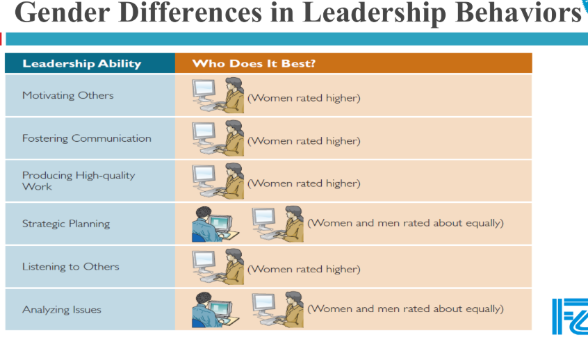

**🡺 From Management to Leadership:**-- Good management is essential, but good managers must also be leaders.

-- **Management**: Promotes stability, order, problem-solving; focuses on "**doing things right**" (*effectiveness*).

-- **Leadership**: Motivates toward vision and change; focuses on "**doing the right things**" (*efficiency*).

-- Leadership cannot replace management; a balance is needed

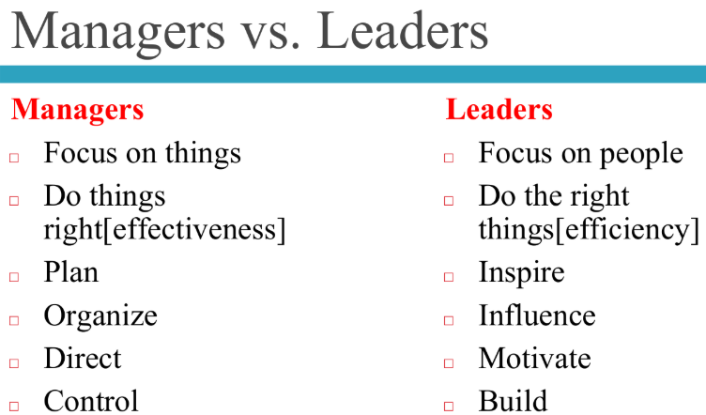

**Leadership Issues in 21st Century:**

In the 21st century, one of the significant leadership issues revolves around **managing power**. Leaders need to understand and effectively use different forms of power to guide their teams and organizations. Here are the types of power detailed in the slides:

* **Legitimate Power:** This is the power that comes directly from a leader's formal position or role within an organization. For example, a CEO has legitimate power because of their title and the authority vested in that position.
* **Coercive Power:** This refers to a leader's ability to punish or control others. This could involve actions like demoting an employee, assigning undesirable tasks, or withholding benefits. While it can enforce compliance, over-reliance on coercive power can damage morale and trust.
* **Reward Power:** This is the ability to give benefits or rewards to team members. Examples include promotions, raises, bonuses, positive recognition, or desirable assignments. Leaders use this to motivate and incentivize desired behaviors.
* **Expert Power:** This type of influence stems from a leader's specialized expertise, skills, or knowledge. When a leader possesses valuable information or capabilities that others need, they gain power. For instance, a lead software engineer might have expert power due to their deep technical knowledge, causing team members to look for guidance.
* **Referent Power:** This power arises from respectful interpersonal relationships, rather than manipulation or coercion. It's based on a leader's personal charisma, integrity, and the admiration or respect they command. People follow a leader with referent power because they like, trust, and identify with them.

**Followership:**

**Followership** is a crucial concept in understanding how organizations function, as they cannot exist without followers. Leaders must understand their followers to be effective.

Followership can be understood through two main dimensions:

1. **Independent & Critical Thinker vs. Dependent, Uncritical Thinker**:
   * **Independent, Critical Thinkers** are aware of how their own behavior and others' behavior affect achieving organizational goals. They can evaluate the impact of decisions made by their boss and themselves, and they offer constructive criticism, creativity, and innovation.
   * **Dependent, Uncritical Thinkers** do not consider possibilities beyond what they are told. They don't contribute to the organization's development and simply accept their supervisor's ideas without questioning them.
2. **Active Follower vs. Passive Follower**:
   * **Active Followers** participate actively, offer their opinions, and may even challenge the current situation.
   * **Passive Followers** are more reliant on the leader and may be less engaged.

**Styles of Followership:**

Based on these dimensions, different styles of followership emerge:

* **Alienated Followers:** These individuals are independent, critical thinkers but are unmotivated and passive in their behavior. Their passivity prevents them from using their strengths to help the team achieve its goals and distances them from the leader and other team members.
* **Conformist:** A conformist actively participates in their relationship with the leader but does not use critical thinking skills. They are described as "yes men" who willingly carry out all orders without considering the consequences.
* **Passive Followers:** These are dependent, uncritical thinkers who don't engage their brains sufficiently or take real action.
* **Effective Follower:** This type of follower is both a critical, independent thinker and active within the organization. They develop an equitable relationship with their leaders and are willing to take risks.
* **Pragmatic Survivor:** This follower exhibits qualities of all four extremes, adapting their style depending on which approach best suits the situation. They are somewhat like a "politician," constantly assessing the environment and choosing the style that benefits their own agenda and minimizes risk

