**1. What is Decision Making?**

* **Definition**: Decision making is the process of choosing the best solution from available alternatives to solve a problem or achieve a goal.
* **Example**: A manager deciding whether to launch a new product or improve an existing one.

**2. Types of Decisions**

**a. Programmed Decisions (For Structured Problems):**

* **Definition**: Routine, repetitive decisions that follow a set of rules or procedures.
* **Example**: A retail store automatically reorders stock when inventory levels drop below a certain point.

**b. Non-Programmed Decisions (For Unstructured Problems):**

* **Definition**: Unique, complex decisions that require custom solutions.
* **Example**: A company deciding to enter a new market or launch a new product.

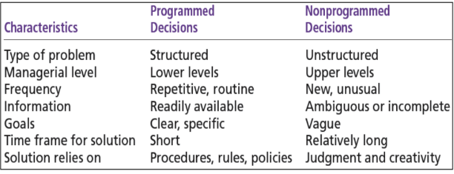

**3. Decision-Making Conditions**

**a. Certainty:**

* **Definition**: All information is available, and outcomes are predictable.
* **Example**: Ordering raw materials from a trusted supplier with guaranteed delivery times.

**b. Risk:**

* **Definition**: Outcomes are uncertain, but probabilities can be estimated based on past data.
* **Example**: Investing in a new advertising campaign with a 70% chance of increasing sales.

**c. Uncertainty:**

* **Definition**: Outcomes are unpredictable due to lack of information.
* **Example**: Expanding into a new international market with unknown customer preferences.

**4. Decision-Making Models:**

**I) Rational Decision-Making Model**

**Definition**: A logical, step-by-step approach to making decisions that maximize outcomes.

* **Steps**:
  1. Define the problem.
  2. Identify decision criteria (e.g., cost, quality, time).
  3. Weigh the criteria (e.g., cost is more important than time).
  4. Generate alternatives.
  5. Evaluate alternatives.
  6. Choose the best alternative.
* **Example**: A manager selecting the best supplier by comparing prices, quality, and delivery times.

**II) Bounded Rationality (Simon Model)**

* **Definition**: Managers make decisions based on limited information and time, aiming for a "good enough" solution rather than the perfect one.
* **Example**: A manager hiring the first qualified candidate instead of interviewing all applicants.

**III) Intuitive Decision Making**

* **Definition**: Making decisions based on experience, feelings, and quick judgment.
* **Example**: A manager deciding to launch a product based on their gut feeling about market trends.

**IV) Political Decision-Making Model**

* **Definition**: Decisions are influenced by negotiations, alliances, and power dynamics within the organization.
* **Example**: A manager building support among team members to approve a new project.

**5. Steps in Managerial Decision Making**

1. **Identify the Problem**: Recognize the issue that needs to be solved.
   * **Example**: Sales are declining.
2. **Gather Information**: Collect data related to the problem.
   * **Example**: Analyze sales reports and customer feedback.
3. **Generate Alternatives**: Brainstorm possible solutions.
   * 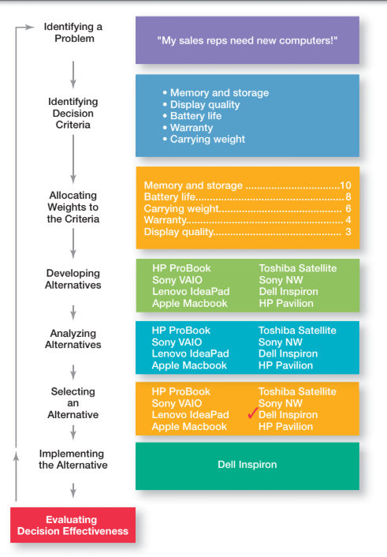**Example**: Increase advertising, improve product quality, or reduce prices.
4. **Evaluate Alternatives**: Weigh the pros and cons of each option.
   * **Example**: Compare the cost and potential impact of each solution.
5. **Choose the Best Alternative**: Select the most effective solution.
   * **Example**: Decide to increase advertising.
6. **Implement the Decision**: Put the chosen solution into action.
   * **Example**: Launch a new marketing campaign.
7. **Monitor and Evaluate**: Check if the decision is working and make adjustments if needed.
   * **Example**: Track sales after the campaign and adjust the strategy if necessary.