**Chapter 12: Managing Human Resources**

**Human Resource Management (HRM)**

* HRM refers to activities undertaken to attract, develop, and maintain an effective workforce over the long term.
* Strategic decisions determine the demand for skills and employees.
* The human resource strategy must include the **correct employee makeup** to implement the organization's strategy.
* The "**correct employee makeup**" refers to having the right kind of employees to successfully implement an organization's strategy. This means ensuring that the human resource strategy aligns with the overall organizational strategy by having employees with the necessary skills and characteristics.

**Importance of HRM**

* HRM can be a significant source of competitive advantage by creating superior shareholder value through people-oriented HR.
* It is an important part of organizational strategies.
* Achieving competitive success through people requires managers to view employees as partners, not just costs that need to be minimized or avoided.
* How organizations treat their people significantly impacts organizational performance.
* Improving work practices can increase market value by as much as 30 percent.

**Finding the Right People: Attracting an Effective Workforce**

This involves 4 steps:

1. **Planning and predicting** the need for new employees based on existing vacancies.
2. **Recruitment;** attracting qualified candidates to apply.
3. **Selecting** those with the best potential.
4. **Orientation & Onboarding**, welcoming the new employee to the organization.

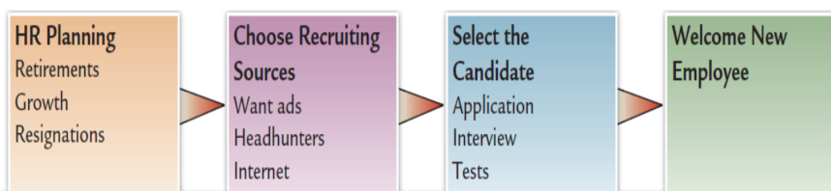

**1. Human Resource Planning**

* **Definition:** The process by which managers ensure they have the right number and kinds of capable people in the right places and at the right times.
* **Steps of Human Resource Planning:**
  + - 1.Assessing current human resources
    - 2. Meeting future HR needs
  + **1. Current Assessment:** Managers begin by inventorying current employees.
    - This inventory typically includes information on employees like name, education, training, prior employment, languages, special capabilities, and specialized skills.
    - Sophisticated databases facilitate this process.
  + **2. Forecasting Future Needs:** This involves considering questions such as:
    - What new technologies are emerging?
    - What is the likely business volume in the next 5-10 years?
    - What is the employee turnover rate? **Employee turnover rate** is the percentage of employees who left a company over a certain period of time.
    - Can temporary, part-time, or virtual workers be utilized?
    - **Purpose:** Determines future HR needs based on the organization's mission, goals, and strategies. Demand for employees results from the demand for the organization's products or services.
    - **Example:** An organization's expansion into developing countries might be slowed by a lack of qualified employees, requiring a plan to find them.

**2. Recruitment (Talent Acquisition)**

* **Definition:** Searching and finding the best talent for an open job vacancy within the organization in a specific time and cost. Recruitment is a systematic process for hiring talent by using job postings, social media, referrals, and agencies.
* **7 Stages:** It starts from identifying, attracting, screening, shortlisting, interviewing, selecting, and finally hiring the most potential candidates for filling up the vacancies.
* **Job Analysis:** A systematic process of gathering and interpreting information about the essential duties, tasks, responsibilities, and context of a job.
  + **Job Description:** A clear and concise summary of tasks, duties, and responsibilities.
  + **Job Specification:** Details the knowledge, skills, education, physical abilities, etc., required for a job.
* **Realistic Job Previews (RJP):** Provide relevant information, both positive and negative, about the job and organization. This transparency helps candidates decide if the job is a good fit for them, potentially leading to better matches, reduced employee turnover and misaligned expectations, and improves employee retention.
* **Recruiting Sources:**

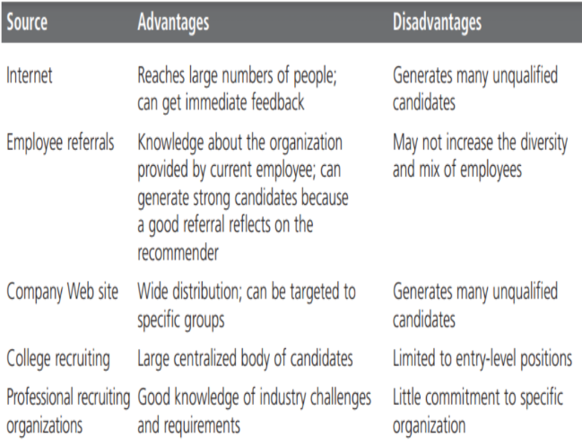

**3. Selection**

* **Definition:** Shortlisting the right candidates with the required qualifications to fill vacancies in an organization.
* **Correct Decision:** A decision is correct when the applicant was predicted to be successful and proved to be successful, or when the applicant was predicted to be unsuccessful and was not hired.
  + Successfully accepted: Applicant predicted to be successful and was successful on the job.
  + Successfully rejected: Applicant predicted to be unsuccessful and was not hired.
* **Selection Tools:**

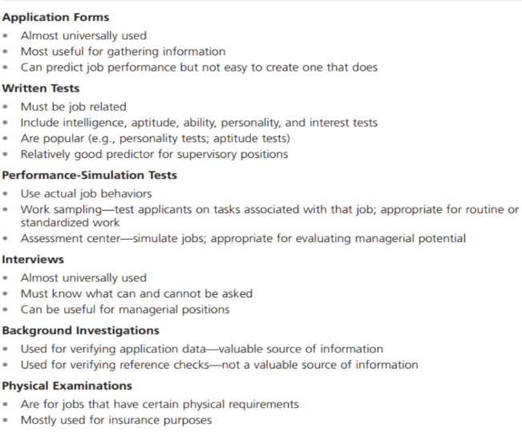

**4. Orientation**

* **Work Unit Orientation:**
  + Familiarizes the employee with the goals of the work unit.
  + Clarifies how their job contributes to the unit's goals.
  + Includes an introduction to new coworkers.
* **Organization Orientation:**
  + Informs the new employee about the company’s goals, vision, mission, and rules.
  + Should also include relevant HR policies and potentially a tour of the facilities.

**Employee Training**: **Providing Employees with Needed Skills and Knowledge**

* **Definition:** Employee training is the process of teaching employees the knowledge, skills, and behaviors leading to growth in job skills required for organizational growth.
* **Importance:** Represents a good opportunity for employees to grow their knowledge base and improve job skills to become more effective.
* **Return on Investment:** Despite the cost, the return on investment from consistent training is immense.
* **Training Methods:**
  + **On-the-Job Training**: Learning while working under supervision.
    - **Job Rotation:**
      * Involves moving trainees from one job to another to gain knowledge and experience from **different assignments**. Helps trainees understand the problems of other employees.
      * *Example:* A software developer moving to customer service to understand product feature impact on user experience.
    - **Mentoring:**
      * Pairs a less experienced employee with a senior colleague to help them learn and grow. Promotes **long-term relationships** and provides ongoing support.
    - **Role-Playing:**
      * **Highly interactive technique** where employees act out scenarios they might encounter.
      * Focuses on developing soft skills like communication, conflict resolution, and decision-making by practicing in real-world situations.
    - **In-House Workshops and Seminars:**
      * Organized training sessions on specific topics **relevant to employees' roles**.
      * Can be conducted by internal experts or external professionals, offering a structured learning environment.
  + **Off-the-Job Training**: Training outside the normal work environment (workshops or courses).
    - **Simulation Training:**
      * Employees engage in simulated work scenarios mirroring real-world challenges.
      * Beneficial where **hands-on practice is essential** but difficult to replicate safely or economically (e.g., emergency response training).

**The Impact of Government Legislation on HRM**

HR managers must stay current with the legal and regulatory environment. Many laws exist to ensure equal opportunity and prevent discrimination.

* **Discrimination:** The hiring or promotion of applicants based on non-job-related criteria.
* **Affirmative Action:** Requires employers to take positive steps to guarantee equal employment opportunities for people in protected groups.

**Key Areas of Law:** Equal Opportunity/Discrimination law, Compensation/Benefits law, Health/Safety law.

**The Changing Nature of Careers**

* **Old Social Contract:**
  + *Employee Contribution:* Employees were expected to:
    - Bring **skills and education** to the job
    - Show **loyalty and commitment** to one company
    - Stay in the same job or organization for **many years** (even a lifetime)
    - Rely on the company for **career growth and job security**
  + *Employer Provision:* In return, companies provided:
    - **Stable wages** and **employee benefits** (like health insurance or pensions)
    - **Secure jobs** with low risk of sudden termination
    - **Training programs** to help workers grow
    - Clear **promotion paths** within the company
* **New Social Contract:**
  + Based on employability rather than lifetime employment.
  + *Employees:*
    - Face **less job security** due to **downsizing**, **outsourcing**, and **restructuring**
    - Get **fewer subsidized benefits** (e.g., fewer pensions, bonuses, and permanent positions)
    - Are expected to:
      * Be **self-directed** in learning and career development
      * Constantly **upskill** to remain **employable**, not just employed
      * Be **flexible**, mobile, and open to change
  + *Employers:*
    - Don’t promise lifelong employment — they hire based on **project needs** and **performance**
    - Must offer **creative training and development** opportunities (e.g., online courses, mentorship)
    - Use **new performance appraisal systems** (e.g., 360-degree feedback, KPIs, peer reviews)
    - Seek **agile** and **adaptable** employees who can grow with the company

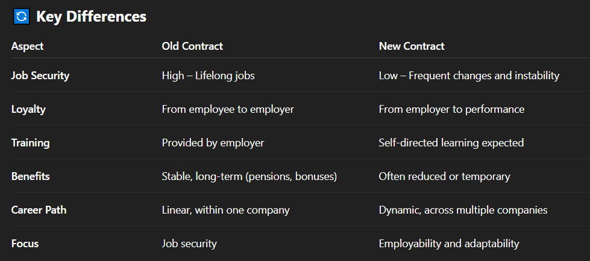

**Innovations in HRM**

1. **Becoming an Employer of Choice:**
   * Organizations that are highly attractive to potential employees due to HR practices focusing on:
     + Tangible benefits (pay, profit sharing).
     + Intangibles (work/life balance, trust-based work climate, healthy corporate culture).
     + Embracing a long-term view to solving immediate problems.
2. **Using Contingent Workers:**
   * **Contingent workers:** Temporary/part-time employees who are not permanent, used to maintain flexibility and keep costs low.
   * The temporary staffing industry showed significant growth, projected to reach $200 billion by 2010.
   * These workers perform diverse roles, from data entry to interim CEO.
3. **Promoting Work-Life Balance:**
   * A critical **employee** **retention strategy**.
   * Includes practices like part-time work, telecommuting (email or video conference), and flexible scheduling. Helps workers lead a balanced life.
   * Gen Y/Millennials often demand more work-life balance.
   * May include on-site gyms, childcare, eldercare, etc.

**Managing Talent**

**1. Performance Appraisal**

* **Definition:** Observing and assessing employee performance, recording the assessment, and providing feedback to the employee.
* **Key Aspects:**
  + Give feedback and praise.
  + Reward high performers with merit pay, recognition, and other rewards – this must be an ongoing process.
* **HRM professionals concentrate on:**
  + Accurate assessment of performance.
  + Training managers to use the performance appraisal interview effectively.
* **Performance Appraisal Methods:**
  + **Assessing Performance Accurately:** System should evaluate relevant performance.
  + **360-degree Feedback:** Imagine you're standing in the center of a circle, and everyone around you (supervisors, teammates, juniors, sometimes even clients) gives input on your **skills, behavior, communication, and effectiveness**. It’s called “360-degree” because it gives a **full-circle view** of your performance.

* + **Performance Rating Scales:** A standardized tool for assessing an employee’s job performance based on **predetermined criteria or expectations**.
    - *Example:* Graphic Rating Scale with categories like Quality of Work, Quantity of Work, Job Knowledge, Dependability, and Attitude rated from "**Does Not Meet Requirements**" to "**Far Exceeds**."

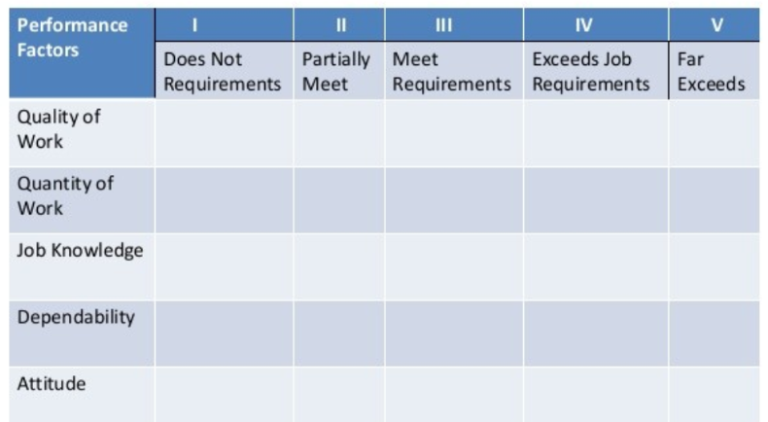

* + **Behaviourally Anchored Rating Scales (BARS):** A rating technique to evaluate an employee’s performance based on **specific behaviors** related to a **particular job** role.
    - BARS uses **descriptive behavioural examples** (called *anchors*) to rate employees on a scale. These anchors are **based on real-life job behaviors.** It is **job-specific, and behaviour based.**
    - *Example (Waiter):* Ratings might assume specific behaviors like talking on the phone while taking orders, making eye contact with customers, or greeting customers cheerfully and offering menu suggestions.

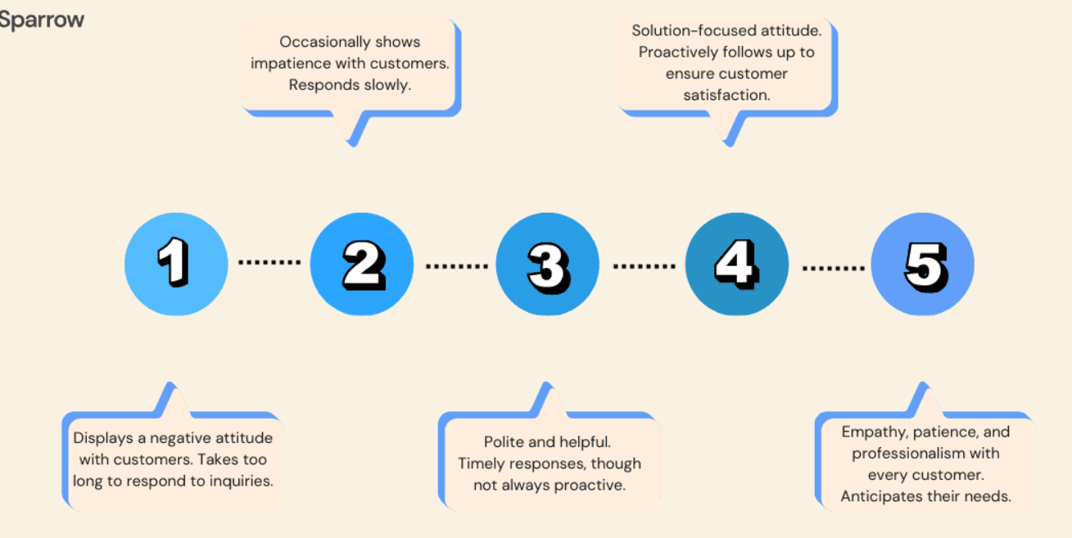

* + - *Likert Scale:* Shown as a common rating scale for performance reviews (Strongly Disagree to Strongly Agree).

**2. Performance Evaluation Errors:**

* + **Halo Effect:**
    - The **Halo Effect** occurs when the evaluator allows **one positive or negative trait or impression** of an employee to **influence their entire evaluation**, even if it’s unrelated to other performance areas. It is an implicit bias where performance is viewed unfairly (positive or negative) due to an unrelated attribute.
    - If a coworker excels in one area, you might assume they're high-performing in unrelated areas, potentially overlooking shortcomings.
    - This overestimation of their abilities can significantly cloud judgment, causing evaluators to overlook potential shortcomings in other aspects of their performance.
  + **Stereotyping:**
    - **Stereotyping** happens when the evaluator **judges an employee** based onassumptions about a group they belong to (e.g., age, gender, background), regardless of their personal characteristics.
    - *Example:* A manager might rate a young employee lower, assuming less experience or expertise than an older employee.

**Maintain an Effective Workforce**

**1. Compensation**

Compensation refers to the **money paid to employees** in return for their work. It includes **salaries, hourly wages, bonuses, incentives**, and **commissions**.

* **Types of Wage and Salary Systems:**
  + **Job-based pay:**
* You are paid based on **your job title and responsibilities**.
* Doesn’t encourage you to **learn new skills** or improve — it’s more about doing the assigned tasks.
* Usually found in **strict, hierarchical systems** with centralized control.
  + **Skill-based pay (Competency-based pay):**
    - Encourages employees to **develop skills** and competencies, making them more valuable to the firm and more employable. It is more **flexible** and modern approach.
  + **Compensation Equity:** Fairness and **equity in pay**. Employees doing similar work should receive similar compensation regardless of gender, race, or background.
  + **Pay for Performance (Incentive Pay):** Aims to raise **productivity** and cut labour costs in a competitive environment. You earn more **if you perform better.**

**2. Benefits**

* Annual vacation leaves, holiday leaves, casual leaves (full payment), sick leaves (50% payment), old age benefits (5% payment), healthcare coverage, insurance.
* **Cafeteria-plan benefits packages:** Allow employees to **choose their own benefits** from a set of options.

**3. Rightsizing the Organization**

* Reducing the company’s workforce to the "right" size, also known as **downsizing**.
* **Goal:** To make the company stronger, more competitive and to save costs and align the team with the **current needs** of the company.
* **HR Department's Role:** Must handle layoffs **professionally and kindly**. Should provide **clear communication** and **emotional support** (like counselling or job transition help) to affected employees.

**4. Termination**

* **Types of Termination:**
* **Voluntary**: When employees **quit** or **retire**.
* **Involuntary**: When employees are **laid off or fired** due to performance or restructuring.
* **Exit interviews** can be used to learn about dissatisfaction to improve the workplace for others.