**Some Important Terms to Know**

1. **Organization:**  
   A group of people working together in a structured and coordinated way to achieve a specific set of goals is called Organization. Organizations can be businesses, non-profits, or governmental institutions.

*Example: A company like Apple is an organization where employees work together to create innovative products.*

1. **Goals:**  
   A goal is an achievable outcome that is generally broad, general, and long-term that an organization aims to achieve. Goals provide directions and a sense of purpose.

*Example: A goal could be "Become the leading smartphone brand in the world."*

1. **Objectives:**  
   Objectives are specific and measurable steps that help achieve organizational goals. They are often short-term.

*Example: "Increase smartphone sales by 10% in the next year."*

1. **Strategy:**  
   A high-level plan of action designed to achieve the organizational objectives.

*Example: "Launch a new smartphone model with advanced features."*

1. **Tactics:**  
   The specific actions taken to execute strategies. Tactics are often focused on immediate outcomes.

*Example: "Run social media ads targeting young professionals."*

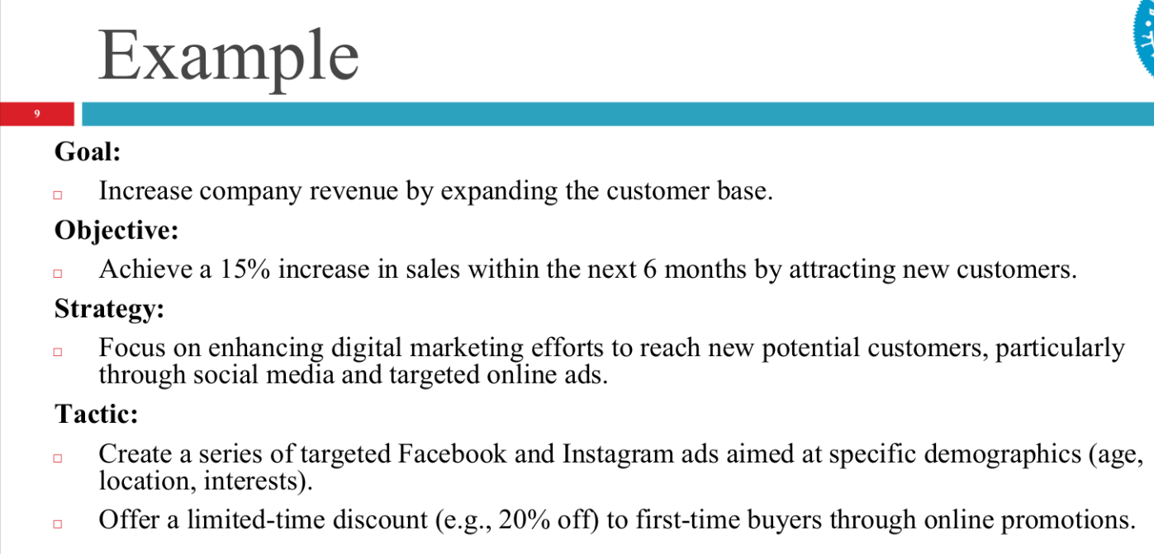

**Key Difference in Efficiently & Effectively**

Efficiency is about **how well you do things**, while effectiveness is about **whether you achieve the right outcomes**. In today’s big corporations, effectiveness is given more value than efficiency.

**Efficiency:**

* **Definition:** Doing things in the best possible way with minimum resources, time, and effort.
* **Focus:** Optimizing resources and reducing waste.
* **Example:** Producing 100 units of a product using fewer raw materials and less time than competitors.

**Effectiveness:**

* **Definition:** Doing the right things to achieve desired goals or outcomes.
* **Focus:** Achieving objectives, regardless of resource usage.
* **Example:** The factory producing high-quality products that customers love is effective.

**Management**

Management is about achieving organizational goals **effectively** (doing the right things) and **efficiently** (doing things right) through:

* **Planning**: Setting goals and deciding how to achieve them.
* **Organizing**: Arranging resources and tasks.
* **Leading**: Motivating and guiding employees.
* **Controlling**: Monitoring progress and making corrections.

**Example**: A restaurant manager plans the menu (planning), assigns tasks to chefs and waiters (organizing), motivates the staff (leading), and checks if customers are satisfied (controlling).

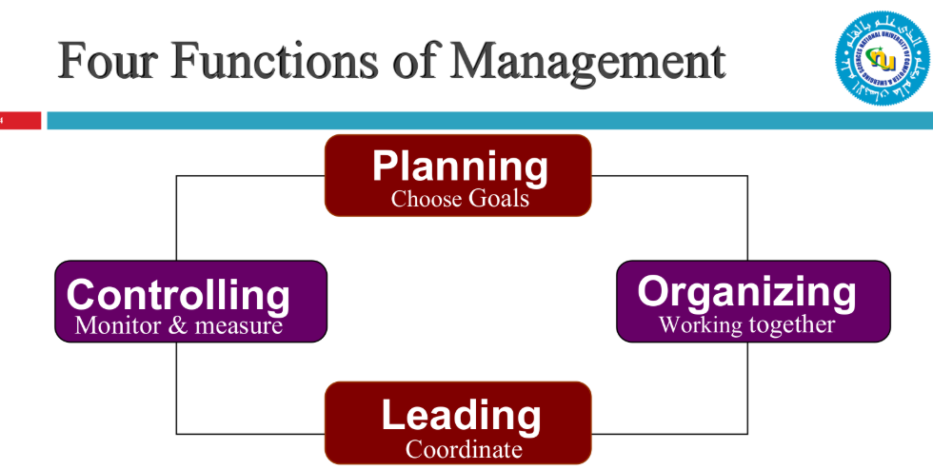

**Four Functions of Management:**

**a. Planning:**

* Setting goals and deciding how to achieve them.
* **Steps**: Set objectives, forecast, create strategies, set standards, and continual review.
* **Example**: A company plans to increase sales by 20% next year by launching a new product.

**b. Organizing:**

* Delegate authority and arrange tasks, people, and resources to achieve goals.
* Function of Organizing involves: Division of Labor, Departmentalization, Staff positioning, Assigning authority or Delegation of Power, Equalizing authority and responsibility
* **Example**: A manager assigns roles to team members for a project.

**c. Leading:**

* Motivating and guiding employees to achieve goals.
* Components: Supervision, Motivation, Communication, Bringing about change, Managing conflict
* **Example**: A team leader inspires employees to work harder by recognizing their efforts.

**d. Controlling:**

* Monitoring employees’ activities, progress and making corrections.
* **Example**: A manager checks if sales targets are met and adjusts the strategy if needed.
* **Controlling Process**:
  + Measuring: Gathering data on current performance to understand how things are currently performing.
  + Comparing: Comparing current performance data with the standards.
  + Correcting: Taking steps to correct any differences found during the comparison.
* **Types of Controlling:**
  + Feedback Control: A type of control that occurs after an activity or process has been completed. To review past performance, identify errors or inefficiencies, and apply corrective measures for future operations.
  + Feed Forward Control: A proactive control mechanism that focuses on preventing problems before they occur by monitoring inputs and processes. To predict potential issues and take corrective action in advance to avoid deviations from planned outcomes.

**Types of Resources:**

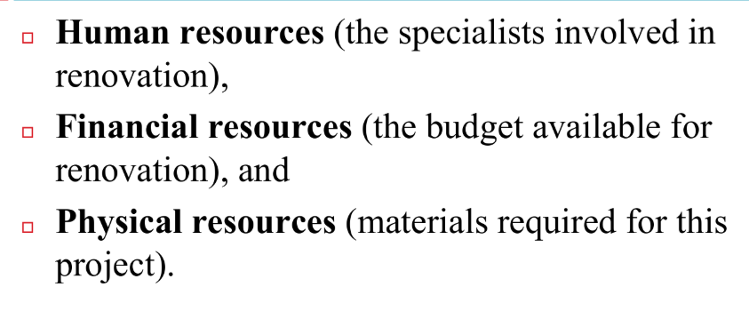

**Who is a Manager?**

A manager is someone who coordinates and oversees the work of others to achieve organizational goals. Managers are not just focused on their own success but on helping others succeed.

**Example**: A store manager ensures that employees provide excellent customer service and meet sales targets.

**What Do Managers Do??**

**Set Objectives**

* **What it means**: Managers define clear goals and objectives for their team or organization.
* **Example**: A sales manager sets a goal for the team to increase sales by 15% in the next quarter.

**2. Organize**

* **What it means**: Managers break down tasks into manageable activities and assign them to the right people. They also ensure that resources (like time, money, and tools) are available.
* **Example**: A project manager divides a large project into smaller tasks and assigns each task to team members based on their skills.

**3. Motivate and Communicate**

* **What it means**: Managers inspire and encourage their team to perform well. They also ensure clear communication to keep everyone aligned.
* **Example**: A team leader holds regular meetings to update the team on progress and provides positive feedback to keep morale high.

**4. Measure**

* **What it means**: Managers set performance standards and evaluate how well the team is meeting them. They also make decisions about rewards, promotions, or corrective actions.
* **Example**: A manager reviews monthly sales reports to see if the team is meeting targets and decides on bonuses for top performers.

**5. Develop People**

* **What it means**: Managers recognize the value of their employees and invest in their growth through training, mentoring, and career development opportunities.
* **Example**: A manager provides training sessions for employees to learn new software or offers mentorship programs to help them grow in their careers.

**Example in Action**

Imagine you’re a manager at a tech company:

1. **Set Objectives**: You set a goal to launch a new app feature by the end of the quarter.
2. **Organize**: You divide the work among designers, developers, and testers.
3. **Motivate and Communicate**: You hold weekly meetings to track progress and encourage the team.
4. **Measure**: You evaluate the team’s performance and reward those who contributed the most.
5. **Develop People**: You provide training for the team to learn new programming languages.

**Management Skills:**

Managers need three types of skills:

* **Conceptual Skills**: Ability to think creatively and solve problems.  
  **Example**: A CEO develops a long-term strategy for the company.
* **Human Skills**: Ability to work well with people and motivative team members.  
  **Example**: A manager resolves conflicts between team members.
* **Technical Skills**: Job-specific knowledge.  
  **Example**: An IT manager knows how to troubleshoot software issues.

**Management Levels:**

**1. Top-Level Managers (Big Bosses)**

**🔹 *Who are they?***

CEO (Chief Executive Officer)

CFO (Chief Financial Officer)

Company President

**🔹 *What do they do?***

✅ Make big decisions about the company’s future.

✅ Set the company’s goals and plans.

✅ Manage the whole company.

✅ Talk to investors and government.

**🔹 *Example*:**

The CEO of a mobile company decides to launch a new smartphone model.

**2. Middle-Level Managers (Department Heads)**

**🔹 *Who are they*?**

Marketing Manager

HR Manager

Sales Manager

**🔹 *What do they do?***

✅ Follow the plans made by top managers.

✅ Manage different departments like sales, marketing, or HR.

✅ Make sure teams work properly and meet goals.

✅ Report progress to top managers.

**🔹 *Example*:**

The Sales Manager plans how to sell more products in different cities.

**3. First-Line Managers (Supervisors & Team Leaders)**

**🔹 *Who are they?***

Office Supervisor

Shift Manager

Team Leader

**🔹 *What do they do?***

✅ Manage workers who do daily tasks.

✅ Give instructions and solve small problems.

✅ Check work quality and performance.

✅ Report to middle managers.

**🔹 *Example:***

A Team Leader in a factory makes sure workers assemble products correctly.

**Top Causes of Manager Failure:**

1. Ineffective communication skills.
2. Poor work relationships.
3. Person-job mismatch.
4. Lack of clear direction.
5. Resistance to change.
6. Failure to delegate.
7. Lack of integrity.
8. Poor teamwork development.
9. Inability to motivate others.
10. Poor planning and reactionary behavior.

**10 Management Roles:**

**a). Interpersonal Roles (Dealing with People)**

These roles focus on building relationships and leading teams.

1. **Figurehead** – Represents the company in events and ceremonies.  
   Example: A CEO attending a business conference.
2. **Leader** – Motivates and guides employees.  
   Example: A manager encouraging employees to work harder.
3. **Liaison** – Connects with people inside and outside the company.  
   Example: A marketing manager meeting with advertising agencies.

**b). Informational Roles (Handling Information)**

These roles focus on gathering, sharing, and analyzing information.

1. **Monitor** – Collects important information for decision-making.  
   Example: A manager reading reports about market trends.
2. **Disseminator** – Shares important information with employees.  
   Example: A supervisor explaining new company rules to workers.
3. **Spokesperson** – Represents the company and provides information to outsiders.  
   Example: A CEO giving a press interview about company growth.

**c). Decisional Roles (Making Decisions)**

These roles focus on solving problems and making key decisions.

1. **Entrepreneur** – Brings new ideas and innovations.  
   Example: A manager launching a new product in the market.
2. **Disturbance Handler** – Solves problems and conflicts.  
   Example: A manager resolving an argument between two employees.
3. **Resource Allocator** – Decides where to use company resources.  
   Example: A finance manager deciding how much budget to give for marketing.
4. **Negotiator** – Makes deals and agreements with others.  
   Example: A purchasing manager negotiating prices with suppliers.

**Multiple Choice Questions (MCQs)**

1. **What is the primary purpose of an organization?**  
   a) To make profits  
   b) To achieve a set of goals  
   c) To compete with other organizations  
   d) To provide employment  
   **Answer**: b) To achieve a set of goals
2. **Which of the following is an example of a goal?**  
   a) Increase sales by 10% in the next quarter  
   b) Launch a new product  
   c) Become the market leader in the industry  
   d) Run social media ads  
   **Answer**: c) Become the market leader in the industry
3. **What is the difference between efficiency and effectiveness?**  
   a) Efficiency is about doing the right things, while effectiveness is about doing things right.  
   b) Efficiency is about doing things right, while effectiveness is about doing the right things.  
   c) Efficiency is about reducing costs, while effectiveness is about increasing profits.  
   d) Efficiency is about planning, while effectiveness is about execution.  
   **Answer**: b) Efficiency is about doing things right, while effectiveness is about doing the right things.
4. **Which of the following is NOT a function of management?**  
   a) Planning  
   b) Organizing  
   c) Marketing  
   d) Controlling  
   **Answer**: c) Marketing
5. **What is the role of a manager as a "Figurehead"?**  
   a) Motivating employees  
   b) Representing the organization in ceremonial duties  
   c) Resolving conflicts  
   d) Allocating resources  
   **Answer**: b) Representing the organization in ceremonial duties
6. **Which management level is responsible for long-term strategic decisions?**  
   a) Top-Level Management  
   b) Middle-Level Management  
   c) Lower-Level Management  
   d) Operational Management  
   **Answer**: a) Top-Level Management
7. **What is the main focus of "Feedback Control"?**  
   a) Preventing problems before they occur  
   b) Reviewing past performance and correcting errors  
   c) Motivating employees  
   d) Allocating resources  
   **Answer**: b) Reviewing past performance and correcting errors
8. **Which skill is most important for a first-line manager?**  
   a) Conceptual skills  
   b) Human skills  
   c) Technical skills  
   d) Strategic skills  
   **Answer**: c) Technical skills
9. **What is the role of a manager as a "Liaison"?**  
   a) Building relationships with external stakeholders  
   b) Motivating employees  
   c) Making strategic decisions  
   d) Monitoring performance  
   **Answer**: a) Building relationships with external stakeholders
10. **Which of the following is a cause of manager failure?**  
    a) Effective communication  
    b) Resistance to change  
    c) Clear direction  
    d) Strong teamwork  
    **Answer**: b) Resistance to change

**Scenario-Based MCQs**

1. **Scenario**: A manager sets a goal to increase customer satisfaction by 20% in the next year. They decide to achieve this by training employees and improving service quality.  
   **Question**: Which function of management is the manager performing?  
   a) Planning  
   b) Organizing  
   c) Leading  
   d) Controlling  
   **Answer**: a) Planning
2. **Scenario**: A team leader notices that employees are not meeting their sales targets. They hold a meeting to discuss the issue and provide guidance on how to improve performance.  
   **Question**: Which management role is the team leader performing?  
   a) Figurehead  
   b) Leader  
   c) Disturbance Handler  
   d) Negotiator  
   **Answer**: b) Leader
3. **Scenario**: A company’s CEO decides to enter a new market by launching a new product line. The marketing manager is tasked with creating a campaign to promote the product.  
   **Question**: Which management level is the marketing manager part of?  
   a) Top-Level Management  
   b) Middle-Level Management  
   c) Lower-Level Management  
   d) Operational Management  
   **Answer**: b) Middle-Level Management
4. **Scenario**: A factory supervisor ensures that workers are assembling products correctly and meeting daily production targets.  
   **Question**: Which management level is the supervisor part of?  
   a) Top-Level Management  
   b) Middle-Level Management  
   c) Lower-Level Management  
   d) Strategic Management  
   **Answer**: c) Lower-Level Management
5. **Scenario**: A manager reviews monthly sales reports and notices a decline in sales. They decide to offer discounts to attract more customers.  
   **Question**: Which type of control is the manager using?  
   a) Feedforward Control  
   b) Feedback Control  
   c) Concurrent Control  
   d) Preventive Control  
   **Answer**: b) Feedback Control

**Scenario-Based Questions**

1. **Scenario**: A company’s CEO wants to expand into international markets. They ask the marketing manager to develop a strategy to enter these markets.  
   **Question**: What steps should the marketing manager take to create an effective strategy?  
   **Answer**: The marketing manager should:

* Conduct market research to understand the new markets.
* Set clear objectives (e.g., increase market share by 10% in 2 years).
* Develop a marketing plan (e.g., digital campaigns, partnerships).
* Allocate resources (e.g., budget, personnel).
* Monitor progress and adjust the strategy as needed.

1. **Scenario**: A team leader notices that two team members are constantly arguing, which is affecting team productivity.  
   **Question**: How should the team leader handle this situation?  
   **Answer**: The team leader should:

* Act as a "Disturbance Handler" by mediating the conflict.
* Listen to both sides and understand the root cause of the argument.
* Provide guidance and set clear expectations for teamwork.
* Follow up to ensure the conflict is resolved and productivity improves.

1. **Scenario**: A manager is tasked with launching a new product but has a limited budget.  
   **Question**: How can the manager ensure the product launch is successful despite budget constraints?  
   **Answer**: The manager should:

* Prioritize key activities (e.g., focus on digital marketing instead of expensive TV ads).
* Allocate resources efficiently (e.g., use in-house talent instead of hiring external agencies).
* Monitor expenses and adjust the plan as needed.
* Motivate the team to work creatively within the budget.

1. **Scenario**: A company’s sales team is not meeting its targets. The sales manager decides to implement a new incentive program to motivate the team.  
   **Question**: What steps should the sales manager take to ensure the incentive program is effective?  
   **Answer**: The sales manager should:

* Set clear and achievable targets for the team.
* Communicate the incentive program clearly to all team members.
* Monitor performance and provide regular feedback.
* Reward top performers to motivate others.

1. **Scenario**: A manager is planning to introduce a new software system to improve productivity. However, employees are resistant to change.  
   **Question**: How can the manager overcome resistance and ensure a smooth transition?  
   **Answer**: The manager should:

* Communicate the benefits of the new system to employees.
* Provide training to help employees adapt to the new software.
* Involve employees in the decision-making process to gain their buy-in.
* Address concerns and provide support during the transition.