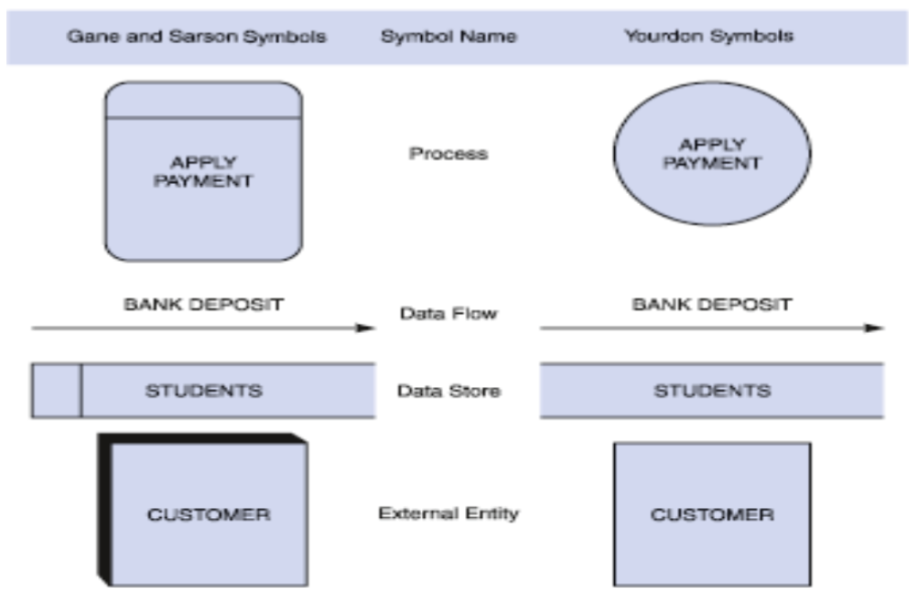

**There are two types of external entities:  
1**: **Source**: Entities that supply data to the system

**2**: **Sink**: Entities that receive data from the system

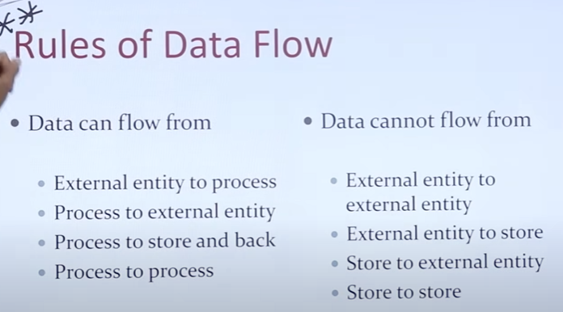

**Level 0:**

It is also known as a context diagram. It’s designed to be an abstraction view, showing the system as a **single process** with its relationship to external entities. It represents the **entire system as a single bubble with input and output data** indicated by incoming/outgoing arrows. Level 0 **identifies external links**. It models the system as **one process box** which represents the scope of the system and identifies external entities and related inputs and outputs.

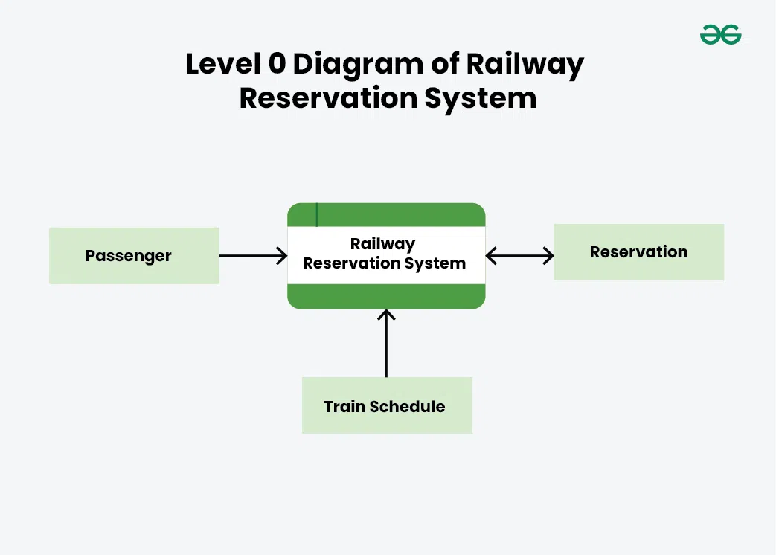

**Level 1:**

This level provides a more detailed view of the system by breaking down the major process identified in the level 0 DFD into sub-processes. Each sub-process is depicted as a separate process on level 1 DFD. The data flows and data stores associated with each sub-process are also shown. In 1-level DFD, the context diagram is decomposed into multiple processes. In this level, we highlight the main functions of the system and breakdown the high-level process of 0-level DFD into subprocesses.

* Boundary level 1 is the context diagram
* On level 1 processes are numbered 1, 2, 3…
* Number is used to uniquely identify process not to represent any order of processing
* Data store numbers are usually D1, D2, D3...

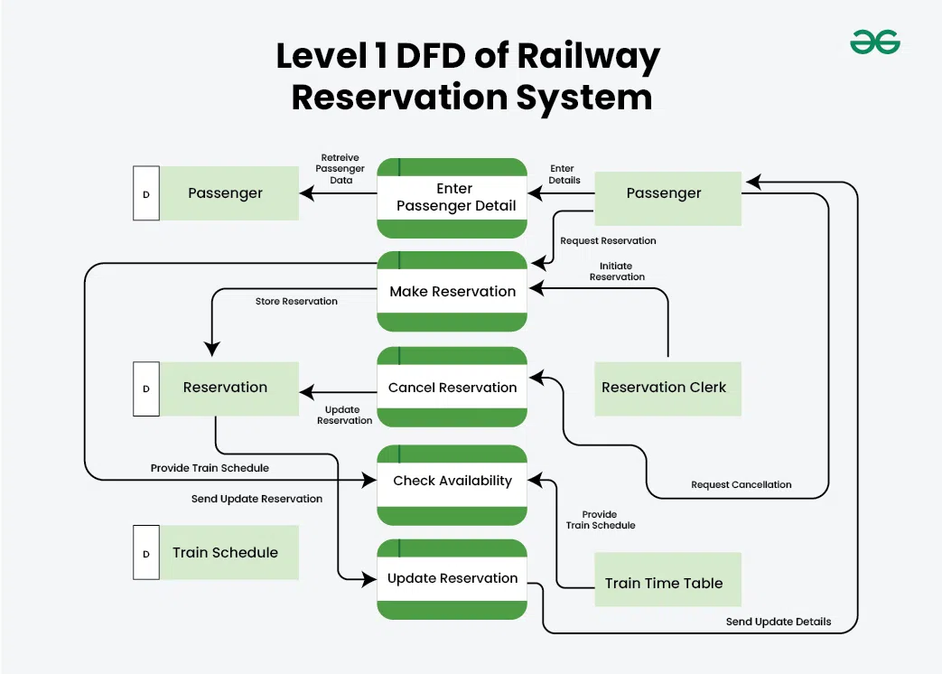

**Level 2:**

This level provides an even more detailed view of the system by breaking down the subprocesses identified in the level 1 DFD into further sub-processes. Each sub-process is depicted as a separate process on level 2 DFD. The data flows and data stores associated with each sub-process are also shown.

* Boundary of level 2 is the level 1 process
* you can decide which Level 1 processes require further decomposition into Level 2.
* Each process in level 1 is decomposed to show its constituent processes
* On level 2 processes are numbered x.1, x.2, x.3… where x is the number of the parent level 1 process
* If there are more than 8 data flows break it (Stop drawing further)

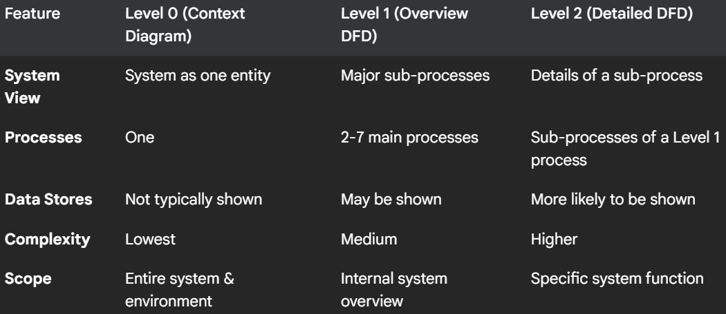

**How to Draw Data Flow Diagram?**

Following are the steps to Draw Data Flow Diagram

* Understand the System
* Identify External Entities
* Identify Processes
* Identify Data Stores
* Use Standard Symbols
* Create Level 0 Diagram
* Based on Complexity Draw Further Level Diagram like Level 1, 2 and so on.
* Identify Data Flows:
* Number Processes and Data Stores
* Review and Validate

**DFD Examples:**

**Level 0:**

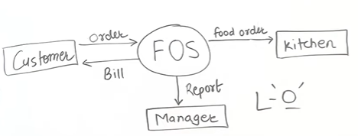

**Level 1:**

**Level 2:**

Decomposed Order Processing Process into more two processes:



**Level 1:**

**Level 2:**

