**Domain Model**

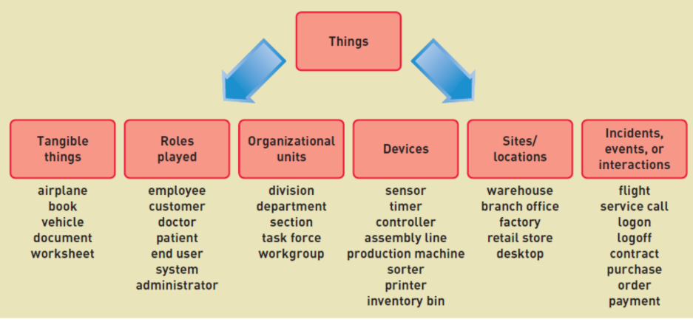

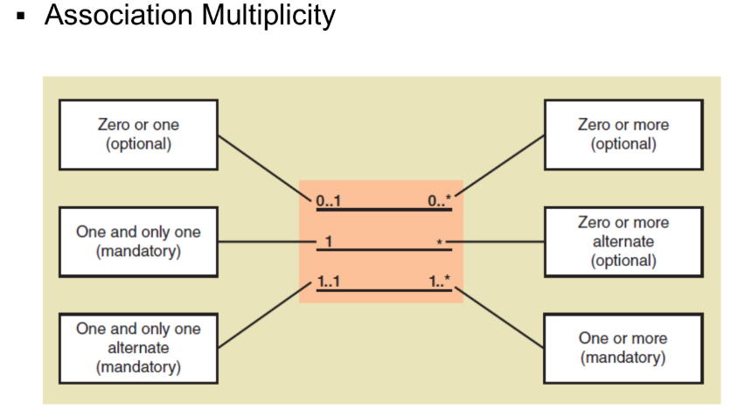

* **Zero or One (Optional):** Useful when the relationship is not always necessary, such as a user having an optional profile picture.
* **One and Only One (Mandatory):** Useful for strict one-to-one relationships, such as a person having exactly one passport.
* **One and Only One Alternate (Mandatory):** Useful for mutual one-to-one relationships, such as a marriage where each spouse is uniquely associated with the other.
* **Zero or More (Optional):** Useful for collections or lists where the presence of items is not mandatory, such as a user having multiple addresses.
* **Zero or More Alternate (Optional):** Useful for mutual collections where the relationship is optional on both sides, such as students enrolling in multiple courses and courses having multiple students.
* **One or More (Mandatory):** Useful for mandatory collections, such as a book having at least one author.

**Guidelines for Domain Modeling:**

1. **Concepts** – Keep them if unsure to avoid future gaps.
2. **Associations** – Drop them if unsure to maintain simplicity.
3. **Derivable Associations** – Avoid them to prevent redundancy.



