**System Sequence Diagram**

A **System Sequence Diagram (SSD)** illustrates input and output events and flow of events in the system.

**We draw a System Sequence Diagram (SSD) for a *single main use case scenario* — not for the entire use case diagram.**

SSDs should be done for the main success scenario of the use-case, and frequent and alternative scenarios.

**Unified Process Artifact**

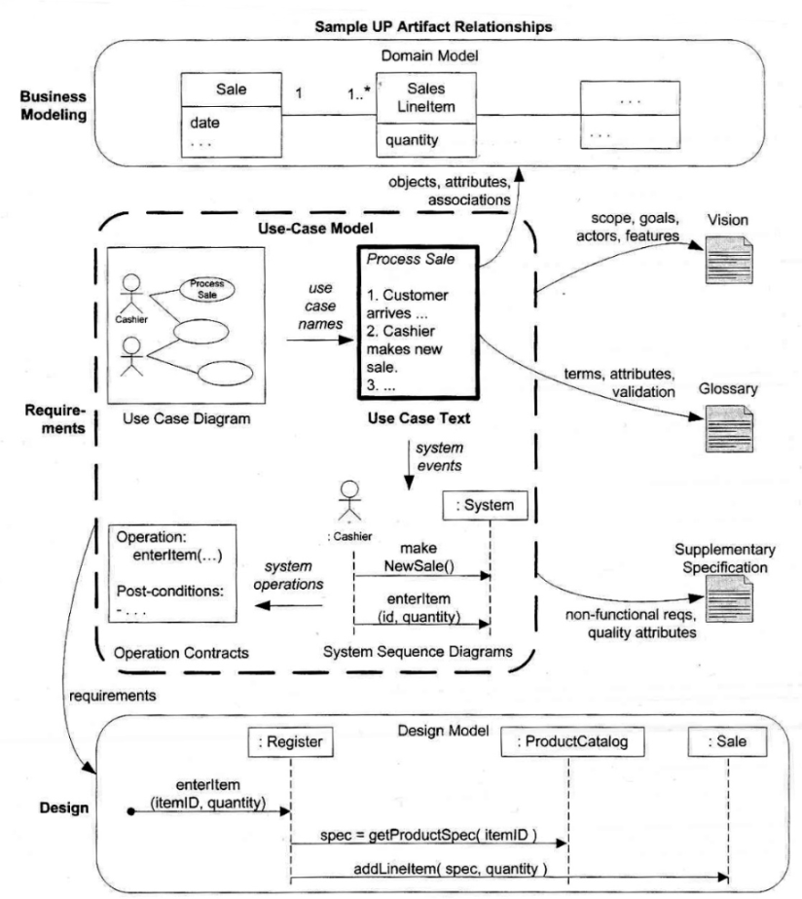

**System Sequence Diagram - Scenario**

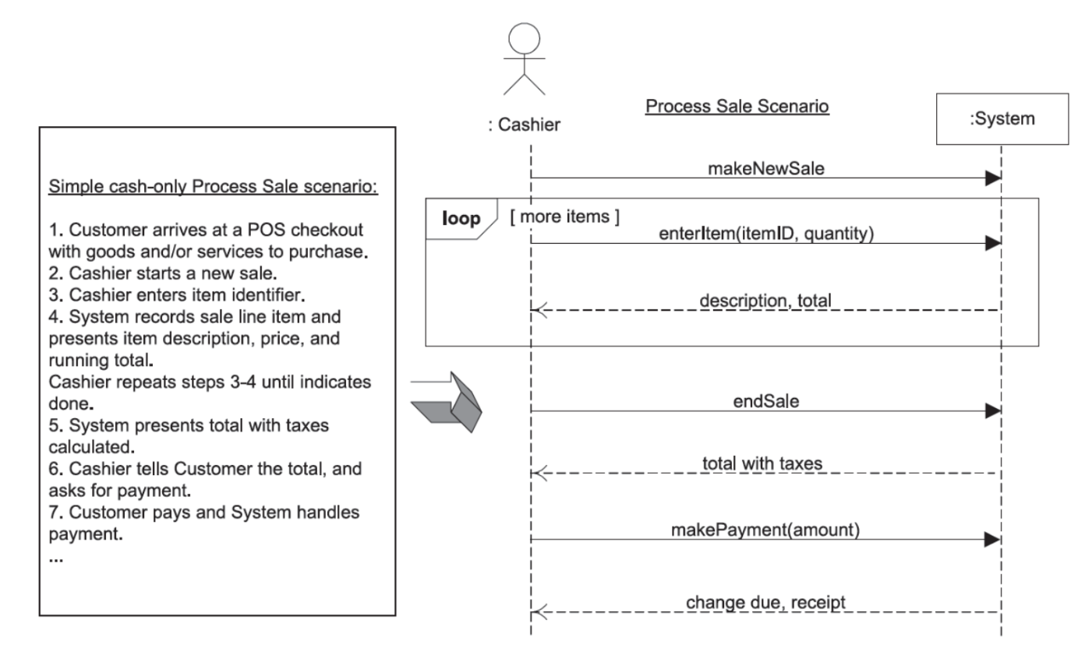

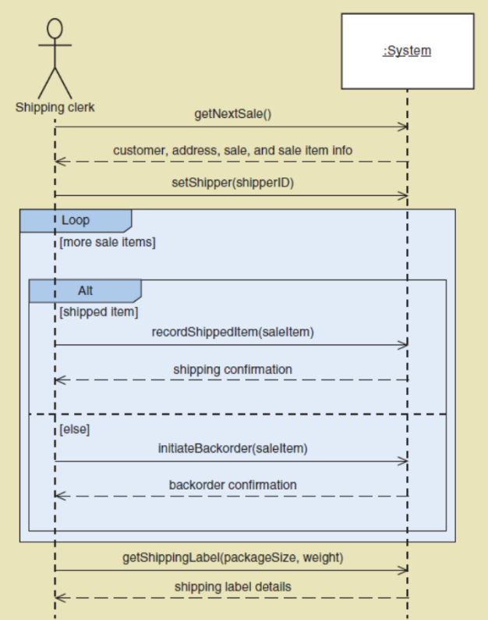

**User:** Actor (:Customer)

**System:** Rectangle (:Bank)

**User to System:** Arrow, function/method calls with parameters

**System to User:** Dotted Arrow, return values/messages

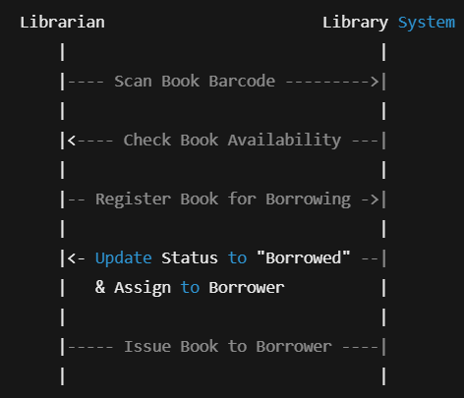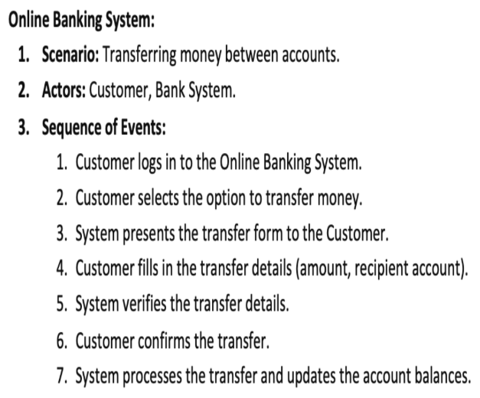

**Operation/Method Contracts**

Contracts for operations can help define system behavior. Contracts describe detailed system behavior in terms of state changes to objects in the Domain Model, after a system operation has executed.

**Operation contracts** are created for **each method/function** to describe the state changes to object and overall system behavior.

To describe the postconditions, use ONLY:

* instance creation and deletion
* attribute modification
* associations formed and broken