**Activity Diagram**

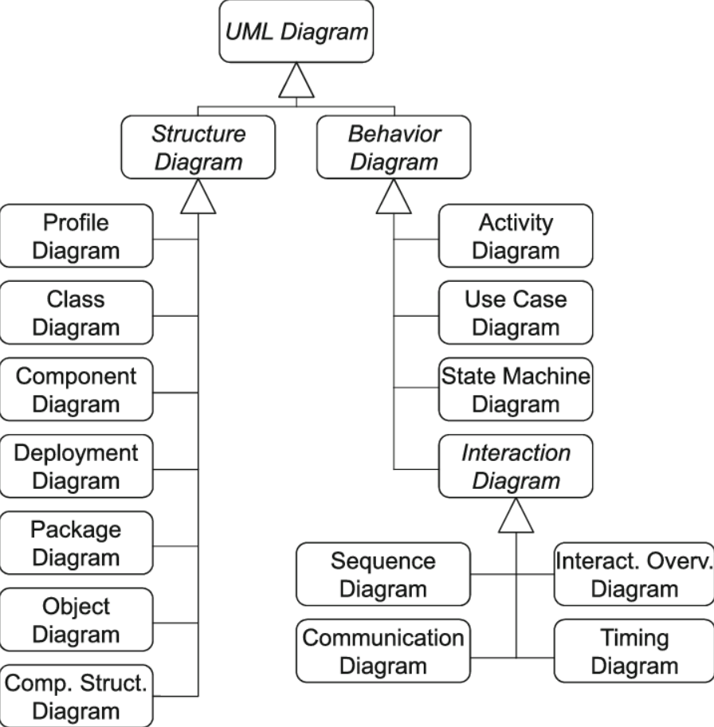

**Behavioural models** are models of the dynamic behavior of a system as it is executing. They show what happens or what is supposed to happen when a system responds to a stimulus from its environment. Stimulus can be Data or Event.

**Activity Diagram**

* It is a conceptual diagram, used to:
* Model system behavior in the context of data processing.
* Model workflows between/within use cases
* Model complex workflows in operations on objects
* Model in detail complex activities in a high level activity Diagram
* It is not directly related to system implementation but helps to improve system understanding.
* We can design activity diagram:
  + For each use case
  + One for the whole system
  + One for each user

| **Symbol** | **Name** | **Description** |
| --- | --- | --- |
| ◯ (Rounded Rectangle) | **Activity Node** | An action or step in the process |
| ◇ (Diamond) | **Decision Node** | Conditional branching |
| ▬▬▬▬ (Thick Bar) | **Fork Node** | One to many (parallel split) |
| ▬▬▬▬ (Thick Bar) | **Join Node** | Many to one (parallel join) |
| (No formal symbol) | **Splitter** | Informal term for fork/decision |

**Swimlane**

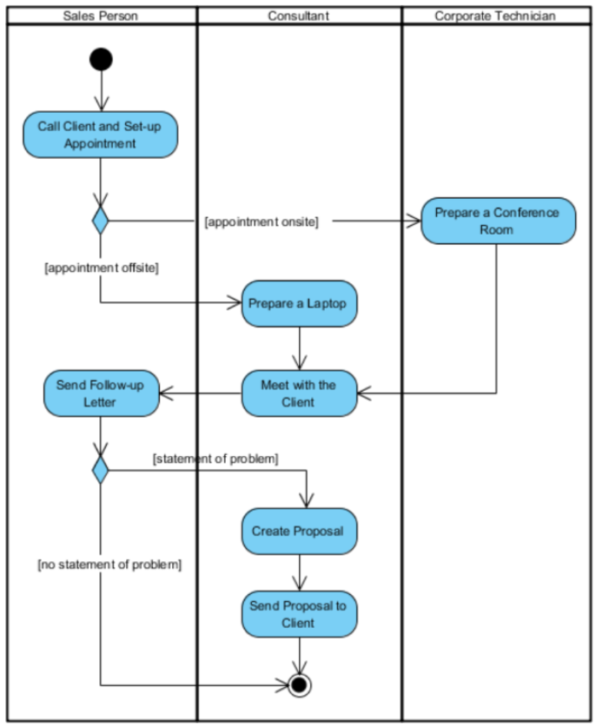A way to group activities performed by the same actor.

**Scenario**

**Sales Person:**

1. **Call Client and Set-up Appointment:** The salesperson initiates the process by contacting the client to arrange a meeting time and place.
2. **Send Follow-up Letter:** After the meeting with the client, the salesperson is responsible for sending a letter to the client. This letter likely contains a summary of the meeting, any next steps, or simply serves as a courtesy to thank the client for their time.

**Consultant:**

1. **Prepare a Laptop (if the appointment is offsite):** If the meeting is not going to be at the company's office (offsite), the consultant prepares a laptop, possibly to present information or proposals during the meeting.
2. **Meet with the Client:** The consultant is responsible for the actual meeting with the client, discussing their needs and potential issues that might require a solution.
3. **Create Proposal (if there's a statement of problem):** If during the meeting, a client's problem is identified that requires a solution, the consultant will create a proposal outlining how they can address this issue.
4. **Send Proposal to Client:** Once the proposal is ready, it's the consultant's job to ensure it's sent to the client for consideration.

**Corporate Technician:**

**1. Prepare a Conference Room (if the appointment is onsite):** When the meeting is at the company's office (onsite), the corporate technician sets up a conference room for the meeting. This could involve arranging chairs, setting up projectors, or preparing other necessary equipment.

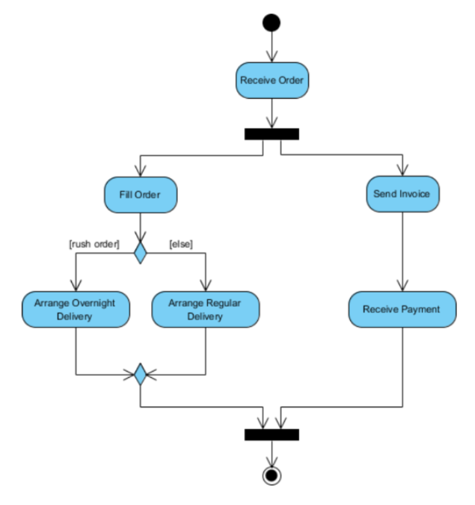**Scenario**

* Once the order is received, the activities split into two parallel sets of activities. One side fills and sends the order while the other handles the billing.
* On the Fill Order side, the method of delivery is decided conditionally. Depending on the condition either the Overnight Delivery activity or the Regular Delivery activity is performed.
* Finally the parallel activities combine to close the order.

**Activity Diagram for meeting a new client:**

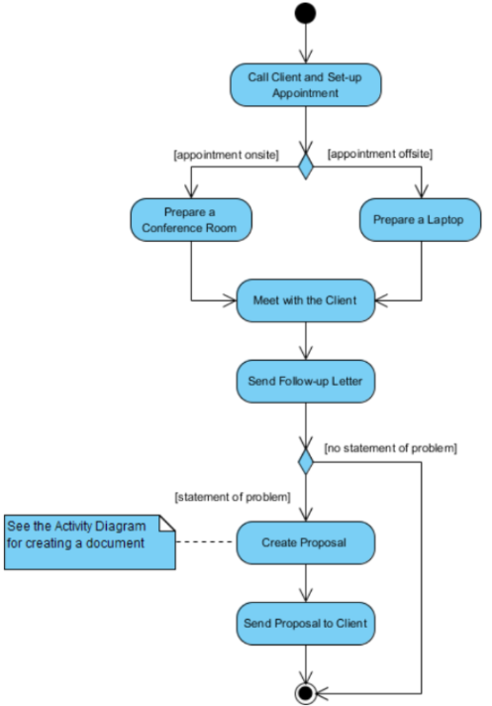

**Activity Diagram Scenario - Borrow Book**

