**What is Vision in System Development?**

* **Vision** is the **goal** or **outcome** that a company wants to achieve through a new system or product. It defines **what** the system should do, but not **how** it will do it.
* The vision is aligned with the company’s **business strategy** and **investment portfolio**.
* It answers big questions like:
  + Why are we building this system?
  + What problem will it solve?
  + What benefits will it provide?
  + Who will benefit from it?
  + What performance and reliability are expected?

**Example of Vision:**

* *"To create an AI-powered healthcare assistant that improves patient diagnosis and reduces hospital wait times."*

**System Vision Document**

The **System Vision Document** is a key tool that outlines:

1. **Problem Description**: What is the problem, and what is the proposed solution?
2. **System Capabilities**: What features and functionalities will the new system have?
3. **Business Benefits**: What **tangible** (e.g., cost savings) and **intangible** (e.g., improved customer satisfaction) benefits will the system bring?

**Types of Vision/Identify the Problem**

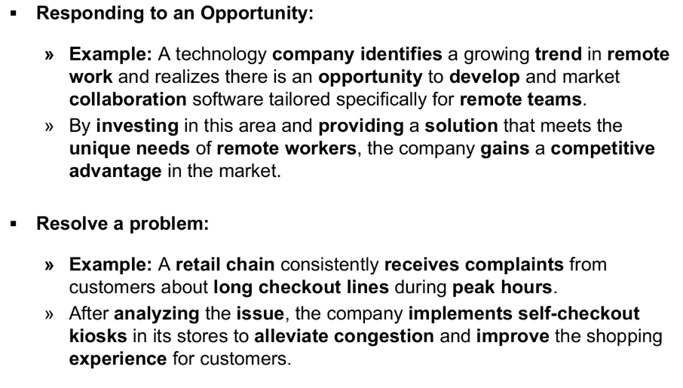

**Key Activities in System Analysis and Design:**

1. **Understand the Need**: Identify the business problem or opportunity.
2. **Capture the Vision**: Define the goal of the system.
3. **Define a Solution**: Develop a plan to solve the problem.
4. **Communicate the Vision and Solution**: Share the plan with stakeholders.
5. **Build the Solution**: Develop the system or guide others in building it.
6. **Confirm the Solution**: Ensure the system meets the business need.
7. **Launch the Solution**: Deploy the system for use.

**System Analysis and Design:**

* **System Analysis**: **What** is required for the new system to solve the problem.
* **System Design**: Defining and describing **how** the system will solve the identified problem.

**Role of a System Analyst**

A **System Analyst** is a key player in the development of information systems. Their responsibilities include:

* Investigating, analyzing, designing, developing, and maintaining information systems.
* Acting as a **bridge** between **managers** (who define business needs) and **programmers** (who build the system).
* Ensuring that the system meets both the user needs and business goals.

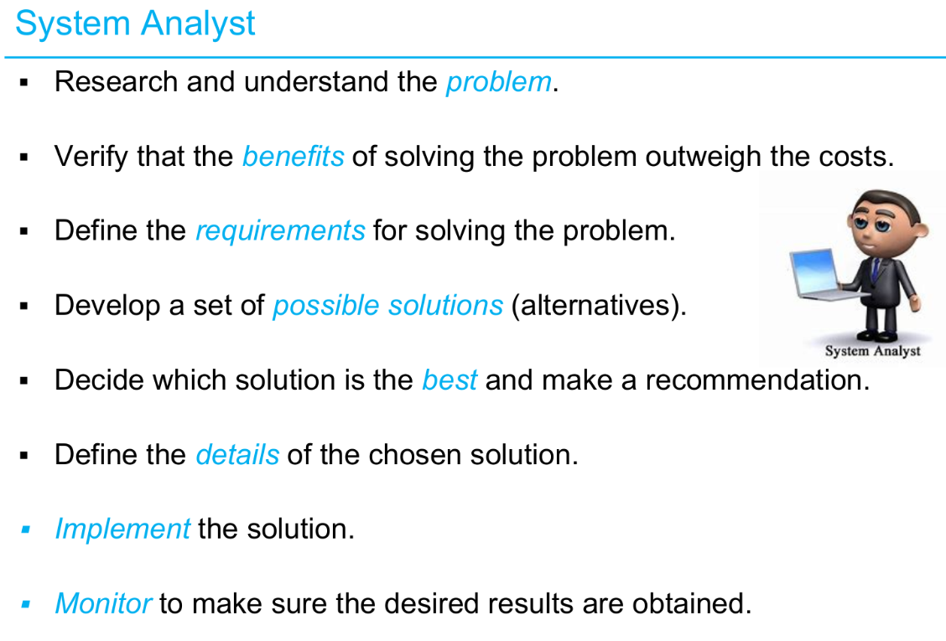

**Practice Questions: (Scenario Based)**

**🡪 Use Case 1: Retail Store Checkout System**

**Scenario**:  
A retail store is facing long checkout lines during peak hours, leading to customer complaints. The management wants to implement a new system to reduce wait times and improve the shopping experience.

**Questions**:

1. What would be the **vision** for this new system?
2. What **capabilities** should the new system have?
3. What **business benefits** would the store gain from this system?
4. As a system analyst, what steps would you take to ensure the system meets the store’s needs?

**Answer**:

**1. Vision:**

*"To implement a fast and efficient checkout system that reduces wait times during peak hours, improves customer satisfaction, and increases sales by providing a seamless shopping experience."*

**2. Capabilities:**

* **Self-Checkout Kiosks**: Allow customers to scan and pay for items themselves.
* **Mobile Payment Options**: Enable customers to pay via mobile wallets (e.g., Apple Pay, Google Pay).
* **Real-Time Queue Management**: Monitor and manage checkout lines in real-time to reduce wait times.
* **Customer Loyalty Integration**: Save customer login info for faster repeat purchases.
* **Inventory Integration**: Automatically update inventory levels after each purchase.

**3. Business Benefits:**

* **Tangible Benefits**:
  + Increased sales due to faster checkout and reduced customer abandonment.
  + Cost savings from reduced labor (e.g., fewer cashiers needed).
* **Intangible Benefits**:
  + Improved customer satisfaction and loyalty.
  + Enhanced brand reputation due to a better shopping experience.
  + Reduced stress for employees and customers during peak hours.

**4. System Analyst’s Role:**

1. **Investigate**: Observe checkout lines, interview customers and employees to understand pain points.
2. **Analyze**: Identify bottlenecks (e.g., slow payment processing, insufficient cashiers) and determine the root cause of long wait times.
3. **Design**: Work with managers to define requirements (e.g., reduce wait times by 50%) and collaborate with programmers to design the system (e.g., self-checkout kiosks).
4. **Implement**: Deploy self-checkout kiosks and mobile payment options.
5. **Validate**: Test the system with a small group of customers, gather feedback, and make improvements before full deployment.

**🡪 Use Case 2: Fitness Tracking App**

**Scenario**:  
A mobile app development company notices that users are frustrated with the complexity of existing fitness tracking apps. They want to create a simple, user-friendly app that focuses on key features like step tracking and calorie intake.

**Questions**:

1. What would be the **vision** for this new fitness app?
2. How would you **capture user needs** for this app?
3. What **system capabilities** should the app have to meet user expectations?
4. How would you ensure the app is **user-friendly** and meets the needs of its target audience?

- **Answer**:

**1. Vision:**

*"To create a simple, user-friendly fitness tracking app that focuses on key features like step tracking and calorie intake, helping users achieve their health goals with ease."*

**2. Capturing User Needs:**

* Conduct **user surveys** to understand what features users want most (e.g., step tracking, calorie counting).
* Analyze **competitor apps** to identify gaps and areas for improvement.
* Hold **focus groups** with potential users to gather feedback on app design and functionality.

**3. System Capabilities:**

* **Step Tracking**: Accurately track daily steps using the phone’s sensors.
* **Calorie Intake Tracking**: Allow users to log meals and calculate calorie intake.
* **User-Friendly Interface**: Simple, intuitive design with easy navigation.
* **Goal Setting**: Let users set daily or weekly fitness goals (e.g., 10,000 steps per day).
* **Progress Reports**: Provide visual progress reports (e.g., charts, graphs) to motivate users.

**4. Ensuring User-Friendliness:**

* Conduct **usability testing** with real users to identify pain points in the app’s design.
* Use **feedback loops** to continuously improve the app based on user suggestions.
* Keep the app **minimalistic** by focusing only on key features users want most.