AEROMIND
The Physical AI Travel Concierge
A Gemini-powered multimodal agent that sees, hears, reasons and acts across your entire journey

Project Overview · System Architecture (HLD & LLD) · Feature Specification · Tech Stack · UI Design System
Prepared for: Gemini X Prize Hackathon Submission
Document Version 1.0

Table of Contents

1. Executive Summary
AeroMind is an autonomous, multimodal travel companion built on Gemini that perceives the physical world through a phone's camera, microphone, and location sensors, reasons about a traveler's live itinerary, and acts on their behalf — rebooking flights, updating hotels, guiding them to gates, and warning them before a disruption ever becomes visible on an airport board. It moves beyond the chatbot paradigm into a genuine physical-AI agent: an assistant that operates in the real world, not just in a text box.
This document refines the original concept into a hackathon-ready, judge-defensible solution: it defines the complete feature set (including entirely new capabilities such as predictive disruption scoring, cascading digital-twin rebooking, AR wayfinding, and a real-time conversational Flight Advisor built on open flight-tracking data), the full technology stack, a High-Level Design (HLD) and Low-Level Design (LLD), Firestore data models, API contracts, and a UI design system built around a strict black-and-white aesthetic with Poppins typography and motion-rich open-source React component libraries.

2. Problem Statement
- Fragmented information: boarding passes, gate boards, emails, and hotel confirmations live in five different apps and none of them talk to each other.
- Reactive, not proactive: travelers find out about a delay or gate change only when they physically look at a screen — by then it may be too late to act.
- Disruption is a full-day problem, not a flight problem: a missed connection cascades into a missed hotel check-in, missed meeting, and a frantic scramble across three different customer-service lines.
- Airports are physically confusing: unfamiliar terminals, foreign-language signage, and long unpredictable security queues cause avoidable stress and missed flights.

3. Solution Overview
AeroMind is delivered as a responsive React web application (installable as a PWA) that acts as a single pane of glass across a trip. It combines four perceptual channels — vision, voice, location, and structured data — with a Gemini-orchestrated agent layer that can call real tools: search flights, query live tracking data, rebook, message hotels, and push notifications. A background monitoring layer (Cloud Functions + Pub/Sub) watches every leg of a trip continuously, even while the app is closed, and wakes the agent the instant something changes.

3.1 Core Pillars
- Perceive: Gemini Vision reads boarding passes, itineraries, emails, and physical gate/departure signage.
- Converse: Gemini Live provides low-latency, proactive, natural voice interaction — including a real-time "Ask My Flight Anything" advisor.
- Reason: Gemini function calling orchestrates flight search, weather, historical on-time data, and rebooking APIs to decide the best course of action.
- Act: the agent autonomously (with one-tap human confirmation for anything irreversible) rebooks flights, updates hotel dates, and notifies the traveler and their companions.

4. Refined & Innovative Feature Set
Beyond the original scan-and-notify concept, the following features differentiate AeroMind and are designed specifically to stand out in hackathon judging.

4.1 Real-Time Conversational Flight Advisor (new)
A persistent chat/voice surface, always accessible, where a traveler can ask literally anything about their trip in natural language — "Will my connection be tight?", "Is this plane in the air yet?", "What's the on-time rate for this route?", "Why is my flight delayed?" — and get a grounded, cited answer synthesized from live open flight-tracking data.
- Data sources: OpenSky Network (free, open ADS-B live position data), AviationStack / FlightAware AeroAPI (schedules, gate, status), OpenWeather (enroute and destination weather), and historical on-time-performance datasets.
- Grounded answers: Gemini function calling fetches live data per question rather than hallucinating — every answer is traceable to a tool call and timestamp.
- Proactive interjections: the advisor doesn't just wait to be asked; via Gemini Live it can interrupt with a short spoken alert when something the traveler cares about changes.

4.2 Predictive Disruption Score (new)
Rather than waiting for an airline to announce a delay, AeroMind continuously computes a 0–100 disruption-risk score per flight leg by combining live ATC/weather congestion at origin and destination, the aircraft's current live position versus scheduled departure, and that route/airline's historical on-time performance. When the score crosses a threshold, the agent proactively begins pre-computing rebooking alternatives — before the airline even announces the delay.

4.3 Digital-Twin Itinerary Graph & Cascading Re-Planning (new)
Every trip is modeled in Firestore as a dependency graph of nodes — flight legs, hotel stays, car rentals, ground transfers, meetings — with directed edges representing time dependencies. A single disruption event triggers a graph traversal: the agent recalculates every downstream node, not just the flight, and proposes a single consolidated re-plan (new flight + shifted hotel check-in + updated car rental) for one-tap approval, instead of forcing the traveler to fix each booking separately.

4.4 AR Wayfinding Overlay (new)
Using the phone camera combined with Gemini Vision (to read wall signage as a coordinate anchor) and Google Maps Platform indoor routing, AeroMind renders live AR directional arrows over the camera feed to guide travelers to their gate, restroom, or lounge — accounting for a real-time walking-pace-aware countdown against boarding time.

4.5 Gate-Change Whisper Alerts & Walking ETA
Ambient, low-friction Gemini Live voice nudges calculated against live indoor walking distance: "Gate changed to C14 — that's an 8-minute walk and boarding starts in 12. Leave now."

4.6 Autonomous Rebooking Negotiation Agent
- Detect: Pub/Sub event fires on cancellation/severe delay.
- Search: function calling queries multiple flight-search and hotel APIs in parallel.
- Rank: options are scored against traveler preferences — cost, arrival time, loyalty program, layover comfort, and carbon emissions.
- Confirm: a single push notification presents the top option with a one-tap Approve / See Alternatives action — the agent never spends money without explicit human confirmation.
- Execute & notify: on approval, Cloud Functions call the booking APIs, update Firestore, and notify all trip companions.

4.7 Co-Traveler Sync
Trips can be shared with a group. All members see a merged itinerary and live map; the agent flags when members are diverging from each other (e.g., one is stuck at security) and can proactively suggest the group split or wait.

4.8 Carbon & Comfort-Aware Rebooking
Every alternative flight surfaced during rebooking is scored not only on price and time but also on estimated CO₂ emissions and layover comfort (seat pitch, lounge access, terminal quality), so disruption recovery aligns with traveler values, not just the airline's default choice.

4.9 Airport Crowd & Security-Wait Predictor
Crowdsourced check-ins combined with historical time-of-day security-line data feed a personalized "leave for the airport by" recommendation, delivered the night before and re-confirmed the morning of the flight.

4.10 Accessibility & Emergency Mode
A high-contrast, large-text, voice-first mode with haptic gate-proximity buzzes, designed for visually impaired or anxious travelers — demonstrating inclusive design, a strong judging signal.

4.11 Multimodal Inbox Ingestion
Travelers can forward any confirmation email or screenshot to a dedicated trip inbox; Gemini Vision + text extraction automatically parses and merges it into the Firestore itinerary graph with zero manual entry.

4.12 Post-Trip AI Travel Journal
At trip end, Gemini automatically compiles a shareable digital journal from scanned boarding passes, photos, and timeline events — turning operational data exhaust into a delightful keepsake, and giving the demo a strong emotional closing beat.

4.13 Offline-First Resilience
Firestore offline persistence caches the active itinerary, maps, and last-known flight status so the app remains usable in airport dead zones and airplane mode.

5. Google & Open-Source Technology Stack
Layer | Technology | Purpose
Multimodal Perception | Gemini Vision (Vertex AI) | Reads boarding passes, itineraries, emails, gate/departure signage
Conversational AI | Gemini Live API | Low-latency proactive voice interaction, Flight Advisor voice mode
Agent Orchestration | Gemini 2.x Function Calling | Flight search, rebooking, notification tool invocation
Backend Compute | Firebase Cloud Functions | Event handlers, rebooking agent, disruption scoring
Eventing | Cloud Pub/Sub | Real-time flight-status change events, gate-change events
Database | Firestore | Trip graph, itinerary, user context, offline cache
Scheduling | Cloud Scheduler | Periodic flight-status polling per active leg
Push Notifications | Firebase Cloud Messaging (FCM) | Proactive alerts to traveler and companions
Maps & Wayfinding | Google Maps Platform (Directions, Places, Indoor Maps) | Gate navigation, walking ETA, indoor routing
AR | ARCore + Google Maps Platform | Camera-overlay wayfinding arrows
Live Flight Tracking | OpenSky Network API (open source) | Real-time ADS-B aircraft position data
Flight Schedule & Status | AviationStack / FlightAware AeroAPI | Gate, terminal, delay, and status data
Weather | OpenWeather API | Enroute & destination weather for disruption scoring
Auth | Firebase Authentication | Traveler and co-traveler group identity
Frontend Framework | React 18 + Next.js 14 | Web application shell, SSR/PWA
Styling | Tailwind CSS | Utility-first styling engine
UI Component Libraries | ReactBits + Lightswind UI + shadcn/ui | Animated, accessible component primitives
Motion | Framer Motion | Page transitions, card and scroll animations
Icons | Lucide Icons | Iconography across the interface
Typography | Poppins (Google Fonts) | Sole typeface across the product
Deployment | Firebase Hosting + Cloud Run | Web app and backend function hosting

6. High-Level Design (HLD)
The system is organized into four layers: a multimodal client, a Gemini agent gateway, a tool/function layer of Cloud Functions, and a data/eventing layer backed by Firestore and Pub/Sub, sitting on top of external live-data sources.
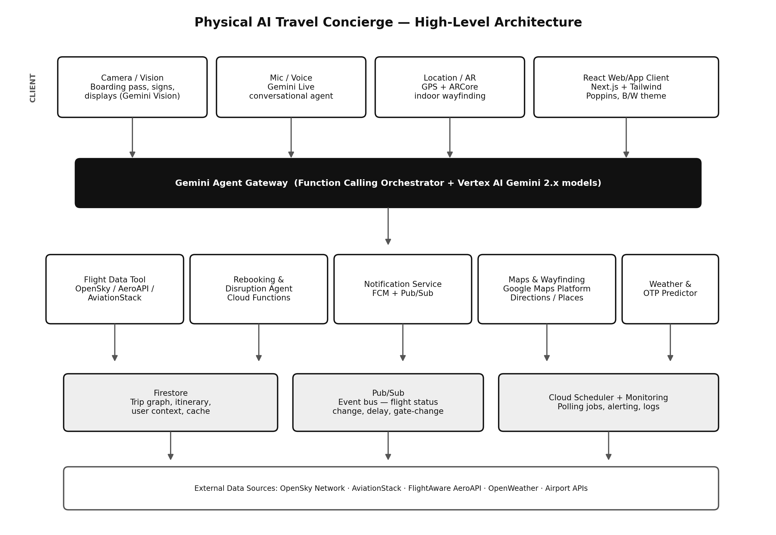
Figure 1 — AeroMind High-Level Architecture

6.1 Layer Responsibilities
- Client Layer: captures camera frames, microphone audio, and GPS/AR data; renders the React UI; maintains a local offline cache.
- Agent Gateway: a Vertex AI–hosted Gemini endpoint that receives multimodal input, maintains conversation/agent state, and issues function calls to backend tools.
- Tool Layer: stateless Cloud Functions, each wrapping one capability (flight lookup, rebooking, notification, maps, weather/OTP prediction) and exposed to Gemini as a callable function schema.
- Data & Eventing Layer: Firestore stores the itinerary graph and trip context; Pub/Sub carries status-change events between the polling layer and the agent; Cloud Scheduler triggers periodic polling of active flight legs.

7. Low-Level Design (LLD)

7.1 Firestore Data Model
Collection | Document Fields | Notes
users/{uid} | name, email, prefs{costVsTime, loyaltyPrograms, accessibilityMode}, homeAirport | Traveler profile & preferences used for ranking
trips/{tripId} | ownerUid, companions[], status, createdAt | Root of the digital-twin itinerary graph
trips/{tripId}/legs/{legId} | type(flight|hotel|car|meeting), flightNo, dep, arr, gate, status, disruptionScore, dependsOn[] | Graph node; dependsOn links form the dependency edges
trips/{tripId}/events/{eventId} | legId, eventType, payload, ts | Immutable audit log of every status change and agent action
trips/{tripId}/rebookingProposals/{id} | options[], rankScore, status(pending|approved|rejected) | Human-in-loop approval queue for agent actions
flightCache/{flightNo_date} | lastPosition, lastStatus, fetchedAt | Shared cache to reduce external API calls across users on the same flight

7.2 Gemini Function-Calling Schema (excerpt)
Each tool exposed to the Gemini agent is declared with a strict JSON schema. Representative examples:
- get_live_flight_status(flightNo, date): returns live position, gate, delay minutes, and disruption score — backed by OpenSky + AeroAPI.
- search_alternative_flights(origin, destination, notBefore, prefs): returns ranked candidate flights (cost, time, carbon, comfort).
- propose_rebooking(tripId, legId, chosenOptionId): writes a pendingapproval document; never books without a subsequent approve_rebooking call.
- approve_rebooking(proposalId): human-confirmed action; triggers the actual booking-API call and cascades updates to dependent legs.
- get_walking_eta(fromGate, toGate): Maps Platform indoor-directions wrapper used for whisper alerts and AR overlay.

7.3 Key Sequence — Disruption Detection to Resolution
- 1. Cloud Scheduler triggers a polling Cloud Function every N minutes for each active leg.
- 2. The function calls AeroAPI/OpenSky; if status or ETA changed materially, it publishes a flight.status.changed event to Pub/Sub.
- 3. A subscriber Cloud Function updates Firestore and, if the change is disruptive, invokes the Gemini agent with trip context.
- 4. The agent calls search_alternative_flights and, for the digital-twin graph, walks dependsOn edges to identify affected hotel/car/meeting nodes.
- 5. A single consolidated rebookingProposals document is created; FCM pushes a rich notification to the traveler and companions.
- 6. On approval, the agent executes booking calls, updates Firestore, appends an events record, and confirms via Gemini Live voice if the app is in foreground.

7.4 API Rate & Cost Controls
- Shared flightCache collection de-duplicates external API calls across all users tracking the same flight number/date.
- Adaptive polling interval tightens automatically as departure approaches (e.g., every 30 min → every 2 min inside the final hour).
- Disruption-score gating avoids invoking the (costlier) Gemini agent call unless the computed risk score or a real status delta crosses a threshold.

8. UI / UX Design System
The interface is deliberately monochrome, letting motion, typography, and iconography carry the personality rather than color — a distinctive, premium aesthetic that stands out against typical hackathon UIs.

8.1 Visual Language
- Palette: strict black & white system — pure black (#0A0A0A) and white (#FFFFFF) as primary surfaces, with a neutral grayscale ramp (5–7 steps) for depth, borders, and disabled states. No accent color; state is communicated via weight, motion, and icon shape, not hue.
- Themes: Light theme is primary/default (white surface, black text/icons); Dark theme is a full inversion (near-black surface, white text) — both share identical component geometry so switching is seamless.
- Typography: Poppins exclusively, across all weights (Light–SemiBold for body, Bold for display/headings), loaded via Google Fonts with `font-display: swap`.
- Component libraries: ReactBits and Lightswind UI supply animated primitives (cards, buttons, marquees, spotlight/hover effects); shadcn/ui supplies accessible base primitives (dialogs, sheets, forms) styled to match the monochrome system.
- Motion: Framer Motion drives page transitions (fade + slight vertical slide), scroll-triggered reveal animations, card hover-lift with soft shadow, and a live "pulse" animation on the disruption-score ring.
- Icons: Lucide, stroke-based, 1.5px weight, consistent with the linear monochrome aesthetic.

8.2 Key Screens
- Home / Trip Timeline: vertical digital-twin graph rendered as a connected timeline of cards (flight → hotel → car), each with live status chip and disruption-score ring.
- Flight Advisor: full-screen chat + voice interface with a live waveform indicator during Gemini Live sessions and inline citations back to data source and timestamp.
- Scan: camera viewfinder with animated corner-brackets and a Gemini Vision parsing shimmer while a boarding pass/sign is analyzed.
- AR Wayfinding: camera passthrough with animated directional arrow overlay and a walking-ETA vs boarding-time countdown bar.
- Rebooking Approval: a single card presenting the consolidated proposal (flight + hotel + car) with a prominent Approve action and a collapsible "See alternatives" comparison table.
- Trip Journal: auto-generated scrollable story layout with scroll-linked fade/parallax animations, shareable as a link or PDF.

9. Hackathon Demo Script (Suggested)
- 1. Scan a boarding pass on camera → itinerary auto-populates in Firestore in real time (Gemini Vision).
- 2. Ask the Flight Advisor aloud, "Is my flight going to be on time?" → live grounded answer with citation to OpenSky/AeroAPI data (Gemini Live + function calling).
- 3. Trigger a simulated delay event → watch the disruption score rise, the digital-twin graph highlight affected downstream legs, and a consolidated rebooking proposal arrive as a push notification within seconds.
- 4. Approve the rebooking with one tap → hotel and car legs update automatically; companion's phone receives a sync notification.
- 5. Walk the AR wayfinding view to the new gate with a live whisper alert countdown.
- 6. Close with the auto-generated Trip Journal — a strong emotional and visual closing beat for judges.

10. Risks & Mitigations
Risk | Mitigation
Free flight-tracking APIs (OpenSky) have rate limits / coverage gaps | Shared flightCache + fallback to AviationStack/AeroAPI; graceful degrade to last-known-good data with a clear "last updated" timestamp
Autonomous booking actions could be irreversible/costly if wrong | Strict human-in-loop approval gate before any booking API is called; full audit trail in events collection
Gemini Live latency in noisy airport environments | On-device VAD/noise suppression + fallback to text chat mode automatically
AR wayfinding accuracy indoors (no GPS) | Hybrid anchoring: Gemini Vision reads static wall signage as ground-truth waypoints to correct drift
Demo-day network reliability | Offline-first Firestore cache + a pre-seeded demo trip as fallback path

11. Why This Wins — Judging Alignment
- Technical depth: genuine multimodal fusion (vision + voice + location) with real agentic function calling and human-in-loop safety, not a UI wrapped around a single prompt.
- Novelty: predictive disruption scoring, cascading digital-twin re-planning, and AR wayfinding are not present in any existing consumer travel app.
- Real-world grounding: live open flight-tracking data (OpenSky) makes the demo verifiably real, not simulated.
- Polish: a distinctive, consistent monochrome design system with motion and Poppins typography signals product craft, not just a prototype.
- Inclusivity: the accessibility/emergency mode broadens impact beyond the average hackathon submission.

