RAZORPAY AI BUILDATHON 2026
Track 04 — AI Finance Controller
Ledgr
An Autonomous AI Finance Controller for Multi-Source Reconciliation, Settlement Intelligence & Cash-Flow Trust
Project Proposal & Technical Architecture Document
Version 1.0 · September 2026

Table of Contents

1. Executive Summary
Ledgr is an autonomous AI Finance Controller that closes the reconciliation, settlement-explanation, and cash-visibility loop for fintech operations — a problem that is still, in 2026, done largely by hand across Indian BFSI and D2C finance teams. We chose Razorpay's AI Finance Controller track deliberately: it is the track where a rigorously measured, honestly-reported system can be built end-to-end by a solo builder inside the buildathon window, and it sits at the exact center of Razorpay's own data — settlement files, gateway records, and merchant ledgers all have to agree with each other, and Razorpay generates a large share of that data itself.
Ledgr ingests multi-source financial records, normalizes them, matches them with a fine-tuned semantic embedding model plus deterministic rule verification, escalates anything below a confidence threshold to a GPT-OSS-120B reasoning agent served through Groq's low-latency inference, and produces an honest, auditable exception list — not a cherry-picked demo. Every decision is logged in a hash-chained audit trail so it can be defended to a finance controller, an auditor, or a Razorpay panel.
What we're building | Why it matters | Why we can win this track
A multi-source reconciliation + settlement Q&A + cash-forecasting agent, unified under one extensible architecture | Reconciliation is still manual at most fintechs; the 2026 builder consensus is that verification capacity, not generation speed, is the real bottleneck | We report an honest match-rate and exception list on a 50+ record synthetic batch, exactly as the track's stated bar demands — no cherry-picking

2. Problem Statement

2.1 The industry-grade problem
Every payment that flows through a gateway like Razorpay eventually has to be proven to match at least three other records: what the bank says settled, what the merchant's internal ledger says was owed, and what the tax/GST filing says was earned. These three views drift apart constantly — processing fees, partial refunds, currency rounding, delayed settlements, chargebacks, and simple data-entry inconsistency across systems that were never designed to talk to each other.
- Manual reconciliation: Finance teams at fast-growing fintechs and D2C merchants spend a disproportionate share of month-end close manually matching bank statements against gateway settlement reports in spreadsheets.
- Overdue receivables: B2B receivables and subscription renewals go overdue not because customers refuse to pay, but because no one has time to chase them systematically — quiet, compounding revenue leakage.
- Settlement opacity: Settlement questions (“why did I receive ₹9,940 instead of ₹10,000?”) are usually answered by a support ticket routed to a human, days later.
- Scale mismatch: As transaction volume grows, the exception list grows faster than headcount — reconciliation does not scale linearly with a manual process.
- Audit & compliance exposure: Every unresolved mismatch is a compliance and audit risk during GST filing, statutory audit, or SOC2/PCI review cycles.

2.2 Why this is Razorpay's problem, not just a merchant's
Razorpay's own buildathon brief names this directly — reconciliation, settlement and forecasting are still done by hand, and the 2026 builder consensus is that verification capacity, not generation speed, is the bottleneck. Razorpay sits at the exact center of this data: it generates the settlement files merchants are trying to reconcile against. A finance controller agent Razorpay can offer natively turns a merchant pain point into a Razorpay product surface — fewer settlement-mismatch support tickets, stickier merchants, and a defensible answer to the question every serious B2B fintech customer eventually asks: how do I trust your numbers against mine?

2.3 Where existing tools fall short
Existing approach | Limitation
Manual spreadsheet reconciliation | Slow, error-prone, doesn't scale, no audit trail beyond a shared sheet
Exact-match rule engines (legacy ERP tools) | Break the moment a reference ID, currency format, or date format shifts — brittle to real-world messiness
Generic RPA / OCR tools | Automate data entry, not judgment — they don't explain why something didn't match
Pure LLM-only agents with no verification layer | Fast but unreliable for money-movement decisions; hallucination risk is unacceptable without a deterministic backstop

3. Our Solution
Ledgr closes one finance-ops loop end to end — multi-source reconciliation — and is architected so the same pipeline extends naturally to settlement Q&A, cash forecasting, and tax-line matching without a redesign. Rather than building five shallow features, we go deep on one and show, in documentation and code structure, exactly how it generalizes.

3.1 Core capability (what we actually ship)
- Multi-source reconciliation engine: Given a batch of 50+ synthetic records from at least two independent sources (bank statement + gateway settlement file, or ledger + bank), automatically match records that refer to the same underlying transaction, even when identifiers, formatting, currency representation, or dates differ.
- Confidence-scored exception queue: Every match carries a confidence score. High-confidence matches auto-resolve; low-confidence matches are escalated to an LLM reasoning agent that explains, in plain language, why a match failed and what it would need to resolve.
- Settlement Q&A Agent: A conversational agent (GPT-OSS-120B via Groq) that answers natural-language questions about the reconciliation batch — “which transactions from Aug 28 are still unmatched?”, “why is this settlement short by ₹60?” — grounded strictly in the actual matched/unmatched data, not free-floating generation.
- Audit trail: Every ingestion, match, escalation, and resolution event is appended to a hash-chained log (each entry includes a hash of the previous entry), so the trail is tamper-evident and exportable for audit or compliance review.

3.2 How this extends to the other four tracks (documented, not separately built)
This is the honest version of “unified across tracks”: one architecture, one deeply-built core, with a clear technical story for how it generalizes — demonstrated in our documentation and code comments, not diluted across five shallow demos.
Track | How Ledgr's architecture extends to it
01 — Growth & Agentic Commerce | The same confidence-gated action pattern (auto-execute above threshold, escalate below) is the exact pattern needed for bounded, explainable agent-initiated commerce actions.
02 — Risk Manager | The anomaly scorer already flags statistically unusual transactions during reconciliation; the same feature pipeline is a fraud/chargeback signal generator with minimal rework.
03 — Revenue Recovery | Unmatched or partially-settled records surfaced by the reconciliation engine are, by definition, revenue at risk — the exception queue is a ready-made recovery worklist.
05 — Open Track | The Settlement Q&A agent's grounded-retrieval pattern generalizes to any finance-data question-answering surface a merchant or ops team might need.

4. Unique Architecture
Ledgr is built as a layered pipeline with a deliberate two-stage matching gate: fast deterministic and embedding-based matching handles the majority of records automatically, while a slower, more expensive LLM reasoning stage is reserved only for genuinely ambiguous cases. This is the core design decision that keeps the system both fast and reliable — most reconciliation systems either go too far in the deterministic direction (brittle, misses fuzzy matches) or too far in the LLM direction (slow, expensive, and less predictable at scale).
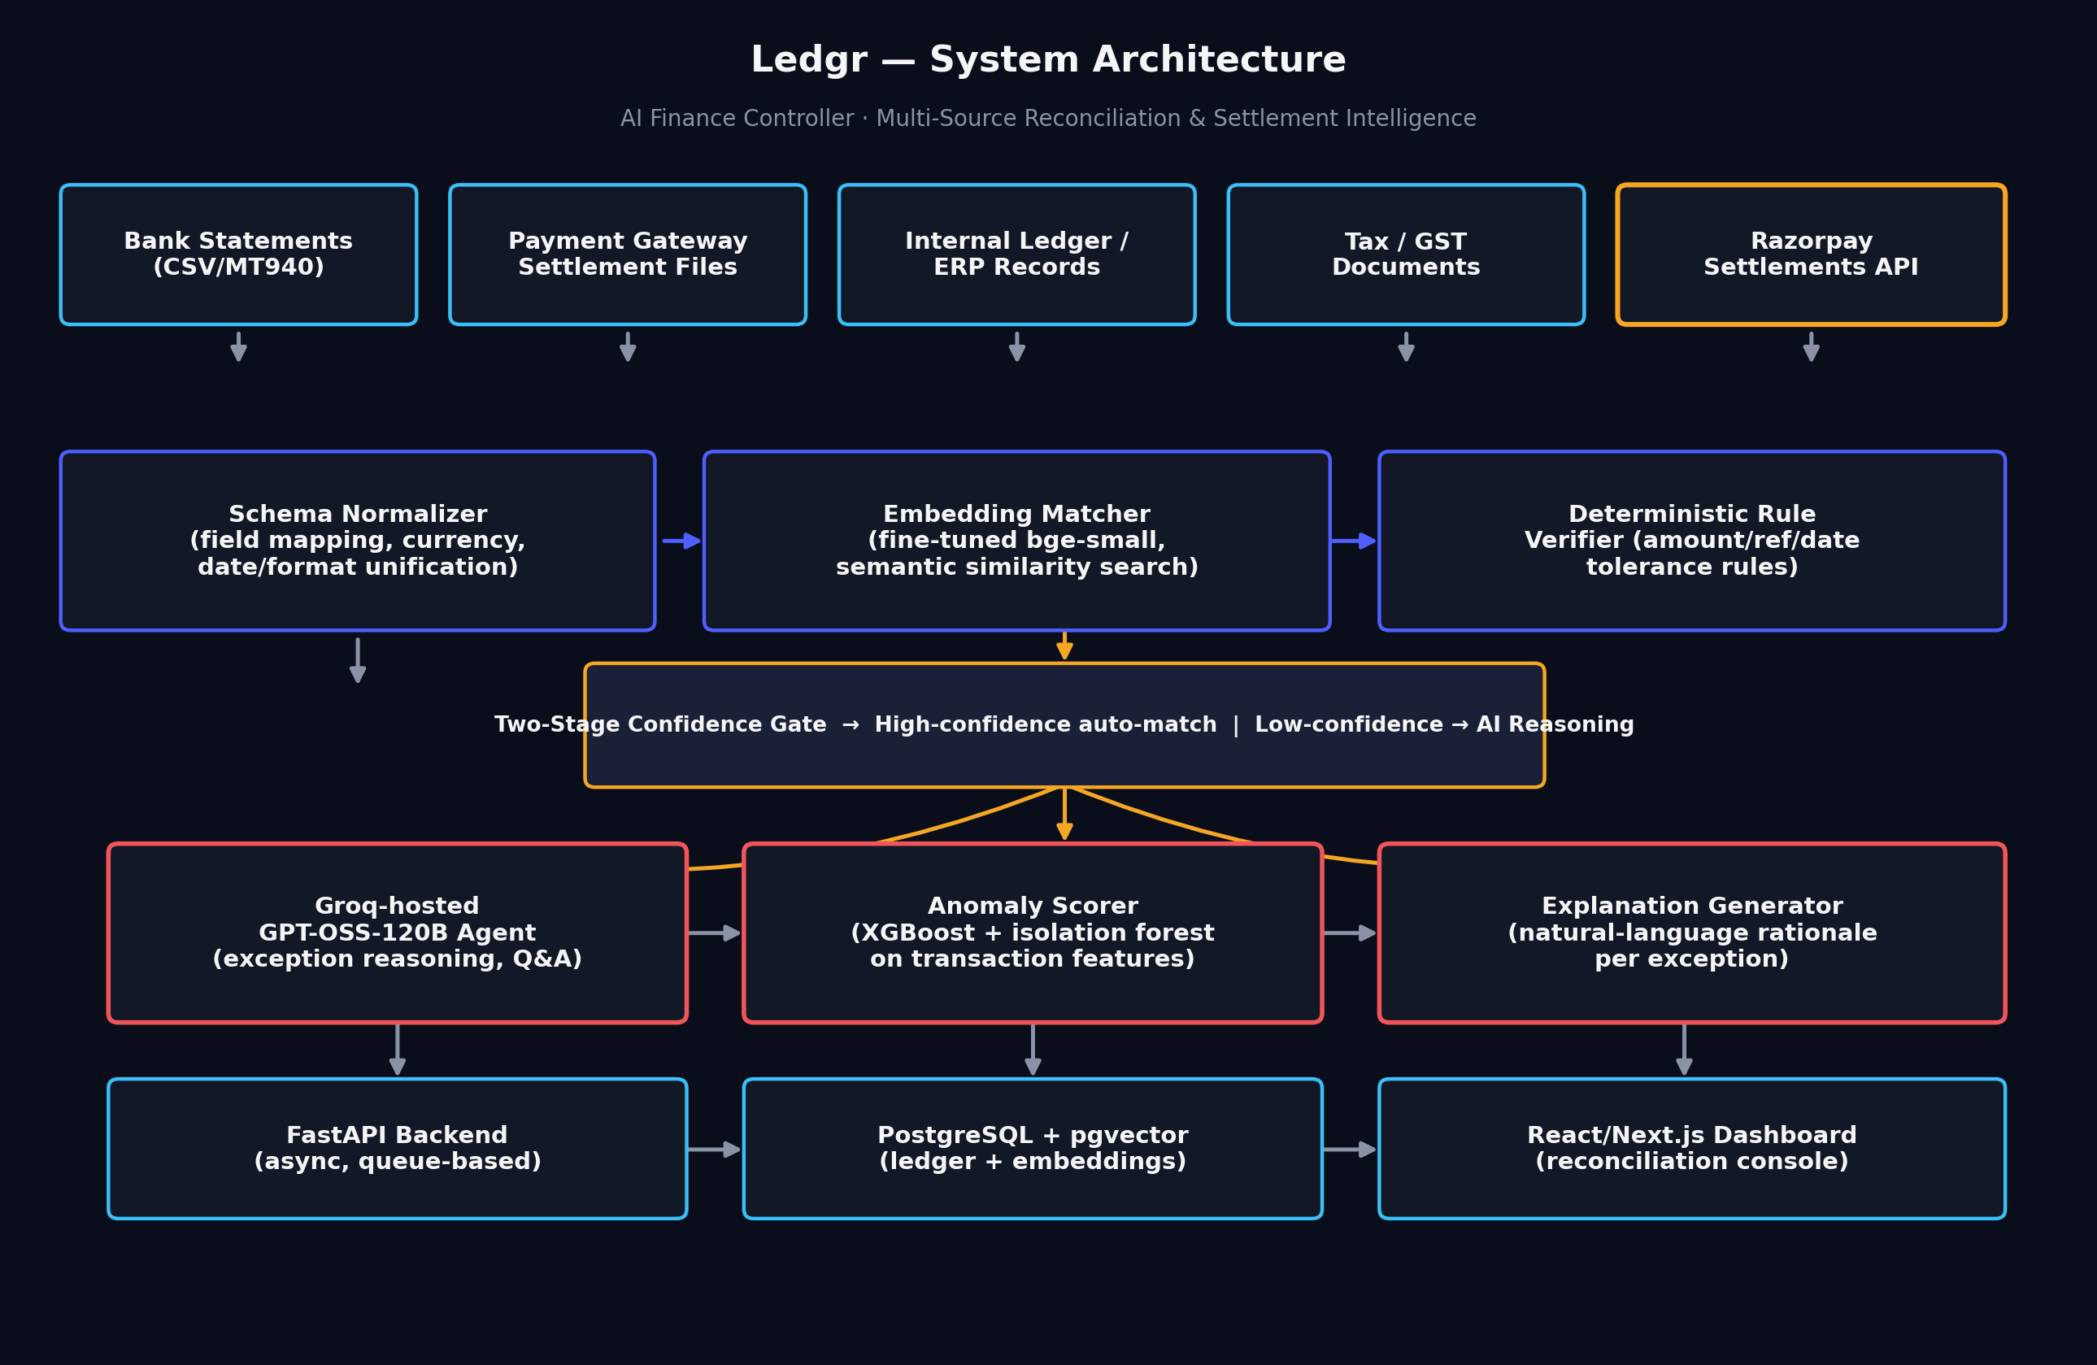
Figure 1 — Ledgr system architecture: ingestion → normalization → two-stage matching → AI reasoning → serving layer.

4.1 Design principle: the two-stage confidence gate
Records are first passed through schema normalization, then scored by a fine-tuned embedding model for semantic similarity and cross-checked by a deterministic rule verifier (amount tolerance, date window, reference substring matching). If both agree with high confidence, the match is auto-resolved — no LLM call needed, which keeps the common case fast and cheap. Only the ambiguous remainder (typically a small fraction of the batch) is escalated to the GPT-OSS-120B reasoning agent, which explains the mismatch in natural language and proposes a resolution, which a human reviewer confirms.
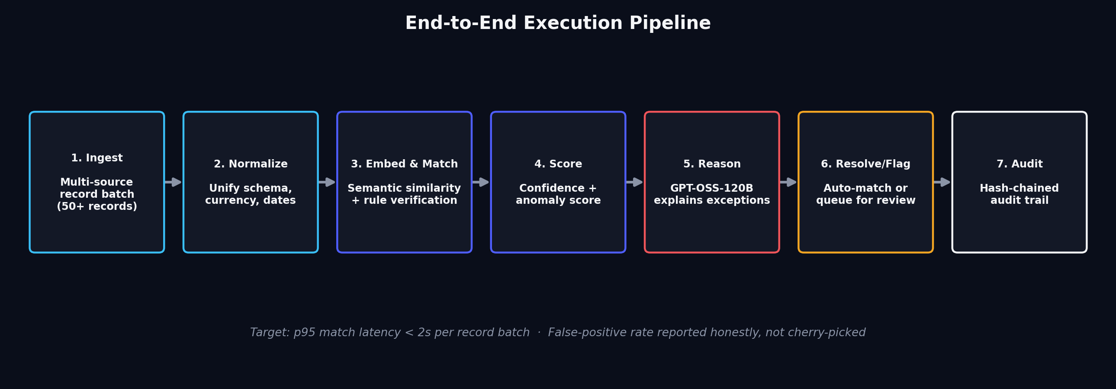
Figure 2 — End-to-end execution pipeline, from ingestion to hash-chained audit log.

5. Technical Stack

5.1 AI / ML layer
Component | Model / Approach | Purpose
Semantic matcher | BAAI/bge-small-en-v1.5 (open-source embedding model), fine-tuned with LoRA on synthetic transaction-description pairs | Matches records across sources despite differing text formatting, abbreviations, and merchant naming
Anomaly / risk scorer | XGBoost classifier + Isolation Forest, trained on engineered transaction features | Flags statistically unusual records for closer review; extends directly into the Risk Manager track
Reasoning & Q&A agent | openai/gpt-oss-120b served via Groq's inference API (LPU-based, low latency) | Explains exceptions in natural language, answers grounded settlement questions, proposes resolutions
Rule verifier | Deterministic Python rules engine (no ML) | Backstops the embedding matcher with amount-tolerance, date-window, and reference-substring checks — this is what keeps false positives low
Why fine-tune bge-small instead of using a bigger model
bge-small is small enough to fine-tune and run inference on a single consumer GPU (RTX 3050, 6GB VRAM) with LoRA adapters, keeping the embedding step fast and fully local — no API cost or network latency for the high-volume matching stage. We reserve the expensive, high-capability model (GPT-OSS-120B via Groq) only for the genuinely hard cases that need reasoning, not pattern matching. This split is deliberate: it is the main reason Ledgr can hit low latency and low cost at the same time.

5.2 Datasets
Dataset | Use | Source
PaySim (Synthetic Financial Dataset for Fraud Detection) | Base transaction distribution and realistic amount/timing patterns for synthetic ledger generation | kaggle.com/datasets/ealaxi/paysim1
Bank Transaction Data / Reconciliation-style CSVs | Structural reference for bank-statement schema variety (MT940-style fields, multi-bank formats) | kaggle.com/datasets/apoorvwatsky/bank-transaction-data
Credit Card Fraud Detection Dataset (ULB) | Anomaly-scoring feature engineering reference and class-imbalance handling technique validation | kaggle.com/mlg-ulb/creditcardfraud
Custom synthetic multi-source ledger generator (our own script) | Primary evaluation dataset: 50+ paired records across bank / gateway / internal-ledger views with deliberately injected mismatches, fee deductions, and formatting drift | Generated in-repo — see /data/generate_synthetic.py
We deliberately generate our own synthetic multi-source batch rather than relying solely on a single public dataset, because the track's bar explicitly requires reporting match rate and an honest exception list on a batch we control end to end — this lets us inject known ground-truth mismatches and verify our reported accuracy is real, not incidental.

6. Full-Stack Development & Deployment
Layer | Technology | Notes
Frontend | Next.js 14 (React) + TypeScript + Tailwind CSS + shadcn/ui | Server components for fast initial load; shadcn/ui gives accessible primitives we skin with our own design tokens
Animation | Framer Motion (lightweight scroll/entry transitions) | Deliberately not full GSAP-scale choreography — kept light so it never competes with build time on the actual AI pipeline
Backend API | FastAPI (Python, async) | Matches our ML stack directly; async endpoints keep p95 latency low under concurrent batch processing
Task queue | Redis + RQ / Celery | Batch reconciliation jobs run asynchronously; UI polls or subscribes via WebSocket for live progress
Database | PostgreSQL + pgvector extension | Single database for both relational ledger data and vector embeddings — avoids running a separate vector DB for a buildathon-scale system
LLM inference | Groq API (openai/gpt-oss-120b) | Chosen specifically for inference latency — Groq's LPU-based serving returns tokens far faster than typical GPU-hosted inference, which matters for a responsive Q&A agent
Local ML inference | PyTorch + sentence-transformers, runs on RTX 3050 (6GB) via LoRA-adapted bge-small | Keeps the high-volume matching stage local, fast, and free of per-call API cost
Containerization | Docker + docker-compose for local dev parity | Same containers run locally and in deployment — reduces “works on my machine” risk before the panel demo
Deployment | Frontend on Vercel; backend + workers on Railway/Render; Postgres managed instance | Zero-downtime deploys, environment-variable-based secrets, all reachable via public HTTPS for the panel to test live
CI | GitHub Actions — lint, type-check, run the evaluation script against the synthetic batch on every push | Keeps our reported match-rate honest and reproducible, not a one-off manual run

7. How Razorpay Can Integrate This
Ledgr is designed to slot into Razorpay's existing surfaces rather than compete with them — as an internal reconciliation microservice, a Razorpay X add-on, or a merchant-facing widget embedded in the existing Dashboard.
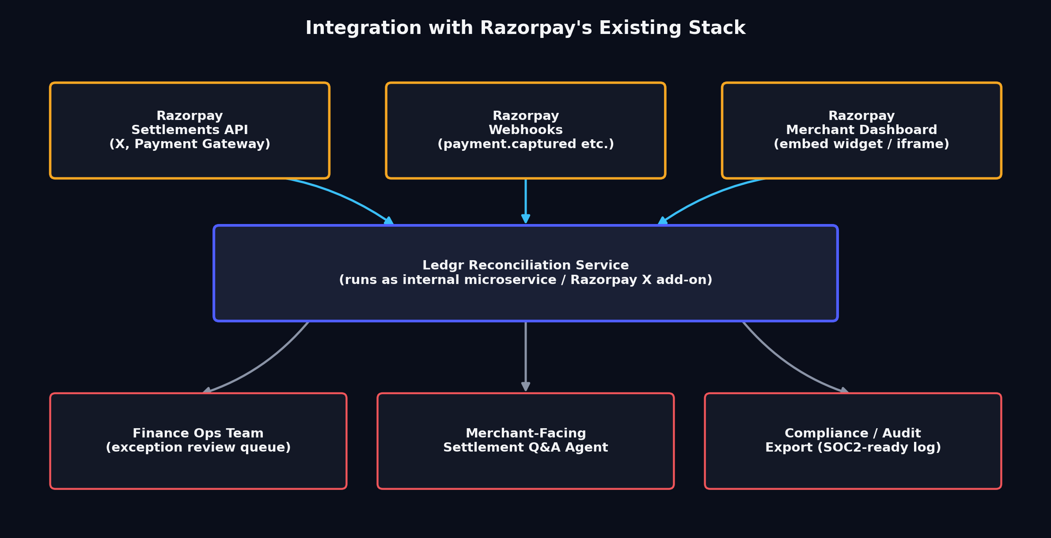
Figure 3 — Integration points with Razorpay's existing Settlements API, webhooks, and merchant dashboard.

7.1 Integration paths
- Webhook-driven ingestion: Ledgr subscribes to payment.captured, payment.failed, settlement.processed and similar events instead of polling, keeping reconciliation near-real-time as settlements land.
- Settlements API as a native source: Rather than requiring merchants to export files, Ledgr pulls settlement records directly from Razorpay's existing Settlements API, removing a manual export/import step entirely.
- Embeddable dashboard widget: The reconciliation console and exception queue can be embedded as a panel or iframe inside the existing Razorpay merchant Dashboard, so finance teams don't need to context-switch to a separate tool.
- Compliance/audit export: For enterprise merchants with strict compliance needs, the hash-chained audit trail exports in a SOC2-review-ready format, positioning this as a trust feature Razorpay can sell into its larger accounts.

7.2 Why this is a strategic fit, not just a technical one
Settlement confusion is one of the most common sources of merchant support tickets at any payment gateway. A native reconciliation layer reduces that support load, increases merchant trust in Razorpay's numbers, and creates a natural upsell surface (advanced reconciliation as part of Razorpay X or a premium finance-ops tier) — turning a cost center (support tickets) into a product opportunity.

8. Why Groq + GPT-OSS-120B
The reasoning agent is the one part of Ledgr where raw local GPU capacity (6GB) is not enough — GPT-OSS-120B is far too large to run locally. We use Groq's API specifically, rather than a standard GPU-hosted API, for a concrete architectural reason: Groq's LPU (Language Processing Unit) inference infrastructure is built for extremely low per-token latency, which matters directly for our two use cases:
- Interactive Settlement Q&A: A finance ops user asking “why didn't this settlement match?” expects a near-instant answer, not a multi-second wait — Groq's low time-to-first-token keeps the Q&A agent feeling conversational rather than batch-like.
- Exception-explanation throughput: During a batch reconciliation run, every low-confidence match may need an LLM explanation. Fast per-call latency means the exception queue populates with explanations quickly instead of trickling in, which is directly visible in a live demo.
Implementation detail
The agent is called through Groq's OpenAI-compatible chat completions endpoint, using the model string openai/gpt-oss-120b, with the API key managed as a server-side environment variable (never exposed client-side). We constrain the agent with a strict system prompt and function-style structured output (JSON mode) so its explanations are grounded in the actual matched/unmatched record data passed into context — not free-floating generation — which is essential for a finance-facing tool where hallucinated explanations would be actively harmful.
Reliability guardrail
Every LLM call includes a timeout and a deterministic fallback: if Groq is unreachable or a response fails schema validation, the record is flagged for manual review with a clear “AI explanation unavailable” label rather than silently failing or fabricating an answer. This is a small detail, but it is exactly the kind of honest failure-handling the buildathon brief explicitly asks builders to show.

9. Step-by-Step Execution Plan
Timeline scoped against the buildathon submission window, assuming a solo builder working with focused daily blocks rather than continuous availability.
Phase | Tasks | Deliverable
Day 1 — Foundation | Set up repo, Docker, Postgres+pgvector, FastAPI skeleton, Next.js skeleton; write synthetic multi-source data generator | Working local dev environment + first synthetic batch
Day 2 — Matching core | Fine-tune bge-small with LoRA on synthetic transaction-description pairs; implement deterministic rule verifier; wire the two-stage confidence gate | Working matcher with measurable match-rate on the synthetic batch
Day 3 — AI reasoning layer | Integrate Groq API + GPT-OSS-120B; build grounded prompt/JSON schema for exception explanations; implement timeout + fallback handling | Exception queue populated with real, grounded explanations
Day 4 — Frontend build | Build landing page (Ramos-inspired hero/sections) and reconciliation dashboard (exception queue, match detail view, audit trail view); wire light/dark theme | Deployed, navigable UI connected to live backend
Day 5 — Anomaly scoring + hardening | Train XGBoost/Isolation Forest anomaly scorer; add hash-chained audit logging; write evaluation script reporting honest match-rate + false-positive cost | Full pipeline producing honest, reproducible metrics
Day 6 — Polish & extension story | Write architecture documentation explaining extension to the other four tracks; record one deliberately-induced failure case and its recovery; finalize README | Submission-ready repo + documentation
Day 7 — Pitch & submission | Record 5-minute pitch video (problem → architecture → live demo → metrics → failure handling → extension story); final QA pass; submit | Public repo + pitch video + architecture doc submitted

10. Frontend Technology, Build & Design System

10.1 Design direction
The landing page follows the layout structure and typographic confidence of the Ramos analytics-SaaS template we studied for inspiration — big stat callouts, floating dashboard-mockup cards, warm confident typography, generous negative space — while the actual working dashboard (reconciliation console, exception queue, audit trail) uses a denser, data-forward layout closer to Linear or a modern fintech admin console. Both share one token-based design system so the transition from landing page to live product feels like one product, not two.

10.2 Color system — dual light/dark theme
We deliberately move away from default “fintech blue”, which is the single most common color choice in this space and risks blending into every other reconciliation/finance submission. Instead we use an indigo-led palette with functional amber/coral accents that do real semantic work in the UI (not just decoration) — amber and coral map directly onto the exception-severity system the product needs anyway.
Token | Dark mode | Light mode | Purpose
Background | #0A0E1A | #FAFAFC | App base
Surface / card | #131826 | #FFFFFF | Cards, panels, table rows
Primary / brand | #4F5EFF (indigo) | #4338CA | CTAs, links, brand elements, primary charts
Secondary data | #3ABFF8 (cyan) | #0E7C9E | Secondary metrics, healthy-state indicators
Warning / exception | #F5A623 (amber) | #B5720A | Low-confidence matches, flagged records needing review
Critical / mismatch | #F0555A (coral) | #C23B3F | Confirmed mismatches, failed matches — reserved, used sparingly
Text primary | #F4F5F7 | #1A1F2E | Body copy, headings
Text muted | #8A93A6 | #6B7280 | Captions, timestamps, secondary labels

10.3 Frontend build stack
- Framework: Next.js 14 (App Router) + TypeScript — chosen for fast static landing-page delivery and server components for dashboard data fetching.
- Styling: Tailwind CSS with a custom token config mapping directly to the color table above, so light/dark mode is a single class toggle, not two separate stylesheets.
- Components: shadcn/ui as the accessible component base (tables, dialogs, dropdowns), restyled with our tokens rather than used with default styling — avoids the generic “shadcn look” most submissions will have.
- Motion: Framer Motion for restrained scroll-in and hover transitions on the landing page — enough to feel alive, deliberately not full GSAP scroll-jacking, so build time stays on the AI pipeline rather than animation choreography.
- Charts: Recharts for match-rate trends and exception-volume charts — lightweight, composable, and reads cleanly on both themes.

10.4 Landing page structure (adapted from the Ramos reference)
- Hero section: Hero with a confident, colored-emphasis headline (“Reconciliation that finally keeps up”), a floating dashboard-mockup card showing a live-looking match-rate stat.
- Proof-point row: Three stat cards — match rate, average resolution time, exceptions auto-explained — mirroring the Ramos template's “45% / +30% / 43K” stat-card pattern but with our own metrics.
- Product showcase: Side-by-side device mockups showing the reconciliation console and the Settlement Q&A agent mid-conversation.
- Get started section: A simple CTA row linking straight to the live deployed dashboard so a panel reviewer can try it immediately, no signup wall.

11. Unique Features & USPs — What We're Bringing on Top
These are the specific, deliberate choices that go beyond “a classifier that matches records” and are what we want a panel to notice in the repo and the demo.
- 1. Two-stage confidence gate (not just “LLM does everything”): The confidence gate isn't a single threshold — it combines embedding similarity AND a deterministic rule check, and only escalates to the LLM when they disagree or both are uncertain. This is the specific mechanism that keeps false positives low without needing an expensive LLM call on every record.
- 2. Explainable exceptions, not just flagged ones: Every exception comes with a plain-language explanation grounded in the actual record data — not a generic “no match found”, but “this looks like transaction TXN4471 minus a ₹12 gateway fee, settled one day late — confidence 71%, below auto-match threshold.” This is the difference between an exception list and a system a finance ops person can actually act on.
- 3. Cryptographically hash-chained audit trail: Each log entry includes a hash of the previous entry, so the reconciliation history is tamper-evident — directly usable in a compliance or audit conversation, and a concrete answer to “how do we trust the AI's decisions?”
- 4. Honest, demonstrated failure handling: We deliberately induce and document at least one real failure case (e.g., a malformed date format from a legacy bank export) and show the system degrading gracefully — flagging for manual review instead of silently mismatching — directly answering the brief's explicit ask to show one failure handled gracefully.
- 5. Hinglish-aware Q&A agent: The Settlement Q&A agent understands mixed Hindi-English finance queries (“yeh transaction match kyu nahi hua?”), reflecting how Indian finance-ops teams actually communicate — a detail most solo builders won't think to include.
- 6. Deliberate local/cloud split, not an API-only wrapper: Local embedding matching (fast, free, private) is paired with cloud LLM reasoning only for the hard cases — an architecture choice we can defend on cost, latency, and data-privacy grounds, not just “we had a GPU so we used it.”
- 7. Reproducible, CI-verified metrics: Every reported number — match rate, false-positive cost, latency — comes from a CI-run evaluation script against our synthetic batch, reproducible by anyone who clones the repo, not a screenshot from one lucky run.

12. Engineering for Low Latency, Low False Positives, and Reliability

12.1 Latency
- Local-first matching: The high-volume matching stage runs locally (bge-small + rule verifier), avoiding network round-trips for the majority of records; only the minority needing reasoning calls out to Groq, whose LPU-based serving keeps that call fast too.
- Async processing: Batch reconciliation jobs run through Redis-backed workers so the UI stays responsive and the user gets live progress rather than a blocking request.
- p95 latency tracked, not just average: We track and report p95 match latency per record as an explicit metric in our evaluation script, not just an average that can hide tail-latency problems.

12.2 False positives
- Dual-signal requirement: A record only auto-matches when both the embedding similarity model and the deterministic rule verifier agree above threshold — disagreement always routes to human-visible review rather than silently auto-matching.
- Cost-weighted evaluation: We report false-positive cost (not just false-positive rate) — an incorrect auto-match is weighted more heavily than an incorrect flag-for-review, since the former is the actually dangerous failure mode in a finance system.
- Threshold tunability: The confidence threshold is a configurable parameter, not a hardcoded constant, so it can be tuned toward precision or recall depending on the deployment's risk tolerance.

12.3 Backend reliability
- Containerized parity: Docker containers ensure the same environment runs locally, in CI, and in deployment.
- Timeout + fallback everywhere: Every external call (Groq API, database) is wrapped with a timeout and a defined fallback behavior — the system degrades to “flag for manual review” rather than crashing or hanging.
- CI on every push: GitHub Actions re-runs the evaluation script on every push, catching regressions in match rate or latency before they reach the demo.

13. Business Impact & Impact on Common People

13.1 For Razorpay
- Fewer merchant support tickets about settlement mismatches — a direct operational cost saving.
- A defensible trust feature for enterprise merchants evaluating Razorpay against competitors on finance-ops maturity.
- A natural upsell surface within Razorpay X or a premium finance-ops tier.

13.2 For merchants and finance teams
- Finance teams get their month-end close time back — time currently spent manually matching spreadsheets can go toward actual financial analysis and decision-making.
- Small and mid-size merchants without a dedicated finance-ops headcount get controller-grade reconciliation without hiring for it.

13.3 For everyday people
This is less visible but real: faster, more reliable reconciliation means fewer delayed payouts to gig workers, small sellers, and freelancers whose income depends on settlement accuracy. When a small business's finance team can trust its numbers quickly, that business can pay its own people, suppliers, and taxes on time — the effect compounds outward from what looks like a purely back-office tool.

14. Future Work, Roadmap & Scaling Plan
Horizon | Planned work
Near-term (post-buildathon) | Extend the confidence-gate pattern to the Revenue Recovery use case (unmatched records → recovery worklist); add a forward cash-forecasting module using historical settlement patterns; expand the rule verifier's coverage of edge cases (multi-currency, partial refunds, split settlements).
Mid-term | Fine-tune a larger open-source embedding model (bge-base or bge-large) as volume grows past what bge-small handles comfortably; add a feedback loop where human corrections on flagged exceptions retrain the matcher periodically; multi-tenant support for agencies/accountants managing reconciliation for multiple merchants.
Long-term / scaling | Move local embedding inference to a small managed GPU fleet as transaction volume scales beyond a single machine; introduce tiered SLAs (real-time reconciliation for enterprise, batch for SMB) to control cost at scale; pursue SOC2 Type II readiness for the audit-trail export, formalizing it as a compliance product.

14.1 Target users, in order of rollout
- Phase 1: Mid-size D2C and B2B merchants on Razorpay already producing enough transaction volume that spreadsheet reconciliation is visibly breaking down.
- Phase 2: Accounting/finance-ops agencies managing reconciliation for multiple merchant clients — multi-tenant support unlocks this segment.
- Phase 3: Enterprise merchants needing SOC2-grade audit trails as part of procurement/compliance requirements.

15. Why Ledgr Should Be Selected
We are not submitting a generic fraud classifier or a thin LLM wrapper. Ledgr is a specific, defensible architectural bet — a two-stage confidence gate that keeps the system fast and cheap for the common case, reserves expensive reasoning for genuinely hard cases, and reports honest, reproducible metrics instead of a cherry-picked demo. Every choice in this document — the local/cloud model split, the hash-chained audit trail, the Hinglish-aware agent, the deliberately induced failure case — is there because it answers something the buildathon brief explicitly asks for, not because it looks impressive in isolation.
“Throughput plus measured accuracy plus an honest exception list. One cherry-picked match proves nothing.” — Razorpay AI Buildathon, Track 04 brief
That line is the bar we built against from day one. When a panel opens our repo, they will find a CI-verified evaluation script, a synthetic dataset with known ground truth, a documented failure case, and an architecture that visibly generalizes to three other tracks without having been shallowly rebuilt for each one. That is the version of “unified” we believe actually holds up under a panel's questions.
Ledgr — Build. Show. Get hired.

