A Seminar Report on

MACHINE TRANSLATION

In the partial fulfillment for the degree of B.Tech.

Seminar (8CS9)

JIET School of Engineering & Technology for Girls
Department of Computer Science & Engineering
<2014-2015>

Guided By: - Submitted By: - Prof. Kamna Agarwal Ms Meenakshi Soni Asst. Professor IV Year (VIII Semester)
ACKNOWLEDGEMENT

It is a matter of great pleasure for me to submit this report on MACHINE LEARNING, as a part of curriculum for award of BACHELOR’S IN TECHNOLOGY (CSE) degree of Rajasthan Technical University, Kota (Rajasthan).
At this moment of accomplishment, I am presenting my work with great pride and pleasure, I would like to express my sincere gratitude to all those who helped me in the successful completion of my venture. I would like to thank our PROF.KAMNA AGARWAL for helping me in the successful accomplishment of my study and for her timely and valuable suggestions. His constructive criticism has contributed immensely to the evolution of my ideas on the subject.
I am exceedingly grateful to my Head of Department PROF. MAMTA GARG and other faculty members for their inspiration and encouragement. I would also like to thank my parents and friends for their over whelming and whole hearted encouragement and support without which this would not have been successful.

MEENAKSHI SONI

JIET SCHOOL OF ENGINEERING & TECHNOLOGY FOR GIRLS, JODHPUR
DEPARTMENT OF COMPUTER SCIENCE & ENGINEERING

CERTIFICATE

This is to certify that the report entitled “MACHINE LEARNING” has been carried out by MEENAKSHI SONI under my guidance in partial fulfillment of the degree of Bachelor of Technology in COMPUTER SCIENCE & ENGINEERING of Rajasthan Technical University, Kota during the academic year 2012-2013.

(Prof. Kammna Agarwal)
Lecturer Examiner

(Prof. Mamta Garg)
Head of Department
CSE

ABSTRACT
Present day computer applications require the representation of huge amount of complex knowledge and data in programs and thus require tremendous amount of work. Our ability to code the computers falls short of the demand for applications. If the computers are endowed with the learning ability, then our burden of coding the machine is eased (or at least reduced). This is particularly true for developing expert systems where the "bottle-neck" is to extract the expert’s knowledge and feed the knowledge to computers. The present day computer programs in general (with the exception of some Machine Learning programs) cannot correct their own errors or improve from past mistakes, or learn to perform a new task by analogy to a previously seen task. In contrast, human beings are capable of all the above. Machine Learning will produce smarter computers capable of all the above intelligent behavior.

The area of Machine Learning deals with the design of programs that can learn rules from data, adapt to changes, and improve performance with experience. In addition to being one of the initial dreams of Computer Science, Machine Learning has become crucial as computers are expected to solve increasingly complex problems and become more integrated into our daily lives. This is a hard problem, since making a machine learn from its computational tasks requires work at several levels, and complexities and ambiguities arise at each of those levels.

So, here we study how the Machine learning take place, what are the methods, remedies associated, applications, present and future status of machine learning.

Index
ACKNOWLEDGEMENT
CERTIFICATE
ABSTRACT
Chapter 1 Introduction to Machine Learning 6
1.1 WHY MACHINE LEARNING?
Chapter 2 Learning means? 9
2.1 THE ARCHITECTURE OF A LEARNING AGENT
Chapter 3 History of Machine leaning 12
3.1 The Neural Modeling (Self Organized System)
3.2 The Symbolic Concept Acquisition Paradigm
3.3 The Modern Knowledge-Intensive Paradigm
Chapter 4 Wellsprings of Machine Learning 14
4.1 Statistics
4.2 Brain Models
4.3 Adaptive Control Theory
4.4 Psychological Models
4.5 Artificial Intelligence
4.6 Evolutionary Models
Chapter 5 Machine Learning Overview 16
5.1 The Aim of Machine Learning
5.2 Machine Learning as a Science
Chapter 6 Classification of Machine Learning 18
Chapter 7 Types of Machine Learning Algorithms 21
7.1 Algorithm Types
7.2 Machine Learning Applications
7.3 Examples of Machine Learning Problems
Chapter 8 Future Directions 28
8.1 Conclusions
REFERENCES 30

Chapter 1
Introduction to Machine Learning

Machine Learning (ML) is the computerized approach to analyzing computational work that is based on both a set of theories and a set of technologies. And, being a very active area of research and development, there is not a single agreed-upon definition that would satisfy everyone, but there are some aspects, which would be part of any knowledgeable person’s definition. The definition mostly offers is:

Definition: Ability of a machine to improve its own performance through the use of a software that employs artificial intelligence techniques to mimic the ways by which humans seem to learn, such as repetition and experience.
Machine Learning (ML) is a sub-field of Artificial Intelligence (AI) which concerns with developing computational theories of learning and building learning machines. The goal of machine learning, closely coupled with the goal of AI, is to achieve a thorough understanding about the nature of learning process (both human learning and other forms of learning), about the computational aspects of learning behaviors, and to implant the learning capability in computer systems. Machine learning has been recognized as central to the success of Artificial Intelligence, and it has applications in various areas of science, engineering and society.
1.1 WHY MACHINE LEARNING?
To answer this question, we should look at two issues:
(1).What are the goals of machine learning;
(2). Why these goals are important and desirable.
1.1.1 The Goals of Machine Learning.
The goal of ML, in simples words, is to understand the nature of (human and other forms of) learning, and to build learning capability in computers. To be more specific, there are three aspects of the goals of ML.
(1) To make the computers smarter, more intelligent. The more direct objective in this aspect is to develop systems (programs) for specific practical learning tasks in application domains.
(2) To develop computational models of human learning process and perform computer simulations. The study in this aspect is also called cognitive modeling.
(3) To explore new learning methods and develop general learning algorithms independent of applications.
1.1.2 Why the goals of ML are important and desirable.
It is self-evident that the goals of ML are important and desirable. However, we still give some more supporting argument to this issue.
First of all, implanting learning ability in computers is practically necessary. Present day computer applications require the representation of huge amount of complex knowledge and data in programs and thus require tremendous amount of work. Our ability to code the computers falls short of the demand for applications. If the computers are endowed with the learning ability, then our burden of coding the machine is eased (or at least reduced). This is particularly true for developing expert systems where the "bottle-neck" is to extract the expert’s knowledge and feed the knowledge to computers. The present day computer programs in general (with the exception of some ML programs) cannot correct their own errors or improve from past mistakes, or learn to perform a new task by analogy to a previously seen task. In contrast, human beings are capable of all the above. ML will produce smarter computers capable of all the above intelligent behavior.
Second, the understanding of human learning and its computational aspect is a worthy scientific goal. We human beings have long been fascinated by our capabilities of intelligent behaviors and have been trying to understand the nature of intelligence. It is clear that central to our intelligence is our ability to learn. Thus a thorough understanding of human learning process is crucial to understand human intelligence. ML will gain us the insight into the underlying principles of human learning and that may lead to the discovery of more effective education techniques. It will also contribute to the design of machine learning systems.
Finally, it is desirable to explore alternative learning mechanisms in the space of all possible learning methods. There is no reason to believe that the way human being learns is the only possible mechanism of learning. It is worth exploring other methods of learning which may be more efficient, effective than human learning.
We remark that Machine Learning has become feasible in many important applications (and hence the popularity of the field) partly because the recent progress in learning algorithms and theory, the rapidly increase of computational power, the great availability of huge amount of data, and interests in commercial ML application development.
Moreover we note that ML is inherently a multi-disciplinary subject area.
We compare the human learning with machine learning along the dimensions of speed, ability to transfer, and others. which shows that machine learning is both an opportunity and challenge, in the sense that we can hope to discover ways for machine to learn which are better than ways human learn (the opportunity), and that there are amply amount of difficulties to be overcome in order to make machines learn (the challenge).
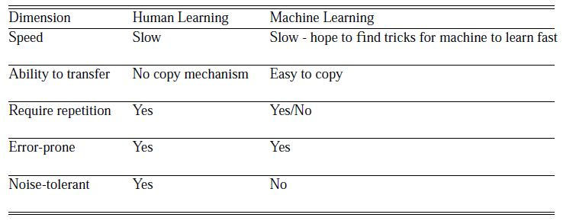

Chapter 2
Learning means?

Learning is a phenomenon and process which has manifestations of various aspects. Roughly speaking, learning process includes (one or more of) the following:
(1) Acquisition of new (symbolic) knowledge. For example, learning mathematics is this kind of learning. When we say someone has learned math, we mean that the learner obtained descriptions of the mathematical concepts, understood their meaning and their relationship with each other. The effect of learning is that the learner has acquired knowledge of mathematical systems and their properties, and that the learner can use this knowledge to solve math problems. Thus this kind of learning is characterized as obtaining new symbolic information plus the ability to apply that information effectively.
(2) Development of motor or cognitive skills through instruction and practice. Examples of this kind of learning are learning to ride a bicycle, to swim, to play piano, etc. This kind of learning is also called skill refinement. In this case, just acquiring a symbolic description of the rules to perform the task is not sufficient, repeated practice is needed for the learner to obtain the skill. Skill refinement takes place at the subconscious level.
(3) Refinement and organization of knowledge into more effective representations or more useful form. One example of this kind of learning can be reorganization of the rules in a knowledge base such that more important rules are given higher priorities so that they can be used more easily and conveniently.
(4) Discovery of new facts and theories through observation and experiment. For example, the discovery of physics and chemistry laws.
The general effect of learning in a system is the improvement of the system’s capability to solve problems. It is hard to imagine a system capable of learning cannot improve its problem-solving performance. A system with learning capability should be able to do self-changing in order to perform better in its future problem-solving.
We also note that learning cannot take place in isolation: We typically learn something (knowledge K) to perform some tasks (T), through some experience E, and whether we have learned well or not will be judged by some performance criteria P at the task T. For example, as Tom Mitchell put it in his ML book, for the "checkers learning problem", the task T is to play the game of checkers, the performance criteria P could be the percentage of games won against opponents, and the experience E could be in the form playing practice games with a teacher (or self). For learning to take place, we do need a learning algorithm A for self-changing, which allows the learner to get experience E in the task T, and acquire knowledge K (thus change the learner’s knowledge set) to improve the learner’s performance at task T.
Learning = Improving performance P at task T by
acquiring knowledge K using self-changing algorithm
A through experience E in an environment for
task T.

There are various forms of improvement of a system’s problem-solving ability:
(1) To solve wider range of problems than before - perform generalization.
(2) To solve the same problem more effectively - give better quality solutions.
(3) To solve the same problem more efficiently - faster.
There are other view points as to what constitutes the notion of learning. For example,
Minsky gives a more general definition,
"Learning is making useful changes in our minds".

McCarthy suggests,
"Learning is constructing or modifying representations of what is being experienced."
Simon suggests,
“Learning denotes changes in the system that are adaptive in the sense that they enable the system to do the same task or tasks drawn from the same population more effectively the next time”.
From this perspective, the central aspect of learning is acquisition of certain forms of representation of some reality, rather than the improvement of performance. However, since it is in general much easier to observe a system’s performance behavior than its internal representation of reality, we usually link the learning behavior with the improvement of the the system’s performance.
2.1 THE ARCHITECTURE OF A LEARNING AGENT
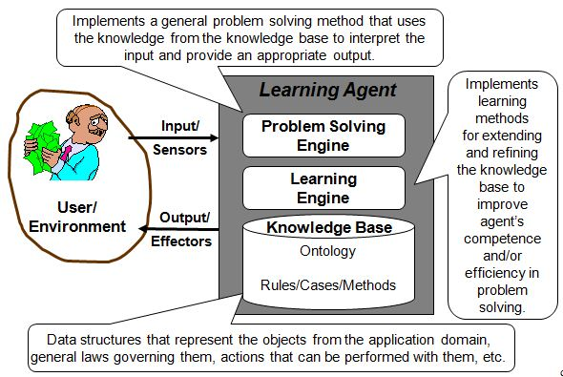

Chapter 3
History of Machine leaning

Over the years, research in machine learning has been pursued with varying degrees of intensity, using different approaches and placing emphasis on different, aspects and goals. Within the relatively short history of this discipline, one may distinguish three major periods, each centered on a different concept:
- neural modeling and decision-theoretic techniques
- symbolic concept-oriented learning
- knowledge-intensive approaches combining various learning strategies
3.1 The Neural Modeling (Self Organized System)
The distinguishing feature of the first concept was the interest in building general purpose learning systems that start with little or no initial structure or task-oriented knowledge. The major thrust of research based on this approach involved constructing a variety of neural model-based machines, with random or partially random initial structure. These systems were generally referred to as neural networks or self-organizing systems. Learning in such systems consisted of incremental changes in the probabilities that neuron-like elements would transmit a signal. Due to the early computer technology, most of the research under this neural network model was either theoretical or involved the construction of special purpose experimental hardware systems. Related research involved the simulation of evolutionary processes that through random mutation and “natural” selection might create a system capable of some intelligent, behavior. Experience in the above areas spawned the new discipline of pattern recognition and led to the development of a decision-theoretic approach to machine learning. In this approach, learning is equated with the acquisition of linear, polynomial, or related discriminated functions from a given set of training examples. One of the best known successful learning systems utilizing such techniques as well as some original new ideas involving non-linear transformations was Samuel’s checkers program. Through repeated training, this program acquired master-level performance somewhat; different, but closely related, techniques utilized methods of statistical decision theory for learning pattern recognition rules.
3.2 The Symbolic Concept Acquisition Paradigm
A second major paradigm started to emerge in the early sixties stemming from the work of psychologist and early AI researchers on models of human learning by Hunt. The paradigm utilized logic or graph structure representations rather than numerical or statistical methods Systems learned symbolic descriptions representing higher level knowledge and made strong structural assumptions about the concepts to be acquired. Examples of work in this paradigm include research on human concept acquisition and various applied pattern recognition systems.
3.3 The Modern Knowledge-Intensive Paradigm
The third paradigm represented the most recent period of research starting in the mid seventies. Researchers have broadened their interest beyond learning isolated concepts from examples, and have begun investigating a wide spectrum of learning methods, most based upon knowledge-rich systems specifically, this paradigm can be characterizing by several new trends, including:
1. Knowledge-Intensive Approaches: Researchers are strongly emphasizing the use of task-oriented knowledge and the constraints it provides in guiding the learning process One lesson from the failures of earlier knowledge and poor learning systems that is acquire and to acquire new knowledge a system must already possess a great deal of initial knowledge
2. Exploration of alternative methods of learning: In addition to the earlier research emphasis on learning from examples, researchers are now investigating a wider variety of learning methods such as learning from instruction.
In contrast to previous efforts, a number of current systems are incorporating abilities to generate and select tasks and also incorporate heuristics to control their focus of attention by generating learning tasks, proposing experiments to gather training data, and choosing concepts to acquire

Chapter 4
Wellsprings of Machine Learning

Work in machine learning is now converging from several sources. These different traditions each bring different methods and different vocabulary which are now being assimilated into a more unified discipline. Here is a brief listing of some of the separate disciplines that have contributed to machine learning;
4.1 Statistics
A long-standing problem in statistics is how best to use samples drawn from unknown probability distributions to help decide from which distribution some new sample is drawn. A related problem is how to estimate the value of an unknown function at a new point given the values of this function at a set of sample points. Statistical methods for dealing with these problems can be considered instances of machine learning because the decision and estimation rules depend on a corpus of samples drawn from the problem environment.
4.2 Brain Models
Non-linear elements with weighted inputs have been suggested as simple models of biological neurons. Brain modelers are interested in how closely these networks approximate the learning phenomena of living brains. Several important machine learning techniques are based on networks of nonlinear elements often called neural networks. Work inspired by this school is sometimes called connectionism, brain-style computation, or sub-symbolic processing.
4.3 Adaptive Control Theory
Control theorists study the problem of controlling a process having unknown parameters which must be estimated during operation. Often, the parameters change during operation, and the control process must track these changes. Some aspects of controlling a robot based on sensory inputs represent instances of this sort of problem.
4.4 Psychological Models
Psychologists have studied the performance of humans in various learning tasks. An early example is the EPAM network for storing and retrieving one member of a pair of words when given another. Related work led to a number of early decision tree and semantic network methods. More recent work of this sort has been influenced by activities in artificial.
4.5 Artificial Intelligence
From the beginning, AI research has been concerned with machine learning. Samuel developed a prominent early program that learned parameters of a function for evaluating board positions in the game of checkers. AI researchers have also explored the role of analogies in learning and how future actions and decisions can be based on previous exemplary cases. Recent work has been directed at discovering rules for expert systems using decision-tree methods and inductive logic programming.
Another theme has been saving and generalizing the results of problem solving using explanation-based learning.
4.6 Evolutionary Models
In nature, not only do individual animals learn to perform better, but species evolve to be better but in their individual niches. Since the distinction between evolving and learning can be blurred in computer systems, techniques that model certain aspects of biological evolution have been proposed as learning methods to improve the performance of computer programs. Genetic algorithms and genetic programming are the most prominent computational techniques for evolution.

Chapter 5
Machine Learning Overview

Machine Learning can still be defined as learning the theory automatically from the data, through a process of inference, model fitting, or learning from examples:
- Automated extraction of useful information from a body of data by building good probabilistic models.
- Ideally suited for areas with lots of data in the absence of a general theory.

5.1 The Aim of Machine Learning
The field of machine learning can be organized around three primary research Areas:
- Task-Oriented Studies: The development and analysis of learning systems oriented toward solving a predetermined set, of tasks (also known as the “engineering approach”).
- Cognitive Simulation: The investigation and computer simulation of human learning processes (also known as the “cognitive modeling approach”)
- Theoretical Analysis: The theoretical exploration of the space of possible learning methods and algorithms independent application domain.
Although many research efforts strive primarily towards one of these objectives, progress in on objective often lends to progress in another. For example, in order to investigate the space of possible learning methods, a reasonable starting point may be to consider the only known example of robust learning behavior, namely humans (and perhaps other biological systems) Similarly, psychological investigations of human learning may held by theoretical analysis that may suggest various possible learning models. The need to acquire a particular form of knowledge in stone task-oriented study may itself spawn new theoretical analysis or pose the question: “how do humans acquire this specific skill (or knowledge)?” The existence of these mutually supportive objectives reflects the entire field of artificial intelligence where expert system research, cognitive simulation, and theoretical studies provide some cross-fertilization of problems and ideas.
5.2 Machine Learning as a Science
The clear contender for a cognitive invariant in human is the learning mechanism which is the ability facts, skills and more abstractive concepts. Therefore understanding human learning well enough to reproduce aspect of that learning behavior in a computer system is, in itself, a worthy scientific goal. Moreover, the computer can render substantial assistance to cognitive psychology, in that it may be used to test the consistency and completeness of learning theories and enforce a commitment to the fine-structure process level detail that precludes meaningless tautological or untestable theories (Bishop, 2006).
The study of human learning processes is also of considerable practical significance. Gaining insights into the principles underlying human learning abilities is likely to lead to more effective educational techniques. Machine learning research is all about developing intelligent computer assistant or a computer tutoring systems and many of these goals are shared within the machine learning fields. According to Jaime et al who stated computer tutoring are starting to incorporate abilities to infer models of student competence from observed performance. Inferring the scope of a student’s knowledge and skills in a particular area allows much more effective and individualized tutoring of the student.

Chapter 6
Classification of Machine Learning

There are several areas of machine learning that could be exploited to solve the problems of email management and our approach implemented unsupervised machine learning method. Unsupervised learning is a method of machine learning whereby the algorithm is presented with examples from the input space only and a model is fit to these observations. In unsupervised learning, a data set of input objects is gathered. Unsupervised learning then typically treats input objects as a set of random variables. A joint density model is then built for the data set. The problem of unsupervised learning involved learning patterns in the input when no specific output values are supplied”.
In the unsupervised learning problem, we observe only the features and have no measurements of the outcome. Our task is rather to describe how the data are organized or clustered”. Trevor Hastie explained that "In unsupervised learning or clustering there is no explicit teacher, and the system forms clusters or ‘natural groupings’ of the input patterns. “Natural” is always defined explicitly or implicitly in the clustering system itself; and given a particular set of patterns or cost function; different clustering algorithms lead to different clusters. Often the user will set the hypothesized number of different clusters ahead of time, but how should this be done? According to Richard O. Duda, “How do we avoid inappropriate representations?"
There are various categories in the field of artificial intelligence. The classifications of machine learning systems are:
- Supervised Machine Learning: Supervised learning is a machine learning technique for learning a function from training data. The training data consist of pairs of input objects (typically vectors), and desired outputs. The output of the function can be a continuous value (called regression), or can predict a class label of the input object (called classification).
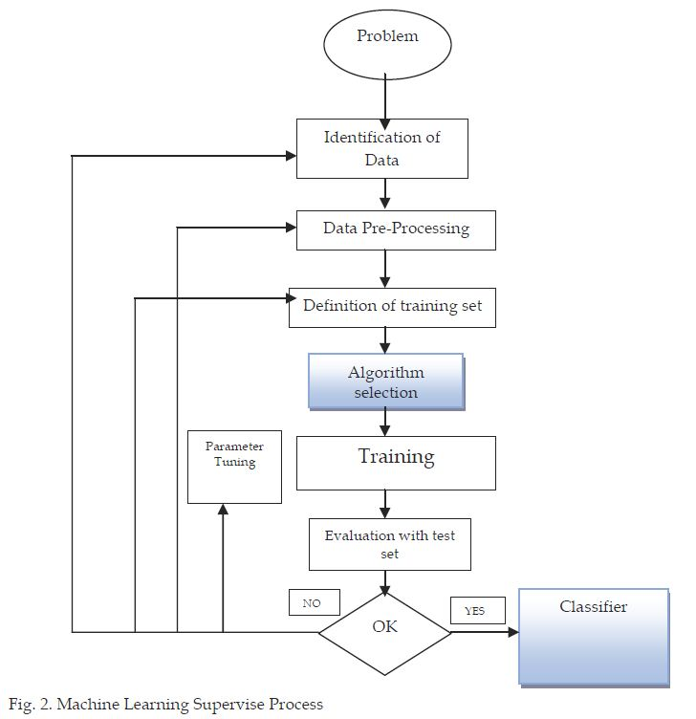
The task of the supervised learner is to predict the value of the function for any valid input object after having seen a number of training examples (i.e. pairs of input and target output). To achieve this, the learner has to generalize from the presented data to unseen situations in a "reasonable" way. Supervised learning is a machine learning technique whereby the algorithm is first presented with training data which consists of examples which include both the inputs and the desired outputs; thus enabling it to learn a function. The learner should then be able to generalize from the presented data to unseen examples." by Mitchell. Supervised learning also implies we are given a training set of (X, Y) pairs by a “teacher”. We know (sometimes only approximately) the values of f for the m samples in the training set, ≡ we assume that if we can find a hypothesis, h, that closely agrees with f for the members of ≡ then this hypothesis will be a good guess for f especially if ≡ is large. Curve fitting is a simple example of supervised learning of a function.
- Unsupervised Machine Learning: Unsupervised learning is a type of machine learning where manual labels of inputs are not used. It is distinguished from supervised learning approaches which learn how to perform a task, such as classification or regression, using a set of human prepared examples. Unsupervised learning means we are only given the Xs and some (ultimate) feedback function on our performance. We simply have a training set of vectors without function values of them. The problem in this case, typically, is to partition the training set into subsets, ≡₁ ……≡ _{R} , in some appropriate way.

Chapter 7
Types of Machine Learning Algorithms

Machine learning algorithms are organized into taxonomy, based on the desired outcome of the algorithm. Common algorithm types include:
- Supervised learning → where the algorithm generates a function that maps inputs to desired outputs. One standard formulation of the supervised learning task is the classification problem: the learner is required to learn (to approximate the behavior of) a function which maps a vector into one of several classes by looking at several input-output examples of the function.
- Unsupervised learning →which models a set of inputs, labeled examples are not available.
- Semi-supervised learning → which combines both labeled and unlabeled examples to generate an appropriate function or classifier.
- Reinforcement learning → where the algorithm learns a policy of how to act given an observation of the world. Every action has some impact in the environment, and the environment provides feedback that guides the learning algorithm.
- Transduction → similar to supervised learning, but does not explicitly construct a function: instead, tries to predict new outputs based on training inputs, training outputs, and new inputs.
- Learning to learn → where the algorithm learns its own inductive bias based on previous experience.
The performance and computational analysis of machine learning algorithms is a branch of statistics known as computational learning theory. Machine learning is about designing algorithms that allow a computer to learn. Learning is not necessarily involves consciousness but learning is a matter of finding statistical regularities or other patterns in the data. Thus, many machine learning algorithms will barely resemble how human might approach a learning task. However, learning algorithms can give insight into the relative difficulty of learning in different environments.
7.1 Algorithm Types
In the area of supervised learning which deals much with classification. These are the algorithms types:
- Linear Classifiers
- Fisher’s linear discriminant
- Naïve Bayes Classifier
- Perceptron
- Support Vector Machine
- Quadratic Classifiers
- Boosting
- Decision Tree
- Neural networks
- Bayesian Networks
7.1. a Linear Classifiers:
In machine learning, the goal of classification is to group items that have similar feature values, into groups. Timothy et al (Timothy Jason Shepard, 1998) stated that a linear classifier achieves this by making a classification decision based on the value of the linear combination of the features. If the input feature vector to the classifier is a real vector x, then the output score is
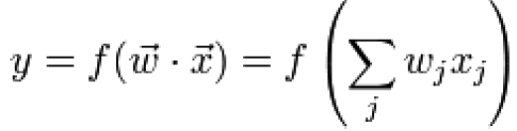

where is a real vector of weights and f is a function that converts the dot product of the two vectors into the desired output.
7.1. (a.1) Fisher’s linear discriminant
Linear discriminant analysis (LDA) and the related Fisher's linear discriminant are methods used in machine learning to find a linear combination of features which characterizes or separates two or more classes of objects or events. The resulting combination may be used as a linear classifier or, more commonly, for dimensionality reduction before later classification.
7.1. (a.2) Naïve Bayes Classifier
A naive Bayes classifier is a simple probabilistic classifier based on applying Bayes' theorem with strong (naive) independence assumptions. A more descriptive term for the underlying probability model would be "independent feature model".
In simple terms, a naive Bayes classifier assumes that the presence or absence of a particular feature is unrelated to the presence or absence of any other feature, given the class variable. For example, a fruit may be considered to be an apple if it is red, round, and about 3" in diameter. A naive Bayes classifier considers each of these features to contribute independently to the probability that this fruit is an apple, regardless of the presence or absence of the other features.
7.1. (a.3) Perceptron
The perceptron is an algorithm for supervised classification of an input into one of several possible non-binary outputs. The learning algorithm for perceptrons is an online algorithm, in that it processes elements in the training set one at a time.
7.1. (a.4) Support vector machines
In machine learning, support vector machines (SVMs) are supervised learning models with associated learning algorithms that analyze data and recognize patterns, used for classification and regression analysis. The basic SVM takes a set of input data and predicts, for each given input, which of two possible classes forms the output, making it a non-probabilistic binary linear classifier. Given a set of training examples, each marked as belonging to one of two categories, an SVM training algorithm builds a model that assigns new examples into one category or the other. An SVM model is a representation of the examples as points in space, mapped so that the examples of the separate categories are divided by a clear gap that is as wide as possible. New examples are then mapped into that same space and predicted to belong to a category based on which side of the gap they fall on.
7.1.b Quadratic classifier
A quadratic classifier is used in machine learning and statistical classification to separate measurements of two or more classes of objects or events by a quadric surface. It is a more general version of the linear classifier.
7.1.c Boosting
Boosting is a machine learning meta-algorithm for reducing bias in supervised learning. Boosting is based on the question posed as “Can a set of weak learners create a single strong learner?” A weak learner is defined to be a classifier which is only slightly correlated with the true classification. In contrast, a strong learner is a classifier that is arbitrarily well-correlated with the true classification.
7.1.d Neural networks
Neural networks are capable of machine learning and pattern recognition. They are usually presented as systems of interconnected "neurons" that can compute values from inputs by feeding information through the network. Neural networking is the science of creating computational solutions modeled after the brain. Like the human brain, neural networks are trainable-once they are taught to solve one complex problem, they can apply their skills to a new set of problems without having to start the learning process from scratch.
7.1.e Bayesian network
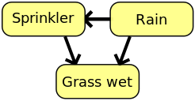
A Bayesian network, Bayes network, belief network, Bayes(ian) model or probabilistic directed acyclic graphical model is a probabilistic graphical model (a type ofstatistical model) that represents a set of random variables and their conditional dependencies via a directed acyclic graph (DAG). For example, suppose that there are two events which could cause grass to be wet: either the sprinkler is on or it's raining. Also, suppose that the rain has a direct effect on the use of the sprinkler (namely that when it rains, the sprinkler is usually not turned on). Then the situation can be modeled with a Bayesian network (shown). All three variables have two possible values, T (for true) and F (for false).

7.1.f Decision Trees
A decision tree is a hierarchical data structure implementing the divide-and-conquer strategy. It is an efficient nonparametric method, which can be used for both classification and regression. A decision tree is a hierarchical model for supervised learning whereby the local region is identified in a sequence of recursive splits in a smaller number of steps. A decision tree is composed of internal decision nodes and terminal leaves (see figure). Each decision node m implements a test function fm(x) with discrete outcomes labeling the branches. Given an input, at each node, a test is applied and one of the branches is taken depending on the outcome. This process starts at the root and is repeated recursively until a leaf node is hit, at which point the value written in the leaf constitutes the output.
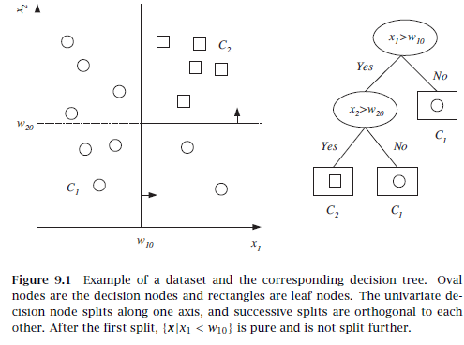

7.2 Machine Learning Applications
The other aspect for classifying learning systems is the area of application which gives a new dimension for machine learning. Below are areas to which various existing learning systems have been applied. They are:
1) Computer Programming
2) Game playing (chess, poker, and so on)
3) Image recognition, Speech recognition
4) Medical diagnosis
5) Agriculture, Physics
6) Email management, Robotics
7) Music
8) Mathematics
9) Natural Language Processing and many more.

7.3 Examples of Machine Learning Problems
There are many examples of machine learning problems. Much of this course will focus on classification problems in which the goal is to categorize objects into a fixed set of categories. Here are several examples:
• Optical character recognition: categorize images of handwritten characters by the letters represented
• Face detection: find faces in images (or indicate if a face is present)
• Spam filtering: identify email messages as spam or non-spam
• Topic spotting: categorize news articles (say) as to whether they are about politics, sports, entertainment, etc.
• Spoken language understanding: within the context of a limited domain, determine the meaning of something uttered by a speaker to the extent that it can be classified into one of a fixed set of categories
• Medical diagnosis: diagnose a patient as a sufferer or non-sufferer of some disease
• Customer segmentation: predict, for instance, which customers will respond to a particular promotion
• Fraud detection: identify credit card transactions (for instance) which may be fraudulent in nature
• Weather prediction: predict, for instance, whether or not it will rain tomorrow

Chapter 8
Future Directions

Research in Machine Learning Theory is a combination of attacking established fundamental questions, and developing new frameworks for modeling the needs of new machine learning applications. While it is impossible to know where the next breakthroughs will come, a few topics one can expect the future to hold include:
• Better understanding how auxiliary information, such as unlabeled data, hints from a user, or previously-learned tasks, can best be used by a machine learning algorithm to improve its ability to learn new things. Traditionally, Machine Learning Theory has focused on problems of learning a task (say, identifying spam) from labeled examples (email labeled as spam or not). However, often there is additional information available. One might have access to large quantities of unlabeled data (email messages not labeled by their type, or discussion-group transcripts on the web) that could potentially provide useful information. One might have other hints from the user besides just labels, e.g. highlighting relevant portions of the email message. Or, one might have previously learned similar tasks and want to transfer some of that experience to the job at hand. These are all issues for which a solid theory is only beginning to be developed.
• Further developing connections to economic theory. As software agents based on machine learning are used in competitive settings, “strategic” issues become increasingly important. Most algorithms and models to date have focused on the case of a single learning algorithm operating in an environment that, while it may be changing, does not have its own motivations and strategies. However, if learning algorithms are to operate in settings dominated by other adaptive algorithms acting in their own users’ interests, such as bidding on items or performing various kinds of negotiations, then we have a true merging of computer science and economic models. In this combination, many of the fundamental issues are still wide open.
• Development of learning algorithms with an eye towards the use of learning as part of a larger system. Most machine learning models view learning as a standalone process, focusing on prediction accuracy as the measure of performance. However, when a learning algorithm is placed in a larger system, other issues may come into play. For example, one would like algorithms that have more powerful models of their own confidence or that can optimize multiple objectives. One would like models that capture the process of deciding what to learn, in addition to how to learn it. There has been some theoretical work on these issues, but there is certainly is much more to be done.
8.1 Conclusions
Machine Learning Theory is both a fundamental theory with many basic and compelling foundational questions, and a topic of practical importance that helps to advance the state of the art in software by providing mathematical frameworks for designing new machine learning algorithms. It is an exciting time for the field, as connections to many other areas are being discovered and explored, and as new machine learning applications bring new questions to be modeled and studied. It is safe to say that the potential of Machine Learning and its theory lie beyond the frontiers of our imagination.

REFERENCES
- Alpaydin, E. (2004). Introduction to Machine Learning. Massachusetts, USA: MIT Press.
- http://www.intechopen.com/books/new-advances-in-machine-learning/types-of-machine-learning-algorithms
- Carling, A. (1992). Introducing Neural Networks. Wilmslow, UK: Sigma Press
- Friedberg, R. M. (1958). A learning machine: Part, 1. IBM Journal, 2-13.
- Mitchell, T. M. (2006). The Discipline of Machine Learning. Machine Learning Department technical report CMU-ML-06-108, Carnegie Mellon University.
- Richard S. Sutton, A. G. (1998). Reinforcement Learning. MIT Press.
- Ripley, B. (1996). Pattern Recognition and Neural Networks. Cambridge University Press.
- Tom, M. (1997). Machine Learning. Machine Learning, Tom Mitchell, McGraw Hill, 1997: McGraw Hill.
- Nilsson, N. J. (1965) Learning machines New York: McGraw-Hill Popper.
- Rosenblatt, F. (1958) “The perceptron: a probabilistic model for information storage and organization in the brain” Psychological Review.
- Michalski, R S , Carhoncll, .J G , & Mitchcll, T. M. (1983) (Eds) Machine Learning, an Artificial Intelligence Approach Palo Alto, CA: Tioga Press.
- Anderson, J. A. (1983) Acquisition of proof skills in geometry.In R. S. Michalski, J. G. Carbonell & T M Mitchell (Eds ), Machine Learnzng, An Artzficaal Intelligence Approach Palo Alto,

