**GROUP 10 – “TASKER”**

**PROJECT PLAN**

**CONTENTS**

1 – INTRODUCTION………………………………………………………………………………………3

* 1. *– Purpose of this Document…………………………………………………………...3*
  2. *– Scope………………………………………………………………………………………….3*
  3. *– Objectives………………………………………………………………………………….. 3*

2 - GANTT CHART ANALYSIS………………………………………………………………………….3

*2.1 – Gantt Chart…………………………………………………………………………………3*

*2.2 – Analysis………………………………………………………………………………………3*

3 – RISK ANALYSIS………………………………………………………………………………………...4

*3.1 – Team Member Absences……………………………………………………………..4*

*3.2 – Technical Difficulties………………………………………………………………….4*

*3.3 – Work Slippage……………………………………………………………………………4*

**1 – INTRODUCTION**

This document specifies the project plan for the CS22120 Group Project.

* 1. **– Purpose of this Document**

The purpose of this document is to provide information and guidelines for the group members and project manager to follow so that milestones can be achieved throughout the project.

* 1. **– Scope**

This document specifies the project plan for the CS22120 Group Project

* 1. **– Objectives**

The main objective of this document is to provide a successful project plan for team members to monitor as the project progresses. As project monitoring will be in place, the plan will also help in task allocation to individual members as well as the whole team to keep the project running smooth and flexible and ideally with no difficulties.

1. **– GANTT CHART**

A Gantt Chart will be used in order to illustrate the time allocation of the tasks and deadlines of the project. This chart will therefore be used to monitor progress and also to allocate tasks to members within the group.

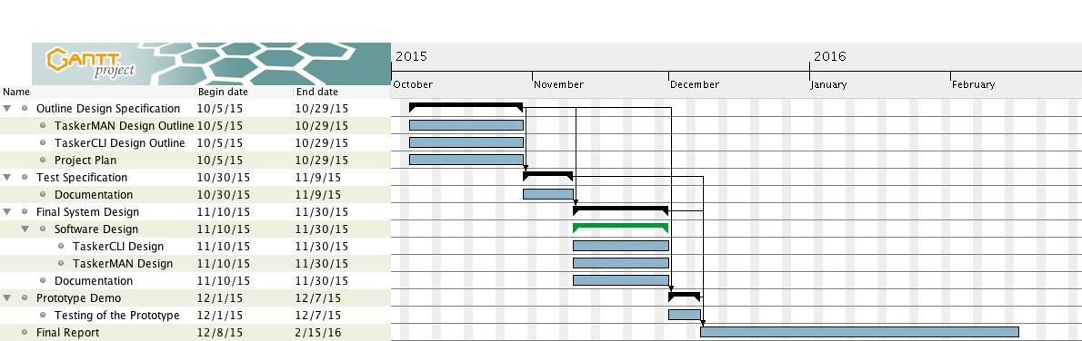

* 1. **– Gantt Chart Presentation**

**2.2 – Gantt Chart Analysis**

The Gantt Chart is a task planner, which specifies the major deadlines of the project and rough outlines of the subtasks that could potentially be added or changed as the project goes on. For the “Tasker” project we will be using this rough plan to follow the project and meet its deadlines. The plan contains a variety of main tasks and subtasks in order to specify what roughly needs to be done to meet a certain deadline. I have also used the predecessor functions in order to link the major deadlines together to show that one stage cannot be done without the other. This of course helps monitoring the progress of the project for all group members. The Gantt Chart will also help in allocation of the variety of tasks to individuals as well as the whole team so that the project goes smoothly and flexibly.

**3 – RISK ANALYSIS**

Hoping that during the project there will be no complications, as a team we are aware that there potential hazards and any unseen circumstances could appear throughout the project and these could be:

* 1. **– Team Member Absences**

Considering that within a project each member will have an allocated task, it is important that in the potential case of an individual being absent resulting in not being able to complete the task, there will be someone within the project team to cover for the individual to ensure that the project runs smoothly with no major complications.

* 1. **– Technical Difficulties**

This project consists of designing a website and desktop client user interface therefore the project team will be heavily relying on their workstations and software in order to complete the project whether it is coding, testing, or writing documentation. System malfunction is of course an unseen circumstance however it could be a high threat to the project if no data is backed up on any additional storage devices, local server, or a cloud interface which could result in the loss of all of the work carried out by the team. This would delay the project by not being able to meet set deadlines and would not satisfy the client. In order to therefore avoid this potential problem, the team has to make to store all versions of their work on a GitHub server, in a group repository for all members to access.

* 1. **– Work Slippage**

Sometimes deadlines for projects can be very tight, especially if some of the tasks can take significantly longer than expected which as a result can cause a delay in the overall project. The reasons for tasks taking longer to complete could potentially be:

* An individual not knowing exactly what to do.
* Task is not complete to a satisfying standard.
* An individual could not catch up on work missed.
* The time allocation of the task was wrongly estimated.

There are also many other reason to why work can be delayed therefore in order to prevent work slippage and meet deadlines at a specified date, the team could ensure to split a certain task between two members so that the task can then be completed on time.