Interaction and Design Specification

|  |  |
| --- | --- |
| Author: | C.Palmer, C.Daldry, K.Rai, D.Kastelik, M.Hill, S.Johansen, C.Griffiths |
| Config Ref: | SE_10_2_1 |
| Date: | 2015-10-17 |
| Version: | 1.0 |
| Status: | Build |

Department of Computer Science

Aberystwyth University

Aberystwyth

Ceredigion

SY23 3DB

Copyright © Aberystwyth University 2015

CONTENTS

CONTENTS 2

1. Introduction 3

1.1 Purpose of this Document 3

1.2 Scope 3

1.3 Objectives 3

2. Deployment DESCRIPTION 3

2.1 Applications in the system 3

2.1.1 TaskerSRV 4

2.1.2 TaskerMAN 4

2.1.3 TaskerCLI 4

2.2 Application Interactions 4

3. Interaction DESIGN 5

3.1 Use-cases 5

3.2 User Interface Designs 6

REFERENCES 6

DOCUMENT HISTORY 7

# Introduction

## Purpose of this Document

This document will provide the design specification that will be used by the group to ultimately implement the system required. The document will use a variety of different designs and diagrams to give the group as accurate information as possible, for the end system to be as efficient as possible. The document will cover all areas of the system, and describe the different components and how they will be implemented at a high level, this will consist of many different designs, from UML diagrams, to interface designs to clearly outline how the group intend on implementing the system, and what it will go on to achieve. Due to the level of detail this document will delve into, it will therefore be a lengthy document, with many sections covering the topics that are required to be discussed to produce the best quality of product possible.

## Scope

The scope of this document will be very broad in terms of what the content will go on to cover, it will consist of five main sections:

* Deployment Description
* Interaction Design
* Component Design
* Significant Classes
* Detailed Design

Each section is completely relevant to being able to produce the most effect of end products. Different sections of the document are aimed at different components that will make up the end system, detail is required to be inputted for every component, ensuring every component is built to a high standard. The document is required to be read only by the people that are involved with the project group, as it is important for everyone that is included within the group to have awareness to what the system is, and how it will be implemented.

## Objectives

The main, primary objective of the design specification document is to provide the members of the group how to explain and describe how the system should be implemented. The objectives of this document are:

* Provide the group with a detailed description of what makes up the system.
* Provide details on how the different components of the system will be built.
* Specifics regarding how the components of the system will interact.
* Supply both interface and detailed code designs giving a full idea on how the components will work.

# Deployment DESCRIPTION

## Applications in the system

This first section of the design document, the deployment description is mainly aimed at what makes up the system, the separate applications involved that will interact to provide the overall system. The specification requires there to be a CLI (TaskerCLI) and a web (TaskerMAN) interfaces that the user is able to use, there already there are two separate applications that will be a part of the system, with both of them having different purposes in the system. There will also be one more application that will complete the system and will be the central application that the CLI and the web page will use to function, this will be known as the TaskerSRV, and will provide the database that will store, centrally, all of the detail that the applications will need to act as the task management system. The diagram below simply shows how the system is built up, showing the three applications involved that are listed above, as well as showing a simple version of the interactions between the applications (which is discussed further in the next section 2.2). As it shows, TaskerMAN and TaskerCLI will work separately from one another, and will both only rely on the TaskerSRV to store the information.

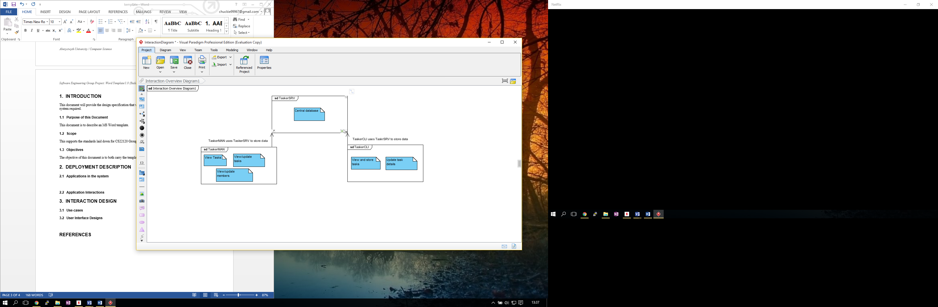

### TaskerSRV

As shown in the diagram above and briefly described, the TaskerSRV is on the three applications used in the system, this will provide the backbone storage for the remaining two applications, as well as being the applications that the users won’t see or use (directly), only the implementers of the system will use the TaskerSRV as the database will be used by the two applications to store data. Although this component of the system won’t be directly used by any member of the company, be it an Admin member or just an employee, it is ultimately the most crucial component to the system as it provides the storage for all the information that allows the task management system to be able to run.

### TaskerMAN

The TaskerMAN will provide a web based interface that should be accessible from and machines online, this will be the main application that will be used by the employees, it will provide the majority of the functionality that the system will proved, as shown in the diagram above, the overall functionality is to be able to view the tasks, update the tasks, and finally the admin staff must be able to edit the team members information, as well as it being shown. All of the information that the website will use and manipulate will be stored in the TaskerSRV that the TaskerMAN website will use. Because the TaskerMAN component will be a web interface, the users will have to access it through the use of a web browser, from a given URL that will provide the interface for the site. The TaskerMAN will actually be hosted on the server that the TaskerSRV is on, but the HTML client side will use the PHP server side to access the database on TaskerSRV.

### TaskerCLI

The final component of the system to discuss is the desktop application that will be provided through TaskerCLI, it will be a runnable application that users can run from their machine desktops (provided they meet the requirements which will come later on in the document). The TaskerCLI component will provide similar functionality to the TaskerMAN component, just not as extensive, as the only functionality will be to view and update the tasks, according to a specific user, also, the application must allow for the local storage of the tasks from the database on TaskerSRV so that this component can work offline, and then the synchronisation when the device is back online again. This application will be built using the Java language, and will provide the user with a conventional user interface, similar to the website in TaskerMAN, providing the user with an alternative method, with its main purpose being that the employee is able to use the application, and update tasks offline, furthering the efficiency of the system.

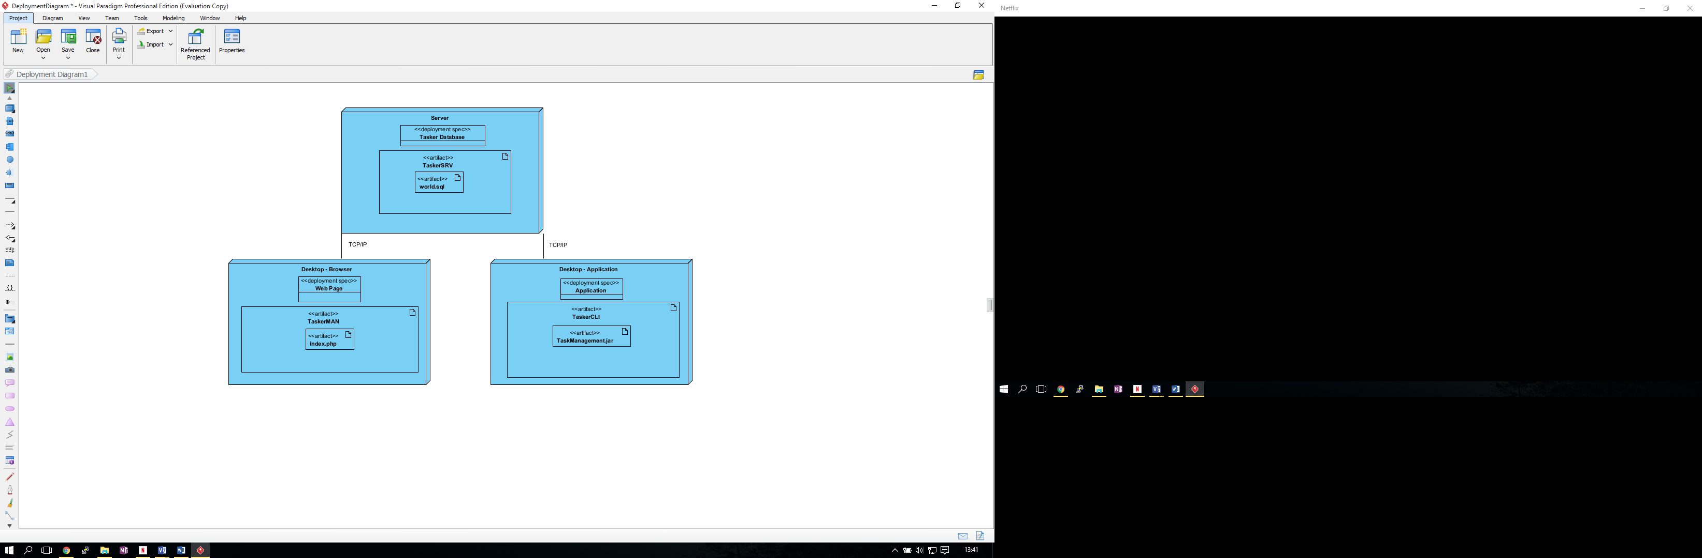

This deployment diagram shows in a bit more detail than the previous diagram what is involves in the three different components, and what makes them up, such as stating that the TaskerCLI desktop application will be runnable through the use of a .jar file, and that the web page will be centred around the index.php file, that provides both the client side and server side of functionality to the component. The diagram clearly, and simply outlines the separate applications that will be combined to produce the overall system.

## Application Interactions

Now that the components, and separate applications in the system have been identified, the next stage for the design specification is to provide a design on the interactions between the components. The following component diagram is similar to the diagrams above in section 2.1, however, providing further detail to how the different aspects of the different components will interact with each other.

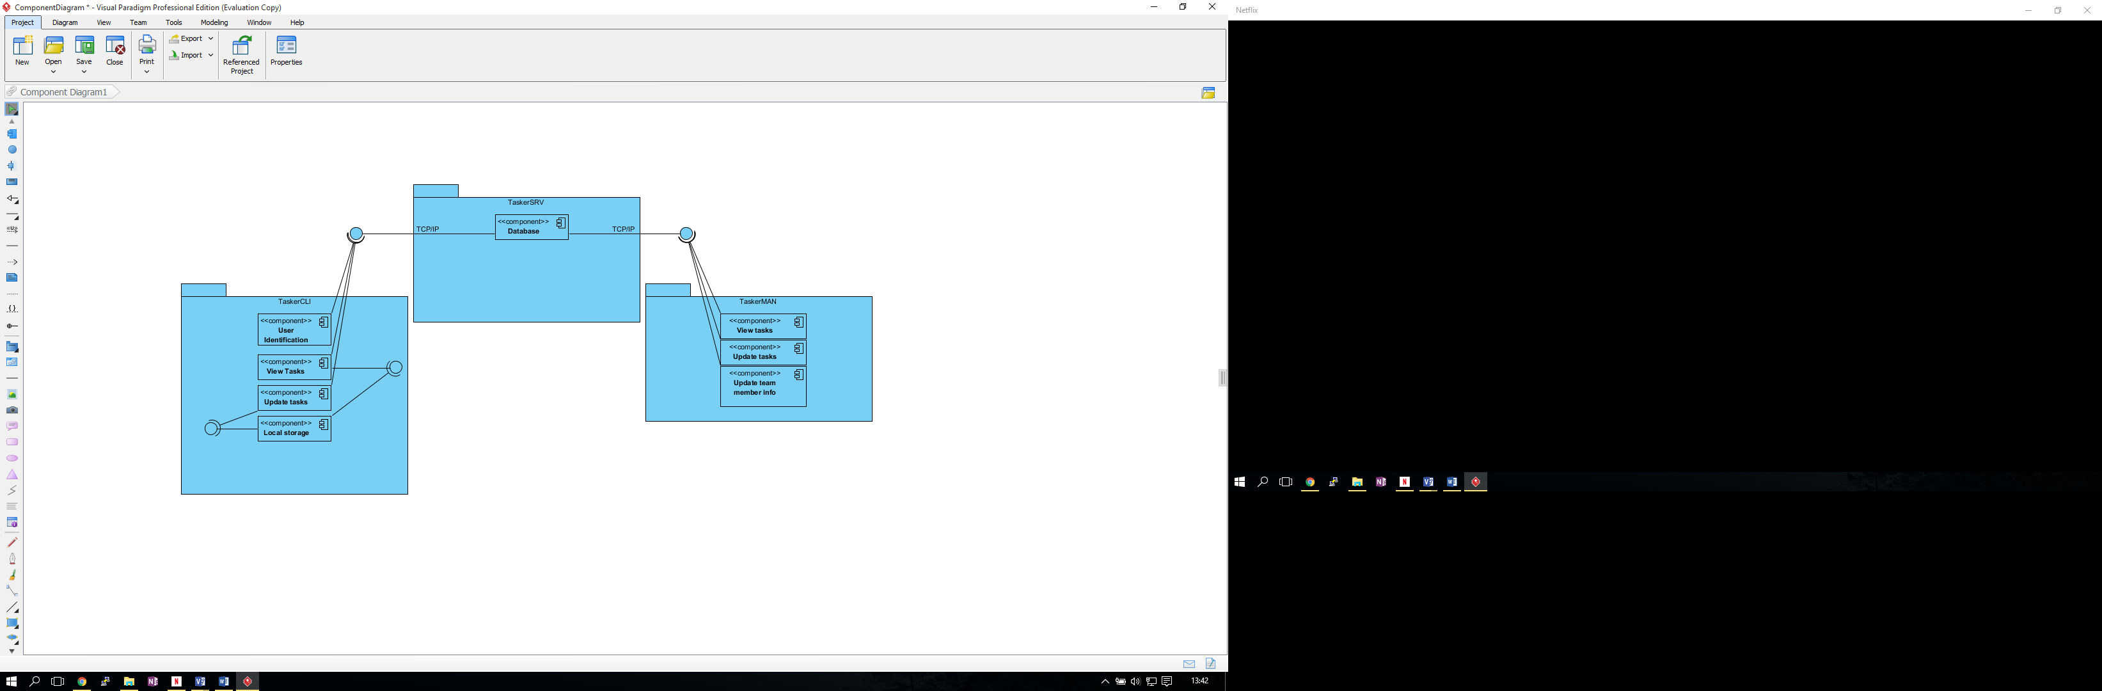

In the diagram above, the three different components have components within them that describe the functionality that the applications will provide, for example, displaying the data to the user, this diagram shows what component of the different applications will use the other applications. The only interactions between the applications that will happen within the system are the ones shown in the diagram, and they are the interactions between the TaskerCLI and TaskerMAN applications interacting with the TaskerSRV interface in order to manipulate the data in the database to allow the complete system to work, other than that, there are no other interactions between any of the applications that make up the system. The calls that are used in order to interact with the TaskerSRV database to the desktop applications and the website is TCP/IP on both occasions to pass the queries to the database, and pass the information back to the application,

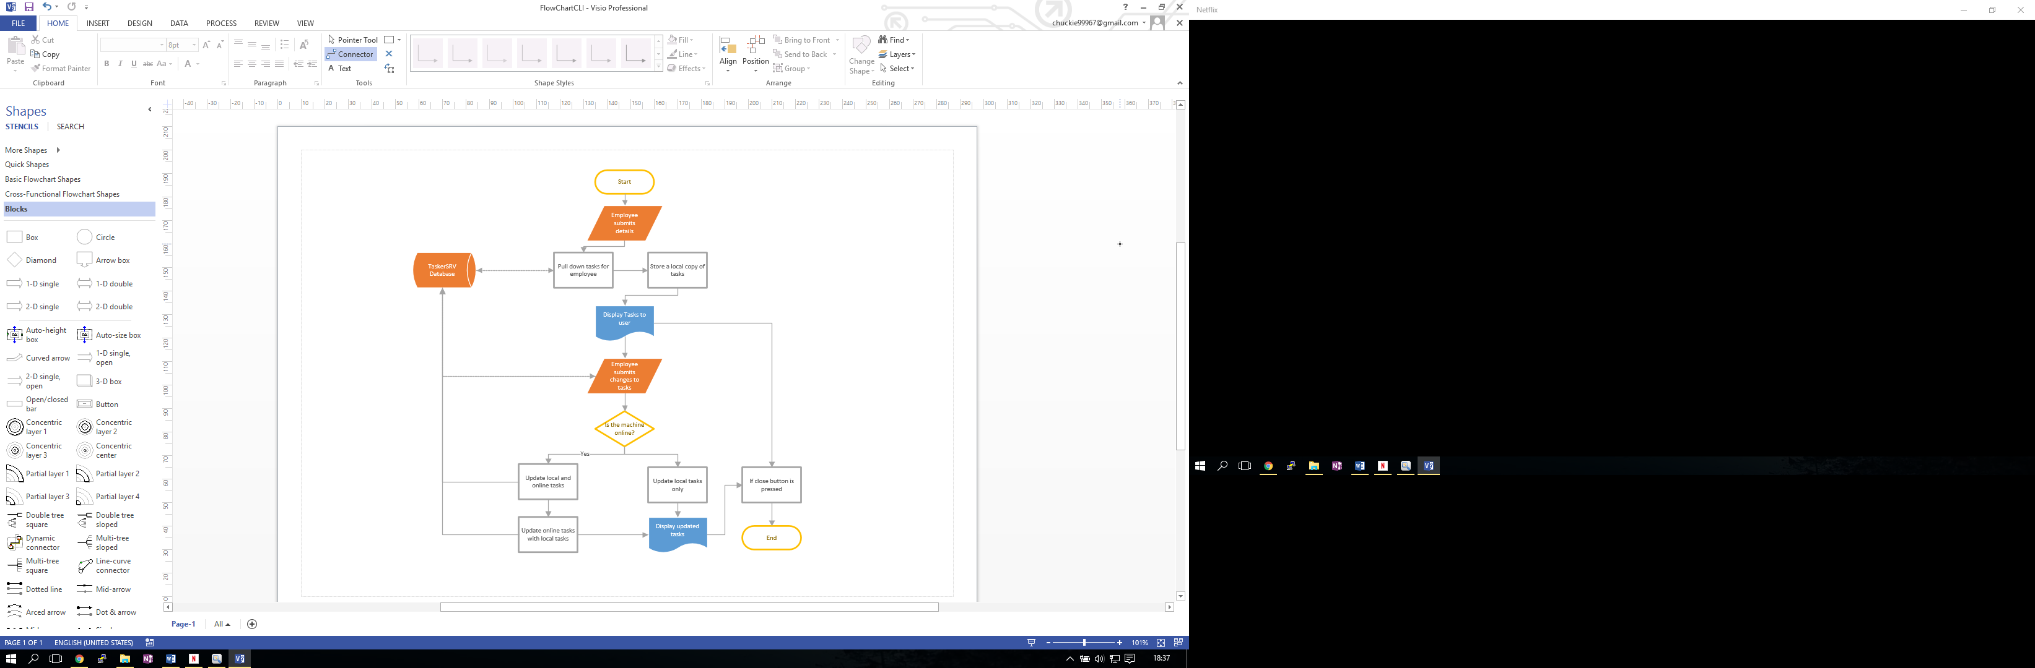

An example of the interactions are shown above in the flowchart shows the flow of the TaskerCLI application, and what functions of the application are required to interact with another application within the system. As is visible, there are four occasions where the TaskerCLI application will need to interact with the database, the database is shown in the flowchart on the far left, and the four occasions where the application is required to use the database are shown with linked connections and arrows pointing to and from the database.

# Interaction DESIGN

## Use-cases

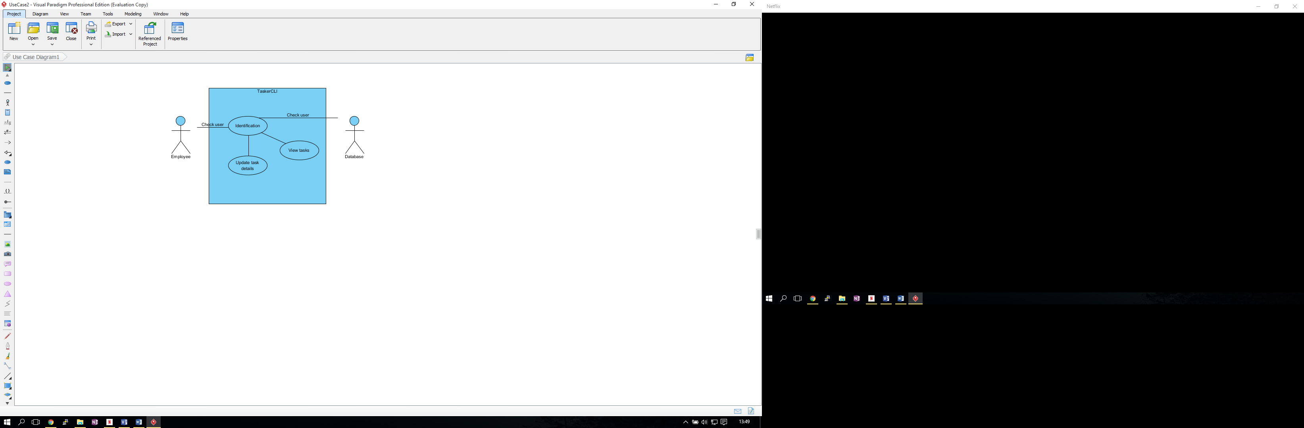

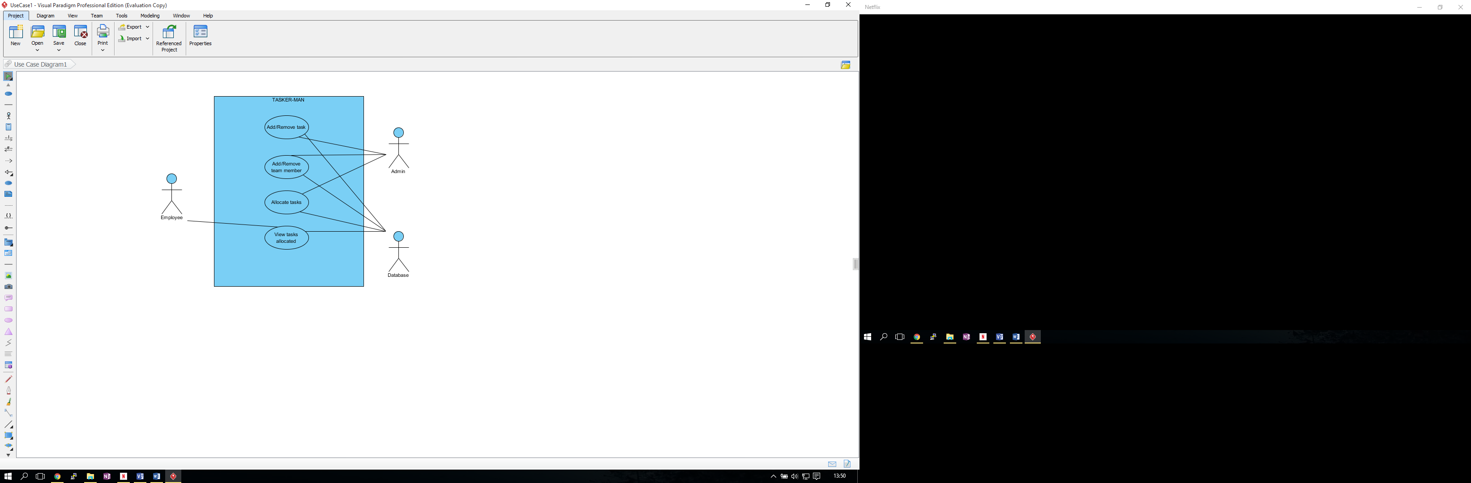

## User Interface Designs

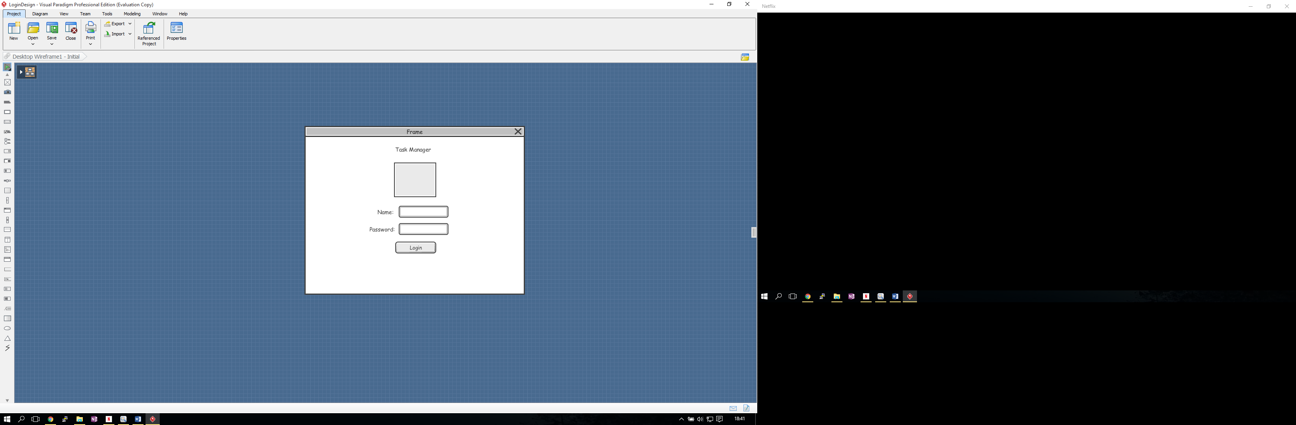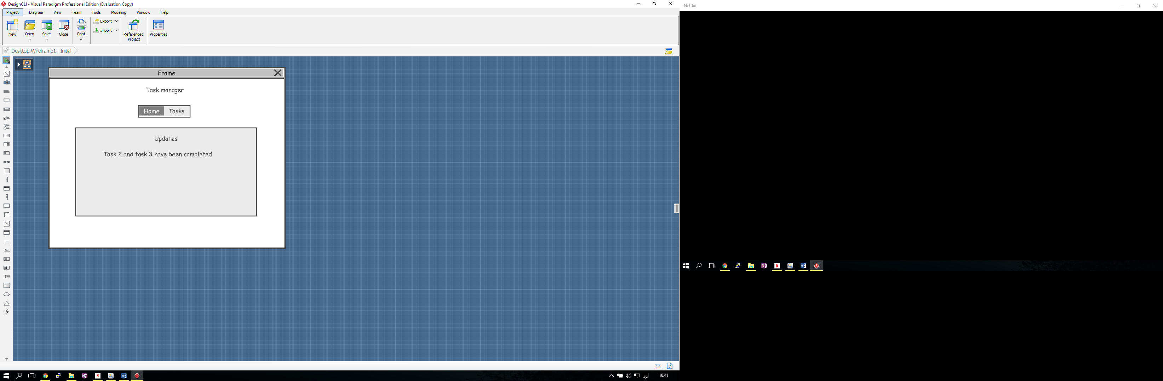

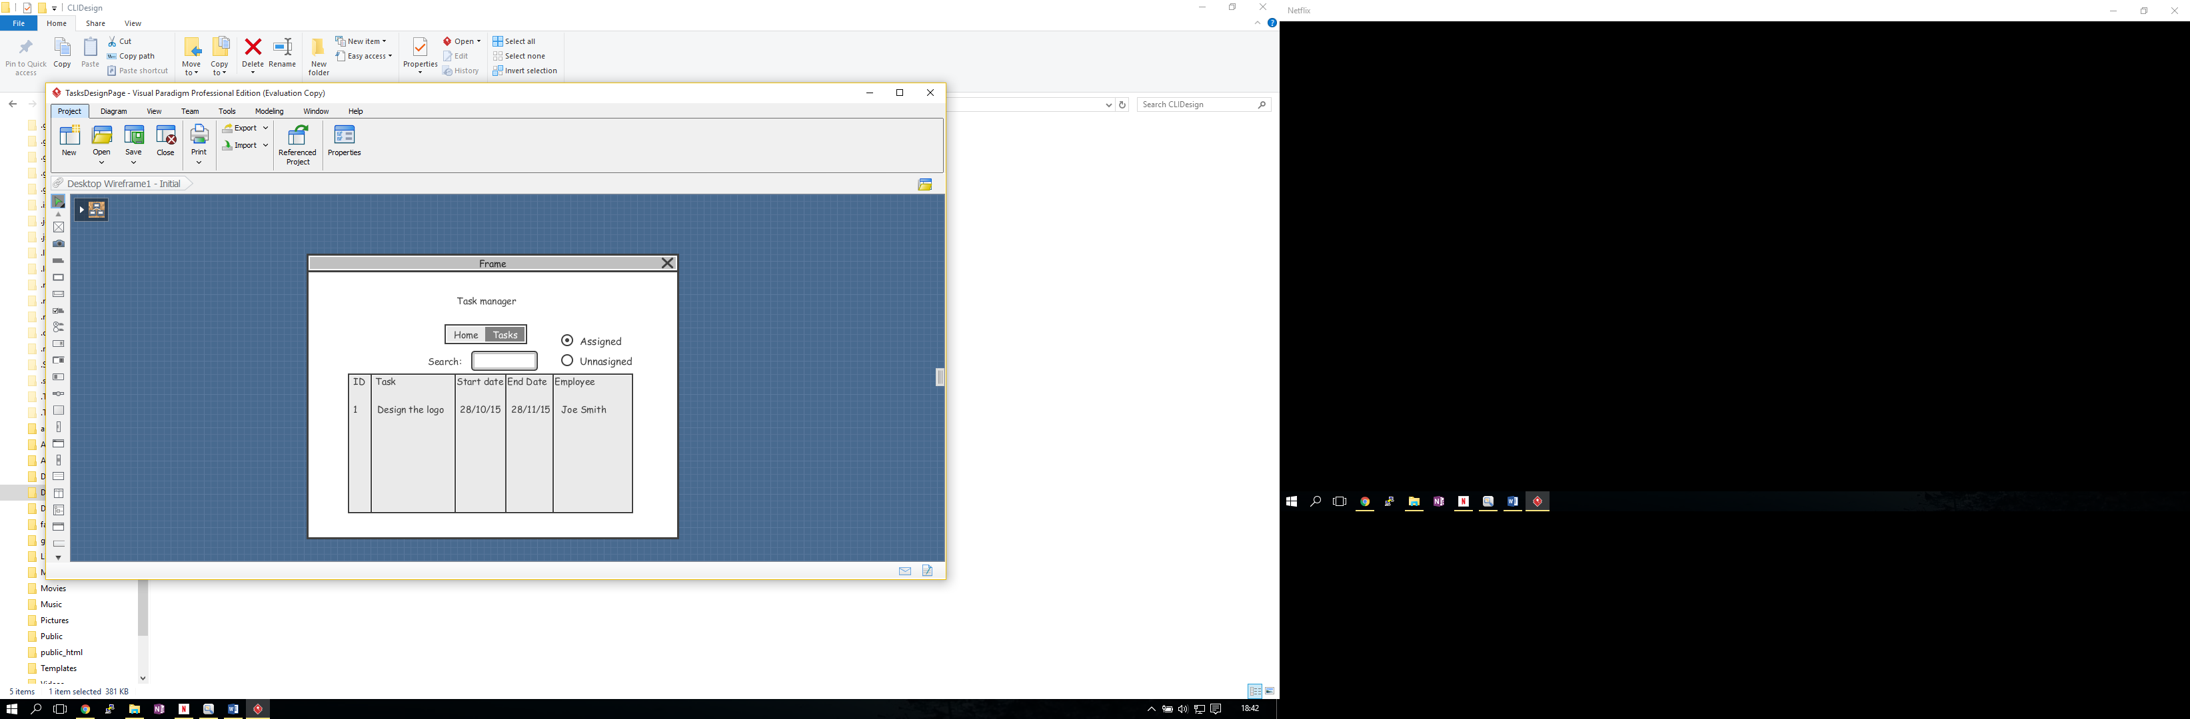

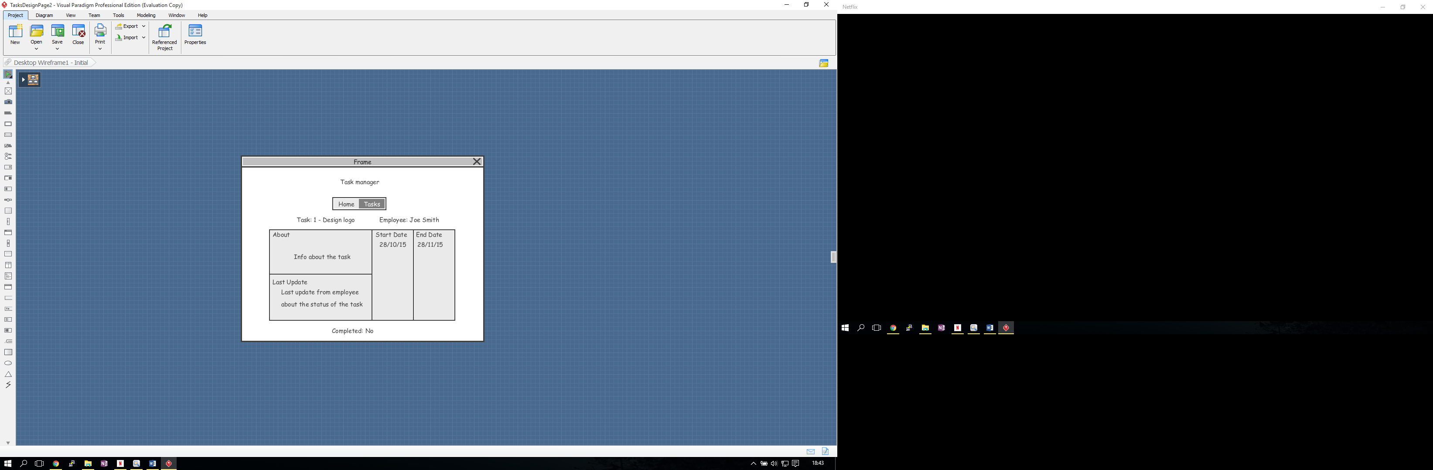



REFERENCES

DOCUMENT HISTORY

| *Version* | *CCF No.* | *Date* | *Changes made to document* | *Changed by* |
| --- | --- | --- | --- | --- |
| 1.0 | N/A | 28/10/15 | First Version | C.Palmer |