Title: Serial Port Programming
Author: Craig Duffy 29/11/04. 29/09/05
Module: Embedded Real-Time Systems Programming
Awards: CRTS 2, BSc Computing (Part-Time)
Prerequisites: Some ARM assembler and SA1110 knowledge

This worksheet looks at the details of the SA1110 implementation of serial ports. It discusses serial port initialisation and reconfiguration, as well as the operations to receive and transmit (RX/TX).

Note. Problems downloading. There seems to be some problems downloading MSBin files to the Puppeteer. As the process involves gcc creating an elf binary, elf2bin converting it into an MSBin file, eloadsvr sending it to the Puppeteer, it has been quite hard to track down. However there are a couple of work arounds. Firstly the elf2bin program doesn’t delete any existing file so it can end up with extraneous data on the end, which messes up the load ether command. You can tell this is happening because rather than get the last record which should have a record start of 0x00000000 a size of 0X00000000 and a launch address of 0xc0000000, it comes out with random values. This is solved by changing the makefile to delete any existing MSBin file, so replace,

$(APPNAME).bin : $(APPNAME)
elf2bin $(APPNAME) $@ >nul

with

$(APPNAME).bin : $(APPNAME)
rm -f $@
elf2bin $(APPNAME) $@ >nul

The other problem, that might be to do with the load ether command, is that it doesn’t work too well with small binaries, some sizes it likes, some it doesn’t. So if you pad the boot.s file with extra ‘no-ops’, just after the halt routine, by adding the following.

.rept 100
nop
.endr

this should increase the binary size and keep load ether happy.

The code on this worksheet assumes that you have a makefile, boot.s, and lib with at least crt0.o in it.

The SA1110 Memory Map

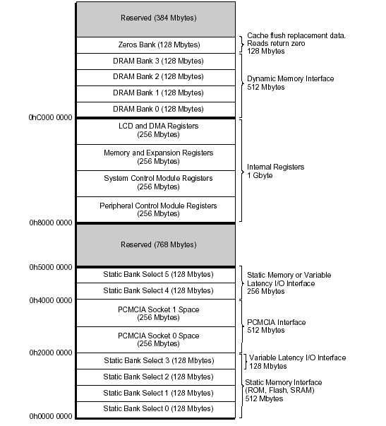

The area we are interested in is the internal registers from 0x80000000 to 0xC0000000. This implements the main logic of the chip. The section that deals with the serial ports is the Peripheral Control Module (PCM). This is at addresses 0x80000000-0x90000014. It controls the serial ports and LCD screens – the block diagram for this module is given below.

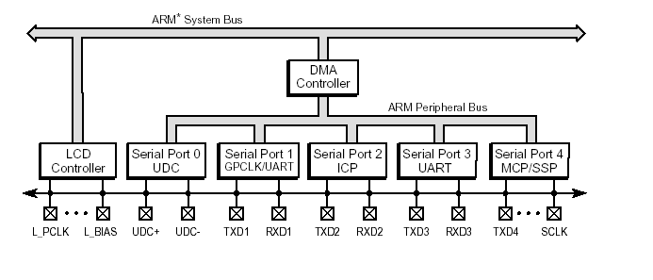

There are 5 64Kbyte blocks allocated for each set of serial port registers, serial ports 1, 2 and 4 have 2 distinct serial port implementations within the allocation, meaning that the SA1110 has 8 possible serial ports.
Serial port 0 is primarily for USB applications, although it can be used as a standard serial port.
The only dedicated UART is serial port 3 and this is the one we shall use for all our discussion of serial ports. The register setting details for this serial port will also work on serial port 1, as long as it is not being used as a General Purpose CLocK controller (GPCLK).

Serial Port 3 Register summary

Serial port 3 implements much of the 16650 or RS232 protocol functionality. It supports a number of baud rates (speeds); from 56.25bps to 230.4Kbps. It allows 7 or 8 bits of data (odd, even or no parity), one start bit and one or two stop bits. The device can buffer 8 X 8 bits of output (TX) data and 12 X 11 bits of input (RX) data – the extra 3 bits of input data are used for error flags. The serial ports can work under interrupts, and the data can be supplied by DMA or from the CPU. Unusually none of the serial ports support hardware control signals (RTS/CTS, DTR/DSR), these must be supplied externally either through the use of the General Purpose IO pins (GPIO) or through some other logic. On the Puppeteer this logic is provided by the FPGA.

On hardware reset serial port 3 is disabled. The Transpond BSP does not set up this port unless requested, so you are likely to find that serial port 1, the one used for messages and interaction, will work but serial port 3 doesn’t respond. The reason that the BSP does this is to save power, when disabled all ports are handed over to the Peripheral Pin Controller (PPC) and are treated as inputs. In order to set up the port we need to do the following:

1. Wait for any transmissions to clear – we can’t be sure that there aren’t any.
2. Disable RX and TX – just in case, it can’t do any harm.
3. Clear the status ‘sticky’ bits. These bits will enable the UART and release it from the PPC.
4. Set up the transmission modes that we require – no. of bits, parity, baud etc.
5. Enable RX and TX.

We can either wait for interrupts if they have been enabled, poll for data if they haven’t or transmit data, or send/receive the data using DMA, if that has been set up. In this worksheet we will only work with programmed or polled I/O.

It is worth noting here that despite the fact that most of the registers and data is 7 or 8 bit bytes, the peripheral bus only works with word (32 bit) data reads and writes. You will notice that in the code ldr/str are used instead of ldrb/strb.

The data is sent/received in the following frame format.

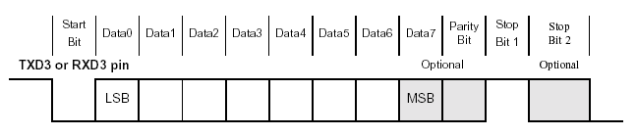

The exact size of the frame will depend upon which settings are selected – it can be between 9 and 12 bits. The frame information is automatically placed around the data on transmission and removed upon reception.

The set of registers for the UART are given below plus their addresses.

0h 8005 0000 | UTCR0 | UART control register 0
0h 8005 0004 | UTCR1 | UART control register 1
0h 8005 0008 | UTCR2 | UART control register 2
0h 8005 000C | UTCR3 | UART control register 3
0h 8005 0010 | — | Reserved
0h 8005 0014 | UTDR | UART data register
0h 8005 0018 | — | Reserved
0h 8005 001C | UTSR0 | UART status register 0
0h 8005 0020 | UTSR1 | UART status register 1
0h 8005 0024 | — | Reserved
0h 8005 FFFF | — | Reserved

As you can see there are 4 control registers, 2 status registers and 1 data register. The data register address is shared for the RX and TX functions, so it knows that when it is being read it is in RX mode and in TX mode when written to.

UART Control Register 0, UTCR0

Control register 0 deals with the data size and error detection. The bits that deal with clock selection won’t be dealt with here as we will be using the standard system clock, therefore we will always set bits 4-6 to 0. The other bit settings will depend upon the type of RX/TX we want. So to have 8 bits, no parity and 1 stop bit, we would write 0x8, binary 0b00001000 to this address.

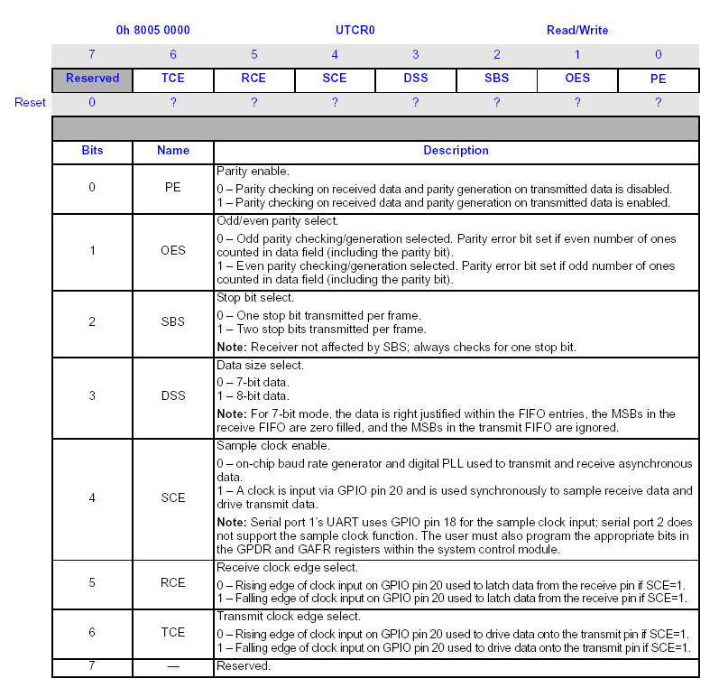

UART Control Registers 1 and 2 - UTCR1 UTCR2

These registers deal with the baud rate selection for the port. The baud rate is controlled by a Baud Rate Divisor (BRD) which is a 12-bit number. This is stored in two parts: the upper 4 bits are stored in the UTCR1 (bits 0-3) and the lower 8 bits in UTCR2 (bits 0-7). The value to store is arrived at by the following formula:
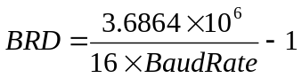

So to get the BRD for 115200 we need to work out

BRD = ( ( 3.6864 * 1000000) / 1843200 ) -1
BRD = 2;

If we write the value 0x0 to UTCR1 and 0x02 to UTCR2, the baud rate is 115200.

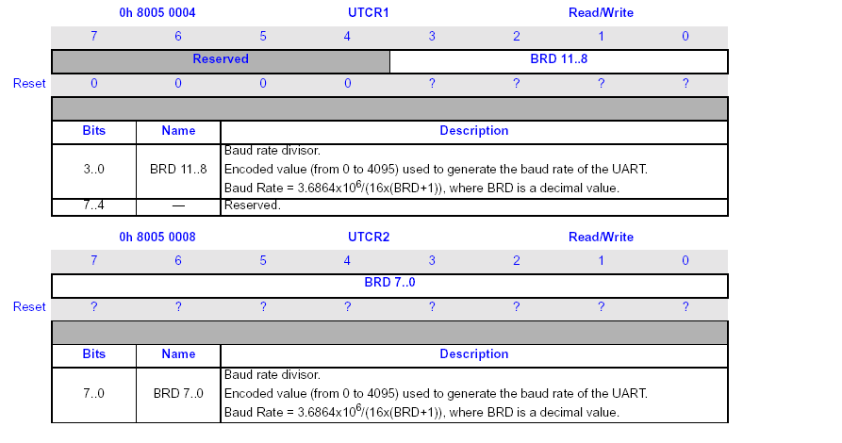

UART Control Register 3 - UTCR3

This control register sets up various features and functions of the port. The only two we are interested in at the moment are the TX and RX enable bits – TXE and RXE. These bits need setting to 1 in order to enable the device. However this must be done last – after the device settings have been altered. So to enable the device we must write 0x3 to this address.

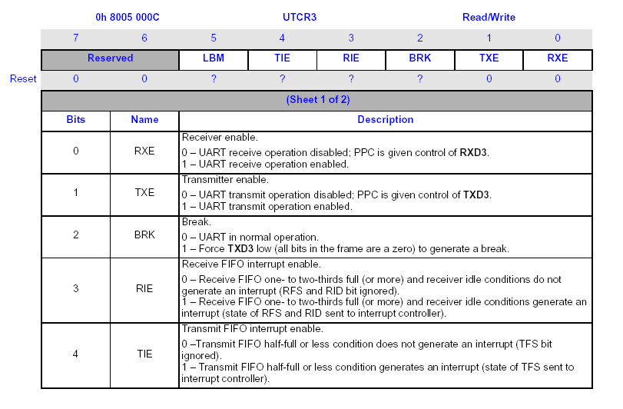

UART Data Register - UTDR

This register allows the reading and writing of data: for each read, or write, only 7 or 8 bits of data are transferred. The error bit settings, bits 8-10, are copied across to the status register into the appropriate fields. As the buffer is a FIFO there can be transmission delays on TX – therefore the programmer can either use interrupts to tell when data has been transferred or poll the Transmitter BusY (TBY) bit in the status register (UTSR1) twice – 0 to 1 then 1 to 0 for programmed I/O.

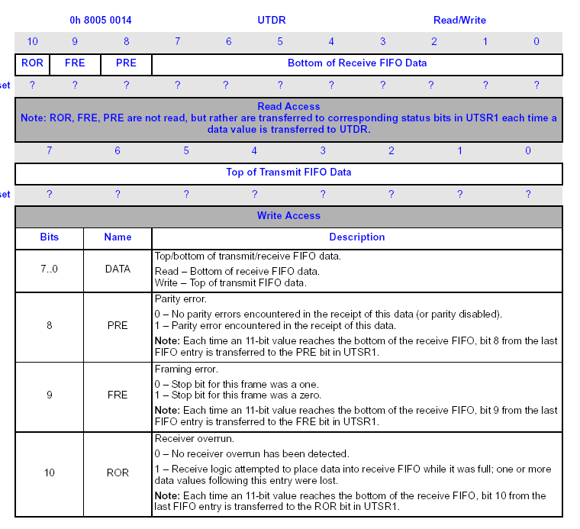

UART Status Register 0 - UTSR0

This register deals with various events and conditions of the port. As we won’t be using interrupts we won’t need to deal with this register except to reset it by writing the value 0x07 to the bottom 3 bits. This enables the UART and allows us to set it up.

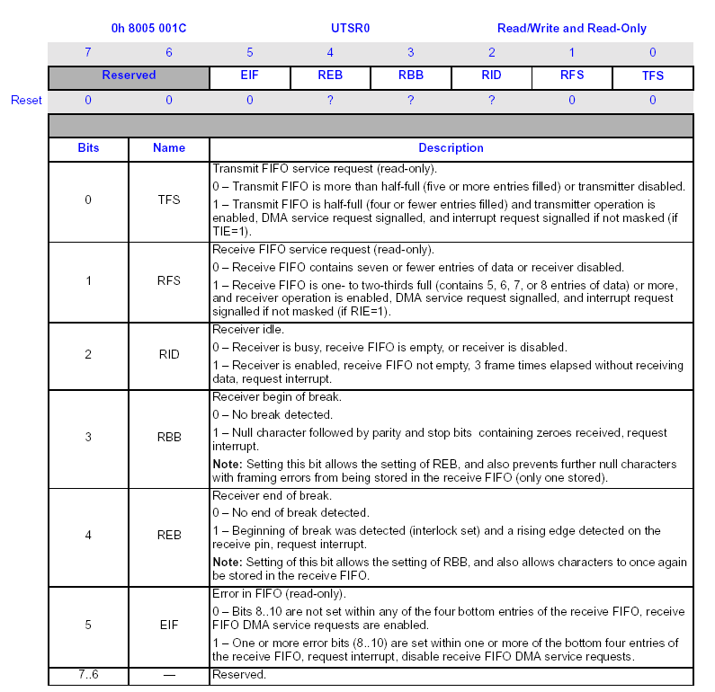

UART Status Register 1 - UTSR1

This read-only register reports on the status of receive and transmit operations. It is tested before attempting to write data to the transmit buffer or read from the receive buffer. The first 3 bits are to do with RX/TX status. The Receive Not Ready (RNE) and Transmit Not Full (TNF) bits are both traditional ready to read (RXRDY) or ready to write (TXRDY) bits – these are tested prior to read and write operations. The TBY bit is to make sure that the data delay in the write FIFO is handled. The other 3 bits are all error condition bits.
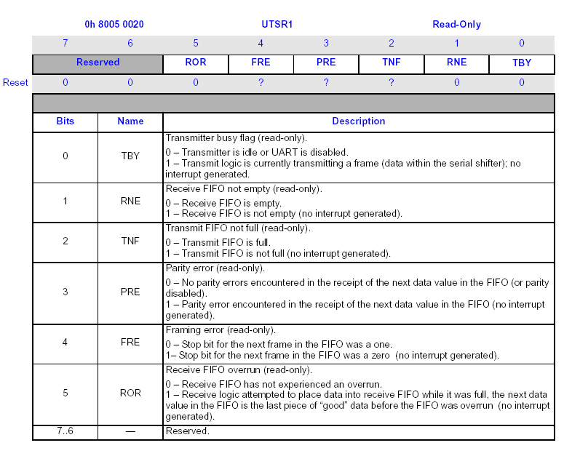

Some code examples.

Note. Sometimes when making changes to the serial port you can quite easily reset the terminal emulator (minicom or cu), this is because you may have written out control characters, which change the program’s operation. It is worth quitting the emulator (^Azq in minicom ~. in cu), and starting it up again, otherwise your code may output a decent string only to get it messed up by the emulator’s display

Attached are some code examples. The first is a rather simple write character routine that is called with the characters ‘h’e’l’l’o’\n’. The only difference with this and the one in the earlier worksheet is that this one writes to serial port 3 not port 1. As port 3 is not set up by the BSP, we need to do this. If you don’t believe me, remove the set up code and run the program.

The code extract that does this is given below.

ldr r1, =SP1 @ Use R1 as a base register for uart

1:
ldr r3,[r1,#UTSR1] @ read out pending transmissions
ands r0,r3,#1
bne 1b

mov r0,#0 @ disable rx/tx
str r0,[r1,#UTCR3]

mov r0, #0xFF @ clear SR9 to reset
str r0,[r1,#UTSR0] @ clear bottom 3 bit first 2 r/o?

mov r0,#0x8 @ 8 bits no parity, 1 stop
str r0,[r1,#UTCR0]

mov r0,#0x0 @ set top bit of BRD to 0
str r0,[r1,#UTCR1]
mov r0,#0x1 @ set baud to 115200
str r0,[r1,#UTCR2] @ write to bottom bits of BRD

mov r0,#0x3 @ set RXE & TXE no ints
str r0,[r1,#UTCR3]

ldr r0,=WaitDelay @ delay loop
2:
subs r0,r0,#1
bne 2b

The code waits for any pending transmissions, disables RX/TX and resets the ‘sticky bits’ in the status register by writing 1 to them. This overwrites some reserved bits and read-only bits, but this does not cause any problems. We then set up the data sizes and baud rates in the control registers, and enable RX/TX. The delay is just to allow the hardware to settle down before transmitting.

The program also implements a simple get character routine. This polls the status register and when a byte arrives it reads it into register r0.

@read a character from the port - return it in r0
rb: ldr r2, [r1, #UTSR1] @ Check the Serial Status port
tst r2, #UTSR1_RNE @ Can a character be sent out?
beq rb @ no check again
ldr r0,[r1,#UTDR] @ yes read the char
mov pc, lr @ go back

C Code

The C code is fairly similar. The SerialWriteByte() routine checks the FIFO before continuing, to make sure that data has propagated through the FIFO. The only other difference is that the data entered from serial port 3 is sent to serial port 1 as well.

Examples

- Try changing the characteristics of the serial port – baud rate, stop bits and so on. Verify the changes by resetting minicom/cu and seeing that they run correctly. You should verify baud rate changes, 7/8 data bits, parity settings, and number of stop bits.
- Write a get string routine (gets) that reads data into a passed string pointer. It should return its own address on return. So it can be used in other function calls

char * gets(char *); /*prototype */

char buffer[size];
strlen(gets(buffer));
The program can be written in either C or assembler.
- Modify the gets routine to include error detection. So parity, frame and overrun errors can be detected. You can check by sending data with bad parity – for example minicom has parity even, Puppeteer parity odd.

Serial port 3 init, get and put assembler program

@Serial port 3 init, get and put assembler program

@ -----------------------------------------------------------------------
@ Constant values used in this program

.set SP1, 0x80030000 @ Base of the Microcontroller I/O space

.set UTCR0, 0x00 @ Offset to the Serial Status port
.set UTCR1, 0x04 @ Offset to the Serial Status port
.set UTCR2, 0x08 @ Offset to the Serial Status port
.set UTCR3, 0x0C @ Offset to the Serial Status port
.set UTDR, 0x14 @ Offset to the Serial Data Register

.set UTSR0, 0x1c @ Offset to SP status reg 0
.set UTSR1, 0x20 @ Offset to the Serial Status port

.set UTSR1_TNF, 0b00000100 @ Mask to check Tx FIFO Not Full
.set UTSR1_RNE, 0b00000010 @ Mask to check Rx FIFO Not Empty
.set UTSR1_TBY, 0b00000001 @ Mask to check Tx Busy

.set WaitDelay, 0x100000 @ arbitrary delay count

@ -----------------------------------------------------------------------
@ Assembly-language preamble

.text @ Executable code follows
.global _start @ "_start" is required by the linker
.global main @ "main" is our main program

_start:
b main

@ -----------------------------------------------------------------------
@ Start of the main program
main:

ldr r1, =SP1 @ Use R1 as a base register for uart

1:
ldr r3,[r1,#UTSR1] @ read out pending transmissions
ands r0,r3,#1
bne 1b

mov r0,#0 @ disable rx/tx
str r0,[r1,#UTCR3]

mov r0, #0xFF @ clear SR9 to reset
str r0,[r1,#UTSR0] @ clear bottom 3 bit 1st 2 r/o?

mov r0,#0x8 @ 8 bits no parity, 1 stop
str r0,[r1,#UTCR0]

mov r0,#0x0 @ set top bit of BRD to 0
str r0,[r1,#UTCR1]
mov r0,#0x1 @ set baud to 115200
str r0,[r1,#UTCR2] @ write to bottom bits of BRD

mov r0,#0x3 @ set RXE & TXE no ints
str r0,[r1,#UTCR3]

ldr r0,=WaitDelay @ delay loop
2:
subs r0,r0,#1
bne 2b

mov r0, #'\n'
bl wb
mov r0, #'h'
bl wb
mov r0, #'e'
bl wb
mov r0, #'l'
bl wb
mov r0, #'l'
bl wb
mov r0, #'o'
bl wb
bl rb
bl wb
bl wb

b halt

@ Send the character to the internal serial port

wb: ldr r2, [r1, #UTSR1] @ Check the Serial Status port
tst r2, #UTSR1_TNF @ Can a character be sent out?
beq wb @ No: wait until port is ready

str r0, [r1, #UTDR] @ Send the actual character out
mov pc, lr @ go back

@ Read a character from the port - return it in r0

rb: ldr r2, [r1, #UTSR1] @ Check the Serial Status port
tst r2, #UTSR1_RNE @ Can a character be sent out?
beq rb @ no check again
ldr r0,[r1,#UTDR] @ yes read the char
mov pc, lr @ go back

halt: b halt @ Do this forever (or until stopped)

@ -----------------------------------------------------------------------
.end
/*****************************************************************************\
*
* Setting serial port 3 - get and put routines
* Craig 30/11/04
*
\*****************************************************************************/

/*----------------------------------------------------includes---------------*/
#include "include/bios/stdio.h"

/*----------------------------------------------------defines----------------*/

/*************************************
*
* Basic type definitions.
*
************************************/
typedef char S08;
typedef unsigned char U08;

typedef short S16;
typedef unsigned short U16;

typedef int S32;
typedef unsigned int U32;

typedef long S64;
typedef unsigned long U64;

typedef float F32;

typedef U32 Terr;
typedef U08 BOOL;

#define NULL ((void *) 0)

/* UART defines */
#define SA1100_UART1_BASE 0x80010000
#define SA1100_UART3_BASE 0x80030000
#define SA1100_UTCR0 0x00
#define SA1100_UTCR1 0x04
#define SA1100_UTCR2 0x08
#define SA1100_UTCR3 0x0C
#define SA1100_UTCR4 0x10
#define SA1100_UTDR 0x14
#define SA1100_UTSR0 0x1C
#define SA1100_UTSR1 0x20

/*
** UART status definitions
*/
#define SA1100_UTSR1_TBY 0x1 /* transmitter busy flag */
#define SA1100_UTSR1_RNE 0x2 /* receiver not empty (LSR_DR) */
#define SA1100_UTSR1_TNF 0x4 /* transmit fifo non full */
#define SA1100_UTSR1_PRE 0x8 /* parity read error (LSR_PE) */
#define SA1100_UTSR1_FRE 0x10 /* framing error (LSR_FE) */
#define SA1100_UTSR1_ROR 0x20 /* receive fifo overrun (LSR_OE) */

/*
** UART Macros
*/
#define UART_PUT_CHAR(p,c) ((*(volatile U32 *)(p + SA1100_UTDR)) = c)
#define UART_GET_STATUS(p) (*(volatile U32 *)(p + SA1100_UTSR1))
#define UART_GET_CHAR(p) (*(volatile U32 *)(p + SA1100_UTDR))
#define UART_RX_READY(s) ((s & UTSR1_RNE) == 1)
#define UART_TX_READY(s) ((s & 4) != 0)
#define UART_TBY_READY(s) ((s & 1) != 0)

#define UartBase SA1100_UART3_BASE

/***************************************************************************
* Prototypes of functions used
***************************************************************************/

void SerialWriteByte(U32,const U08);
U32 SerialReadByte(U32);
void delay(void);
/***************************************************************************
*
* Test - C - entry point.
*
***************************************************************************/

int main(int argc, char** argv)
{
volatile U32* pU32CR0 = (U32 *)((U08 *)(UartBase) + SA1100_UTCR0);
volatile U32* pU32CR1 = (U32 *)((U08 *)(UartBase) + SA1100_UTCR1);
volatile U32* pU32CR2 = (U32 *)((U08 *)(UartBase) + SA1100_UTCR2);
volatile U32* pU32CR3 = (U32 *)((U08 *)(UartBase) + SA1100_UTCR3);
volatile U32* pU32SR0 = (U32 *)((U08 *)(UartBase) + SA1100_UTSR0);
volatile U32* pU32SR1 = (U32 *)((U08 *)(UartBase) + SA1100_UTSR1);
int i;
U32 ch;

/* Wait for any pending transmissions to complete */
while(*pU32SR1 & 0x01);

/* Disable rx, tx and interrupts - to reset line speed */
*pU32CR3 = 0x0;

/* Clear status by writing 1's overkill does doesn't hurt*/
*pU32SR0 = 0xFF;

/* 8 bit, no parity, 1 stop */
*pU32CR0 = 0x08;

/* Set default baud rate, high byte & low byte */
*pU32CR1 = 0x00; /* upper baud rate select */
*pU32CR2 = 1; /* 1 == 115200 baud. 23 == 9600 baud */

/* Enable rx and tx, NOT interrupts */
*pU32CR3 = 0x03 ;

delay(); /* wait a while */

SerialWriteByte(SA1100_UART3_BASE,'h');
SerialWriteByte(SA1100_UART3_BASE,'e');
SerialWriteByte(SA1100_UART3_BASE,'l');
SerialWriteByte(SA1100_UART3_BASE,'l');
SerialWriteByte(SA1100_UART3_BASE,'o');
SerialWriteByte(SA1100_UART3_BASE,'\n');
for ( i = 0; i != 9; i++ )
{
ch = SerialReadByte(SA1100_UART3_BASE);
SerialWriteByte(SA1100_UART3_BASE,(U08)ch);
SerialWriteByte(SA1100_UART1_BASE,(U08)ch);
}

SerialWriteByte(SA1100_UART1_BASE,'B');
SerialWriteByte(SA1100_UART1_BASE,'Y');
SerialWriteByte(SA1100_UART1_BASE,'E');
SerialWriteByte(SA1100_UART1_BASE,'\n');

Halt(); /* Some sort of halt to let us see the results! */
} /* main - halt */

/******************************************************************************
* Functions.
******************************************************************************/

void SerialWriteByte(U32 UB,const U08 U08Char)
{
volatile S32 S32Status ;

/* wait until we can transmit */
do
{
S32Status = UART_GET_STATUS(UB) ;
}
while (!UART_TX_READY(S32Status)) ;

UART_PUT_CHAR(UB, U08Char) ;

/* wait for the data to flush through the FIFO
wait for TBY to go 0 - 1 then 1 - 0
*/
do /* 0 to 1 */
{
S32Status = UART_GET_STATUS(UB) ;
}
while (!UART_TBY_READY(S32Status)) ;
do /* 1 to 0 */
{
S32Status = UART_GET_STATUS(UB) ;
}
while (UART_TBY_READY(S32Status)) ;

} /* SerialWriteByte */

U32 SerialReadByte(U32 UB)
{
U08 U08Char;
volatile S32 U32Status;
do
{
U32Status = UART_GET_STATUS(UB) ;
}
while (!(U32Status & SA1100_UTSR1_RNE)); /* wait until ready */

U08Char = UART_GET_CHAR(UB);
return (U32)U08Char;
} /* SerialReadByte */

void delay(void)
{
volatile int i;

for (i=0; i != 100000; i++)
;
} /* delay */

