Foundation Programs Design Document

Foundation Program #1: Abstraction with YouTube Videos

Class Diagrams
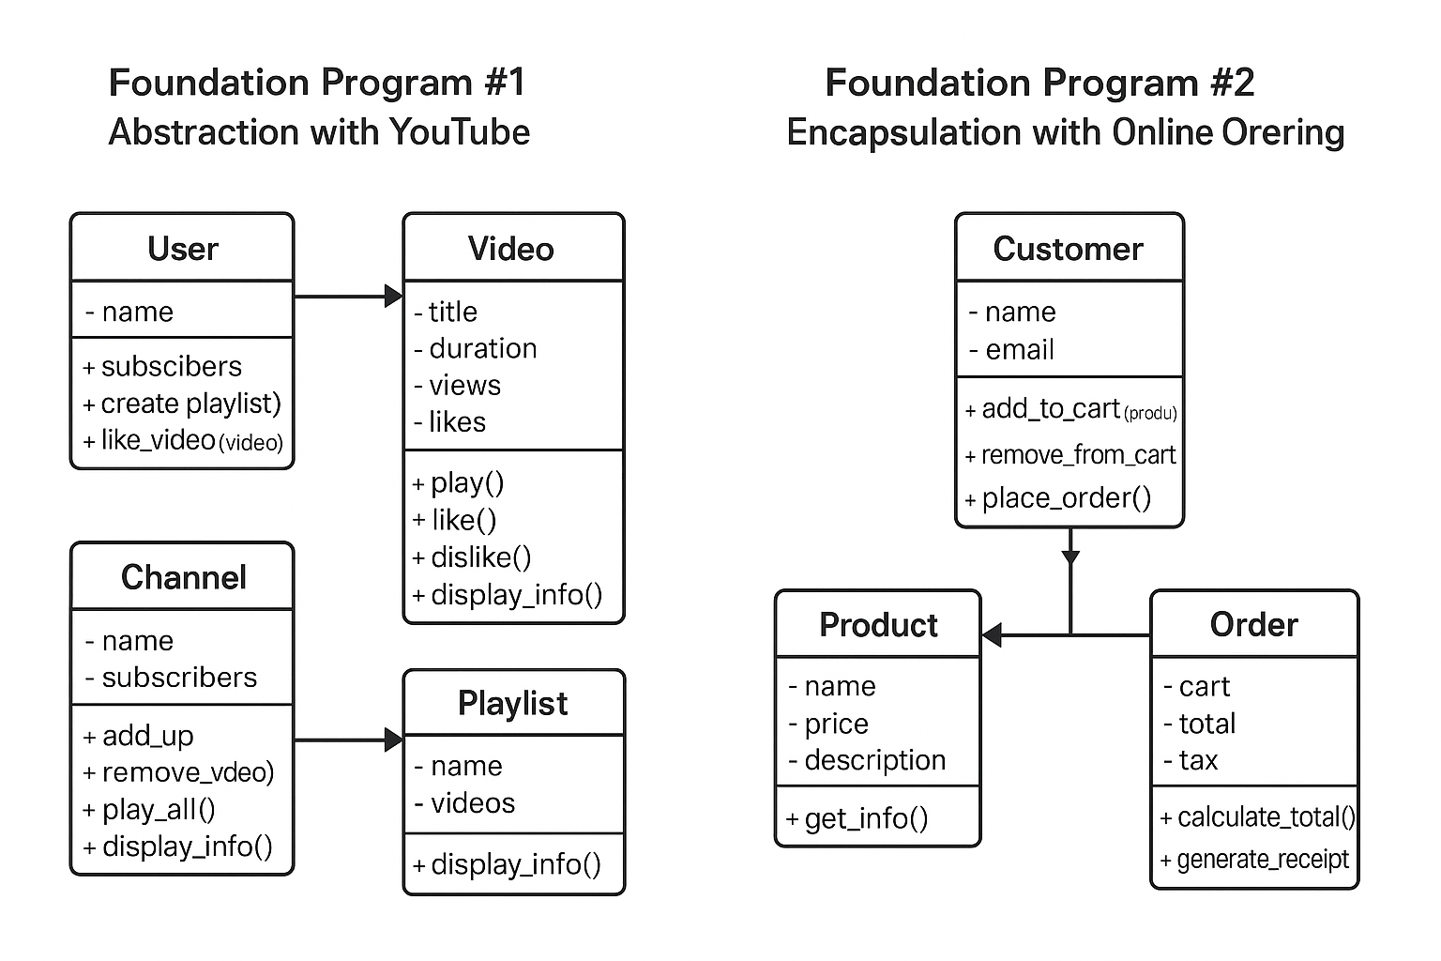

Classes, Attributes, and Methods
User
- name: String
- subscriptions: List<Channel>
- playlists: List<Playlist>
Methods:
+ subscribe(channel)
+ unsubscribe(channel)
+ create_playlist(name)
+ like_video(video)
Video
- title: String
- duration: int
- views: int
- likes: int
- dislikes: int
Methods:
+ play()
+ like()
+ dislike()
+ display_info()
Channel
- name: String
- subscribers: int
- videos: List<Video>
Methods:
+ add_video(video)
+ remove_video(video)
+ display_info()
Playlist
- name: String
- videos: List<Video>
Methods:
+ add_video(video)
+ remove_video(video)
+ play_all()
+ display_info()

Program Flow
1. User browses channels and videos.
2. User plays or likes videos.
3. User creates playlists and adds videos.
4. Channel manages uploaded videos.

Foundation Program #2: Encapsulation with Online Ordering

Classes, Attributes, and Methods
Customer
- name: String
- email: String
- cart: Cart
Methods:
+ add_to_cart(product, qty)
+ remove_from_cart(product)
+ place_order()
Product
- id: int
- name: String
- price: float
- description: String
Methods:
+ get_info()
Cart
- items: Map<Product, int>
Methods:
+ add_product(product, qty)
+ remove_product(product)
+ calculate_subtotal()
+ clear()
Order
- id: int
- cart_snapshot: Map<Product, int>
- subtotal: float
- tax: float
- total: float
Methods:
+ calculate_total(taxRate)
+ generate_receipt()

Program Flow
1. Customer browses products.
2. Customer adds or removes items from cart.
3. Customer places order.
4. Order calculates total and generates a receipt.

