**Fundamentals of Computer Science**

**Exercises Week 1**

**Attempt to solve the following exercises using pen and paper.**

**You can use a computer to write your solution or gather information.**

# Exercise 1

What is the cardinality (the number of elements) of the following sets? Can you describe each of them in plain English? Is there anything ambiguous?

1. {1*,*3*,*5*,*7*,*9*,*11}. 🡪 this is a set containing the following numbers, 1,3,5,7,9,11 and there is nothing ambiguous about it, cardinality of 6
2. {rock, paper, scissors}. 🡪 this is a set containing the following elements “rock”, “paper”, “scissors”, cardinality of 3
3. {1*,*1*,*1*,*1}.-🡪 this is an ambiguous set because in set theory we are advised against using the same element multiple times, the cardinality is {1}

# Exercise 2

Consider two sets *X* and *Y*. What is represented by the shaded regions in the Venn diagrams below?

The first shaded regions represent the union of X and Y {1,2,3,4,5,6} and the second one represents the intersection of X and Y {3,4}

X = {1,2,3,4}

Y= {3, 4,5,6}

# Exercise 3

Recall that

* N = {0*,*1*,*2*,...*} is the set of whole numbers (also called positive integers)
* Z = {*...,*−2*,*−1*,*0*,*1*,*2*,...*} is the set of positive and negative integers
* Q is the set of positive and negative integers as well as all the fractions, such as 1/2, 3/5,etc. This is called the set of rational numbers
* R is the set of real numbers, which is the set of rational numbers plus√ √

all those ‘weird’ numbers, such as *π,* 2*,* 3, etc. In other words, these numbers cannot be described as fractions

* C is the set of complex numbers, which include the *imaginary unit i*.

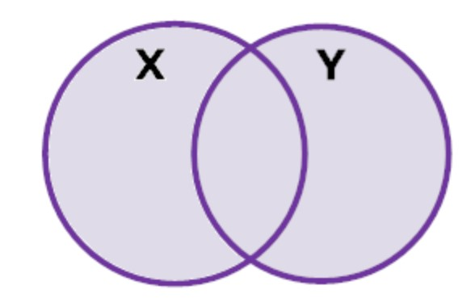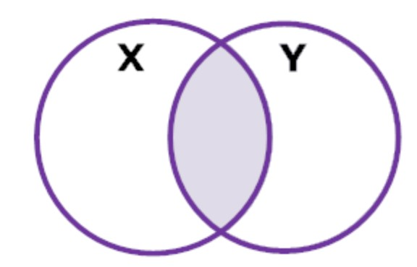

For the following numbers, identify which of the above sets they belong to.

1. 5 🡪 N, Z, Q, R, C
2. 0*.*5 🡪 Q, R, C
3. −15 🡪 Z, Q, R, C
4. 4 − 7*i🡪* C
5. 2 *π 🡪* R, C

6. -3/7 🡪 Q, R, C

7. -3/*π 🡪* R, C

# Exercise 4

Bertrand Russell was a famous mathematician and philosopher, who introduced an important paradox, which can be re-phrased as follows

*Consider a group of barbers who shave only those men who do not shave themselves. Suppose there is a barber in this collection who does not shave himself; then by the definition of the collection, he must shave himself. But no barber in the collection can shave himself. (If so, he would be a man who does shave men who*

*shave themselves.)*

What is the problem identified by this paradox? How would you address this?

Do so some independent research on this paradox.

Russell’s paradox is the reaction to Gottlob Frege’s attempt to develop a foundation for all mathematics using symbolic logic, where one could freely use any property to define other properties. The system is based in terms of sets. If we have the collection of numbers 4,5 and 6, we would be saying that x is the collection of integers, represented by n, that are greater than 3 and less than 7🡪 x = {n: n is an integer and 3 < n < 7} and the objects in the set could be anything, not just numbers. Also, any description of x should fill the space after the colon, however, Russell and, at the same time Ernst Zermelo, observed that x = {a: a is not in a} leads to a contradiction similar to the collection of barbers. The question that leads to that contradiction was: Is x itself in the set x? In the naïve set theory, it was assumed that any coherent condition could be used to determine a set. In the Barber’s case that is “shaves himself” but the set of all men who shave themselves cannot be constructed because we cannot decide whether the barber should or should be in or out of the set which leads to a contradiction.

Russell trye to solve this by proposing the *theory of types* thus introducing a hierarchy of objects, and reasoned that the problem with the barbers stemmed from the confusion of a description of sets of numbers with the description of sets of sets of numbers ( T Baldwn, O Lessmann, 1998). According to the theory of types, at the lowest level there would be the sentences about individuals, then about the sets of individuals and so on which voids the possibility of having to talk about the set of all sets that are not members of themselves. As the two parts of the sentences belong to different levels. This begs the question of why shouldn’t we be allowed to mix levels?

In order to escape the Russell paradox Zermelo-Fraenkel proposed the axiomatisation of set theory: you start with individual entities, make sets out of them and work upwards without assuming there is a set of all sets, therefore you don’t have to attempt to divide the that set up into those sets containing themselves and those that don’t ( H Joyce, 2002).

Helen Joyce also points very well the following: i*f Russell had been aware of the inbuilt sexism of the language of his day, the course of twentieth century mathematics might have been different. There is an easy solution to the Barber's Paradox, which doesn't require the opening of any nasty cans of set-theoretic worms. Just make the barber a woman...*