1 layer of velostat

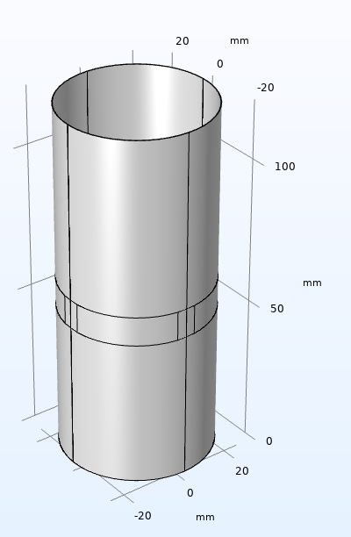

Figure : 1 layer of Velostat before adding the electrodes

Figure : belt partitioned to add electrodes

Figure : Boundary explicit division for 16 electrodes

Figure : velostat material assigned

Figure : velostat pressed