Primeiro relatório

Beatriz

2023-01-26

# devtools::session_info()

library(tidyverse)

## ── Attaching packages ─────────────────────────────────────── tidyverse 1.3.2 ──  
## ✔ ggplot2 3.4.0 ✔ purrr 0.3.5   
## ✔ tibble 3.1.8 ✔ dplyr 1.0.10  
## ✔ tidyr 1.2.1 ✔ stringr 1.5.0   
## ✔ readr 2.1.3 ✔ forcats 0.5.1   
## ── Conflicts ────────────────────────────────────────── tidyverse_conflicts() ──  
## ✖ dplyr::filter() masks stats::filter()  
## ✖ dplyr::lag() masks stats::lag()

pinguins2 <- read_csv('dados/pinguins.csv')

## Rows: 344 Columns: 8  
## ── Column specification ────────────────────────────────────────────────────────  
## Delimiter: ","  
## chr (3): especie, ilha, sexo  
## dbl (5): comprimento_bico, profundidade_bico, comprimento_nadadeira, massa_c...  
##   
## ℹ Use `spec()` to retrieve the full column specification for this data.  
## ℹ Specify the column types or set `show_col_types = FALSE` to quiet this message.

glimpse(pinguins2)

## Rows: 344  
## Columns: 8  
## $ especie <chr> "Pinguim-de-adélia", "Pinguim-de-adélia", "Pingu…  
## $ ilha <chr> "Torgersen", "Torgersen", "Torgersen", "Torgerse…  
## $ comprimento_bico <dbl> 39.1, 39.5, 40.3, NA, 36.7, 39.3, 38.9, 39.2, 34…  
## $ profundidade_bico <dbl> 18.7, 17.4, 18.0, NA, 19.3, 20.6, 17.8, 19.6, 18…  
## $ comprimento_nadadeira <dbl> 181, 186, 195, NA, 193, 190, 181, 195, 193, 190,…  
## $ massa_corporal <dbl> 3750, 3800, 3250, NA, 3450, 3650, 3625, 4675, 34…  
## $ sexo <chr> "macho", "fêmea", "fêmea", NA, "fêmea", "macho",…  
## $ ano <dbl> 2007, 2007, 2007, 2007, 2007, 2007, 2007, 2007, …

## R Markdown

This is a**n R Markdo**wn document. Markdown is a s*imple formatti*ng syntax for authoring HTML, PDF, and MS Word documents. For more details on using R Markdown see <http://rmarkdown.rstudio.com>.

[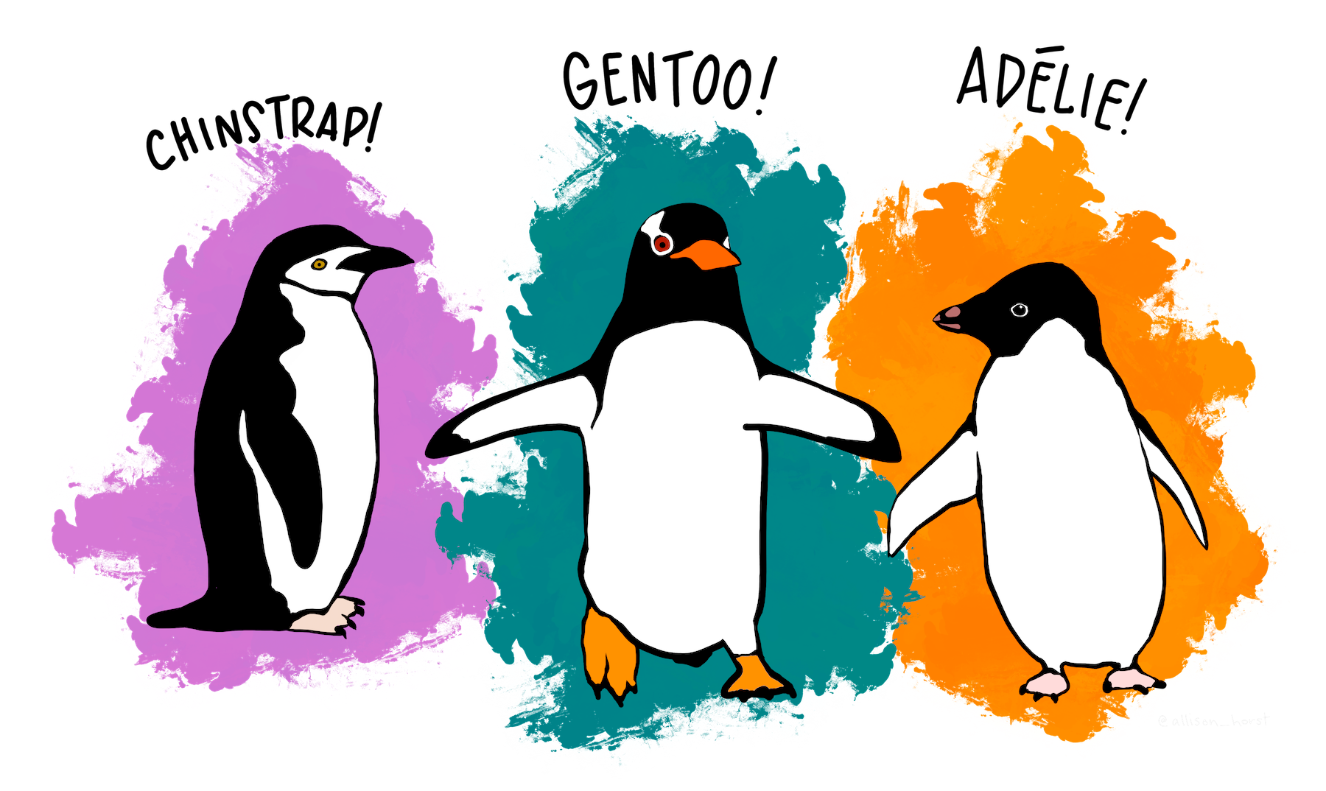](https://allisonhorst.github.io/palmerpenguins/)

[Materiais do curso](https://beatrizmilz.github.io/2023-curso-de-verao-ime-usp-relatorios/slides.html)

* arroz
* feijao
* macarrão

1. Bea
2. Andressa
3. Vitor
4. Gabi
5. Dani

Segundo

exemplo

| Col1 | Col2 | Col3 |
| --- | --- | --- |
|  |  |  |
|  |  |  |
|  |  |  |

When you click the **Knit** button a document will be generated that includes both content as well as the output of any embedded R code chunks within the document. You can embed an R code chunk like this:

summary(cars)

## speed dist   
## Min. : 4.0 Min. : 2.00   
## 1st Qu.:12.0 1st Qu.: 26.00   
## Median :15.0 Median : 36.00   
## Mean :15.4 Mean : 42.98   
## 3rd Qu.:19.0 3rd Qu.: 56.00   
## Max. :25.0 Max. :120.00

## Including Plots

You can also embed plots, for example:

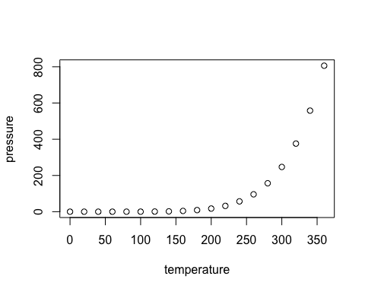

Note that the echo = FALSE parameter was added to the code chunk to prevent printing of the R code that generated the plot.