Machine Problem 1

By: Christopher Masloub

Student Number: 20052223

# Code:

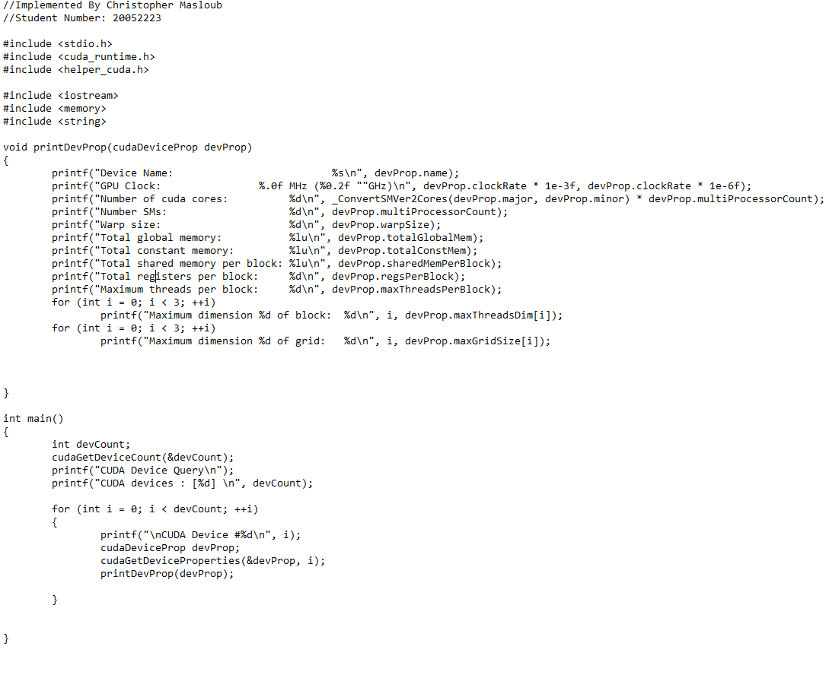The code was written in conjunction with the GPU slides, CUDA sample code and CUDA documentation.

# Output

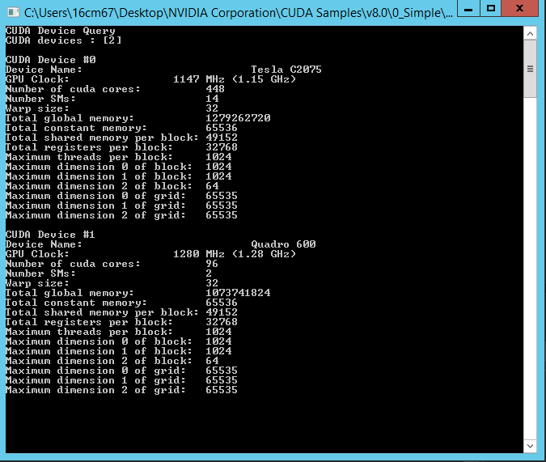We can conclude that there are 2 GPU as identified by the script which are Nvidia Tesla C2075 and Quadro 600.