Which reverts count? Reverter populations, attribution rules and observation windows behind a Wikipedia indicator of information quality work
Hongwon Jeong
Center for Creative Convergence Education, Hanyang University ERICA, Ansan, Republic of Korea. ORCID 0009-0003-7908-7478. Email: beatsbywoni@hanyang.ac.kr

Abstract
Whether an edit was reverted is the most widely used trace of information quality work in Wikipedia, feeding studies of quality control, conflict, newcomer reception and human-bot collaboration. Yet “reverted” depends on choices that are seldom reported: who may count as a reverter, by which rule a later revision is attributed to an earlier edit, and for how long the edit is observed. A structured review of 34 studies shows that most leave these choices unstated and none varies the reverter population. This study measures their effects. The first edits of 3.2 million newcomers in seven language editions are held fixed while reverter population, attribution rule and window are varied; three editions were held out for registered tests. Bots, one-click tools, unregistered editors and the newcomers themselves each make a share of reverts, and the newcomers they revert differ in later retention. Excluding a class changes the indicator by its share, and later reverts do not compensate: follow-up reverts are as frequent after human as after automated first reverts. The direction of the window effect reverses between attribution rules, and the software’s revert tag omits most reverts by unpatrolled editors where edits are patrolled. A tiered reporting checklist is proposed.
Keywords: information quality; trace data; measurement validity; Wikipedia; reverts; bots; operationalization

Introduction
Information science treats quality as something that has to be constructed before it can be measured. Frameworks of information quality distinguish dimensions, link them to the activities that produce them and warn that the same indicator can stand for different things in different contexts of use (Stvilia et al., 2007; Arazy & Kopak, 2011; Mai, 2013). Wikipedia has been the field’s main site for studying how quality is produced collectively, and research on its content and community is large enough to have been systematically reviewed in this journal (Mesgari et al., 2015). Stvilia et al. (2008) described the organization of “information quality work” in Wikipedia: the roles, processes and tools through which articles are corrected and defended. The most accessible trace of that work is the revert, an edit that restores a page to an earlier state and thereby removes someone else’s contribution.
Because every revert is recorded, “was this edit reverted” has become a general-purpose indicator. It is read as a judgement on the quality of an edit, as a measure of conflict (Kittur et al., 2007; Yasseri et al., 2012; Arazy et al., 2013), as the rejection a newcomer experiences (Halfaker et al., 2011, 2013), as a label for training quality-prediction models (Trokhymovych et al., 2023), as an outcome in onboarding experiments (Warncke-Wang et al., 2023) and as evidence about the division of labor between humans and automated agents (Geiger & Halfaker, 2013; Zheng et al., 2019; Gao et al., 2026). These uses presuppose different constructs. A judgement on an edit, an experience of rejection and a quantity of human effort are not the same thing, and they are not carried by the same reverts.
A revert is a relation between an edit and a later revision, so the indicator requires the analyst to decide which later revisions count. Three decisions are involved. The first is the reverter population: Wikipedia’s quality work is done by bots, by trusted editors using one-click tools such as rollback, Huggle and Twinkle, by other registered and unregistered editors using the undo function or editing by hand, and by authors who take back their own edits (Geiger & Ribes, 2010; Halfaker & Riedl, 2012). The second is the attribution rule that links a later revision to the edit it undoes: the Wikimedia history dumps search a page’s entire history, the widely used mwreverts library searches the last 15 revisions, and since 2020 the MediaWiki software tags reverted revisions itself. The third is the observation window, from the 48 hours used in Wikimedia’s experiments to the whole lifetime of the page. Research on the validity of digital trace data has shown repeatedly that decisions of this kind, taken during preprocessing and often undocumented, can drive results (Howison et al., 2011; Hill & Shaw, 2014; Geiger & Halfaker, 2017; Sen et al., 2021). For reverts, detection accuracy has been examined (Ekstrand & Riedl, 2009; Flöck et al., 2012; Kiesel et al., 2017), but how far the indicator moves with the three decisions has not been measured.
This study asks three questions. How are the three decisions handled and reported in published work? Holding the measured edits fixed, how far do the newcomer revert rate, editor rankings and the association between being reverted and staying move when the decisions change? And are reverts made by different classes of reverter the same kind of event, in what follows them and in whom they affect? I answer the first with a structured review of practice and the others with a fixed-edit audit of 3.2 million newcomer first edits in seven language editions of Wikipedia, in the spirit of a multiverse analysis (Steegen et al., 2016) but with a registered split: four editions were explored, the design and hypotheses were registered, and three editions were opened afterwards.
The contribution to information science is a specification of what this indicator of quality work is an indicator of. The audit shows that a revert rate is a mixture whose components differ by who acted, that the components are not interchangeable in what they imply for the reverted contributor, that removing a component is not offset by later reverts, that the window effect depends on the attribution rule, and that the software’s own tag encodes the reverting editor’s trust status. Some of these results are arithmetic consequences of definitions and are presented as such; the empirical content lies in the sizes of the components, in what follows a first revert, and in the coverage of the tag. The paper ends with a reporting checklist tied to the construct an analyst intends to measure.

Conceptual background

One trace, three constructs
Stvilia et al. (2007) define information quality relative to activities and their contexts, and Mai (2013) argues that quality cannot be read off an information object without reference to the conversation in which it is used. Applied to reverts, the point is that the trace is produced by quality work but is not itself a quality score. Arazy and Kopak (2011) found that raters often disagree when assessing quality dimensions of Wikipedia articles, which makes it all the more important to know what a behavioral proxy admits.
Three constructs recur in the literature, and each implies a different reverter population (Table 1). If the revert stands for a quality judgement on the edit, every revert that removes the edit counts, whoever made it, though a self-revert is a different judgement from a rejection by others. If it stands for the contributor’s experience of rejection, as in research on newcomer socialization and retention (Choi et al., 2010; Halfaker et al., 2013; Morgan & Halfaker, 2018), self-reverts should not count and the mode of rejection matters, since a templated rollback within seconds and a hand-written correction are different encounters. If it stands for human quality-work effort, as in studies of how communities and algorithms share governance (Müller-Birn et al., 2013; Zheng et al., 2019; TeBlunthuis et al., 2021), bot reverts are a separate category and the status of one-click tools has to be decided, because a tool revert is a human judgement delivered with machine assistance (Halfaker & Riedl, 2012).
Table 1. Constructs a revert is used to indicate and the choices each implies.
Construct | Reverter population implied | Window implied | Attribution concern
Quality judgement on the edit | All reverters; self-reverts reported separately | Long or unbounded: has the edit survived | Reverts that undo many edits at once
Contributor’s experience of rejection | Others only; mode (bot, tool, manual) distinguished | Short: what the contributor meets while still present | Was this edit the one targeted
Human quality-work effort | Humans; bots separate; tools decided explicitly | Matches the period of work studied | Each act of reverting counted once

Detecting and attributing reverts
The identity revert, an edit that returns a page to a byte-identical earlier state, is the standard operationalization (Kittur et al., 2007). Ekstrand and Riedl (2009), Flöck et al. (2012) and Kiesel et al. (2017) examined its accuracy and proposed alternatives. Two implementations dominate. The mwreverts library searches a window of 15 revisions; the convention goes back to Priedhorsky et al. (2007), who limited the distance between a damaged revision and its repair to 15 revisions on the stated assumption that essentially all damage is repaired within that span. The mediawiki_history dataset released by the Wikimedia Foundation instead marks a revision as reverted if any later revision of the page restores a state that preceded it, with no radius and no time limit. A third source is the mw-reverted change tag, active on Wikimedia wikis since 15 September 2020, which the software applies when it recognizes the reverting edit as an undo, a rollback or a manual revert within 15 revisions.
The rules differ in what they attribute. Under the unbounded rule, an edit removed by one revert can be “reverted” again years later by any revision that returns the page to a still earlier state; under the radius rule this is rare. The difference is immaterial for asking whether an edit was ever undone, and decisive for asking who undid it and when.

Automation and edition differences
Geiger and Halfaker (2013) used an outage of the anti-vandalism bot ClueBot NG as a natural experiment and found that edits made during the outage were eventually reverted, but more slowly. The study has become the standard justification for the 48-hour window. What it does not license is an inference about observational data in which the bot is present: there, discarding bot reverts after the fact does not reveal what humans would have done. Language editions also differ in institutions that shape reverting. Some hold edits by new and unregistered users for review through FlaggedRevs (Tran et al., 2022), some patrol recent changes, the rollback right is granted on different terms, and communities differ in norms of interaction (Hara et al., 2010). An indicator compared across editions inherits these differences.

How reverts are operationalized in published work
To establish what practice the audit should address, I reviewed empirical studies and official Wikimedia analyses from 2005 to 2026 in which a revert-based measure is an outcome, an exposure, a label or a key descriptive quantity. Candidates were assembled from the citation networks of the works cited above and from keyword searches of OpenAlex; a study was retained only if its methods text could be read, so the set is a structured sample, not a census. Each was coded for detection rule, treatment of reverts made by bots, by one-click tools and by the author, observation window, and any sensitivity analysis over these choices. Coding was done with the assistance of a language model and then re-verified against the source text; the supplement lists every study with the establishing sentence and its evidence level (Table S1).
Table 2. Reporting of revert operationalization in 34 studies, 2005 to 2026.
Choice | Stated | Not stated
Detection rule | 24 (identity hash 14; dump field 3; hash plus edit summaries 3; other 4) | 10
Search radius, where a hash rule is used | 6 | 28
Reverts made by bots | 9 (modelled separately 5; counted 2; excluded 2) | 25
Reverts made with one-click tools | 4 (modelled separately 2; counted 2) | 30
Self-reverts | 15 (excluded 14; counted 1) | 19
Observation window | 12 (time-bounded 5; revision-bounded 3; unbounded 4) | 22
Sensitivity analysis over any revert choice | 9 (full 3; partial 6) | 25
Sensitivity analysis over the reverter population | 0 | 34
Thirty-four studies met the criteria, 20 published before 2019 and 14 since; 20 concern the English edition only (Table 2). Ten do not state how reverts were detected, and most that use a hash rule give no radius. Twenty-five do not say whether reverts made by bots are counted. Where bots are mentioned it is often as authors: ten studies remove bot-authored edits from the sample, and eight of these are silent on reverts that bots perform. Two studies exclude bot reverts from the measure (West et al., 2010; Tsvetkova et al., 2016), five treat the type of reverter as a variable or focus on it, all before 2019, and thirty say nothing about one-click tools. Self-reverts are the most often addressed, and when addressed are almost always excluded. Twenty-two studies state no observation window; of the five with a time bound, three use 48 hours, two of them citing Geiger and Halfaker (2013). Only one study reports the detection rule, the treatment of bot reverts and self-reverts, and the window together, and none since 2019 does. No study varies the reverter population as a sensitivity analysis.
Three features of this record shape the audit. First, the exclusions actually made in the literature are of self-reverts, commonly, and of bot reverts, rarely; excluding tool-assisted reverts is not an established practice, although Halfaker et al. (2013) and TeBlunthuis et al. (2018) model tool or bot reverts as a separate exposure. The dominant practice is silence. The audit therefore sizes every reverter class, treats self-revert and bot exclusion as practices and tool exclusion as a hypothetical filter that shows what the indicator contains. Second, where a window is stated it is now usually 48 hours, justified by a single study of the English edition. Third, no study was found that notes the conditions under which the mw-reverted tag is applied.

Method

Data and cohort
The data are the mediawiki_history dumps of version 2026-09. Each row is a revision, page or user event; the column order (78 fields) was taken from the source code of the Wikimedia Analytics Refinery because the published documentation described an older schema (Endnote 1). Seven editions were processed: English (January 2018 to September 2026, 643 million revision rows) and the complete histories of Italian, Korean, German, Polish, French and Japanese.
The unit is a registered editor whose first edit in any namespace was made in the article namespace; that edit is the measured edit. Editors whose first edit was elsewhere (6.5 to 13.1 percent of first-time editors) are outside the cohort, as are unregistered and temporary accounts and accounts flagged as bots. The primary cohort is self-created accounts whose first edit dates from 1 January 2019 to 31 March 2026, leaving at least 180 days of follow-up: 3,246,958 editors (Table 3). First edits are the population for which revert indicators are most often computed in research on newcomers, and one edit per editor makes the editor the unit of inference.

Attribution rules
Three rules are compared. The dump rule is the revision_is_identity_reverted flag with the identifier of and delay to the first reverting revision. Reading the refinery source established that the flag groups a page’s revisions by content hash over its entire history; the first occurrence of a hash is a base, later occurrences are reverts to that base, and a revision is reverted if a later revert has a base that precedes it. Reverts to the same base do not revert each other, and a revision whose parent is the previous revision with the same hash is not counted as a revert, a filter added to the source in mid-2026 (Endnote 1). I reimplemented the rule from the hashes and compared it with the flag on all Korean first edits and on year-stratified samples of 60,000 first edits in each other edition: status agreed on all but 0 or 1 edits in the five other editions with complete histories, on 99.98 percent in Korean and 99.9 percent in English, where the downloaded period is partial. The radius rule applies the mwreverts convention of 15 revisions to the same recomputation. The tag rule is the mw-reverted tag on the measured edit.

Reverter classes
The first revert of each measured edit is assigned to one class, in this order: bot (the dump’s bot flags, current or historical, set by username pattern or bot group); one-click tool (the reverting revision carries the mw-rollback, huggle or twinkle change tag); self (the reverting account is the author); unregistered; and other manual (any other registered account, including those using the undo function). Tool identification rests on tags whose availability differs: rollback is tagged in all seven editions from December 2017; Huggle is tagged in English and French, and in the English data almost no revisions carry the tag in 2021 and 2022; Twinkle is tagged only in English and only from September 2020, and it works through the undo interface. In five editions the tool class is therefore the exercise of the rollback right, and English estimates are given for first edits from 2021 as well as for the whole period (Table S3). Undo is treated as manual; counting it as a tool is reported as a variant.

Quantities
For a window W, p(W) is the share of measured edits reverted within W. Excluding a class in the strict sense recodes edits first reverted by that class as not reverted; the change in p equals the class’s share of first reverts times p. This is an identity, reported as a description of the indicator’s composition. The replace variant, which the registration treated as the object of testing, instead looks for the first later revert by a non-excluded reverter. To learn what such later reverts are, I compute for every first revert whether a manual revert of the same measured edit by someone else follows it, separately by class of the first reverter and under both attribution rules, and classify what happened in between: the measured edit’s content was reinstated, the later revert came immediately and restored a still earlier state, or other edits intervened. Comparing follow-up rates after automated and after manual first reverts serves as a placebo: if later human reverts were a response to automation, they should be more frequent after bot and tool reverts.
Downstream quantities are the share of editors who edit again between day 2 and day 60, by class of first revert within 24 hours; the rank agreement of editor-level success rates (one minus the reverted share of an editor’s article edits in the first 90 days, for editors with at least ten) with and without tool and bot reverts; and tag coverage, the share of reverts found by the radius rule whose measured edit carries no mw-reverted tag, for first edits from October 2020, by class of reverter and by the edition’s patrolling regime read from the Wikimedia configuration (Endnote 2). Intervals are Wilson intervals for shares and percentile intervals from 2,000 bootstrap resamples of editors for ratios. Quantities that need page histories use the 60,000-edit samples (all 47,629 Korean first edits with a usable history).

Registration and its limits
Design, hypotheses and code were registered on Zenodo (https://doi.org/10.5281/zenodo.23720117) after English, Korean, French and German had been analyzed and before the outputs for Japanese, Polish and Italian were opened. The registration should be read as a hold-out replication with thresholds fixed in advance, not as a blind preregistration: the thresholds were set from the exploratory editions, and the confirmatory editions had been downloaded and processed by the same batch driver before the registered commit, with output files unopened, a sequence documented by commit and log timestamps that a reader cannot independently verify (the registration text states elsewhere that these editions had not been downloaded, which is inaccurate). Four hypotheses were registered: H1, that the replace effect of excluding bots and tools is larger within 24 hours than in the unbounded window, with the ratio R of the two as effect size; H2, that the share of bot- or tool-reverted edits later reverted by a human within 24 hours is below .25; H3, that the tag and radius rules agree on at least 95 percent of edits and that more than half of the edits the dump rule marks reverted but the tag does not lie beyond the radius; and H4, that the odds ratio of retention for reverted versus non-reverted edits varies by a factor of at least 1.5 across nine filter-by-window cells. All four outcomes are reported below. The analyses of follow-up reverts by reverter class, of the radius rule for H1, of self-reverts, of retention by class and of tag coverage by class were designed after a critical reading of the first results and are exploratory in all seven editions; the deviation log in the repository lists them, together with registered analyses that were dropped because they could not fail (a negative control) or carried no information (a saturated regression and a simulation).

Transparency
Code, cell-level aggregates, the review table, figure data, logs and the deviation log are public (https://github.com/beatsbywoni/wiki-revert-audit; archived release, Jeong, 2026). Editor-level files are not released, and usernames of reverting accounts were used only to identify self-reverts and are not retained in outputs. The study uses public edit histories, reports aggregates only and involved no interaction with editors; it was not submitted for ethics review on that ground. Generative AI (Claude, Anthropic) was used to draft analysis code and prose and to assist the coding of the literature review; the author specified the design, made the analytic decisions, checked the code against the primary sources cited and against independent recomputation, verified the review coding against source texts, and is responsible for every statement. All computation is by the released deterministic code on unmodified dumps. The study received no funding, and the author declares no competing interests.

Results

What a revert rate is made of
Within 24 hours, 14.0 percent (Japanese) to 37.0 percent (English) of newcomer first edits were reverted (Table 3, Figure 1). The first revert came from a bot in 12.2 percent of cases in English and 4.2 percent in French, where anti-vandalism bots operate, and in at most 0.3 percent elsewhere. One-click tools made 24.7 percent (Japanese) to 52.5 percent (Italian) of first reverts. The newcomers themselves made 2.7 to 11.4 percent and unregistered editors 1.2 to 9.6 percent; the remainder, 28.9 to 64.3 percent, were manual reverts by other registered editors, 48 to 71 percent of them through the undo function.
Table 3. Cohorts and composition of first reverts within 24 hours (dump rule, all first edits of self-created accounts, 2019 to March 2026). Shares are of first reverts; the strict effect of excluding a class, in percentage points, is its share times p. Editions marked * were held out for registered tests.
Edition | First edits | p(24 h) | Bot | One-click tool | Other manual | Unregistered | Self
English | 2,189,284 | .370 | .122 | .448 | .364 | .023 | .044
Italian* | 135,400 | .342 | .000 | .525 | .407 | .024 | .044
Korean | 47,633 | .216 | .003 | .516 | .289 | .096 | .096
German | 236,903 | .256 | .001 | .410 | .545 | .017 | .027
Polish* | 67,755 | .222 | .001 | .315 | .616 | .030 | .038
French | 346,938 | .243 | .042 | .255 | .643 | .012 | .047
Japanese* | 223,045 | .140 | .001 | .247 | .558 | .080 | .114
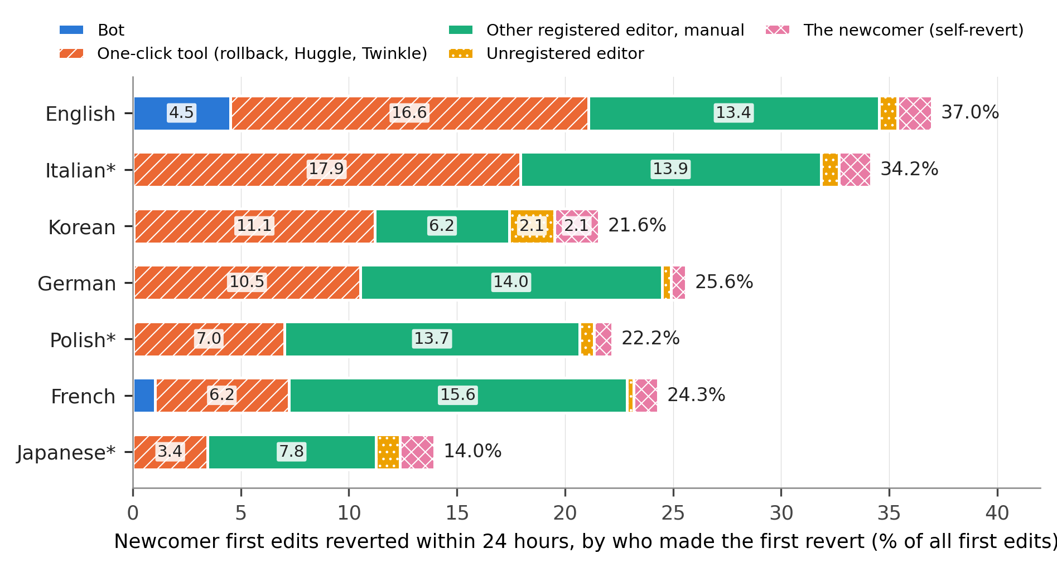
Figure 1. Newcomer first edits reverted within 24 hours, by who made the first revert, as a percentage of all first edits. Segment widths are the strict effects of excluding each class. Asterisks mark editions held out for registered tests.
The practices found in the literature therefore have small and edition-specific effects. Excluding bot reverts lowers the 24-hour rate by 4.5 points in English, 1.0 in French and less than 0.1 elsewhere. Excluding self-reverts lowers it by 0.7 (German) to 2.1 points (Korean). The hypothetical exclusion of one-click tools would lower it by 3.4 (Japanese) to 17.9 points (Italian), and counting undo as a tool would add 5.7 to 11.7 points more (Table S3). In English the tool share rises from .448 to .524 for first edits from 2021, when Twinkle reverts are tagged; the whole-period figure understates it. These are compositional facts, not effects: they say that between a quarter and a half of what a newcomer revert rate counts is the use of one-click tools, almost none of it outside English and French is bot activity, and a non-trivial part is newcomers correcting themselves.

Later reverts do not replace excluded ones
If a class of reverts is excluded, does a later revert by someone else take its place? Under the dump rule, a later manual revert of the same first edit followed 8.9 to 14.5 percent of bot or tool first reverts within 24 hours and 19.8 to 38.5 percent in the unbounded window (Table 4). The registered H2, that this share is below .25 within 24 hours, was supported in the three held-out editions (Japanese .145, one-sided 95 percent upper bound .157; Polish .111, .119; Italian .114, .119).
The placebo shows what this quantity is. After a manual first revert by another editor, a further manual revert followed 9.1 to 23.9 percent of cases within 24 hours and 18.7 to 41.9 percent in the unbounded window. Follow-up was more frequent after manual than after automated first reverts in English, Italian, Korean, French and Japanese, about equal in German and less frequent in Polish (Figure 2); nowhere is it concentrated after automation. The follow-up revert is not a human response to automation. Its composition says the same. Of all first edits first reverted by a bot or tool, only 1.2 to 4.4 percent (12.7 percent in Korean) were reverted again after their content had been reinstated; the other follow-up events were reverts that reached further back or that undid unrelated later edits, which the dump rule attributes to every earlier revision they span. Under the radius rule follow-up is rare whoever reverted first: 1.7 to 6.3 percent within 24 hours and 2.7 to 7.4 percent unbounded after bots and tools, 0.8 to 5.1 and 1.1 to 6.4 percent after manual reverts.
Table 4. Follow-up manual reverts and the window ratio R under two attribution rules. Follow-up: share of first edits first reverted by the class shown that were later reverted manually by another editor, unbounded window. R: replace effect of excluding bots and tools in the unbounded window divided by the effect within 24 hours, with 95 percent bootstrap intervals.
Edition | Follow-up after bot or tool, dump rule | Follow-up after manual, dump rule | Follow-up after bot or tool, radius rule | Follow-up after manual, radius rule | R, dump rule | R, radius rule
English | .217 | .282 | .027 | .027 | .92 [.92, .93] | 1.05 [1.04, 1.05]
Italian* | .279 | .318 | .044 | .036 | .84 [.83, .85] | 1.02 [1.02, 1.03]
Korean | .385 | .419 | .074 | .064 | .78 [.76, .79] | 1.07 [1.07, 1.09]
German | .198 | .187 | .033 | .011 | .92 [.91, .93] | 1.04 [1.03, 1.04]
Polish* | .280 | .217 | .060 | .017 | .88 [.86, .89] | 1.07 [1.06, 1.08]
French | .279 | .293 | .034 | .022 | .86 [.84, .87] | 1.04 [1.03, 1.05]
Japanese* | .258 | .320 | .070 | .040 | .92 [.90, .94] | 1.05 [1.04, 1.06]
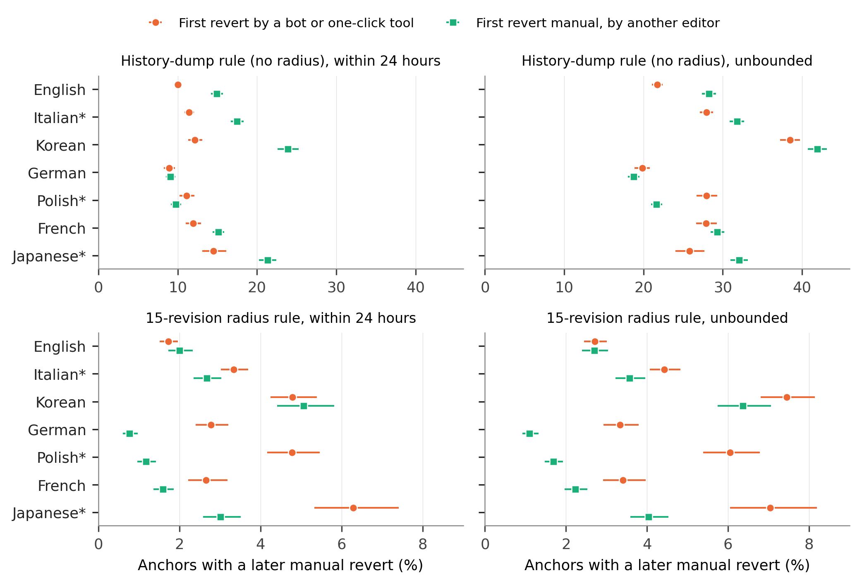
Figure 2. First edits with a later manual revert by another editor, by who made the first revert, under the dump rule (top) and the 15-revision radius rule (bottom), within 24 hours (left) and unbounded (right). Bars are 95 percent Wilson intervals. Note the different horizontal scales.

The window effect depends on the attribution rule
The registered H1 predicted that the replace effect of excluding bots and tools shrinks as the window lengthens. Under the dump rule it did, in all three held-out editions: the difference between the 24-hour and unbounded effects was 0.24 points in Japanese (one-sided 95 percent lower bound 0.19), 0.77 in Polish (0.68) and 2.49 in Italian (2.36), and R was .92, .88 and .84 (Table 4). Under the radius rule the direction reverses in all seven editions: R ranges from 1.02 to 1.07, with every interval above 1. With a fixed 180-day window in place of the unbounded one the pattern is the same (Table S4). H1 is thus supported as registered and not robust to the attribution rule; because R is an algebraic function of the follow-up shares at the two windows, H1 and H2 are one finding, not two. What can be said without qualification is that the size of a class’s contribution does not fade with a longer window under either rule, and that whether it appears to shrink or grow is a property of the rule.

Reverts by different classes are different events
Newcomers whose first edit was not reverted within 24 hours edited again on days 2 to 60 in 17.1 to 26.6 percent of cases (Figure 3). Of those reverted with a one-click tool, 3.5 to 8.6 percent did; of those reverted manually by another registered editor, 10.4 to 14.2 percent; of those who reverted themselves, 11.3 to 19.9 percent. Expressed as odds ratios against non-reverted newcomers, tool reverts range from 0.10 to 0.38, manual reverts by others from 0.41 to 0.71 and self-reverts from 0.55 to 0.68 (Table S5). These are associations: tools are aimed at vandalism, and the edits they remove differ from those corrected by hand. The point for measurement is that a single “reverted” category averages over events whose relation to the contributor’s future differs by a factor of 1.4 to 4 in odds.
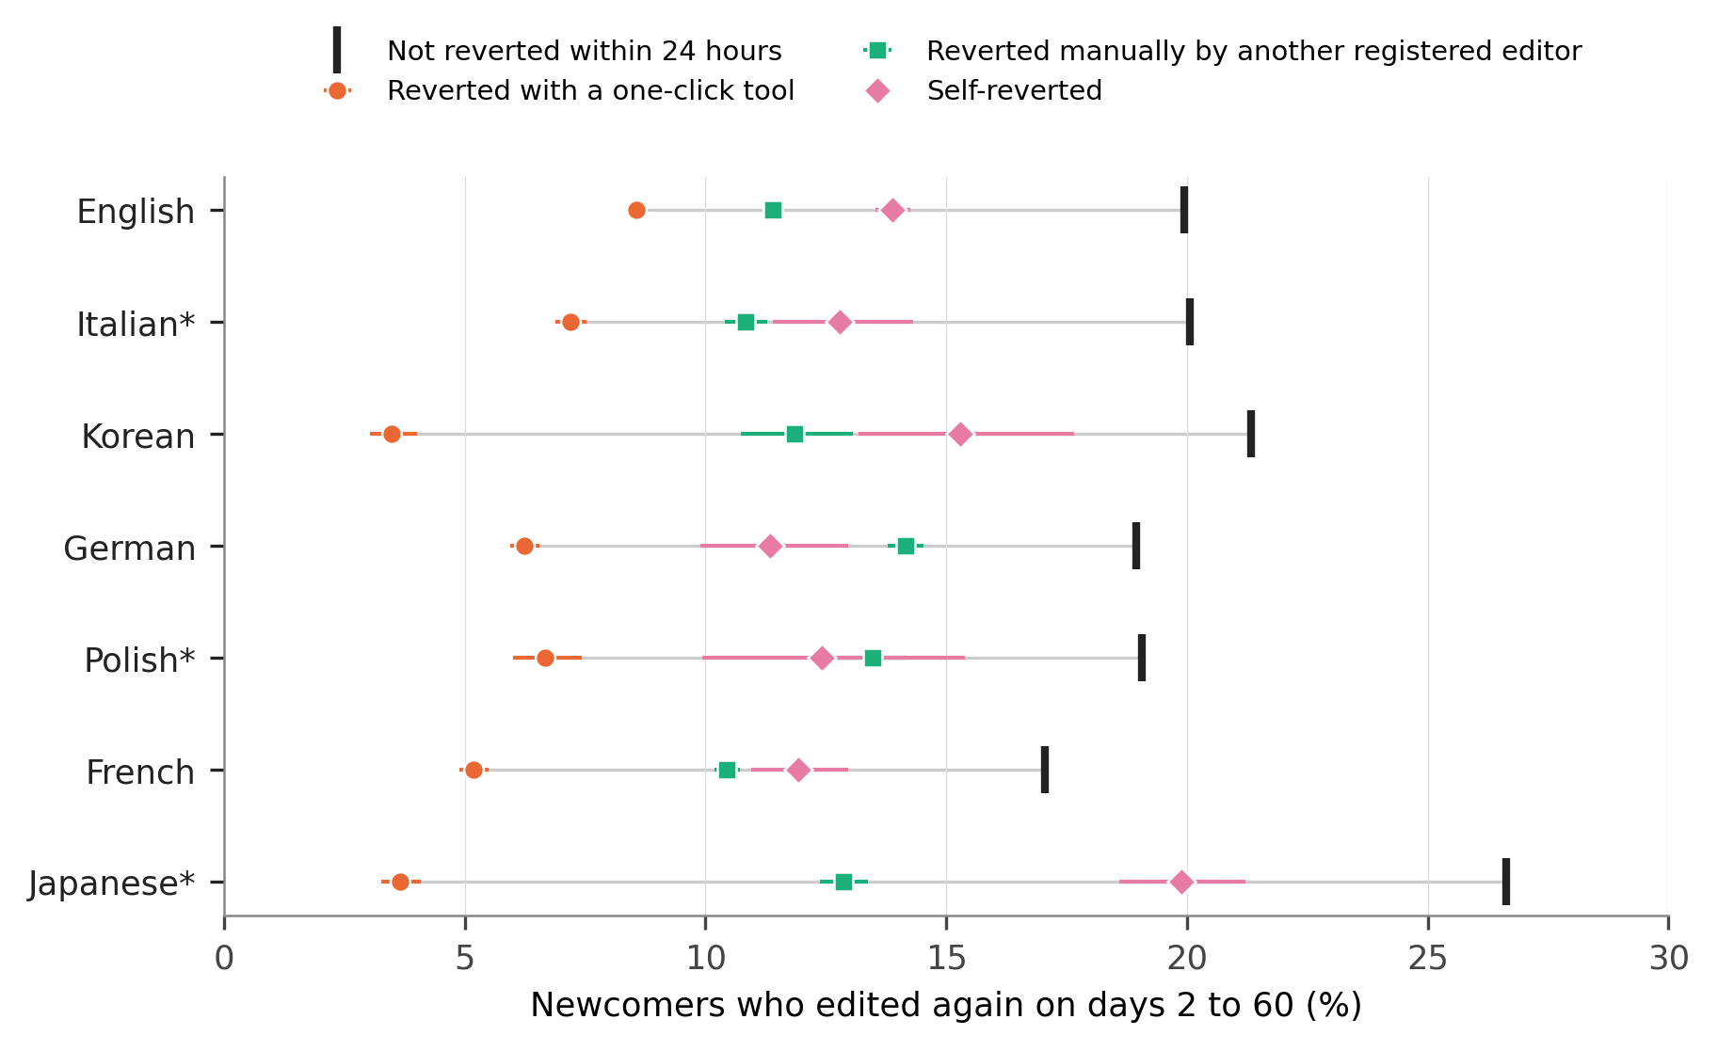
Figure 3. Newcomers who edited again on days 2 to 60, by who made the first revert of their first edit within 24 hours. Bars are 95 percent Wilson intervals; the grey line spans the classes within an edition.
This is what moves downstream estimates when the reverter population changes. The registered H4 compared nine cells (all reverts, without bots, without bots and tools; 24 hours, 7 days, unbounded). The ratio of the largest to the smallest odds ratio was 1.84 [1.79, 1.89] in Japanese and 1.78 [1.72, 1.85] in Italian, above the registered 1.5, and 1.43 [1.37, 1.49] in Polish, below it; the exploratory values were 1.51 to 1.79, and 3.01 in Korean. The movement is compositional: recoding tool-reverted newcomers, the group least likely to return, as not reverted raises the odds ratio mechanically, and the longer windows in these cells overlap the outcome period, so only the 24-hour cells have a clean temporal order. Editor-level rankings shift for the same reason. Among editors with at least ten article edits in 90 days (5,781 in Polish to 204,717 in English), the rank correlation between success rates with and without bot and tool reverts was .75 to .94, and 25 to 56 percent of the lowest decile changed membership.

The tag rule depends on who reverted
The tag and radius rules agreed on 98.6 percent of first edits in Japanese, 97.9 in Polish and 95.4 in Italian, meeting the first clause of H3. The second clause was rejected in all three: of the edits that the dump rule marked reverted and the tag did not, 42, 9 and 7 percent lay beyond the radius, against the registered expectation of more than half, which had been derived from Korean.
The exploratory follow-up locates the gap. The MediaWiki manual states that the tag is applied by a deferred job once the reverting edit is approved: immediately if the reverter has the autopatrol right, and otherwise when another user patrols the edit, so that “reverts that are not patrolled will not be marked with the reverted tag”; the job also skips reverts deeper than 15 revisions and reverting edits that are themselves reverted or deleted (MediaWiki, n.d.). Tag coverage follows this rule closely (Figure 4). For first edits from October 2020, the share of radius-rule reverts whose measured edit carries no tag was 0.3 to 1.0 percent in English, Korean and Japanese, which do not patrol edits; 2.4 and 3.9 percent in German and Polish, which use FlaggedRevs; and 9.6 and 7.0 percent in Italian and French, which patrol recent changes. By reverter the contrast is starker. In Italian and French, 79 and 72 percent of reverts by unregistered editors and 71 and 73 percent of newcomers’ self-reverts were untagged, against 11 and 3 percent of manual reverts by other registered editors and under 1 percent of tool reverts. In German and Polish the figures for unregistered reverters were 24 and 29 percent, and in the three editions without patrolling at most 0.2 percent. Patrol status itself is not in the dumps, and seven editions cannot separate the regime from other differences between communities; but the mechanism is documented in the software and the pattern by reverter class is what it predicts.
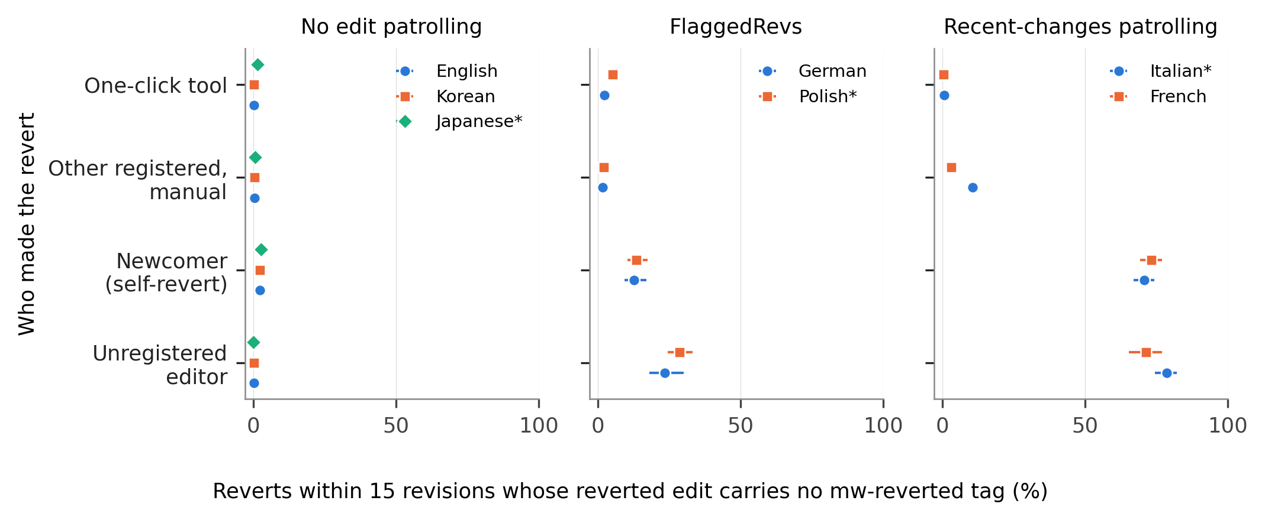
Figure 4. Reverts found by the 15-revision radius rule whose reverted edit carries no mw-reverted tag, first edits from October 2020, by who made the revert and by the edition’s patrolling regime. Bars are 95 percent Wilson intervals. Exploratory.

Discussion

What the indicator indicates
Returning to the three constructs: as a quality judgement on the edit, the revert flag performs as intended only in its most inclusive form, and even then 3 to 11 percent of the judgements are the authors’ own. As the contributor’s experience of rejection, it mixes encounters that differ both in kind and in what follows them: a newcomer reverted with a one-click tool and a newcomer corrected by hand are 1.4 to 4 times apart in their odds of returning, and the edition determines which encounter is typical, a tool in Italian, Korean and English, a manual revert in Polish, French and Japanese. As human quality-work effort, the flag needs the least adjustment where it is most often adjusted: bots account for a material share of first reverts only in English and French, while the unsettled question, whether a rollback is human work, concerns a quarter to a half of all reverts everywhere. The review found that published studies seldom say which of these they mean, and Table 1 is offered as a way to say it.
Two results concern what cannot be recovered by analysis. Excluding a class of reverts after the fact does not produce the indicator that would have been observed without that class: later reverts by others follow at similar rates whoever acted first, and most of them are not about the same content. The window, on which practice has converged, matters less than the rule by which reverts are attributed, and the apparent fading of a filter’s effect over time is produced by the unbounded rule’s attribution of deep reverts to every revision they span. Neither rule is wrong. The unbounded rule answers whether content was ever removed, the radius rule answers who removed it; analysts using the history dumps for the second question inherit the first rule unless they recompute.

Implications
For studies of quality work and of human-bot collaboration in knowledge communities (Stvilia et al., 2008; Gao et al., 2026), the practical consequence is to report the composition of reverts by reverter class alongside any rate, and to choose exclusions from the construct, not from convention. For comparative work, the indicator is not edition-neutral: tool shares reflect how each community grants the rollback right and which tools are tagged, FlaggedRevs changes what an unreviewed edit and its revert mean (Tran et al., 2022), and a 48-hour window validated on English is applied elsewhere without test.
The tag result is the most immediately usable. The mw-reverted tag is the cheapest revert indicator, since it needs no recomputation, and in editions that patrol edits it systematically omits reverts by unregistered and newly registered people. A comparison of tag-based revert rates between, say, French and English will read a configuration difference as a difference in reception, and a model trained on the tag will learn that reverts by unpatrolled editors did not happen.
Beyond Wikipedia the argument can only be stated as a conjecture. Indicators built from later events, such as removals and flags on platforms that combine automated and human moderation (Jhaver et al., 2019; Gorwa et al., 2020), have the same structure, and the same questions about who acted and by which rule an action is tied to a contribution apply to them. Whether excluded automated actions are followed by human ones there is an empirical matter that this study does not address.

A tiered reporting checklist
The review suggests that a short list with a low entry cost is more likely to be used than an ideal one, in the manner of earlier calls for reporting standards in this field (Geiger & Halfaker, 2017; Geiger et al., 2020). Table 5 separates what any study can state from what requires recomputation.
Table 5. Reporting checklist for revert-based indicators.
Tier | Item
Always (no extra computation) | 1. The construct the revert stands for (Table 1).
 | 2. The attribution rule: source field, library and radius, or tag.
 | 3. The observation window and its justification for the editions studied.
 | 4. Whether reverts by bots, by one-click tools and by the author are counted.
When reverter data are available | 5. The share of reverts made by each reverter class, since excluding a class changes the rate by that share.
 | 6. Outcomes separately by reverter class when the construct is the contributor’s experience.
When page histories are available | 7. Results under both an unbounded and a radius rule if timing or the identity of the reverter matters.
For tag-based indicators | 8. The edition’s patrolling regime and the period of tag availability; a coverage check against a hash-based rule.

Limitations
The measured edits are first edits of self-created accounts, so the audit says nothing directly about established editors or article-level conflict measures, where shares will differ. Reverter classes rest on bot flags and change tags: unflagged bots are few (reverts within 5 seconds by non-bot accounts are 0.1 to 0.7 percent), but tools without a tag are counted as manual, the tool class means rollback in five editions and more in English, and the English tags are incomplete before 2021. Edit filters, which stop some edits before they are saved (Vaseva & Müller-Birn, 2020), remove cases from the data altogether. An identity revert is not a human judgement that an edit was bad (Flöck et al., 2012), and partial reverts are missed by all hash-based rules; in the other direction, 0.6 to 4.2 percent of tagged first edits had no identity revert within the radius. The follow-up classification identifies reinstatement by exact content only. The registration fixed thresholds chosen from exploratory data and cannot demonstrate that the held-out outputs were unseen; the most informative analyses here are exploratory and should be replicated on other editions and on later dumps. The retention comparison is descriptive, and blocked accounts, which cannot return, are not separated. A coincidence of high newcomer inflow and tool reverting in Korean from mid-2023 to 2024 is documented in the supplement (Figure S2) without an explanation. Finally, the review of practice is a structured sample, not an exhaustive census, and its coding of unstated choices depends on reading methods sections that may describe procedures elsewhere.

Conclusion
A revert is evidence of information quality work, and like other evidence it depends on who produced it and by what procedure it was recorded. The audit shows that a newcomer revert rate is a mixture of acts by bots, tool users, other editors and the newcomers themselves, in proportions that differ across language editions; that the contributors affected by each class differ in what they do next; that removing a class is not made good by later reverts; that the apparent effect of the observation window is a property of the attribution rule; and that the software’s own record omits most reverts by unpatrolled editors where patrolling is used. Stating the construct, the reverter population and the rule costs a sentence each, and it is what makes revert-based findings comparable.

Data availability statement
The data that support the findings are openly available from the Wikimedia Foundation at https://dumps.wikimedia.org/other/mediawiki_history/ (version 2026-09). Code, aggregates, the review table, figure data, logs and the registration (https://doi.org/10.5281/zenodo.23720117) are available at https://github.com/beatsbywoni/wiki-revert-audit and archived at Zenodo (https://doi.org/10.5281/zenodo.24054641). Editor-level derived data are not released because they could be re-identified from public edit histories; the code regenerates them from the dumps.

Endnotes
- Column order and the identity-revert rule were read from the Wikimedia Analytics Refinery source (MediawikiEvent.scala, method toTSVLine; DenormalizedRevisionsBuilder.scala), repository wikimedia/analytics-refinery-source, master branch on 26 October 2026. The filter that excludes a revision whose parent is the previous revision with the same hash was added in commits of 28 May and 3 June 2026 (Phabricator task T266374); earlier dump versions may count such revisions as reverts. Content hashes were reduced to 64 bits for the recomputation.
- Patrolling configuration was read from the Wikimedia configuration repository operations/mediawiki-config on 28 October 2026 and rechecked on 10 November 2026: wgUseRCPatrol is enabled for the French and Italian editions; FlaggedRevs is installed on German, Polish and English (on English it applies to a small set of protected pages, and the edition is grouped here with those that do not patrol edits); Japanese and Korean have neither. The tag was enabled on all Wikimedia wikis on 15 September 2020; its conditions are documented in the MediaWiki manual and implemented in the core class RevertedTagUpdateManager (default $wgRevertedTagMaxDepth 15).

References
Arazy, O., & Kopak, R. (2011). On the measurability of information quality. Journal of the American Society for Information Science and Technology, 62(1), 89–99. https://doi.org/10.1002/asi.21447
Arazy, O., Yeo, L., & Nov, O. (2013). Stay on the Wikipedia task: When task-related disagreements slip into personal and procedural conflicts. Journal of the American Society for Information Science and Technology, 64(8), 1634–1648. https://doi.org/10.1002/asi.22869
Choi, B., Alexander, K., Kraut, R. E., & Levine, J. M. (2010). Socialization tactics in Wikipedia and their effects. In Proceedings of the 2010 ACM Conference on Computer Supported Cooperative Work (pp. 107–116). ACM. https://doi.org/10.1145/1718918.1718940
Ekstrand, M. D., & Riedl, J. T. (2009). rv you’re dumb: Identifying discarded work in wiki article history. In Proceedings of the 5th International Symposium on Wikis and Open Collaboration (pp. 1–10). ACM. https://doi.org/10.1145/1641309.1641317
Flöck, F., Vrandečić, D., & Simperl, E. (2012). Revisiting reverts: Accurate revert detection in Wikipedia. In Proceedings of the 23rd ACM Conference on Hypertext and Social Media (pp. 3–12). ACM. https://doi.org/10.1145/2309996.2310000
Gao, S., Qiu, J., Zhang, F., & Zhao, J. (2026). From divergence to convergence: How human–bot collaboration influences the evolution of collective knowledge in online knowledge communities. Journal of the Association for Information Science and Technology. Advance online publication. https://doi.org/10.1002/asi.70123
Geiger, R. S., & Halfaker, A. (2013). When the levee breaks: Without bots, what happens to Wikipedia’s quality control processes? In Proceedings of the 9th International Symposium on Open Collaboration (pp. 1–6). ACM. https://doi.org/10.1145/2491055.2491061
Geiger, R. S., & Halfaker, A. (2017). Operationalizing conflict and cooperation between automated software agents in Wikipedia: A replication and expansion of “Even good bots fight”. Proceedings of the ACM on Human-Computer Interaction, 1(CSCW), 1–33. https://doi.org/10.1145/3134684
Geiger, R. S., & Ribes, D. (2010). The work of sustaining order in Wikipedia: The banning of a vandal. In Proceedings of the 2010 ACM Conference on Computer Supported Cooperative Work (pp. 117–126). ACM. https://doi.org/10.1145/1718918.1718941
Geiger, R. S., Yu, K., Yang, Y., Dai, M., Qiu, J., Tang, R., & Huang, J. (2020). Garbage in, garbage out? Do machine learning application papers in social computing report where human-labeled training data comes from? In Proceedings of the 2020 Conference on Fairness, Accountability, and Transparency (pp. 325–336). ACM. https://doi.org/10.1145/3351095.3372862
Gorwa, R., Binns, R., & Katzenbach, C. (2020). Algorithmic content moderation: Technical and political challenges in the automation of platform governance. Big Data & Society, 7(1), Article 2053951719897945. https://doi.org/10.1177/2053951719897945
Halfaker, A., Geiger, R. S., Morgan, J. T., & Riedl, J. (2013). The rise and decline of an open collaboration system: How Wikipedia’s reaction to popularity is causing its decline. American Behavioral Scientist, 57(5), 664–688. https://doi.org/10.1177/0002764212469365
Halfaker, A., Kittur, A., & Riedl, J. (2011). Don’t bite the newbies: How reverts affect the quantity and quality of Wikipedia work. In Proceedings of the 7th International Symposium on Wikis and Open Collaboration (pp. 163–172). ACM. https://doi.org/10.1145/2038558.2038585
Halfaker, A., & Riedl, J. (2012). Bots and cyborgs: Wikipedia’s immune system. Computer, 45(3), 79–82. https://doi.org/10.1109/MC.2012.82
Hara, N., Shachaf, P., & Hew, K. F. (2010). Cross-cultural analysis of the Wikipedia community. Journal of the American Society for Information Science and Technology, 61(10), 2097–2108. https://doi.org/10.1002/asi.21373
Hill, B. M., & Shaw, A. (2014). Consider the redirect: A missing dimension of Wikipedia research. In Proceedings of the International Symposium on Open Collaboration (pp. 1–4). ACM. https://doi.org/10.1145/2641580.2641616
Howison, J., Wiggins, A., & Crowston, K. (2011). Validity issues in the use of social network analysis with digital trace data. Journal of the Association for Information Systems, 12(12), 767–797. https://doi.org/10.17705/1jais.00282
Jeong, H. (2026). wiki-revert-audit: Code, aggregates and logs for “Which reverts count?” [Computer software]. Zenodo. https://doi.org/10.5281/zenodo.24054641
Jhaver, S., Birman, I., Gilbert, E., & Bruckman, A. (2019). Human-machine collaboration for content regulation: The case of Reddit Automoderator. ACM Transactions on Computer-Human Interaction, 26(5), 1–35. https://doi.org/10.1145/3338243
Kiesel, J., Potthast, M., Hagen, M., & Stein, B. (2017). Spatio-temporal analysis of reverted Wikipedia edits. Proceedings of the International AAAI Conference on Web and Social Media, 11(1), 122–131. https://doi.org/10.1609/icwsm.v11i1.14900
Kittur, A., Suh, B., Pendleton, B. A., & Chi, E. H. (2007). He says, she says: Conflict and coordination in Wikipedia. In Proceedings of the SIGCHI Conference on Human Factors in Computing Systems (pp. 453–462). ACM. https://doi.org/10.1145/1240624.1240698
Mai, J.-E. (2013). The quality and qualities of information. Journal of the American Society for Information Science and Technology, 64(4), 675–688. https://doi.org/10.1002/asi.22783
MediaWiki. (n.d.). Manual:Reverts. Retrieved November 10, 2026, from https://www.mediawiki.org/wiki/Manual:Reverts
Mesgari, M., Okoli, C., Mehdi, M., Nielsen, F. Å., & Lanamäki, A. (2015). “The sum of all human knowledge”: A systematic review of scholarly research on the content of Wikipedia. Journal of the Association for Information Science and Technology, 66(2), 219–245. https://doi.org/10.1002/asi.23172
Morgan, J. T., & Halfaker, A. (2018). Evaluating the impact of the Wikipedia Teahouse on newcomer socialization and retention. In Proceedings of the 14th International Symposium on Open Collaboration (pp. 1–7). ACM. https://doi.org/10.1145/3233391.3233544
Müller-Birn, C., Dobusch, L., & Herbsleb, J. D. (2013). Work-to-rule: The emergence of algorithmic governance in Wikipedia. In Proceedings of the 6th International Conference on Communities and Technologies (pp. 80–89). ACM. https://doi.org/10.1145/2482991.2482999
Priedhorsky, R., Chen, J., Lam, S. K., Panciera, K., Terveen, L., & Riedl, J. (2007). Creating, destroying, and restoring value in Wikipedia. In Proceedings of the 2007 International ACM Conference on Supporting Group Work (pp. 259–268). ACM. https://doi.org/10.1145/1316624.1316663
Sen, I., Flöck, F., Weller, K., Weiß, B., & Wagner, C. (2021). A total error framework for digital traces of human behavior on online platforms. Public Opinion Quarterly, 85(S1), 399–422. https://doi.org/10.1093/poq/nfab018
Steegen, S., Tuerlinckx, F., Gelman, A., & Vanpaemel, W. (2016). Increasing transparency through a multiverse analysis. Perspectives on Psychological Science, 11(5), 702–712. https://doi.org/10.1177/1745691616658637
Stvilia, B., Gasser, L., Twidale, M. B., & Smith, L. C. (2007). A framework for information quality assessment. Journal of the American Society for Information Science and Technology, 58(12), 1720–1733. https://doi.org/10.1002/asi.20652
Stvilia, B., Twidale, M. B., Smith, L. C., & Gasser, L. (2008). Information quality work organization in Wikipedia. Journal of the American Society for Information Science and Technology, 59(6), 983–1001. https://doi.org/10.1002/asi.20813
TeBlunthuis, N., Hill, B. M., & Halfaker, A. (2021). Effects of algorithmic flagging on fairness: Quasi-experimental evidence from Wikipedia. Proceedings of the ACM on Human-Computer Interaction, 5(CSCW1), 1–27. https://doi.org/10.1145/3449130
TeBlunthuis, N., Shaw, A., & Hill, B. M. (2018). Revisiting “The rise and decline” in a population of peer production projects. In Proceedings of the 2018 CHI Conference on Human Factors in Computing Systems (pp. 1–7). ACM. https://doi.org/10.1145/3173574.3173929
Tran, C., Champion, K., Hill, B. M., & Greenstadt, R. (2022). The risks, benefits, and consequences of prepublication moderation: Evidence from 17 Wikipedia language editions. Proceedings of the ACM on Human-Computer Interaction, 6(CSCW2), 1–25. https://doi.org/10.1145/3555225
Trokhymovych, M., Aslam, M., Chou, A.-J., Baeza-Yates, R., & Saez-Trumper, D. (2023). Fair multilingual vandalism detection system for Wikipedia. In Proceedings of the 29th ACM SIGKDD Conference on Knowledge Discovery and Data Mining (pp. 4981–4990). ACM. https://doi.org/10.1145/3580305.3599823
Tsvetkova, M., García-Gavilanes, R., & Yasseri, T. (2016). Dynamics of disagreement: Large-scale temporal network analysis reveals negative interactions in online collaboration. Scientific Reports, 6, Article 36333. https://doi.org/10.1038/srep36333
Vaseva, L., & Müller-Birn, C. (2020). You shall not publish: Edit filters on English Wikipedia. In Proceedings of the 16th International Symposium on Open Collaboration (pp. 1–10). ACM. https://doi.org/10.1145/3412569.3412580
Warncke-Wang, M., Ho, R., Miller, M., & Johnson, I. (2023). Increasing participation in peer production communities with the Newcomer Homepage. Proceedings of the ACM on Human-Computer Interaction, 7(CSCW2), 1–26. https://doi.org/10.1145/3610071
West, A. G., Kannan, S., & Lee, I. (2010). Detecting Wikipedia vandalism via spatio-temporal analysis of revision metadata? In Proceedings of the Third European Workshop on System Security (pp. 22–28). ACM. https://doi.org/10.1145/1752046.1752050
Wikimedia Foundation. (2026). MediaWiki history dumps (Version 2026-09) [Data set]. https://dumps.wikimedia.org/other/mediawiki_history/
Yasseri, T., Sumi, R., Rung, A., Kornai, A., & Kertész, J. (2012). Dynamics of conflicts in Wikipedia. PLoS ONE, 7(6), Article e38869. https://doi.org/10.1371/journal.pone.0038869
Zheng, L., Albano, C. M., Vora, N. M., Mai, F., & Nickerson, J. V. (2019). The roles bots play in Wikipedia. Proceedings of the ACM on Human-Computer Interaction, 3(CSCW), 1–20. https://doi.org/10.1145/3359317

