THE UNIVERSITY OF DAR ES SALAAM

COLLEGE: COLLEGE OF AGRICULTURAL SCIENCES AND FOOD TECHNOLOGY.
PROGRAMME: BACHELOR OF SCIENCE IN CROP SCIENCE AND TECHNOLOGY.
COURSE NAME: INTRODUCTION TO CELL and MOLECULAR BIOLOGY
COURSE CODE: AG 106.
PREPARED BY: GROUP NO 3.
PREPARED FOR: Ms MARGARETH LUPEMBE
LAB ASSISTANT: Mr KASSIM KABELWA
DATE OF SUBMISSION: 30/04/2024

 | PARTICIPANTS | REGISTRATION NO | SIGN
1 | BORNIFACE, JOSEPH VALENTINO | 2023-04-00921
2 | KILASI, IBRAHIM INOCENT | 2023-04-04554
3 | ELIAB,FURAHA LYDIA | 2023-04-01795
4 | PETER,JOSEPHINA PATRICK | 2023-04-11399
5 | MABOJA,REGINA EDWARD | 2023-04-05841
6 | MAPESA,FREDRICK MUSSA | 2023-04-06551

GROUP ASSIGNMENT 1: Study of Onion Bulb and Elodea Leaf Cells through Microscopic Observation
ABSTRACT
This practical report gives an explanation about the observations of the onion cell and elodea leaf cells under the compound light microscope. The main aim was to explore the cellular structure of an onion cell and elodea leaf cell. Both cells were stained with iodine solution, which make them to highlights some of the cellular structure. The experiment involved preparing a thin section of an onion bulb and a small section of an elodea leaf and examining then under different magnifications starting from 4X to 40X magnification.
Another purpose of this practical was to observe and compare the cellular structure of plant cells from an onion and an elodea leaf. By using the microscope we were able to visualize the major cell components of both cell types. In the onion cell we are able to observe large and well-defined nucleus with well defined cell wall and cytoplasm while in the elodea leaf we were able to see the cells which are very compacted together with nucleus which is smaller but visible also a large central vacuole were observed within the elodea leaf cell.

INTRODUCTION
Cell is a basic and functional units of life, also it is a building Brock of living organisms.There are two types of cells which are, prokaryotic cells and eukaryotic cells.Both plant cell and animal cells belongs to eukaryotic cells because both are multicellular organisms, have membrane bound organelles, they have nucleus,also mode of reproductions are sexual and asexual modes.As cell contains different components like cytoplasm,cell membrane.mitochondria, Endoplasmic reticulum, lysosomes and others, all of them perform different functions.
The cellular structure of plants is diverse and plays a crucial role in their physiological functions. Onion bulbs and Elodea leaves are commonly studied plant tissues that offer insights into plant cell morphology and organization. By observing the inner parts of these structures under a microscope, it is possible to identify and analyze key cellular components, providing valuable information about plant cell biology.
OBJECTIVES
1. To observe and describe the major cellular components of onion root tip and elodea leaf cells, including the nucleus, vacuoles, and chloroplasts.
2. To compare and contrast the structural differences between onion and elodea cells, including the size and shape of their vacuoles, and the presence or absence of chloroplasts
MATERIALS AND METHODS
Onion bulbs
Elodea plant sample
Compound light microscope
Microscope slides
Coverslips
Distilled water
Knife
Forceps
Iodine solution
Dropper Paper towels

PROCEDURE
Wet mount of an onion cell and elodea leaf cell
1. A drop of water was putted onto the microscope slides.
2. Small pieces of the "membranes" of the onion and elodea leaf were peeled gently off tepidermiIt and were very thin and may curl up on itself by using the forceps
3. The onion sample was placed into the drop of water on your slide and add one drop of methyl blue solutioin. Try to unroll/straighten out the sample to view a single layer of cells. You may need to use the dissecting needle to do this.
4. A cover slip was placed onto the slides.
5. The magnification lens of SCANNING (4x) objective was used to focus. Probably the cell was not seen at this power
6. Low power (10x) was switched, Cells walls were seen visible: they will look like semi-clear grid lines.
7. After the cell was located, high power (40×) was switched and refocus.
8. Then the observertion were recorded on each magnifiction from low to high power and below are the observations.

OBSERVATIONS

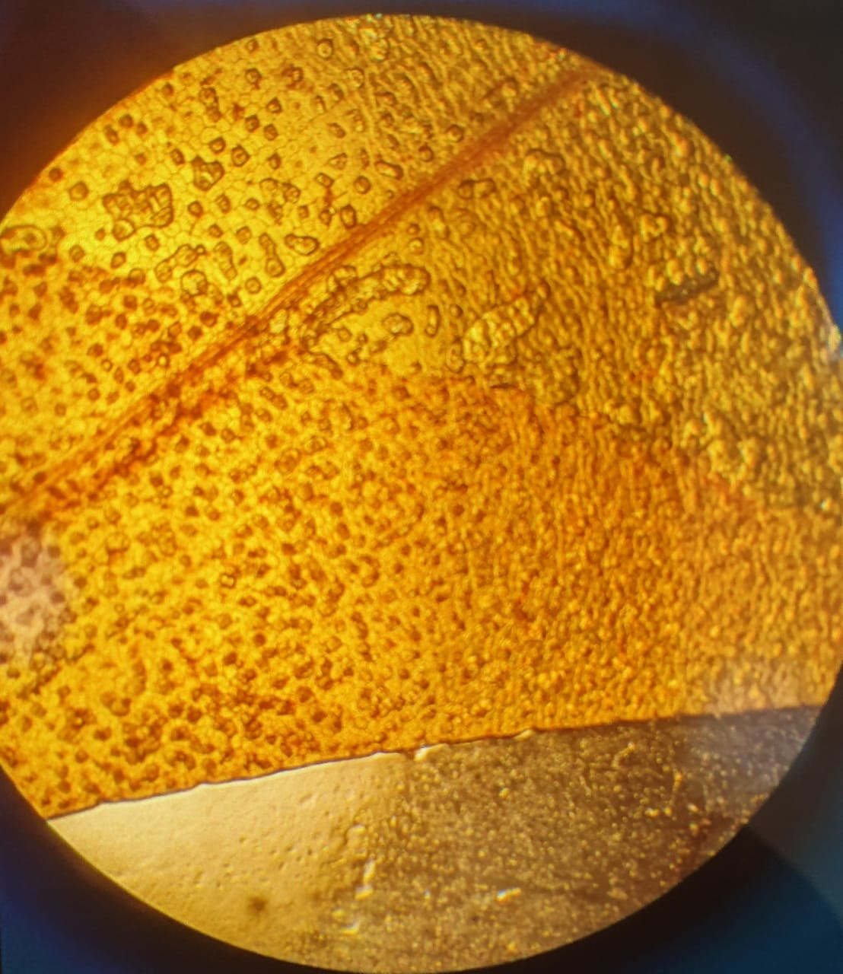
Fig 1. Onion bulb cell at the magnification of 4X
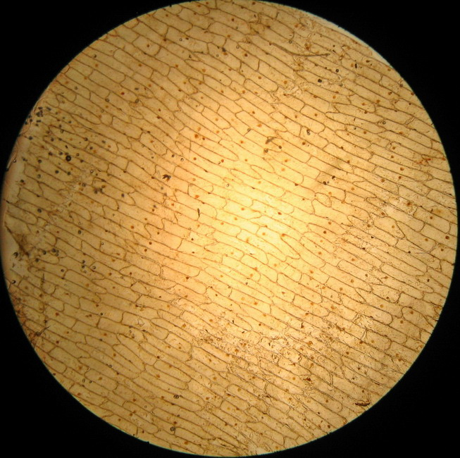
Fig 2. Onion bulb cell at the magnification of 40X

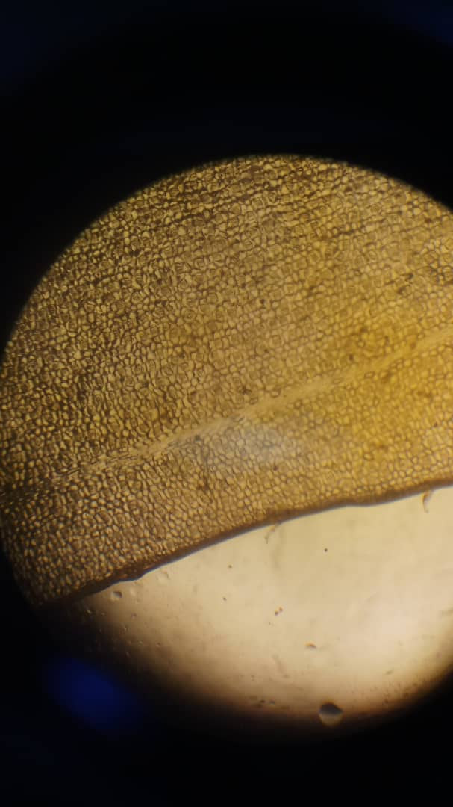
Fig 3. Elodea leaf cell at the magnification of 40X
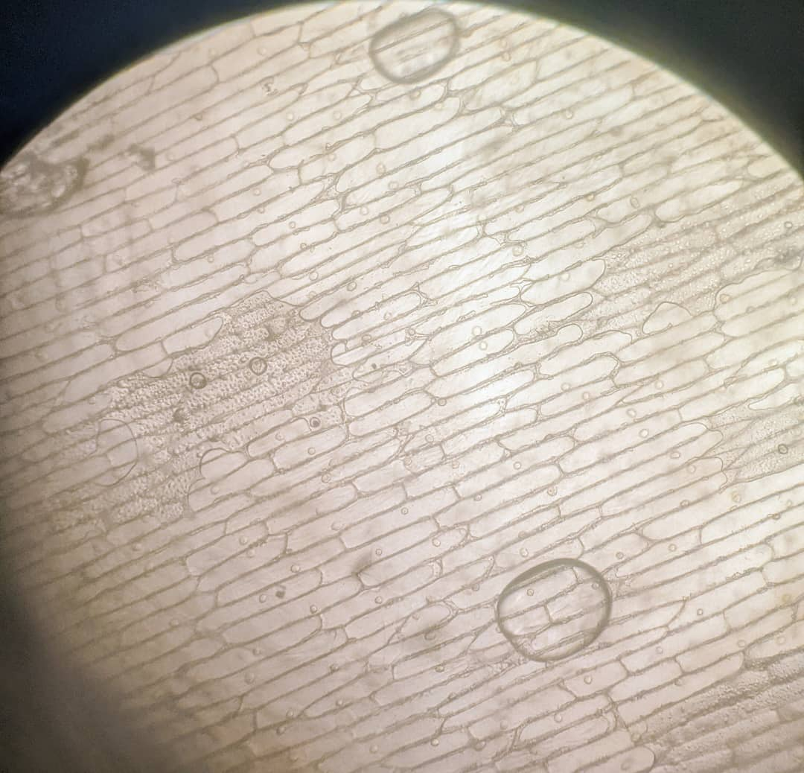
Fig 4. Onion bulb cell without methyl blue solution.

RESULTS
Onion bulb:
Onion cells displayed a polygonal shape with distinct cell walls.Nuclei were visible within the cells, appearing as dark, round structures.Chloroplasts were absent in the inner parts of the onion bulb.The cell wall and the cytoplasm which is gel-like substances that fills the space inside the cell.
Elodea leaf:
Elodea leaf cells exhibited a rectangular shape with thin, transparent cell walls.Numerous chloroplasts were observed within the cells, giving them a green coloration.Nuclei were also visible within the cells, similar to onion cells.

DISCUSSION.
The experiment to observe the the onion cell and elode leaf cell using their tissue was observed using two kinds of magnification which were magnification of 4X and 40X, the observation under 4X was not clearly vissible, but when the magnification of 40X used both cells were clearly observed, this occurred both in stained and unstained onion tissue and elodea tissue respectively.
Stained onion bulb tissue.
- Methyl blue is a dye which when applied in the plant tissue enable the cell’s part to well observed, when applied to onion bulb layers the Iodine blue interact with cell walls and stains them blue. This is because the methyl blue molecule is attracted to negatively charged molecules like the cellulose and pectin in the cell walls.
- Once the onion bulb layers are stained and placed on the microscope different features like grid lines were observed in the cell, block like structure s were observed whvich closely resemble the detailed explaination of the cell as described by Robert Hooke. Other structure observed include the black Dot which are generally known as Nucleus. Also the fluid contained in the cell were observed, thuis fluid are cytoplasm.
Unstained onion bulb tissue
- When the onion tissue placed on the microscope without been stained it was difficult to observe all the structure of the cell, but only the general structure of the cell were observed, this is because of the transparent of the cell wall and the organell of the cell, this transparent is caused by the thiner layer of the cell’s parts and hence this cause the refraction of the light through them. So without the Iodine the cell wall and are the parts cell become less visible and cell appears transparent.

Stained Elodea leaf tissue (Epidermis)
- When Methyl blue is applied to an Elodea leaf, the dye interacts with negatively chargedmolecules in the cell wall resulting in a simiral ionic interaction as with the onion bulb layers. The Methyl blue binds to the negatively charged poolysaccharides in then cell walls causing them to become stained blue. The stained cell walls become more visible under a microscope allowin the obsevation of cell structure, shape and arrangement. The parts observed on the Elodea Leaf includes numerous Chloroplast which used in the synthesis of plant food.

In the figure number one it shows the image of an onion bulb cell under the magnification of 4X. In this magnification we were unable to see the clear structure of the cells and their organelles.But after using the 40X magnification in the fig 2 we were able to see the cells which are in polygonal in shape. Also we were able to see the elodea leaf cells at the fig 3 which shows the cells which are more close packed which are rectangular in shape. In the onion bulb cell we see the clear nucleus which appears as dark and round structure and cell walls was clearly observed in the onion bulb cell but there was no chloroplasts because the onion bulb is not engaged in photosynthesis it function is to store nutrients and water. But in elodea leaf cells there is numerous chloroplasts because their primarily function is to manufacture food through photosynthesis.
In the fig 4 we see the color of the image is pale this is due to that there was no methyl blue solution which were added to the onion bulb tip hence the starch granules will not be stained hence appeared pale and difficult to distinguish from the surrounding cytoplasm.

CONCLUSION
When observing these two plants (onion bulb and elodea leaf) under the compound light microscope it shows how different plant cells have differences in their morphological structures. The cells of an onion bulb differ from those of the elodea leaf, the onion cell have a large central vacuole and the elodea cell having numerous chloroplasts. These differences shows the different functions of each cell, where the onion cell primarily function is for storing water and nutrients and the elodea cell primarily function is engaged in photosynthesis. While both tissues exhibited differences in cellular structure, they shared common features indicative of their plant cell identity.

RECOMMENDATION
Based on what we have observed we recommend future investigations into plant cell structures include staining with different dyes, such as safranin or iodine, to highlight different cellular components. Also we recommend that in the future we can use the microscope which have the lenses which are well and they should be changed after some time in order to ensure we can get the better results from what we are observing. Additionally, we recommend that future studies explore the role of environmental factors, such as light intensity or nutrient availability, in influencing cell structure and function.

REFERRENCES
"Plant cells: their structure and functions." Plant Cells: An Illustrated Guide. New York: Springer, 2005.
"Observing onion and elodea cells under the microscope." Journal of Biological Education, vol. 33, no. 2, 1999, pp. 54-59.
"Comparison of onion and elodea cell structures." Journal of Science Education, vol. 19, no. 2, 2014, pp. 167-174.
"Plant cell structure: a comparative study of onion root tip and elodea leaf." Journal of Cell Biology, vol. 54, no. 2, 2015, pp. 235-240.
"Vacuoles and vacuolar function in onion and elodea cells." American Journal of Botany, vol. 98, no. 4, 2011, pp. 648-655

