# Comparison of Sortings:

# Sorting of Random data:

## Sorting an already sorted data:

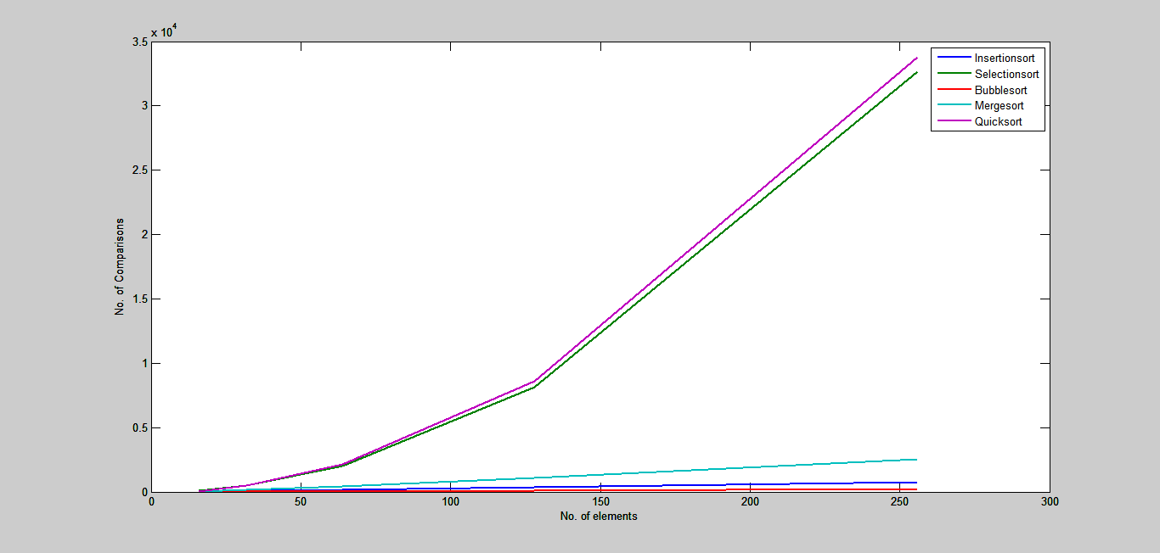

## Sorting of reverse ordered data:

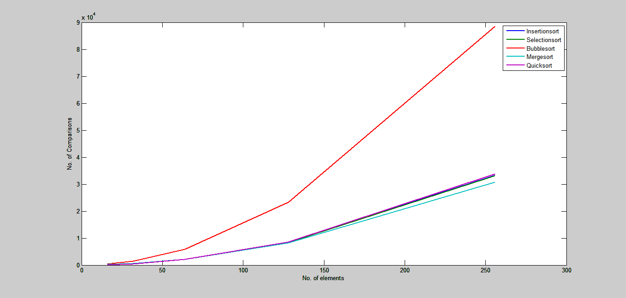

## Sorting of highly repetitive data(Test-1)

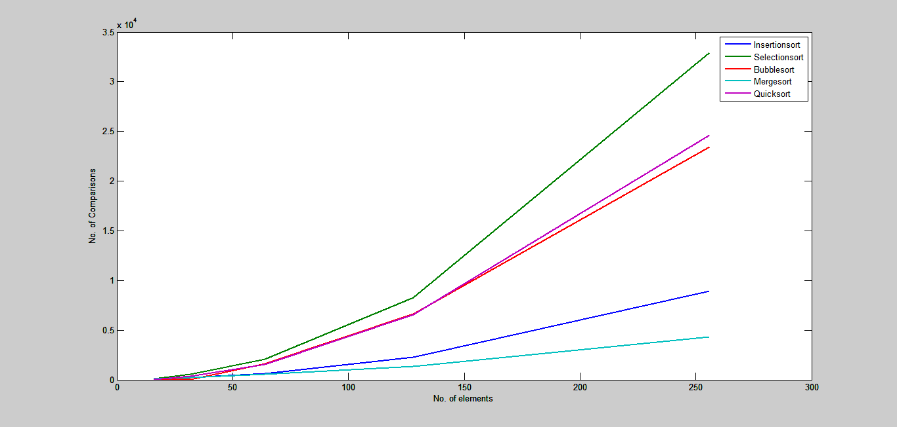

## Sorting of highly repetitive data(Test-2):

