**Astrology of the Star Souls**

**Indigo, Crystal, and Rainbow Children**

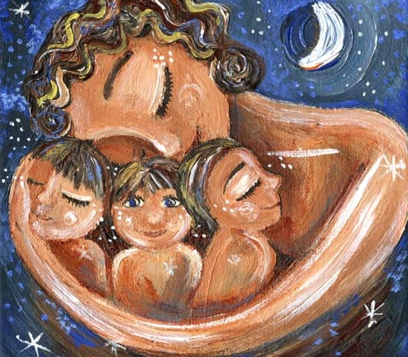

An Astrological Playshop

**Saturday, August 17, 2019 1-4 PM**

**DeMun Healing, 734 De Mun Ave., Clayton, MO 63105**

**Star Souls** – our children, young adults and parents are now coming into the world with purpose and spiritual awareness. Astrology can help us understand these special young ones. We, as parents, can help our star children to grow into and share their gifts that are so needed to serve us in our current shift of consciousness.

**To save a place, pre-registration with birth information for personalized chart (name, birth DATE, birth TIME, and birth PLACE) should be emailed to Nikki at** [**nikiastro@att.net**](mailto:nikiastro@att.net)**.**

**3 Hour Playshop $35.00**