COMP 1202
Assignment ##
Reuse doc head
CLICK HERE for students’ response.
Or see the bottom of the page.
Submission Requirements
Teacher provided
Objective
Teacher provided
Functional Requirements

Console Application of our Flagship Desktop suit


Provideo featued images here
Description
[Program name] is a ...
What we do: …
Main Features (outline)

Feature One Linked to section

Feature Two lined to section
  - Sub details linked

Feature three (Files Involved is a good one)
  - sub detials linked

Short Report
Animated Intro – Exposition (Example)
The program starts with a short animation of a pyramid, company name and author details. Using a simple 3 pass loop the graphics and text are printed line by line, then they are reprinted with an updated color, and finally small segments are updated with a third color. Then the title is colored by rewriting each char in the title with a new color one at a time.
Finally, a loop is entered where a single cube is blinking until the user presses any key to continue. This method uses the very limited Thread.Sleep function in small chunks and loops to see if a key is available for continuing. This is strictly for aesthetics.

Load Files – Exposition (Example)
After the program loads the language being used, a menu is presented to load a file, start with sample data or continue with no transactions.
Bellow are some of the user’s interactions.

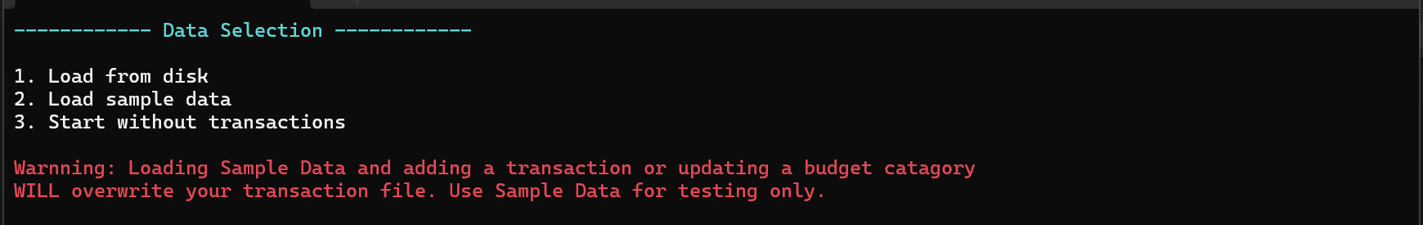
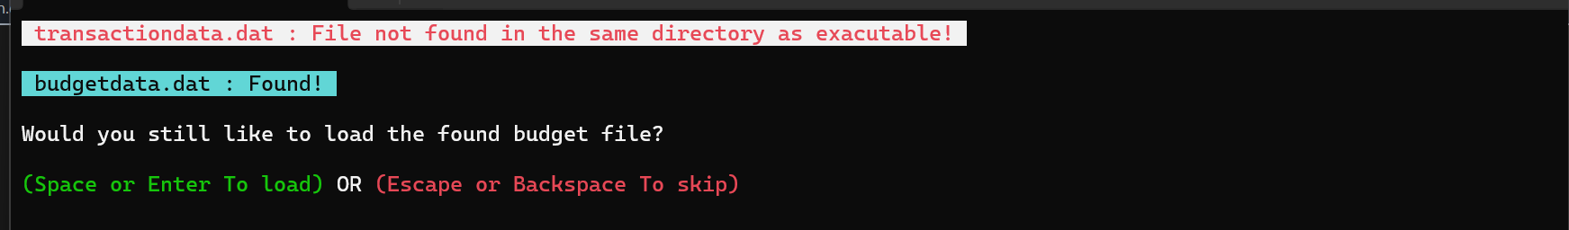

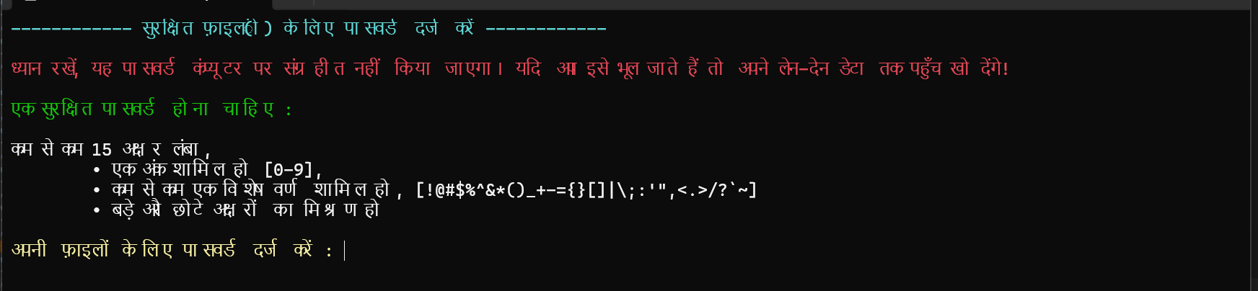

Transaction Management - Exposition
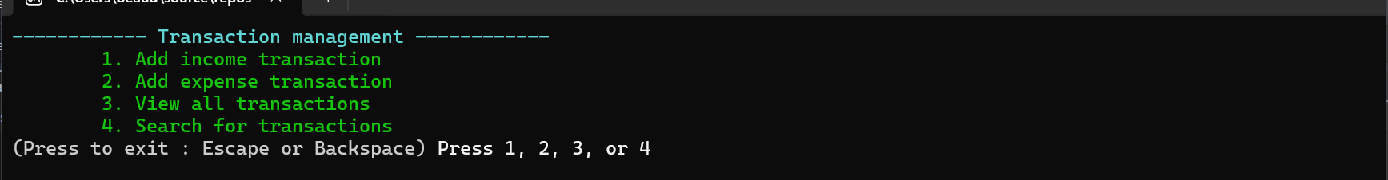
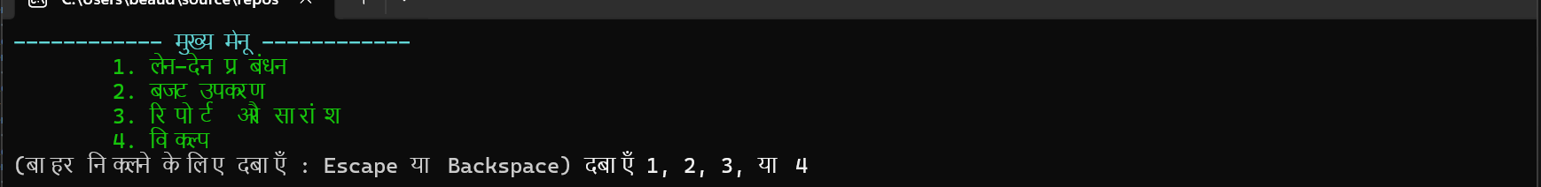
Transaction menu in simplified Chinese
The transaction management menu presents the users with the above four actions.

Add income:
This menu provides the user with the ability to enter an income with the date the transaction occurred. The input is validated that it can not be a negative, or 0, as well as any non digit characters. The user can input a fraction, but it will be rounded to the nearest hundredth. When the input is validated, the transaction is added to the list. Depending on the users’ settings it will be saved.
Below are examples of adding income.
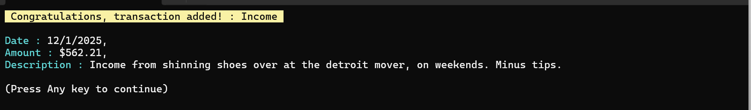
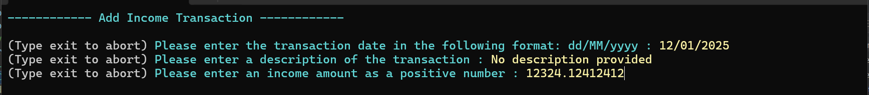
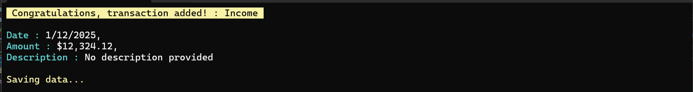
Above shows temporarily saving data message.
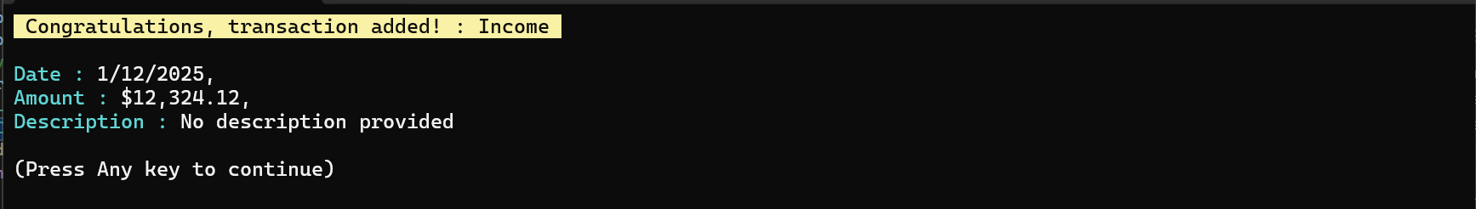
Short Report (example)
Ok now that we have all that long winded stuff out of the way, lets boil this down to a very short report!
How users navigate
- Using key press for numbers associated with options in a list
- Using Backspace, escape to abort or return to previous (optional q in pager)
- Typing exit when inputting text to abort (where a key press can’t be used)
- Using Arrows, Page up and down, for controlling the page view of transactions
- Mostly the program relies on Keypress where possible.
Data structures used:
This program makes use of several structures.
Dictionaries
- Store all the language messages printed to the screen
- Store the color groupings for applying to printouts
- Store language messages from a loaded xml document as strings to be passed to the messages dictionary
- Store budget information with key as Transaction category and value decimal. This is later written to a .dat file.
- Store descriptions for transaction sample data.
- Dictionary to hold date formats where the value is a tuple of string and int (int being longest expected date string length for formatting)
- Dictionary holding Excel Highest category ranges. This is for when there may be categories that are the highest and share the same value. Then we can’t pick 1, we need to print multiple.
Lists
- Transactions are stored in List
- Filtered transactions are stored to a separate List
- Worksheets for excel are stored in a list. This is for iterating through and printing the 12 months in sheets
- List for ranges, used for merging data, and for sheets for repetitive formatting and printing to excel.
- List of strings for holding language labels. This is for getting the languages from xml and looking into current culture to get the proper names for them.
Files
- Transactions file as serialized JSON that uses Advanced Encryption Standard to randomize and password protect the data.
- Budget file, as JSON serialized the same encryption for storing users budget values
- Configuration file, stored as JSON serialized data for the language a user choose. This prevents them from having to pick a language on start up.
- Excel document, for a printable account summary.
- XML document for holding the languages. Langauge.XML. However in this case, I pointed the filename for the language to be the file’s context as a string “””xml here “””. During development I had it as an external file.
Arrays
- Various arrays used for holding messages, integers for the pager to track pages and the index they are responsible to start printing on.
- Byte array for saving files
- Arrays for console colors, foreground and background. This is used a lot with my ColorConsole method.
- Uses int [ ] for storing the position of the cursor with flag options when flagging special options before viewing transactions
- Use array to hold culture names and info when choosing language
- String arrays for sample data descriptions
Tuples
- Used for storing console cursor position a few times. Although I mostly opted to use single integers.
- Used in a few other areas.
Problems encountered
- Problem: When program started, instructions were in English.
Solution: Hardcoded some common languages to get a message based on users current culture info.
- Problem: Users could enter dates that were valid for Date parsing but were very old, such as the year 1111.
Solution: Enforced the date can not be older then 120 years and also added that the date cant be in the future.
  - Problem: Some issues with menus not working, where I mistakenly mixed up numbers or conditins.
Solution: Take my time running through the program and double checking everything makes sense.
  - Problem: Creating language translations in a timely manner
Solution: Trained AI on my XML format, fed it my default English dictionary, and pasted in the elements into the xml. I then decided this was clunky, so I instructed it to make a method that takes a hardcoded dictionary of languages and export it as an xml document that I paste into the lang file. This was better because it was easier for AI to make a bigger list faster of .Add dictionary references of Key and value. Instructed to validate the dictionary keys and report any mismatching. Now if AI gave me 51 keys instead of 173, I get a list of the remaining, I paste to AI and it might generate another 50. At that point I keep pasting what is missing, until nothing is missing. I think passed the entire language block back for it to review. Some minor changes were made a second time.
  - Problem: Big issue trying to manage the Paging method for viewing transactions. I could not keep track of what I would be used going in either direction (forward a page or back). The reason is because more items got printed when the screen size was changed, like a taller window. I was doing math involving the iterator i.
Solution: took a step back and realized I could just put the iterator int inside an array for the first item on each page. This pay each page number has a unique number that was stored when the page started printing. Now every single time the number was correct. If I moved forward, I just continued with the next iterator. So this was more about moving backward.
  - Problem: Issues trying to space out the columns in the transaction view. When a language was changed or a description or value was too long everything broke!
Solution:
      - Calculated the largest length of the transaction amounts, set the width to that.
      - Did this for all columns except description.
      - Used these details and the window width to get a remainder for description.
      - Used cursor position for absolute positioning.
      - Truncated any long descriptions by iterating through the chars, one at a time. Especially important for Chinese where the length never matches the column width, due to the special characters.
      - Added … to make it fancy!
  - Problem: Issues with the password system. Messy if statements, bad regex.
Solution: took a step back and made sure I really documented things.
  - Problem: console color was getting intense and code was getting repetitive and confusing
Solution: Broke code into methods where I could, introduced a colored console method for reducing tons of lines just for changing foreground color. I also added comments everywhere, some my own and some from Intelli-sense. I also tried to use loops to reduce repetitive codes and define variables for reuse for readability.
  - Problem: Language loading was using console keys. 1 – 9, a – z, f1 – f12. This worked but only for a limited number of languages, this was clunky due to the gaps in these character codes, and confusing for the user.
Solution: Just gave an index number and used ReadLine instead! Easy lol, I got obsessed with Key press…
  - Problem: Issues with budget menu and formatting
Solution: Implemented using cursor positioning instead of clearing the screen, I also really took my time in debugging and using additional flags for controlling behavior
  - Problem: Some code really was repetitive. Methods were doing almost the same job!
Solution: I bundled methods together and used Enum as states for controlling who was the caller and adjusting the small variations. I chose Enums so I could give human readable names to the states.
The code still has some various formatting issues that could be addressed, overall I am proud of this application. Stay tuned for the Gui version!
Just a quick not on defensive programming, I use a lot of Try/catch, try Parse, and conditions and loops to validate user input, such as dates, integers, numbers that will be used to check dictionaries. I also wrap dictionary key checking in try/catch for this very reason. (not all the time, just when I am expecting an issue could arise). For further details check the provided document of the user interaction
Final show off of possilbe GUI version (Optional)
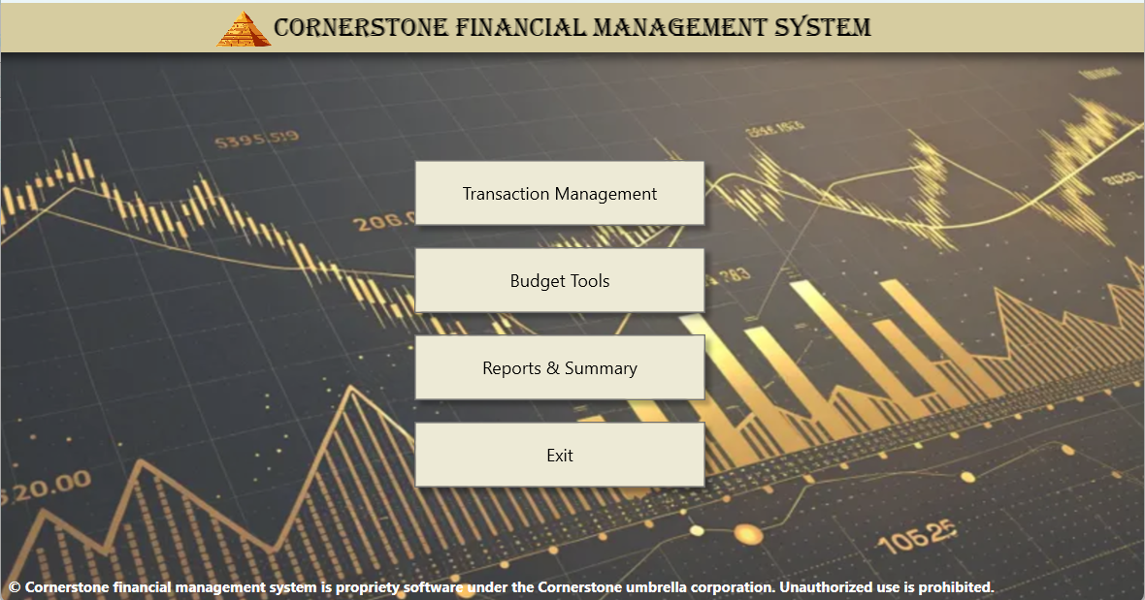

Code (the below code may not render some characters properly)
This code should be done by pasting into notepad++ then exporting using the c# formatting,
And special characters should be accounted for by pasting only into here not into another program inbetween. Look up if any formating issues

