Richard Beaumont

November 19, 2018

IT FDN 100 B Au 18: Foundations of Programming: Python

Assignment 5

A Fifth Dive into the Python World

# Introduction

In this fourth module, we learned about lists, dictionaries, structured error handling, functions, script templates, and GitHub.

# Analyzing The Code

After watching Professor Root’s Module 4 videos, reinforcing the learnings with the labs, and doing the readings, the code was developed in the PyCharm Integrated Development Environment (IDE).

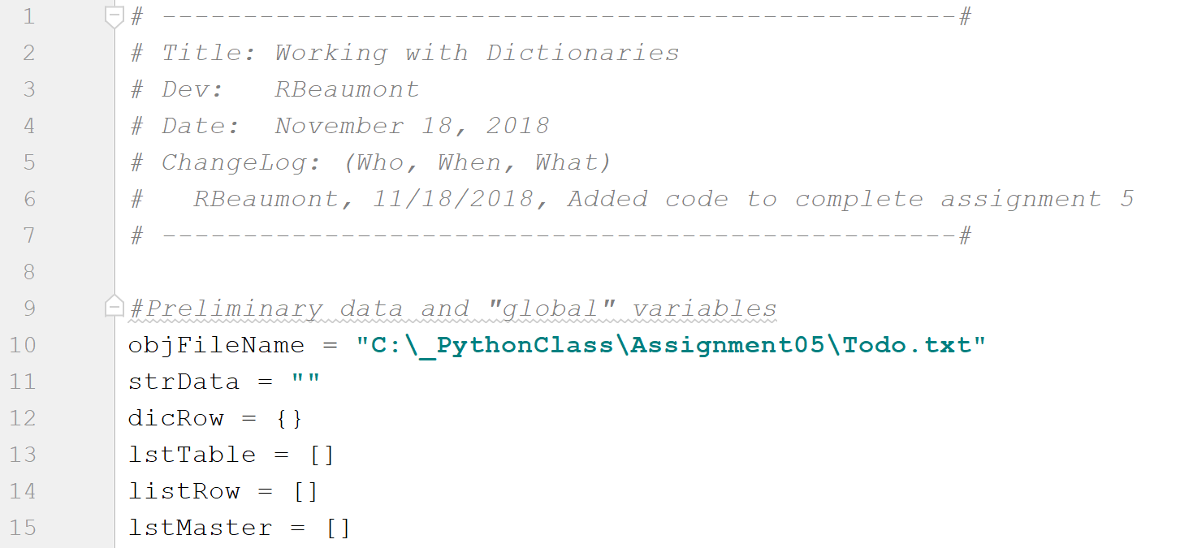

Figure : Code header and preliminary data

In the first section of the code (see Figure 1), the standard code header block is written. This includes the change log. Starting in line 9, variables and data that will be used throughout the code are declared.

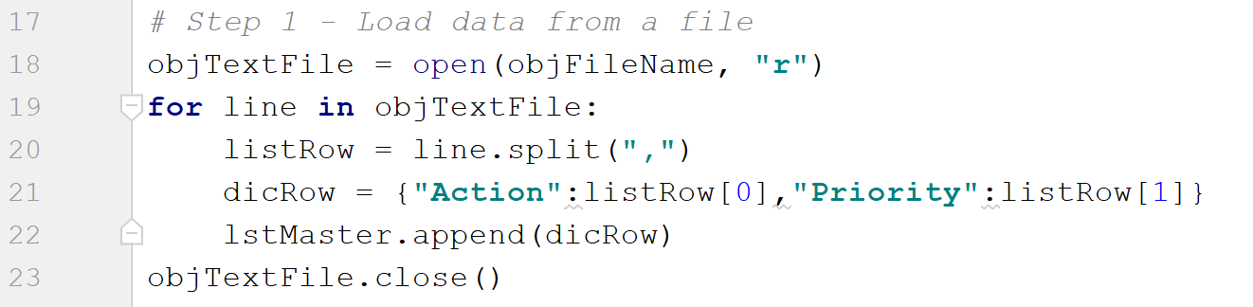

Figure : Step 1

The first step of the code is to load data from a text file. This is done in lines 18 through 23 (see Figure 2). Each line of the text file is read into a row of a list. Each row is of the dictionary type and has a key associated with the “action” and the “priority” for each item on the to-do list. Learning from my previous assignment, I opened and closed the text file in this block of code and did not keep the text file open for the duration of the entire script.

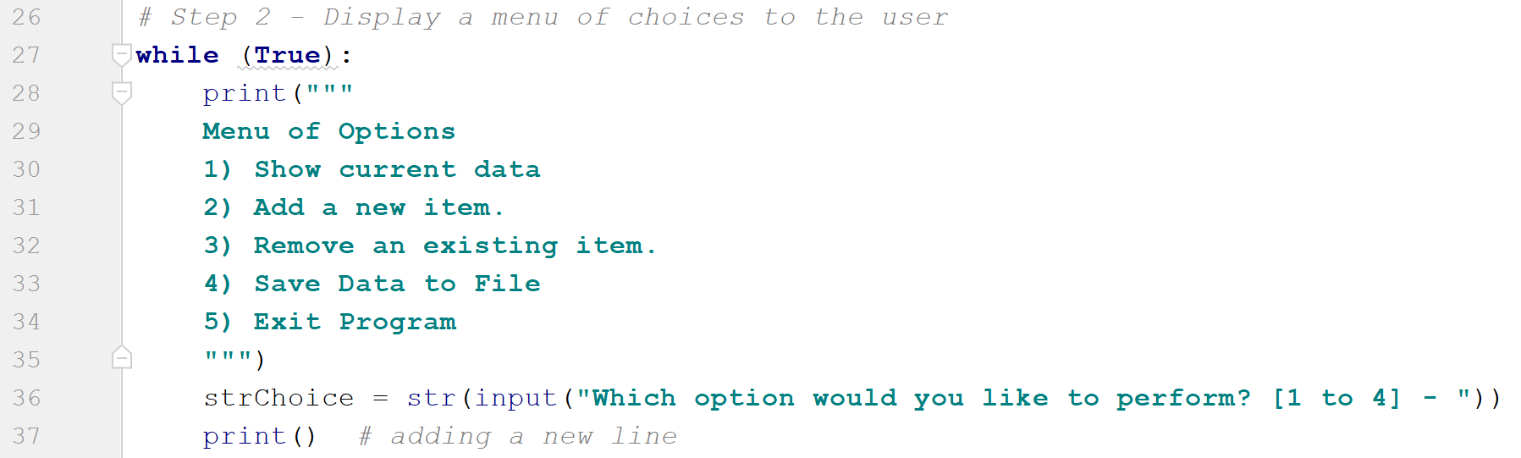

Figure : Step 2

In the second step of the code (see Figure 3) a choice of options is displayed to the user in the form of a menu. Additionally, a *while* loop is used which allows the user to continue with the program after completing their first selection.

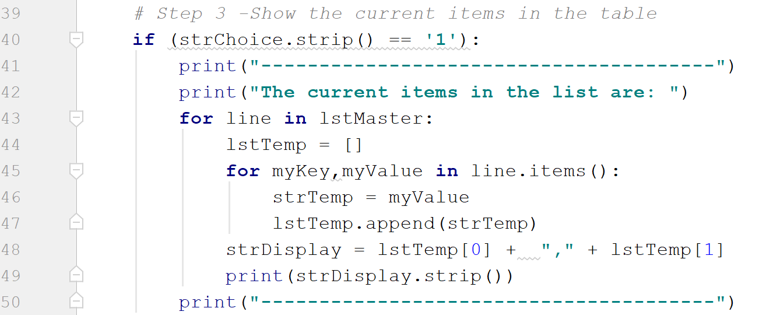

Figure : Step 3

In the third step of the code (see Figure 4), the current items of the list are displayed. This action is taken if the user selects option 1 from the menu. Instead of using a simple *print* function, a nested for loop is used to display the information to the user in a more digestible way. The output of the user selecting this step can be seen in Figure 5.

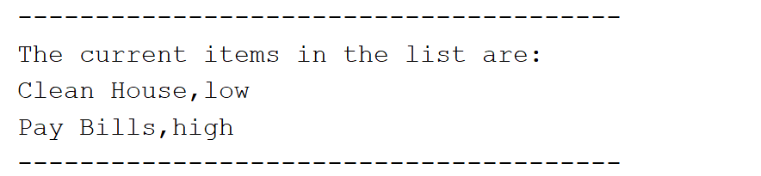

Figure : The formatting of the displayed data if the user selects Option 1

In the fourth step (see Figure 6), the functionality is added to give the user the option to add another item to the table. They do this by entering both the action and the priority. This is then appended (in line 57) to the overall master list of the to-do items. In line 58, the user is informed that the action was successfully added to the list.

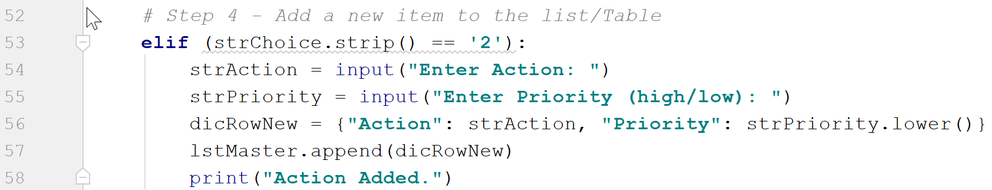

Figure : Step 4

In the fifth step (see Figure 7), the functionality is added to allow the user to remove an item from the to-do list. By entering the name of the action that they wish to remove, the action (and its associated priority) are removed from the to-do list. This is done using the *del* function. Once the action has been removed, the *print* command is used to inform the user that its command has been obeyed successfully.

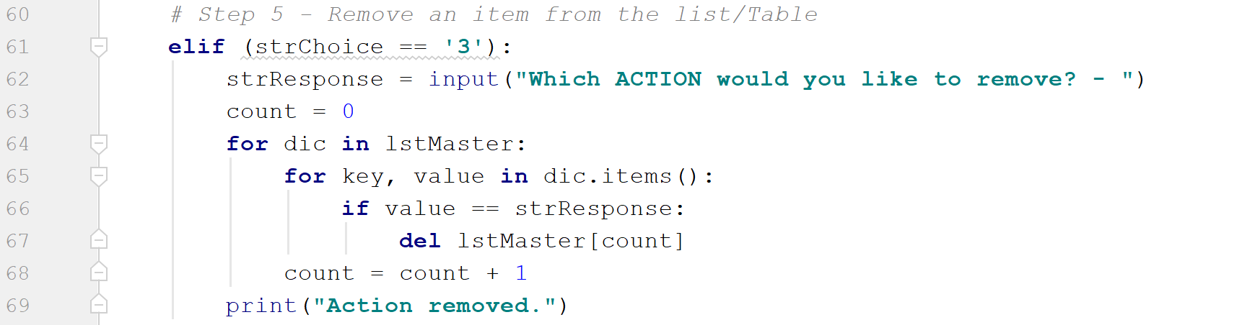

Figure : Step 5

In the sixth step (see Figure 8), the functionality is added to allow the user to save the ToDo.txt file with the latest data. This is done if the user selects “Option 4”. After opening the file, another nested for loop is used to write the data to the file. The file is then closed and the user is informed that the file has been updated.

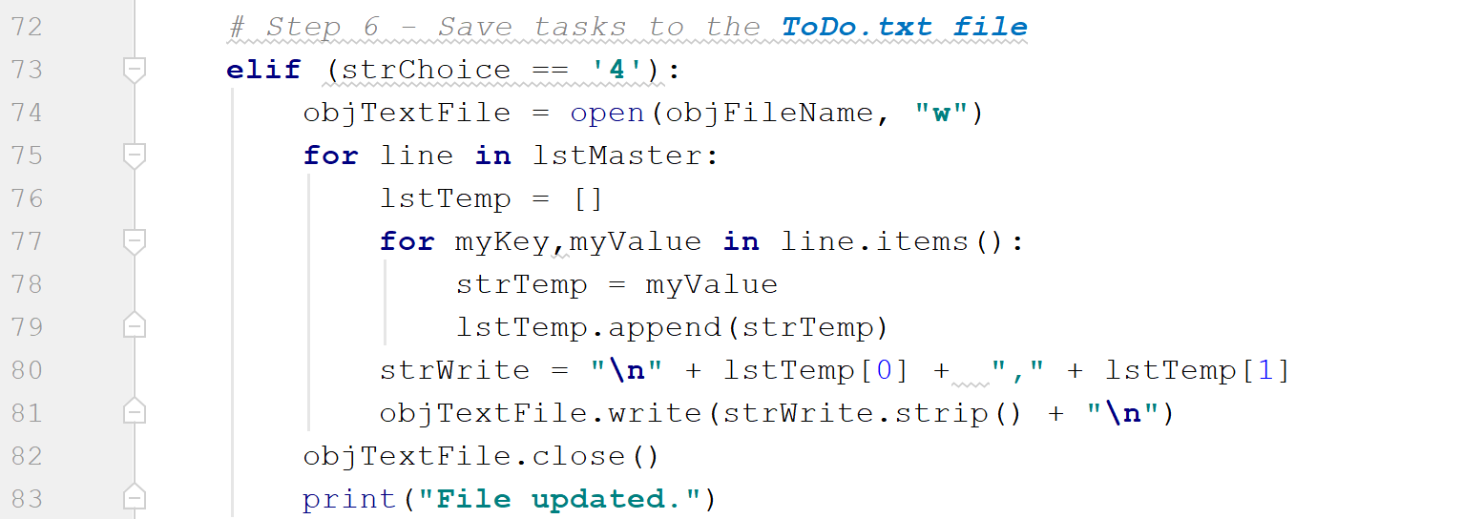

Figure : Step 6

In the final piece of code (see Figure 9), the code is exited if the user selects option 5. A simple *break* command exits the script from the *while* loop of line 27 (see Figure 3) and the script is finished.

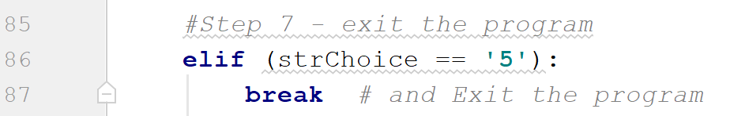

Figure : Step 7

# Testing the Code

Figure 10, Figure 11, and Figure 12 show the code working in PyCharm. In Figure 10, the current list of items are shown and then the action “sweep” with priority “low” is added to the list. In Figure 11, the file is updated with the latest addition and then the script is exited. Figure 12 shows the text file after this update.

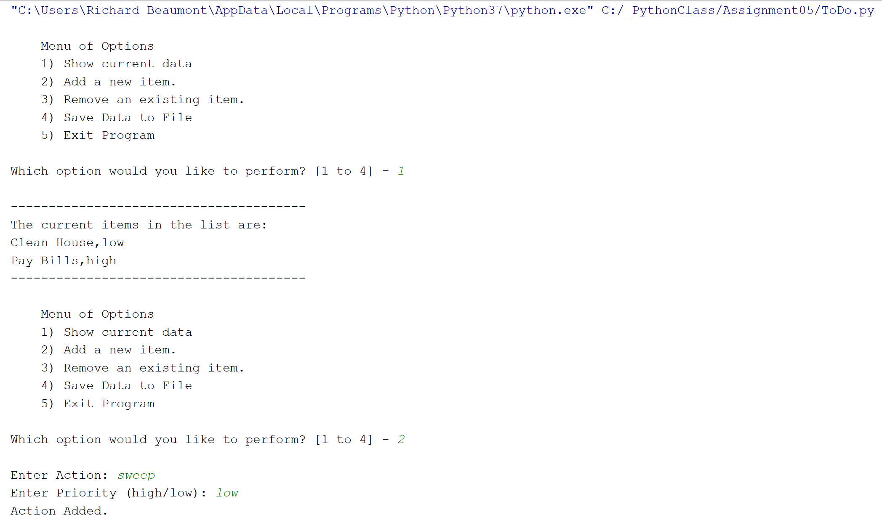

Figure : Options 1 and 2 performed in PyCharm

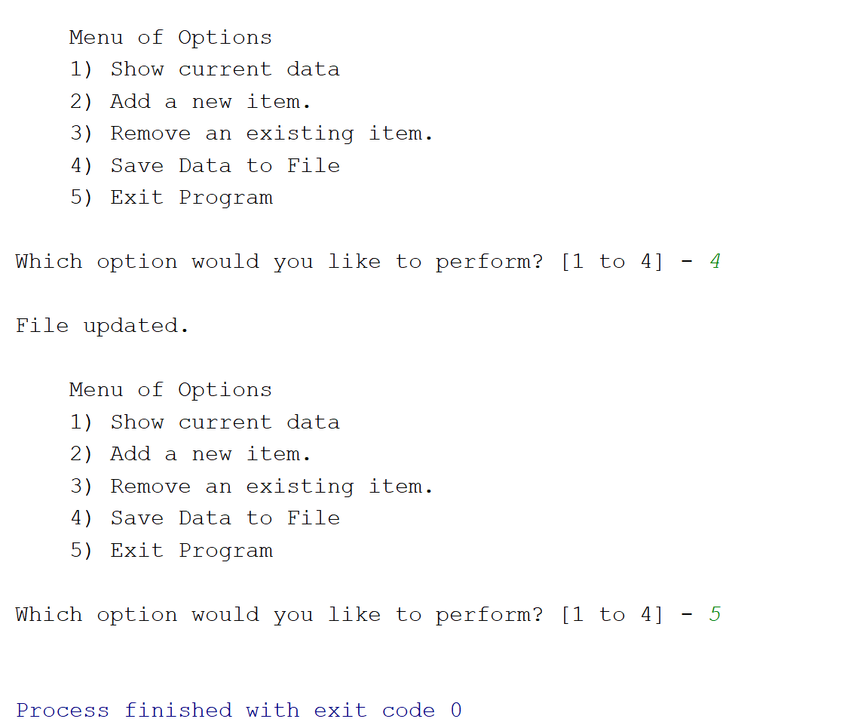

Figure : Options 4 and 5 Performed in PyCharm

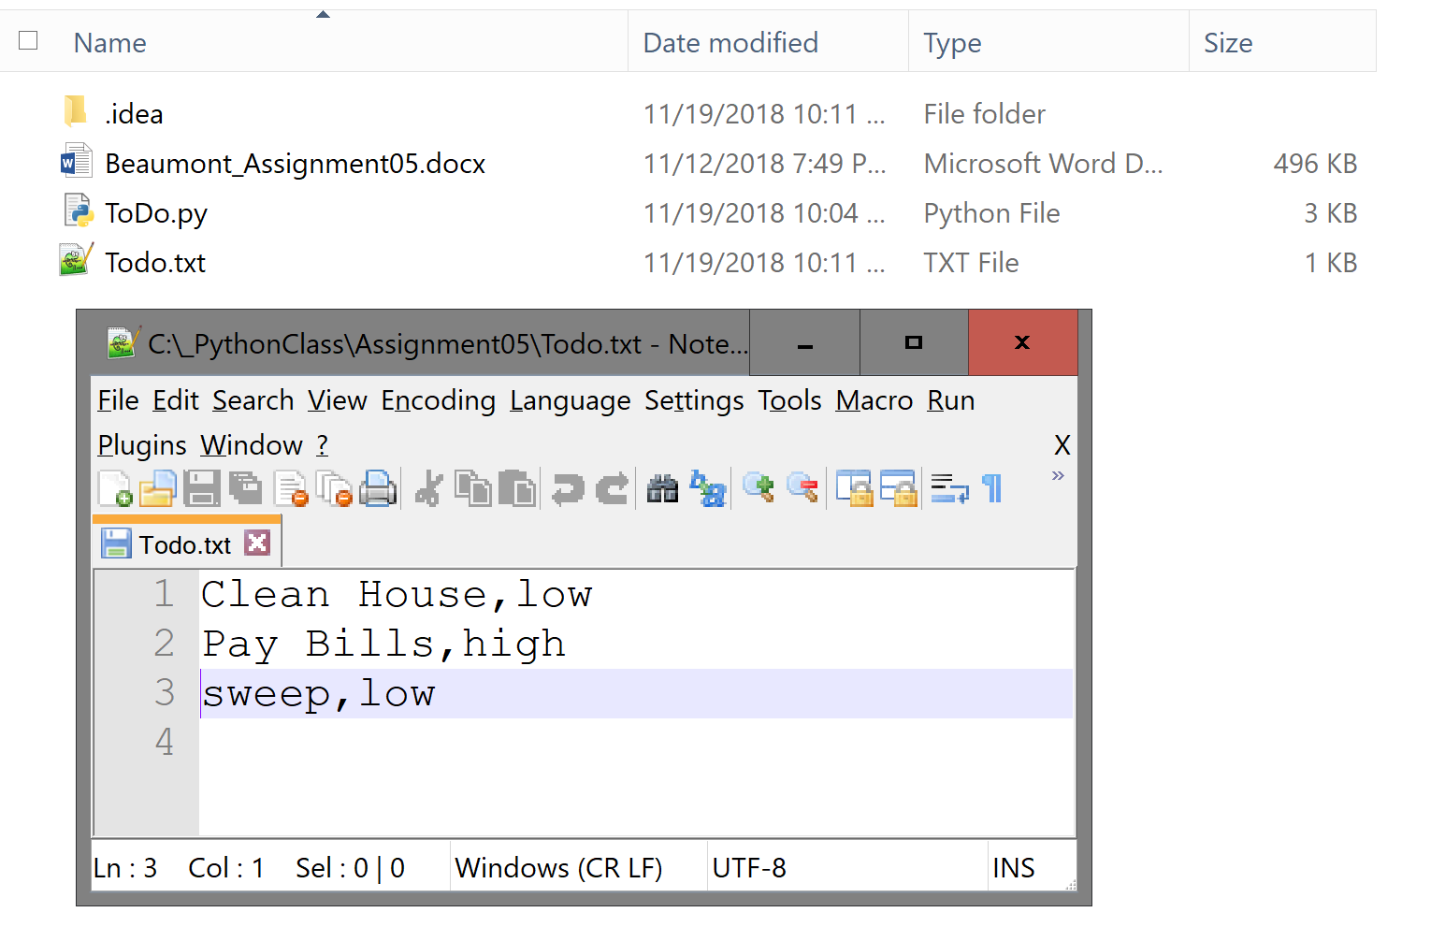

Figure : The ToDo.txt file after running Options 1, 2, 4, and 5 in PyCharm

Figure 13, Figure 14, and Figure 15 show the results of running Options 1-5 in the command prompt. In Figure 13, the current list of items in the file are displayed and then the action “sweep” is removed. Next, in Figure 14, the action “Clean Dishes” is added to the list before saving the file and exiting the program. In Figure 15, the updated text file is shown.

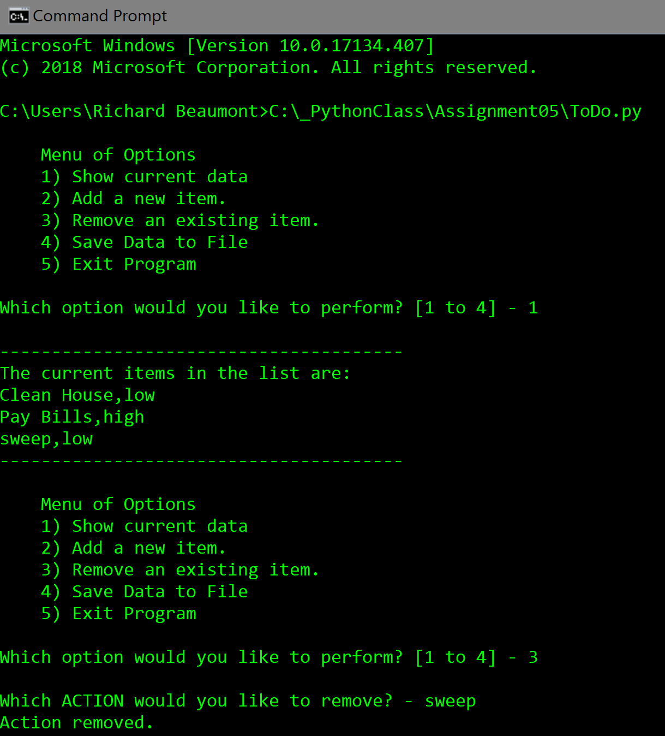

Figure : Options 1 and 3 in Command Prompt

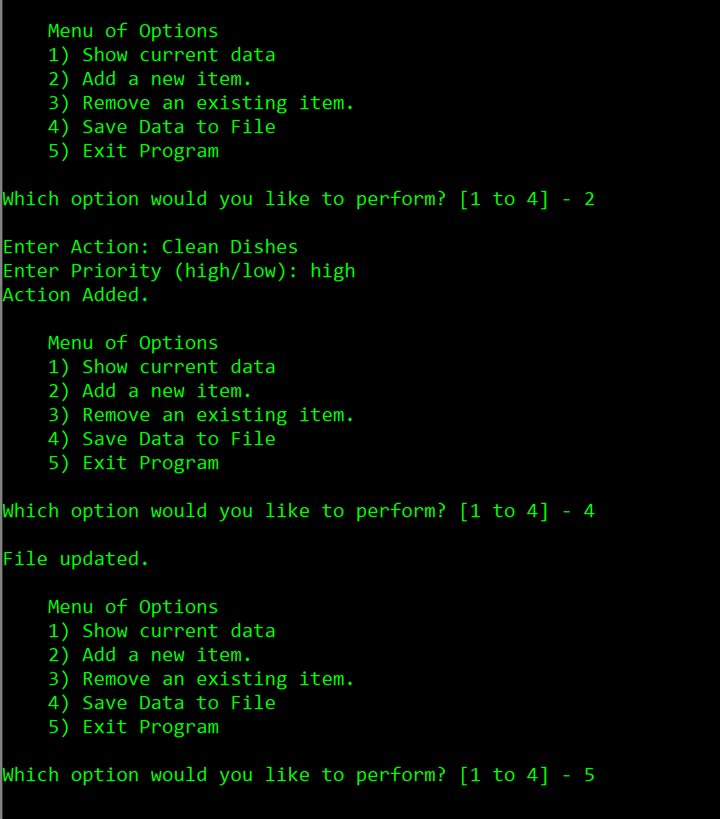

Figure : Option 2, 4, and 5 in Command Prompt

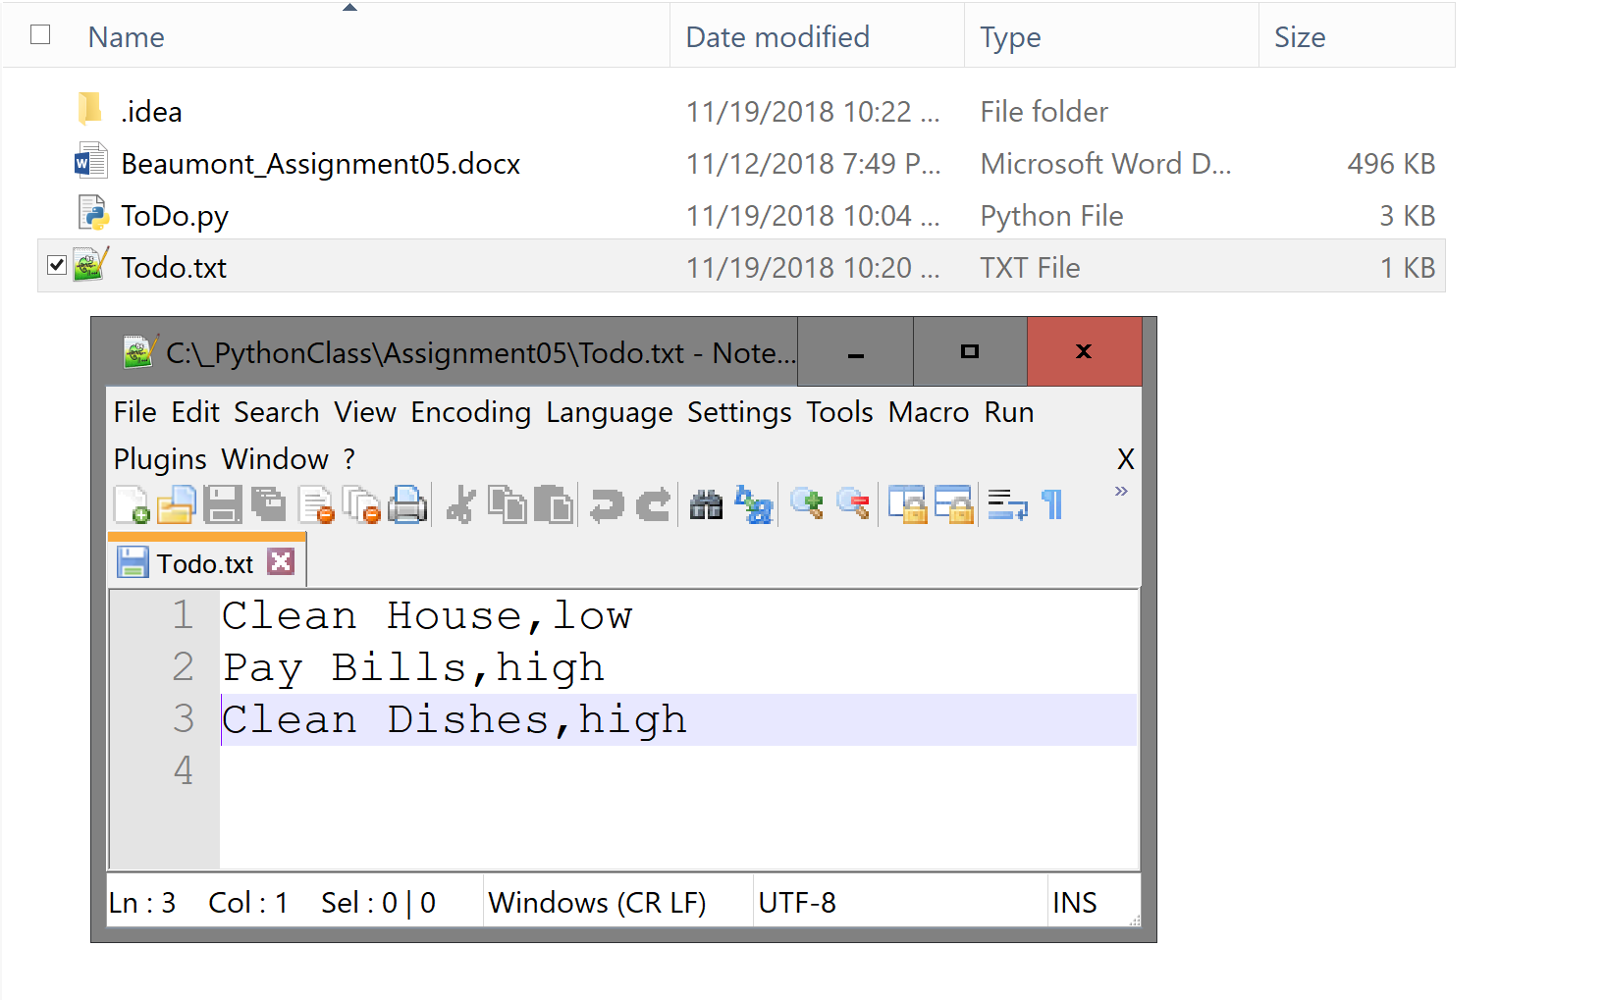

Figure : The ToDo.txt file after running Options 1, 2, 3, 4, and 5 in Command Prompt

# Summary

The completion of Assignment 5 has built upon the foundation developed in the previous assignments. I feel that I was able to successfully complete this assignment and am looking forward to building upon this knowledge in Module 6.