External Data Source ➔ HDB Generic Mapping

Design

This document contains the requirements and design for the “generic” mapping facility that represents the relationship between HDB and various external data sources.

Requirements

The Generic Mapping addresses multiple separate but related requirements:
- Map HDB Sites onto external site coding systems
- Map HDB Datatypes onto external data coding systems

(These two mappings are independent of each other, and independent of the requirements below.)

- Map external data onto HDB site_datatype_ids
- Enable the generation of data files from HDB in the format required by external data sources.

More discussion on requirements 3 and 4 follows.

Map External Data onto HDB Site_Datatype_Ids

The following are important aspects of the site datatype mapping.
- In some cases, a data source identifier, site code, and data code is sufficient to determine a unique HDB site_datatype_id.
- Other cases require that some number of key/value pairs be specified in addition to source, site code and data code. The number of key/value pairs must be unlimited. SHEF, DSS and XML files are good examples of the need for this extended capability.
- The mapping from external data source to HDB must yield an HDB interval_name in addition to an HDB site_datatype_id. Thus, hdb_interval_name is a required field in the mapping table.
- The mapping can also optionally yield: method_id, computation_id and agen_name (agency). These, these are optional fields in the mapping table. If the agency is not specified in the mapping, then the agency in the associated data source can be used by the accessing application.
- Every mapping must have a flag to indicate if it is currently active.
- Every mapping must support a comment.

Generate External Data Files from HDB
Because the Generic Mapping currently supports unlimited key/value pairs, it is likely that most information required to generate an external data file from HDB is already in place. However, it’s also possible that additional information (e.g., information unnecessary or redundant in mapping external data onto HDB) will be required to implement this feature in the future.

Database Design

This design attempts to address all functional requirements in the simplest and most straightforward way possible. The data model diagram is presented below, then the elements and implications of the diagram are discussed.

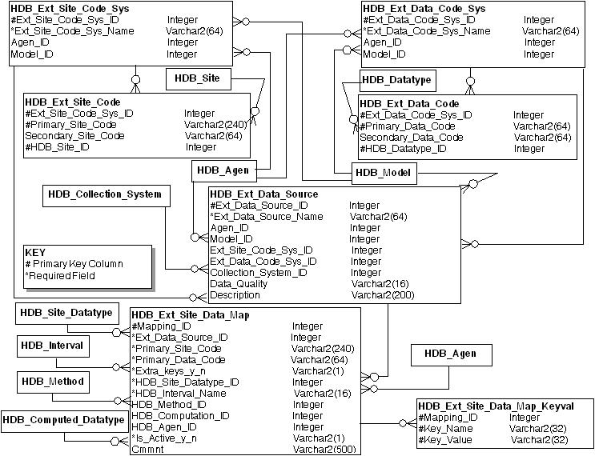

A Note About the Design

This database design leans more toward flexibility than integrity. This choice was made based on 1) the difficulty of using the integrity-driven Hydromet mapping tables and 2) the requirement that usage of site and data mapping tables be optional, even when the site/datatype mapping table is needed. As a result, some foreign keys are absent where they could be present, and some columns are optional where they could be required.

External Coding Systems

External systems that provide sets of codes or names for sites and for types of data are represented in the tables HDB_Ext_Site_Code_Sys and HDB_Ext_Data_Code_Sys.
Each of these tables can represent agency and/or model information about a particular coding system. Both agen_id and model_id are non-required fields.

External Site and Data Code Maps

The tables HDB_Ext_Site_Code and HDB_Ext_Data_Code map external site and data codes or names onto HDB site_ids and datatype_ids.

Features:
- Primary key of Ext_Site_Code_Sys_ID, Primary_Site_Code, and HDB_Site_ID allows a single site code in a system to map to more than one HDB site (e.g., both a reservoir and a climate site).
- HDB_Ext_Data_Code has a similar primary key column that provides the same features.
- Neither the site or data mapping table must be used in order to use the site/datatype mapping table ref_ext_site_data_map. Hence, populating the tables HDB_Ext_Site_Code, HDB_Ext_Data_Code, HDB_Ext_Site_Code_Sys and HDB_Ext_Data_Code_Sys is optional.

External Data Sources

External data sources must be defined in HDB_Ext_Data_Source in order to populate and use the external site/datatype mapping table.

Unique key:
- Ext_Data_Source_name

This key ensures that sources are named uniquely and in a way that makes them easily identifiable.

Features with respect to requirements:
- Same table stores agency and / or model-based external data sources.
- Ext_Site_Code_Sys_ID and Ext_Data_Code_Sys_ID are nullable, so can be specified or not to describe the source. If they are specified, they must match existing external coding systems in HDB.
- Collection_System_ID is nullable, so can be specified or not to describe the collection system.

NOTE: This table is completely independent of HDB_Data_Source, which is included for backward compatibility with the HDB1 source_id column in each of the r_ interval tables.

External Site Datatype Mapping

The tables HDB_Ext_Site_Data_Map and HDB_Ext_Site_Data_Map_Keyval are the core of the generic mapping – the ones that will most often be used by accessing applications.

Features with respect to requirements:
- Enforces that every mapping of external data onto an HDB site_datatype_id and interval must include: external source identifier, external site code, external data code.
- Allows for other key/value pairs to be included in the specification of a given mapping, through the extra_keys_y_n column and the HDB_ext_site_data_map_keyval table. These key/value pairs are related back to site datatype mapping through the mapping_id. Interval information about the external data is one example of a key / value pair that might be included in a mapping.
- The mapping yields a site_datatype, interval, and, optionally, method, computation, and agency.
- Has a flag to indicate if the mapping is active or not.
- Supports a comment on the mapping.
- Because there is no foreign key on either Primary_Site_Code or Primary_Data_Code, this mapping table can be used without defining individual site and data code maps.

Assumptions:
- Accessing applications will need to know their appropriate Ext_Data_Source_ID when looking up HDB site_datatype_ids based on external site and data codes or names.

Examples

Following are a few site/datatype mapping examples, along with their external data source specifications. Hopefully the individual site and datatype mapping tables are self-explanatory, but examples can be provided if needed.

HDB_Ext_Data_Source
*ID | *Name | Agency | Model | SiteCode Sys | DataCode Sys | Collect  Sys | Quality | Descrip
1 | USGS Preliminary |  |  | USGS | EPA |  | Prelim
2 | USGS Final | USGS |  | USGS |  |  | Final
3 | Riverware 24 MO Study | USBR | 10

Note that:
- Agency and model can be used in any combination, including not specifying values for either… though this is probably not the best idea.
- Site and data coding system specifications are optional.

The site/datatype mapping examples that follow are intended to show the flexibility in use of the key/value pairs, but are probably not very realistic: a single site and data code (HVR CFS) maps onto three different site_datatype_ids depending on various extra key/value pairs, which, again, are probably not realistic.

HDB_Ext_Data_Source
*Mapping ID | *Ext_  Source | Site_Code | Data_Code | Extra Keys | Site_Datatype ID | Interval | Method | Comp | Agen | *Active
1 | 1 | HVR | CFS | N | 1421 | instant |  |  | USGS | Y
2 | 1 | HVR | CFS | Y | 1422 | day | ave |  | USGS | Y
3 | 1 | HVR | CFSMAX | Y | 1423 | day |  |  | USBR | Y
15 | 1 | HVR | AF | Y | 1500 | day |  |  |  | N
22 | 1 | HVR | CFS | Y | 1424 | day | ave |  |  | Y

HDB_Ext_Data_Source
*Mapping ID | *Key Name | *Key Value
2 | INT | 1day
2 | FILE | Hoover_cfs.dat
3 | INT | 1day
15 | INT | 1day
15 | FILE | Hoover_af.dat
22 | INT | 1day
22 | FILE | Hoover_cfs.dat
22 | TEST | yes

Mapping 1: When only source (1), site code (HVR) and data code (CFS) are supplied, the SDI is 1421 and the interval is instant. We also get agency of USGS.

Mapping 2: When the same source, site and data code are supplied along with keys INT and FILE (interval 1day, file Hoover_cfs.dat), the SDI changes to 1422 and the interval to day. We also get a method of average and agency of USGS.

Mapping 3: For source 1, site HVR and data CFSMAX, along with key INT of 1day, the SDI is 1423 and the interval is day. We also get agency of USBR.

Mapping 15: For source 1, site HVR and data AF, along with key INT of 1day and FILE Hoover_af.dat, the SDI is 1500 and the interval is day. Note that the INT and FILE keys must be specified when retrieving the mapping, even though there are no other entries for this source for HVR AF. This mapping is not currently active.

Mapping 22: This mapping is identical to mapping 2 with the addition of the TEST key/value pair. This key with value ‘yes’ maps onto site_datatype_id 1424 instead of the 1422 for Mapping 2. Interval is day and we also get a method of average.

Stored Procedures

Stored procedures exist to:

- Insert site/datatype mappings into HDB. This simplifies creating mappings that have multiple key/value pairs, which are spread across two tables. The signature for this function is:

PROCEDURE create_site_data_map

Argument Name Type In/Out
------------------------------ ----------------------- ------
EXT_DATA_SOURCE_ID NUMBER IN
PRIMARY_SITE_CODE VARCHAR2 IN
PRIMARY_DATA_CODE VARCHAR2 IN
NUM_EXTRA_KEYS NUMBER IN
HDB_SITE_DATATYPE_ID NUMBER IN
HDB_INTERVAL_NAME VARCHAR2 IN
HDB_METHOD_ID NUMBER IN
HDB_COMPUTATION_ID NUMBER IN
HDB_AGEN_ID NUMBER IN
IS_ACTIVE VARCHAR2 IN
CMMNT VARCHAR2 IN
EXTRA_KEYS VARCHAR2 IN

All arguments are required.

The following arguments are required, but can be NULL: hdb_method_id, hdb_computation_id, hdb_agen_id, is_active, cmmnt, extra_keys.

If is_active is NULL, it is automatically set to Y (yes) for insert into the mapping table.

If num_extra_keys is zero, extra_keys must be NULL; if num_extra_keys is non-zero, extra_keys must have num_extra_keys key=value pairs.

Extra_keys is a string of the format: key1=value1,key2=value2,key3=value3…,keyn=valuen

- Retrieve site/datatype, interval mappings given the needed lookup information. The signature for this function is:

PROCEDURE get_site_data_map

Argument Name Type In/Out
------------------------------ ----------------------- ------
EXT_DATA_SOURCE_ID_IN NUMBER IN
PRIMARY_SITE_CODE_IN VARCHAR2 IN
PRIMARY_DATA_CODE_IN VARCHAR2 IN
NUM_EXTRA_KEYS NUMBER IN
HDB_SITE_DATATYPE_ID_OUT NUMBER OUT
HDB_INTERVAL_NAME_OUT VARCHAR2 OUT
HDB_METHOD_ID_OUT NUMBER OUT
HDB_COMPUTATION_ID_OUT NUMBER OUT
HDB_AGEN_ID_OUT NUMBER OUT
IS_ACTIVE VARCHAR2 IN
EXTRA_KEYS VARCHAR2 IN

All arguments are required. Num_extra_keys cannot be NULL.

Is_active indicates whether to search active, non-active, or all mappings for a match. It can be Y, N, or A (all). If it is NULL, it is automatically set to Y (yes) for querying the mapping table.

If num_extra_keys is zero, extra_keys must be NULL; if num_extra_keys is non-zero, extra_keys must have num_extra_keys key=value pairs.

Extra_keys is a string of the format: key1=value1,key2=value2,key3=value3…,keyn=valuen

The comment field (cmmnt) is not processed by this procedure.

NOTE: This procedure retrieves only exact matches with respect to the number of key-value pairs. For example, if 2 key/value pairs are passed in (in addition to source, site, and data) and they match 2 key-value pairs for one mapping, but that mapping has a total of 4 key-value pairs, then nothing will be returned. This requirement allows maximum flexibility in specifying mappings while ensuring that only the proper match is returned. Restated: if you have n key/value pairs in your mapping, you need to use all of them, all of the time.

Archiving

Coding systems, site and data code maps, external data sources, and site/datatype maps can all change over time. Each table shown in this data model diagram will support archiving in the following way:
- Effective_Start_Date_Time column will be present in each of the tables shown in the data model diagram. Effective_Start_Date_Time will be required, but not part of the primary key.
- When an existing record is updated or deleted, the archiving trigger will write that record’s data into a corresponding archive table, along with the date/time archived and the reason for archive. The update or delete will then take effect on the main table.

