Logo & Company Name
System/Software Requirements Specification
for
Management System Renting Car
Version 1.0 approved
Prepared by <author>
<organization>
<date created>
Table of Contents
Table of Contents ii
Revision History iii
1. Introduction 1
1.1 Purpose 1
1.2 System Purpose 1
1.3 Definitions, Acronyms and Abbreviations 1
1.4 Document Conventions 1
1.5 Intended Audience and Reading Suggestions 1
1.6 Project Scope 1
1.7 References 2
2. Overall Description 2
2.1 Product/System Perspective 2
2.2 System/Product Features 2
2.3 User requirements 2
2.4 User Classes and Characteristics 2
2.5 Operating Environment 2
2.6 Design and Implementation Constraints 3
2.7 User Documentation 3
2.8 Assumptions and Dependencies 3
2.9 Apportioning of Requirements 3
3. Specific Requirements 3
3.1 Functional Requirements Specification 3
3.1.1 Function1 /Use-case 1 3
3.1.2 Function2 /Use-case 2 4
3.2 Non-Functional Requirements Specification 4
3.2.1 External Interface Requirements 4
3.2.2 Other Nonfunctional Requirements 4
4. Other Requirements 5
Appendix A: Glossary 5
Appendix B: Analysis Models 5
Appendix C: Issues List 6

Revision History
Name | Date | Reason For Changes | Version

Introduction

Purpose
This document consist of all the function and non-function and requirement of the Renting Car Management System and all the requirement related details. This is first version of SRS document and this will be used to as a reference and a guideline for design and development process ahead. This document is recommended to be view by development team , Car Renting company staff and stakeholders. This is used as a way of making sure all stakeholders

System Purpose
<Identify the product whose system requirements are specified in this document, including the revision or release number. Describe the system objectives, scope of the product that is covered by this SRS, particularly if this SRS describes only part of the system or a single subsystem.

Definitions, Acronyms and Abbreviations
RCS: Rental Car System
CRMS: Car Renting Management System SRS
SRS: Software Requirement Specification
Customer: The person want to rental a car
Admin : Car Renting company staff who is manage and change system
Staff : Car Renting company staff who manage and check car when customer rental car

Document Conventions
No special typographical conventions are used in this SRS

Intended Audience and Reading Suggestions
<Describe the different types of reader that the document is intended for, such as developers, project managers, marketing staff, users, testers, and documentation writers. Describe what the rest of this SRS contains and how it is organized. Suggest a sequence for reading the document, beginning with the overview sections and proceeding through the sections that are most pertinent to each reader type.>

Project Scope
RCS will permit people haven’t

References
https://www.tutorialspoint.com (Online)

https://vi.scribd.com/ (Online)

Sortware Requirement (ebook)

Overall Description

Product/System Perspective
- System will automate the manual car reservation process which was carried out by going to the business place or using phone call.
- The new system will consist of two sub system. First, the customer system will handle all functionalities related to customers. Second, the business subsystem will handle all functionalities related to car renting company.
- The new system will be able to develop evolution in a simple way and will be more adaptable to the changing system in the future.

System/Product Features
The following are the high level functionalities of the product. These functions are will explain in Section 3:
- User account management
- Reservation of vehicle and related functions
- User feedback function

User requirements

User Classes and Characteristics
I. User Classes

II. User Characteristics
Having three type of user of the system
1. Customer:
- Do not require any technical expertise
- Having simple knowledge to use internet

3.Staff:
- Having a little require any technical expertise

2.Admin:
-Having high technical expertise
- Well know of system functionalities

Operating Environment
<Describe the environment in which the software will operate, including the hardware platform, operating system and versions, and any other software components or applications with which it must peacefully coexist.>

Design and Implementation Constraints
<Describe any items or issues that will limit the options available to the developers. These might include: corporate or regulatory policies; hardware limitations (timing requirements, memory requirements); interfaces to other applications; specific technologies, tools, and databases to be used; parallel operations; language requirements; communications protocols; security considerations; design conventions or programming standards (for example, if the customer’s organization will be responsible for maintaining the delivered software).>

User Documentation
<List the user documentation components (such as user manuals, on-line help, and tutorials) that will be delivered along with the software. Identify any known user documentation delivery formats or standards.>

Assumptions and Dependencies
1. Assumptions
-The software tools required for the system development are available to the develops
-The project can be hosted in a server

Apportioning of Requirements
<List of all the requirements is optional. They can be deferred to the future or not necessary to implement >

Specific Requirements
<This template illustrates organizing the functional requirements for the product by system features, the major services provided by the product. You may prefer to organize this section by use case, mode of operation, user class, object class, functional hierarchy, or combinations of these, whatever makes the most logical sense for your product.>

Functional Requirements Specification
Customer Subsystem Functionalities

UC01-Create Account
3.1.1.1 Introduction
Customer need to create an account to login into the system. The customer using address email to create an account, an email register only one an account.

3.1.1.2 Screen Design

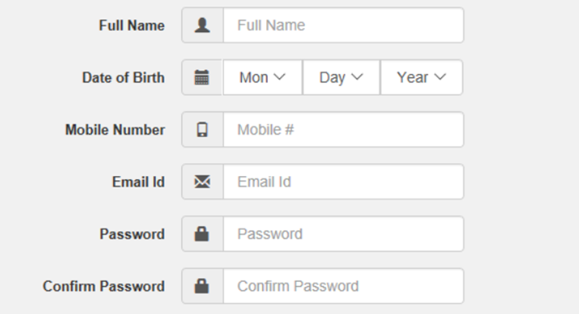



Table 3-1: Screen Definition
# | Field Name | Type | Mandatory | Max Length | Description
1 | Full Name | Text | Yes | 30
2 | Date of Birth | Number | Yes
3 | Mobile Number | Number | Yes | 11-15
4 | Email ID | Text | Yes | 50
5 | Password | Text | Yes | 50 | Display "*" instead of clear character
6 | Confirm Password | Text | Yes | 50 | Display "*" instead of clear character
7 | Register | Button |  |  | Back page home

UC02-Login

Introduction
Customer login in system to can rental car. The customer use address email to login in system

Table
# | Field Name | Type | Mandatory | Max Length | Description
1 | User Name | Text | Yes | 20
2 | Password | Text | Yes | 20 | Display "*" instead of clear character
3 | Login | Button |  |  | Go to home page
4 | Close | Button

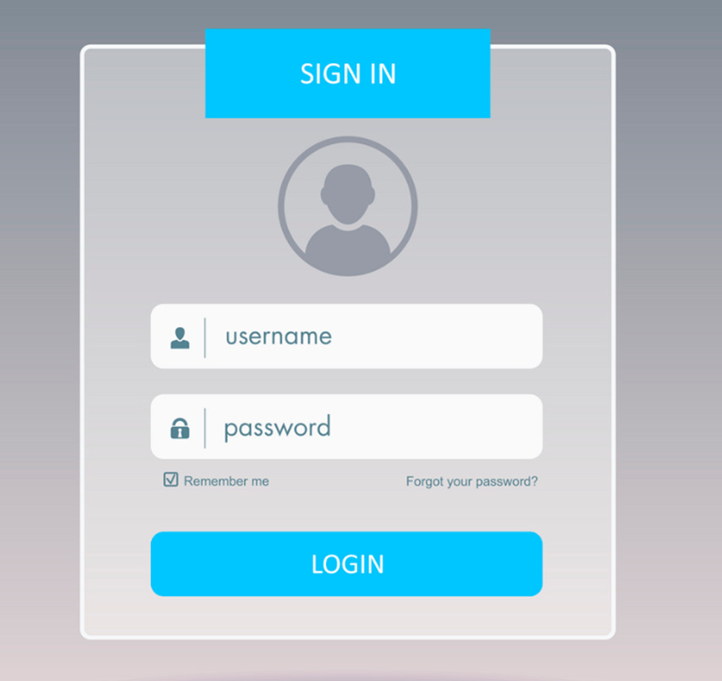

User Case Specification

Non-Functional Requirements Specification

External Interface Requirements

User Interfaces
The Rental Car System screen display shall conform to the process impact Internet
System will provide a help link from each displayed webpage to explain how to use that page. The webpages shall permit complete navigation and car item selection by using keyboard and mouse

Hardware Interfaces
No hardware interfaces have been identified

Software Interfaces
1.
-RCS shall check cars were paying by customers and changing status that cars become
-RCS shall check car is no longer available and change status that become not rental. Besides
if a car was customer pay RCS is going to change car status become rental
2.
-

Communications Interfaces
-RCS shall send email or text message (Based one user account setting) to delivery and notification that customer need has personal document go to store to can rental car
- RCS shall send email or text message (Based one user account setting) to notification report any problems with time rental car.

Other Nonfunctional Requirements

Performance Requirements
<If there are performance requirements for the product under various circumstances, state them here and explain their rationale, to help the developers understand the intent and make suitable design choices. Specify the timing relationships for real time systems. Make such requirements as specific as possible. You may need to state performance requirements for individual functional requirements or features.

This section lists all requirements whose Category has been stated in the goal model to be ‘performance’>

Design constraints
<This section lists all requirements whose Category has been stated in the goal model to be ‘development’ or ‘architecture’ (see Figure 7.5)

Safety Requirements
<Specify those requirements that are concerned with possible loss, damage, or harm that could result from the use of the product. Define any safeguards or actions that must be taken, as well as actions that must be prevented. Refer to any external policies or regulations that state safety issues that affect the product’s design or use. Define any safety certifications that must be satisfied.

This section lists all requirements whose Category has another value e.g. ‘safety’

>

Security Requirements
- All network transactions that involve financial information or personally identifiable information shall be encrypted per BR-33
- Users shall be required to log on to the COS for all operations except viewing a menu or management system
-
- The system shall permit Patrons to view only orders that they placed.

Software Quality Attributes
<Specify any additional quality characteristics for the product that will be important to either the customers or the developers. Some to consider are: adaptability, availability, correctness, flexibility, interoperability, maintainability, portability, reliability, reusability, robustness, testability, and usability. Write these to be specific, quantitative, and verifiable when possible. At the least, clarify the relative preferences for various attributes, such as ease of use over ease of learning.

This section lists all requirements whose Category has another value e.g. ‘accuracy’ >

Other Requirements
<Define any other requirements not covered elsewhere in the SRS. This might include database requirements, internationalization requirements, legal requirements, reuse objectives for the project, and so on. Add any new sections that are pertinent to the project.>
Appendix A: Glossary
<Define all the terms necessary to properly interpret the SRS, including acronyms and abbreviations. You may wish to build a separate glossary that spans multiple projects or the entire organization, and just include terms specific to a single project in each SRS.>
Appendix B: Analysis Models
<Optionally, include any pertinent analysis models, such as data flow diagrams, class diagrams, state-transition diagrams, or entity-relationship diagrams.>
Appendix C: Issues List
< This is a dynamic list of the open requirements issues that remain to be resolved, including TBDs, pending decisions, information that is needed, conflicts awaiting resolution, and the like.>

