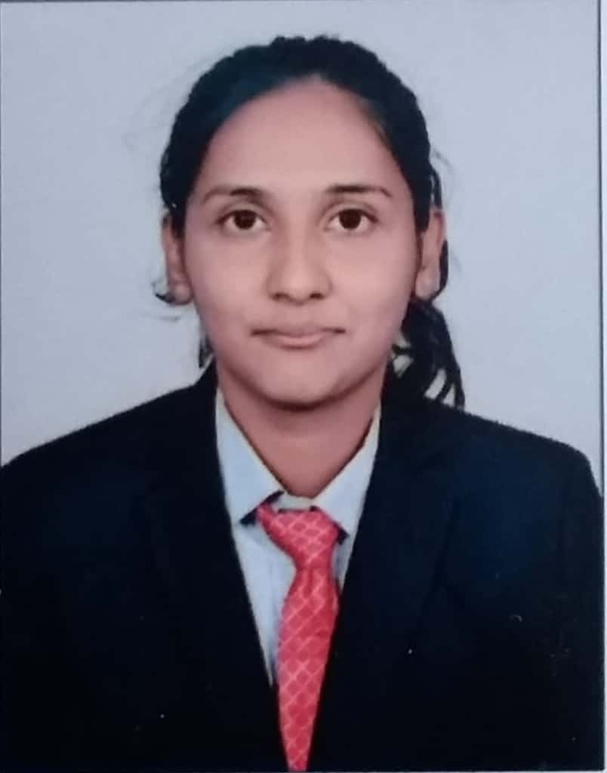Miss .Pooja Shantinath Awati.

Address: A/P Sawalwadi, Tal-Miraj, Dist-sangli.

Contact: 7517944816/ 8483946998

Email: [poojaawati1998@gmail.com](mailto:poojaawati1998@gmail.com)

Education: BE (Electronics and Telecommunication Engineer)

**Career Objective:** To play important role in energetic organization that allows me to utilize my skills for growth of organization as well as to enhance my knowledge about new technologies.

**Educational Qualification:**

|  |  |  |  |
| --- | --- | --- | --- |
| **Exam** | **University/Board** | **Year of Passing** | **Percentage** |
| BE | Shivaji University | April-2020 | 83.25 |
| TE | April-2019 | 65.88 |
| SE | April-2018 | 66.67 |
| FE | April-2017 | 60.86 |
| HSC | Maharashtra State Board | March-2016 | 66.67 |
| SSC | Maharashtra State Board | March-2014 | 90.20 |

**Project Details:**

* **BE Project- “**Meal surving robot used in hotels.”
* **TE Project – “**Density based Traffic light system”

This project detects the density on the road and gives the much needed time for traffic to open or close.

* **Some mini Project**

1.clap switch

**Technical Skills:**

**Languages:** C Program, HTML5 , CSS3,Bootstrap ,Basic Javascript, PCB Design, Simulation.

**Operating Systems**: WINDOWS XP/7/8/10, MS Office (PowerPoint, Word, Excel), Eagle.

**Industrial Experience:**

* I have done 10 days training at “Manicon” Systems. They make the Balancing Equipment. They have different products which are used to check balancing of the Mechanical Components. We done the PCB mounting and soldering of the component. Those PCBs are used in the balancing machine. Also seen how those machines are assembled and tested.
* I have done 15 days training at “Electro India” company. The Company is Digital Weight Machine. We have done soldering, Mounting, wiring, and testing of the digital weight machine.

**Workshops:**

* Actively attended 6 days workshop on “Industrial Automation and PLC Ttanining” in SIT college of engineering from 12th to 17th Feb 2018.
* Attended UTL TechnologyWorkshop for 15 days of Embedded C in SIT college of Engineering..

**Extra-curricular Activities:**

|  |  |  |  |
| --- | --- | --- | --- |
| **Event** | **Competition** | **Date** | **Venue** |
| Master Representer 2K18 | National Level Poster Computation | 11th sep 2018 | Sharad Institute  College Of Engineering |
| TECHNOCART2K18 | Paper Presentation | 29th Sep 2018 | Walchand College Of Engineering |
| PINOEER 2K19 | Project Competition | 27th Jan 2019 | Kolhapur Institute Of Technology |
| INOVATION2K18 | Smart Brain Test | 28th Feb 2018 | Sharad Institute  College Of Engineering |
| ELECTROSPARK | National Level Conference | 11th Feb 2018 | Kolhapur Institute Of Technology |

**Personnel Details:**

Date of Birth : 15 May 1998

Gender : Female

Language Known : English, Hindi and Marathi

Hobbies : Cooking .

**Declaration**:

I hereby declare that the above-mentioned information is correct up to my knowledge. I bear responsibility for the correctness of the above mentioned particulars.

Date: (Pooja Shantinath Awati)

Place: yadrav