Project Documentation MS

**1.Depository :**

Here is a link to our project Depository :

https://github.com/beaverul/MSProject

**2.User requirements :**

-The System we chose to design is simple and easily understandable by any user.

The users will receive notifications through our designed android application. They can access and control any feature it provides(i.e. setting up the alarm or cancelling it during weekends). On the interactive screen it will be shown the outside temperature, the clock and the date.

**3.System overview :**

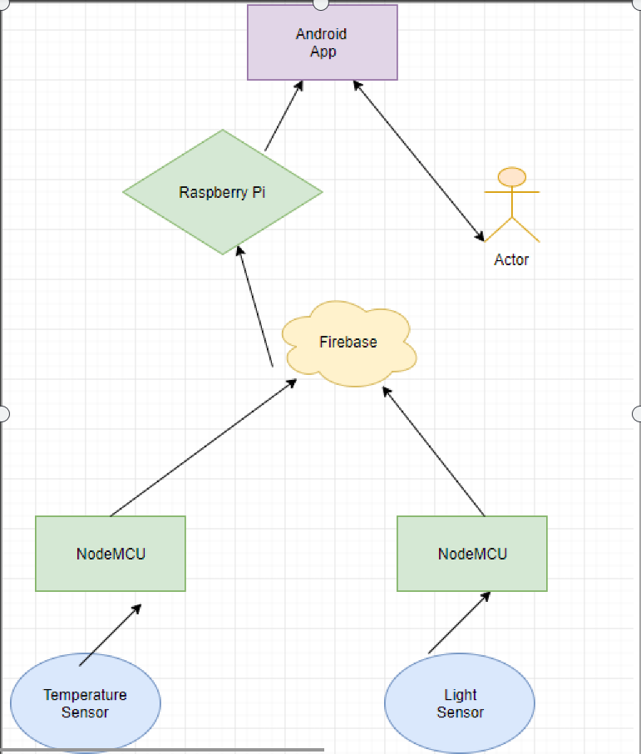

**4.Circuit Design :**

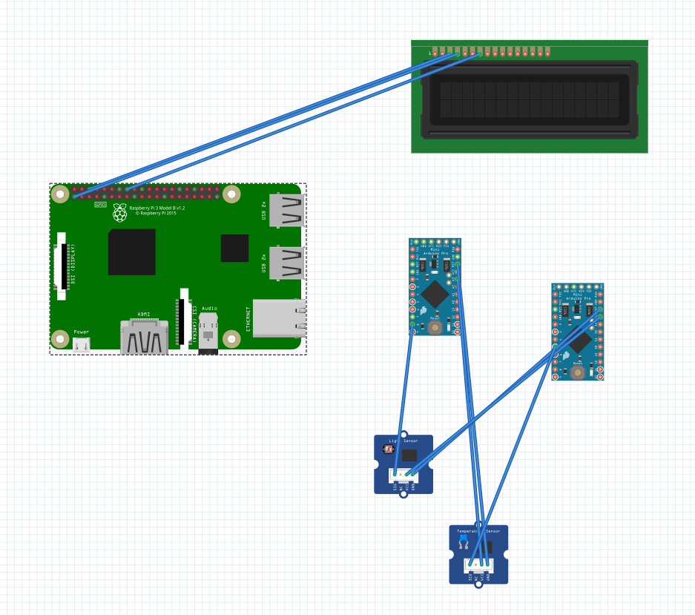

Despite the lack of visual details of the circuit design, the way it works is the following :

-The System consists of 2 NodeMCUs (1 is connected to the Temperature Sensor , the other one is connected to the Light Sensor).

-The Data collected (Temp,Light) is transmitted via Wifi to Firebase.

-Raspberry PI collects information from Firebase ,process data and displays the corresponding date, time ,temperature and light on the Nextion screen.

-One clock sensor is connected to Raspberry sending information about date and time.

-Smart alarm clock comes with an Android Application that facilitates users to set an alarm from their Smart phones.

-System sends push notifications to the user via an application called ''Pushover''.

**5.Software Design :**

Here's a diagram of our Software Design .

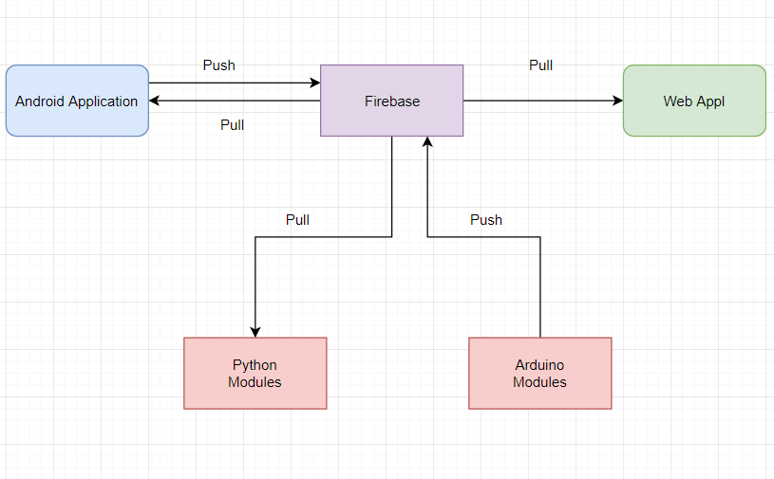

-Languages Used : Python - Java - C (For Arduino).

**6.Result and Further Work :**

**-What we Achieved :**

An alarm System that notifies the user with their important events , Also the system is provided with Temperature and Light Sensors ( For the TEMP , and DARKNESS/LIGHT).

The project has provided us with lots of experience and new ideas , we learned how to use communication protocols and even how powerful are the API’s and tools Google can provide. So we look for the best to improve it even further .

**-Further Work :**

We plan on redesigning the Android application and in the near future to implement our project in order to be more interactive. For example adding a keyword which will be used to stop the alarm and creating a playlist which will work as a database for our application, where the preferences of the users will be stored.

**Made By : NICU RAUL**

**MOHAMED SOBHI**

**LUPITA VLAD**