USER MANUAL
SOR Polymorphizer
Trimming an API contract down to what the System of Record actually supports
Application version | 5.1
Written for | Business analysts and API designers
You will need | The application, one OpenAPI file, one SOR mapping workbook
Time for a first run | About five minutes
Also available | Command line and batch runner, see section 8

This manual assumes no knowledge of the tool and no programming. Section 1 explains what the application decides and why. Sections 2 to 4 walk through a run and show how to read the results. Section 6 covers what to do when something looks wrong, which in practice is almost always the same one problem.

Contents

1 What the application does
A canonical API model describes more than any single System of Record can supply. Publish that model unchanged and consumers receive fields the SOR never populates. Trim it by hand for each operation and the copies drift apart within weeks.
This application does the trimming mechanically. You give it two files: the OpenAPI specification and the field mapping workbook your team already maintains. It produces a new specification carrying only the attributes the SOR supports, and a report explaining every decision it made.

1.1 The one rule
Everything the application does follows from a single rule about the SOR Field column in your mapping workbook.
What the mapping says | What happens | Why
A real SOR field name | The attribute is kept | There is positive evidence the SOR supports it.
Blank, N/A, TBD, a dash,  or Not Used In SOR | The attribute is removed | There is positive evidence the SOR does not.
The attribute is not in the  workbook at all | The attribute is kept, and  listed for you to review | Not finding something is not the same as being told it is unused. The application will not delete on a guess.

Objects and arrays are structure, not data, so they are never removed for lacking an SOR field of their own. But an object that loses every one of its attributes is removed completely, along with every reference to it. That is what stops your payload examples rendering as an empty pair of braces.
Worth knowing. The third row of that table is the most important line in this manual. If a run reports a large number of attributes it could not find, the mapping was not read correctly. It does not mean the SOR is missing those fields. Section 6.1 explains what to do.

1.2 Before you start
- The OpenAPI specification as a .yaml file.
- The SOR field mapping workbook as .xlsx or .xlsm. One workbook per run; it may contain any number of sheets.
- Optionally, the System of Record's own API specification files. Supply these and the application will also check that every SOR field named in your mapping genuinely exists in the SOR.
- A folder you can write to, for the output and the reports.

You do not need to prepare or reformat the workbook. The application works out where the header row is and which columns to read. Section 7 describes what it looks for, in case you are designing a new workbook.

2 Starting the application
If someone has given you PolymorphizeSwagger.exe, double-click it. Nothing else is required; Python is not needed.
If you have the source folder instead, the person who set it up will have run build_windows_exe.bat once to produce that file. It appears in the dist sub-folder.
Check the title bar. It should read SOR Polymorphizer v5.1. If it reads an earlier version you have launched an old copy, most often one left in a previous dist folder. Find the newest file before reporting a problem.
The window opens with the three steps numbered along the top. The Run button stays greyed out until you have analysed, so the steps cannot be taken out of order.

3 Running the application

3.1 Step 1, choose your files
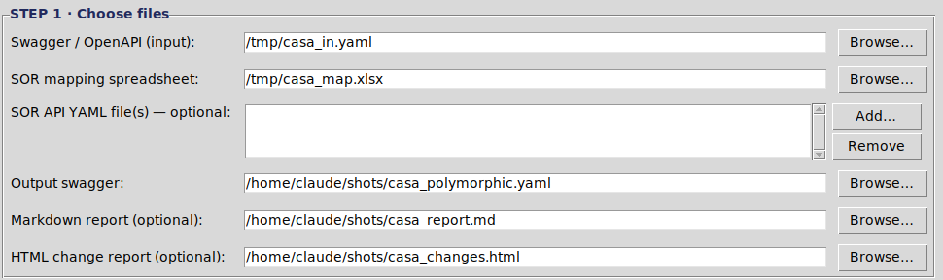
Figure 1. Step 1. Only the first two rows and the output path are required.
Field | Required | What to put there
Swagger / OpenAPI (input) | Yes | The specification you want trimmed.
SOR mapping spreadsheet | Yes | Your field mapping workbook. One file.
SOR API YAML file(s) | No | The SOR's own specifications. Adds a check that each mapped SOR field really exists.
Output swagger | Yes | Where to write the trimmed specification. Use a new file name; do not overwrite your input.
Markdown report | No | A text report. Useful for pasting into a ticket or an email.
HTML change report | No | The one to read first. Left blank, it is created next to the output anyway.

Drag and drop works if the drag-and-drop component is installed; the line under the step heading tells you either way. Browse always works.

3.2 Step 2, analyse
Click Analyze. Nothing is written to disk at this stage. The application reads both files, works out what it would do, and fills in the boxes below.
Read the Mapping coverage box before anything else.
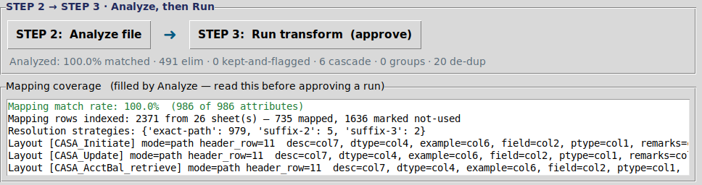
Figure 2. A healthy analysis. The match rate is green and every attribute was resolved.
The four things it tells you:
Line | What it means
Mapping match rate | The share of attributes in your specification that the application found in the workbook. This measures the lookup, not the SOR. Green is good, amber is worth investigating, red means the workbook was not read correctly.
Mapping rows indexed | How many attribute rows it read, and how they split between mapped and marked as not used. If this reads zero, the wrong file or the wrong sheet was supplied.
Resolution strategies | How the attributes were matched. exact-path is the strongest. A large leaf count means it fell back to matching on the last part of the name only, which is less reliable.
Layout | The header row and columns the application decided to read on each sheet. Check that field is the column holding the attribute name and sor is the column holding the SOR field. This one line catches most problems.

The status line beside the buttons summarises the whole proposal: how much matched, how many attributes would be removed, how many would be kept and flagged, how many emptied objects would be cleared away, and how many de-duplications are proposed.

3.3 The review boxes
Below the coverage box, the application fills in what it proposes to restructure. Both boxes are editable; anything you delete will not be applied.
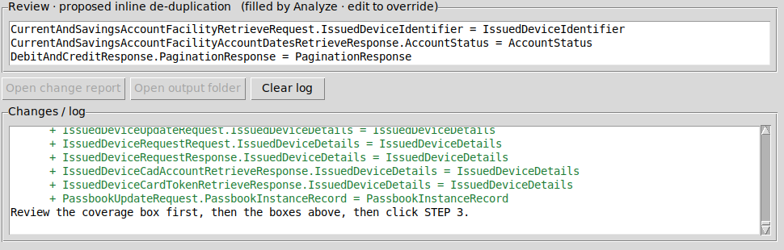
Figure 3. The de-duplication proposals and the colour-coded log. Red is a removal, green is an addition.
- Polymorphism groups. Where two operations share a schema, the shared core can be factored into a base with one subtype per operation. Leave this box empty unless your team has agreed to restructure the contract.
- Inline de-duplication. An object written out inside another schema, identical to a named schema elsewhere, can be replaced by a reference to it. This is safe and is worked out from your original file, never from the trimmed one.
- The log lists every attribute that would be removed, in red, with the reason; every attribute kept but not found, in amber; and every proposed addition in green.

3.4 Step 3, approve and run
Click Run transform. The application restates what it is about to do and waits for you.
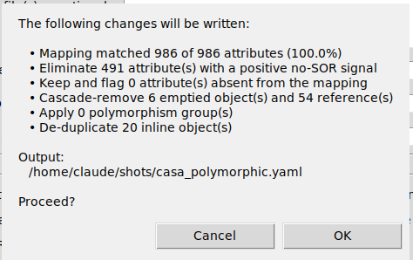
Figure 4. The approval dialogue. Nothing has been written to disk at this point.
If the match rate was low, this dialogue says so plainly before you approve. Cancel costs nothing; you can change the files or the options and analyse again.
Press OK and the application writes the trimmed specification, then the reports. When it finishes, the Open change report and Open output folder buttons become available.
If you change anything after analysing, the analysis is discarded and the Run button greys out again. This is deliberate. An approval always describes the files currently selected.

4 Reading the results

4.1 The HTML change report
Click Open change report. This is the document to share with a developer or attach to a review. It opens in a browser and needs nothing installed.
Section | What to look for
Summary cards | The match rate, attributes removed, attributes kept and flagged, emptied objects cleared, de-duplications and polymorphism groups, at a glance.
Post-run assertions | Should read that all assertions passed. Anything else is a defect worth reporting.
Detected spreadsheet layout | One row per sheet. Confirm the columns before trusting the rest.
Attributes eliminated | Every removal, with the reason, how it was matched, and the SOR field involved.
Kept but not found in the mapping | The review list. Each line shows the lookup keys the application tried, so you can see why it missed.
Cascade removals | Objects that lost every attribute, and the references removed with them.
Full diff | A line-by-line comparison of the original and the result, removals in red and additions in green.

4.2 The Markdown report
The same content as plain text. Convenient for a ticket, an email or a change record, and it can be searched and diffed.

4.3 What the application writes into the specification itself
The trimmed specification carries its own audit trail, so it stands alone once it leaves your hands. At the top is a banner comment summarising the run. Under info, a section named x-sor-polymorphizer records the coverage figures, every eliminated attribute with its reason, every attribute kept but not found, every object and reference removed by the cascade, and any operation body that would have been left empty. Individual schemas that were edited carry a comment marking the change.
Encoding. The output is always written as UTF-8, whatever the input was. Some characters in these specifications have no equivalent in the older Windows ANSI encoding, so if you re-save the file from a text editor, keep it as UTF-8 or 56 characters will be corrupted.

5 The options, and when to touch them
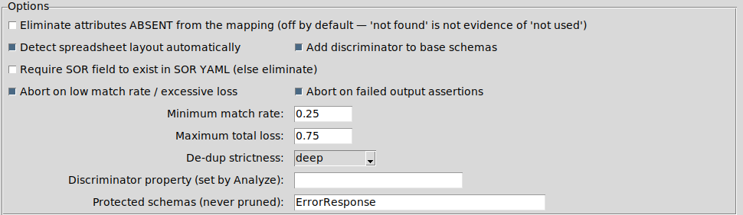
Figure 5. The options panel. The defaults are the safe settings.
Most runs need none of these. The table says plainly which ones carry risk.
Option | Default | Guidance
Eliminate attributes ABSENT from the mapping | Off | Leave it off. Turning it on tells the application to delete anything it could not find, which converts a lookup problem into silent data loss. This is the setting that caused the historical failure this version was built to prevent.
Detect spreadsheet layout automatically | On | Leave it on. Switch it off only if you have been told to use specific column numbers, which are then read from the Advanced panel.
Add discriminator to base schemas | On | Only has an effect when a polymorphism group is applied. It adds a selector field to the payload. Switch it off if the SOR supplies no such field.
Require SOR field to exist in SOR YAML | Off | Turn on only when you have attached the SOR's own specifications and you want mapped attributes removed if their SOR field is not found there.
Abort on low match rate / excessive loss | On | Leave it on. This is the safety net that stops an emptied specification being written.
Abort on failed output assertions | On | Leave it on. It checks the result for empty objects, broken references and other structural faults.
Minimum match rate | 0.25 | The floor below which a run is abandoned. Do not lower it to force a run through; fix the workbook or the layout instead.
Maximum total loss | 0.75 | The ceiling on how much of the specification may be removed. Raise it deliberately, and record why.
De-dup strictness | deep | deep requires the two objects to be identical. shape ignores descriptions and examples. deep is the conservative choice.
Protected schemas | ErrorResponse | Never trimmed. Add any schema that must survive untouched, separated by commas.

6 When something looks wrong

6.1 A low match rate
This is the common one, and it is nearly always the wrong sheet or the wrong column, not a problem with your SOR.
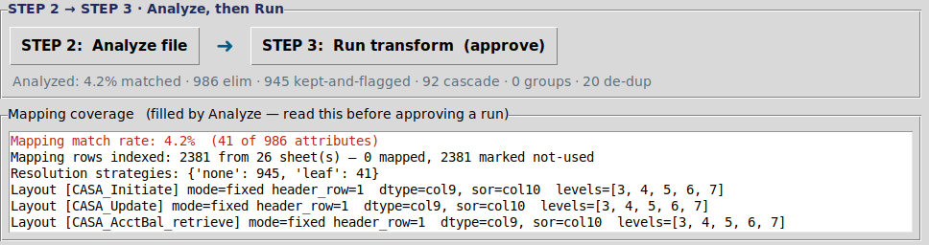
Figure 6. A failed lookup. 4.2% matched, the layout shows mode=fixed, and almost every attribute resolved to nothing.
Compare Figure 6 with Figure 2. Three things give it away:
- The match rate is red, and the number is low.
- Resolution strategies is dominated by none, meaning most attributes matched nothing at all.
- The Layout line shows mode=fixed rather than mode=path, so automatic detection was switched off and fixed column numbers were used instead.

What to do, in order:
- Read the Layout line. Confirm that field points at the column holding the attribute name and sor at the column holding the SOR field.
- Make sure Detect spreadsheet layout automatically is ticked.
- Check you supplied the right workbook, and that the attribute names in it match the names in the specification.
- Analyse again. Do not lower the minimum match rate to get past the warning.

6.2 The run was abandoned
Message | What it means | What to do
Mapping coverage | The match rate was below the floor, so nothing was written. | Follow section 6.1. The guard is telling you the lookup failed, not that the SOR is empty.
Excessive loss | More than three quarters of the attributes would have been removed. | Check whether Eliminate attributes ABSENT from the mapping was ticked. If the loss is genuine, raise the ceiling deliberately.
Assertion failure | The result contained a structural fault. The output and the reports were still written so they can be inspected. | Open the report, read the assertions section, and send it to whoever maintains the tool.
No attribute rows were read | The workbook was opened but nothing usable was found in it. | Wrong file, or a workbook whose layout the application cannot recognise. See section 7.

6.3 Messages that are not problems
Message | Meaning
A de-duplication logged as SKIPPED | Two objects that looked alike turned out to differ. The application refused to merge them, which is correct; merging would have lost a field.
Operation bodies that would be empty | Every attribute of a request or response was removed. The application deliberately leaves the schema in place rather than deleting an operation's body, and tells you which one so you can review the mapping.
Input decoded as cp1252 | Your specification was saved in the older Windows encoding. It was read correctly and the output is UTF-8.
Attributes kept and flagged | Working as designed. These were not found in the mapping and were retained for you to review, not deleted.

7 Preparing a mapping workbook
You do not need to reformat an existing workbook. This section is for anyone designing a new one, or investigating why an old one is not being read.
The application scans the first forty rows of every sheet looking for a header row, then works out the columns from their labels. It handles two shapes of workbook:
- One column holding the full attribute path, written with dots, for example Request.Customer.party.Partyidentifier.partyIdentification. This is the common shape.
- Several columns headed Level 1, Level 2 and so on, with the hierarchy spread across them.

Column labels it recognises. Any reasonable variation of these works, and capitalisation does not matter.
Column | Labels it looks for
The attribute name | Re-usable API Field Name, API Field Name, Field Name, Attribute, Element
The SOR field | SOR API Field Name, SOR Field, SOR
The data type | Schema, Data Type, Type, Format
Usage | Usage, Mandatory, Cardinality
Parameter type | Parameter Type

Values in the SOR field column that mean there is no SOR field:
blank N/A n/a NA - -- TBD TBA
None Null Nil Not Used In SOR Not Applicable
Sheets in one workbook may have different layouts; each is detected separately. Rows above the header, section banners and rows whose data type is object or array are handled automatically. The layout the application settled on is always printed, so you can check it rather than guess.

8 For technical users
The same engine is available from the command line and as a batch runner. Both need Python 3.9 or later with ruamel.yaml and openpyxl installed.

8.1 Check the coverage first
This writes nothing. Run it whenever a mapping workbook is new or has changed.
python polymorphize_cli.py --diagnose \
--swagger api.yaml --mapping mapping.xlsx
It prints the detected layout for every sheet, the number of rows indexed, the match rate, the resolution strategies, and for anything it could not find, the exact keys it tried alongside the nearest keys in the workbook.

8.2 Transform
python polymorphize_cli.py \
--swagger api.yaml --mapping mapping.xlsx \
--out api_polymorphic.yaml --report report.md \
--html-report changes.html --auto-dedupe
Useful switches: --on-unmatched keep or drop, --auto-poly, --dedupe-strictness deep or shape, --protected, --min-match-rate, --max-total-loss, --no-guards, --no-assert, --no-auto-layout. Run with --help for the full list.

8.3 Many files at once
Copy manifest_template.csv, one job per row, at minimum a swagger and a mapping per row. Relative paths resolve against the manifest's own folder.
python polymorphize_batch.py --manifest jobs.csv --jobs 4
It writes each transformed specification with its HTML report, plus batch_summary.csv carrying the match rate and counts per job, and batch_index.html as a linked roll-up. On Windows you can drag a manifest onto run_batch.bat. A job whose mapping barely matched is reported as ABORTED and writes nothing, by design.

8.4 Exit codes
Code | Meaning
0 | Success.
3 | Abandoned on mapping coverage. Nothing was written.
4 | Abandoned on excessive loss. Nothing was written.
5 | Post-run assertion failure. The output and reports were written for inspection.

Appendix Glossary
Term | Meaning
Attribute | A single data field in the specification, such as accountType. Objects and arrays are structure, not attributes.
Cascade removal | Removing an object that lost every one of its attributes, together with every reference pointing at it.
De-duplication | Replacing an object written out inside a schema with a reference to an identical named schema.
Discriminator | A field in the payload whose value tells a consumer which shape the rest of the payload takes.
Kept and flagged | An attribute the mapping never mentioned. Retained and listed for review rather than deleted.
Match rate | The share of attributes in the specification that were found in the mapping workbook. A measure of the lookup, not of the SOR.
Polymorphism group | A shared base schema plus one subtype per operation, so each operation carries only the attributes it maps.
Protected schema | A schema the application will never trim, whatever the mapping says.
Resolution strategy | How an attribute was matched: on its full path, on part of its path, or on its name alone.
SOR | System of Record. The underlying system that actually holds the data.

