Assignment (25 points)
Copy YPL1Parser.cpp into YPL1Compiler.cpp since YPL1Compiler.cpp is the next step of your YPL compiler!

Note There are no plans to create a separate collection of the triples SPLxScanner.cpp, SPLxParser.cpp, and SPLxCompiler.cpp; instead, SPL1Compiler.cpp will “morph into” (transform into) SPL2Compiler.cpp, which will “morph into” SPL3Compiler.cpp, et cetera, until eventually the compiler will be able to translate the entire SPL language (or as much as we can finish developing during the semester). Usually, each increment to SPL requires new scanning logic (because new tokens are added), new parsing logic (because new rules are added and/or existing rules are changed), and new code generation logic because, as always, syntax →_{implies} semantics.

Study the SPL1Compiler.cpp program source code and the SPL1Compiler-generated STM assembly language code (that, by definition, must have the same semantics, though, of course, much different syntax) of each the three SPL1 programs P1.spl, P2.spl, and P3.spl. Pay close attention to the

//CODEGENERATION
...
//ENDCODEGENERATION

segments and to the CODE class found in SPL.h, the SPL compiler’s “library” of class definitions.

Now—and this is the most difficult part of the assignment—incorporate the semantic analysis and code generation design ideas you learned while studying SPL1Compiler.cpp into your YPL1Compiler.cpp.

To test-and-debug YPL1Compiler.cpp, design one or more YPL1 source files that, like Dr. Hanna’s source files P1.spl, P2.spl, and P3.spl, fully white-box test the logic your fledgling compiler uses to do the semantic analysis and code generation for grammatically-correct YPL1 programs. Obviously, the STM files YPL1Compiler.cpp produces must run successfully on STM and produce the expected results.

Send an email to AHanna@StMaryTX.edu with a single Word document attachment that contains (1) your version of YPL1Compiler.cpp; (2) the YPL1 source files you chose to compile; (3) the STM files your compiler generates for each YPL1 source file; and (4) the corresponding STM screen shots that serve as “proof” that the STM programs are semantically-equivalent to their YPL1 counterparts.

Remember, your “YPL Language Reference” is a “living” document. As you make design changes to YPL, make corresponding changes to your language reference. You must include YPL static semantics and dynamic semantics in your language reference. These parts of the YPL language specification are absolutely essential prerequisites for the design of the YPL compiler’s semantic analyzer/code generator.

Computational and Critical Thinking Questions (25 points)
1. Carefully compare SPL1Parser.cpp and SPL1Compiler.cpp. The first difference you should see is the highlighted definition of the macro TRACECOMPILER added to the other three macros “inherited” from SPL1Parser.cpp

//#define TRACEREADER
//#define TRACESCANNER
//#define TRACEPARSER
#define TRACECOMPILER

How many times does the C++ pre-processor “test” the TRACECOMPILER macro in SPL1Compiler.cpp? ______ Hint Easily accomplished by a (F)ind on "TRACECOMPILER".

2. (Continuing 1) The second difference you should see is the global data definition shown below. What is CODE? Where is the definition for CODE found?

// CODEGENERATION
CODE code;
// ENDCODEGENERATION

3. (Continuing 1) The third difference you should see is the code segment shown below that has been added to the function main(). Study SPLCompiler-generatedAssemblyLanguageProgramOutline.doc , the “plan” for assembly language programs that are generated during the semantic analysis/code generation: Which lines of the outline file are emitted by the CODE class member function EmitBeginningCode()? Your answer should be the range of line numbers in found in the outline file, lines ______ thru ______.

// CODEGENERATION
code.EmitBeginningCode(sourceFileName);
// ENDCODEGENERATION

4. (Continuing 1) Also added to the function main() is the following code segment. What lines are emitted by the CODE class member function EmitEndingCode()? Again, your answer should be the range of line numbers in found in the outline file, lines ______ thru ______.

// CODEGENERATION
code.EmitEndingCode();
// ENDCODEGENERATION

*FYI #1* Ensure that you understand the reasoning on which the EmitBeginningCode() and EmitEndingCode() “sandwich” created by the SPL compiler CODEGENERATION is based. The remainder of the detailed “YPL compiler-generated assembly language program outline” is generated by the SPL compiler’s various parsing functions.

5. Which ofstream (associated with a write-only text file) is the destination for all emitted code? Hint Study SPL.h to find the answer.
A: LIST B: SOURCE C: STM D: none of these

*FYI #2* Now is the time to design your version of the “YPL compiler-generated assembly language program outline” so that you can modify the CODE class member functions to accommodate YPL eccentricities.

*FYI #3* Notice the slight changes that Dr. Hanna made to the following lines in SPL1Parser.cpp function main() to convert them for use in SPL1Compiler.cpp main() function.

SPL1Parser.cpp version
lister.ListInformationLine("******* SPL parser ending");
cout << "SPL parser ending\n";

SPL1Compiler.cpp version
lister.ListInformationLine("******* SPL compiler ending");
cout << "SPL compiler ending\n";

6. T or F? SPL1Parser.cpp and SPL1Compiler.cpp use identical versions of ParseSPLProgram().

7. SPL1Compiler.cpp version of ParsePROGRAMDefinition() has been changed so that two segments of CODEGENERATION “sandwich” the unchanged parsing segment in the SPL1Parser.cpp version of ParsePROGRAMDefinition(), a pre-parsing segment of CODEGENERATION and a post-parsing segment of CODEGENERATION. What does the pre-parsing CODEGENERATION segment “fit” into the “SPL compiler-generated assembly language program outline”? Your answer should be the range of line numbers in found in the outline file, lines ______ thru ______.

// CODEGENERATION
...pre-parsing segment of CODEGENERATION
// ENDCODEGENERATION

// unchanged parsing segment in the SPL1Parser.cpp version of ParsePROGRAMDefinition()
GetNextToken(tokens);
while ( tokens[0].type != END )
ParseStatement(tokens);

// CODEGENERATION
...post-parsing segment of CODEGENERATION
// ENDCODEGENERATION

8. (Continuing 7) Where does the post-parsing CODEGENERATION segment output “fit” into the “SPL compiler-generated assembly language program outline”? Your answer should be the range of line numbers in found in the outline file, lines ______ thru ______.

9. (Continuing 7) Collectively, what do the pre-parsing and post-parsing CODEGENERATION segments accomplish?

10. (Continuing 7) Use just one short sentence to explain what kind of CODEGENERATION is generated by the unchanged parsing segment in the SPL1Parser.cpp version of ParsePROGRAMDefinition().

11. T or F? SPL1Parser.cpp and SPL1Compiler.cpp use identical versions of ParseStatement().

12. Concerning ParsePRINTStatement() T or F? The following code segment emits one STM assembly language statement that contains a valid STM comment. The STM statement is output to the STM ofstream.

// CODEGENERATION
sprintf(line,"; **** PRINT statement (%4d)",tokens[0].sourceLineNumber);
code.EmitUnformattedLine(line);
// ENDCODEGENERATION

13. (Continuing 12) Briefly describe the code that is emitted by the ParsePRINTStatement() switch-statement’s case STRING: CODEGENERATION logic shown below.

// CODEGENERATION
char reference[SOURCELINELENGTH+1];

code.AddDSToStaticData(tokens[0].lexeme,"",reference);
code.EmitFormattedLine("","PUSHA",reference);
code.EmitFormattedLine("","SVC","#SVC_WRITE_STRING");
// ENDCODEGENERATION

14. (Continuing 13) The SPL token STRING literal lexeme must be stored in memory so that it can be made available to be output: Where in the “SPL compiler-generated assembly language program outline” is the STM data definition statement DS placed that allocates the lexeme? Hint Study the CODE class constructor CODE() and the AddDSToStaticData() member function and how the two functions interact to maintain the contents of the staticdata data member.

*FYI #4* Compare the CODE class member functions AddRWToStaticData(), AddDWToStaticData(), and AddDSToStaticData() to learn how they are used to build the static data segment of the “SPL compiler-generated assembly language program outline”.

;------------------------------------------------------------
; Static allocation of global data and PROGRAM module data
;------------------------------------------------------------
STATICDATA EQU *

Be sure that you understand how the SPL compiler design use of staticdata relates to the content of the “SPL compiler-generated assembly language program outline”. The design intentions are described in first paragraph of the CODE class introductory comment (repeated below for your convenience). Note There’s no need to fully understand the design notes in the second paragraph until subprogram modules become part of compiler-supported SPL syntax (according to the syllabus, subprogram support occurs in SPL6 (PROCEDURE modules) and in SPL7 (FUNCTION modules)).

/*
SPL static data--global variable/constant definitions, string literals, and
PROGRAM module variables/constants--are parsed both very early in the
compile and near the end of the compile. As a result, their STM code must
be "stored" because the code cannot be emitted until *AFTER* the entire
SPL program has been parsed.

SPL dynamic (frame-resident) data--subprogram module formal parameters and
local variables/constants--have storage space accounted for when their
definitions are parsed. The frame space is then allocated using STM
statements emitted as part of the subprogram module prolog code.
*/

15. The code that is emitted by the ParsePRINTStatement() switch-statement’s case ENDL: CODEGENERATION logic is a single STM assembly language statement that makes a STMOS (STM operating system) system service request. What is the service request number? ______ Hint See the “STMOS system service requests” table in STM.doc or the code emitted by CODE member function EmitBeginningCode().

// CODEGENERATION
code.EmitFormattedLine("","SVC","#SVC_WRITE_ENDL");
// ENDCODEGENERATION

16. (Continuing 15) A STM assembly language <statement> may have up to four fields (1) <identifier> to label the <statement>; (2) an “operation” (<HWMnemonic>, ORG, EQU, RW, DW, or DS); (3) operand(s); and (4) a line-ending comment. Here’s an excerpt from the STM BNF found in STM.doc. The EmitFormattedLine() member function formats a STM source line by left-aligning each of the four fields at Dr.-Hanna’s-eye-pleasing tab stops (smile). What column number is the tab stop for “operands”? ______ Note The first column is numbered 1, not 0. You are allowed to change the tab stops if your aesthetics differ from those of Dr. Hanna (smile) but answer this question using Dr. Hanna’s tab stops!

<statement> ::= <instruction> [ <comment> ]
| <comment>

<instruction> ::= [ <identifier> ] <HWMnemonic> [ <operand> ]
| [ <identifier> ] ORG <I16>
| <identifier> EQU (( <W16> | * ))
| [ <identifier> ] RW [ <I16> ]
| [ <identifier> ] DW <W16>
| [ <identifier> ] DS <string>

17. (Continuing 15) The actual parameter corresponding to the fourth formal parameter of EmitFormattedLine(), comment (see prototype below), is missing from the call to EmitFormattedLine(). T or F? The actual parameter value supplied by the C++ compiler is the default value null-string "".

void EmitFormattedLine(const char label[],const char mnemonic[],const char operand[] = "",const char comment[] = "");

18. The code segment shown below has been added to Callback2(). T or F? line is added to the STM file as a STM comment. Hint Study the CODE class member function EmitUnformattedLine() to find the answer.

// CODEGENERATION
sprintf(line,"; %4d %s",sourceLineNumber,sourceLine);
code.EmitUnformattedLine(line);
// ENDCODEGENERATION

19. (Continuing 18) Complete the following sentence, “The <stdio.h> function sprintf() “works” just like the function printf() except that the characters that result from the formatting directed by the parameters "; %4d %s",sourceLineNumber,sourceLine are not output to the standard output device, but to…”

20. T or F? SPL1Parser.cpp and SPL1Compiler.cpp use identical versions of GetNextToken().

21. The SPL compiler is designed to make a single pass through the source file. As a result, because of SPL grammar rules, T or F? the SPL subprogram-module definitions must be compiled (that is, scanned, parsed, and semantically-analyzed) before the PROGRAM module is compiled. Hint See SPLLanguageReference.doc for the complete set of SPL grammar rules.

22. The “SPL compiler-generated assembly language program outline” handling of SPL run-time errors is repeated below. T or F? By design, all currently-defined SPL run-time errors abort program execution after issuing an error message.

;=============================================================
; *ALL* diagnosed run-time errors are issued using the same message (see below).
; Assumes line# and error# have been pushed on run-time stack (in that order)
; before jump-to HANDLERUNTIMEERROR label.
;
; Run-time error #X..X near line #X..X
;
; error# description of run-time error
; ------ ----------------------------------------------------------------------
; 1 Assertion failure
; 2 FOR-statement with E3 = 0
; 3 Body of FUNCTION module *MUST* execute RETURN
; 4 Body of HANDLER module *MUST* execute RESUME or EXIT
; 5 HANDLER module executed an EXIT
;=============================================================
;------------------------------------------------------------
; Issue message "Run-time error #X..X near line #X..X" to handle run-time errors
;------------------------------------------------------------
HANDLERUNTIMEERROR EQU *
SVC #SVC_WRITE_ENDL
PUSHA SB:0D("Run-time error #")
SVC #SVC_WRITE_STRING
SVC #SVC_WRITE_INTEGER
PUSHA SB:0D(" near line #")
SVC #SVC_WRITE_STRING
SVC #SVC_WRITE_INTEGER
SVC #SVC_WRITE_ENDL
PUSH #0D1
SVC #SVC_TERMINATE

*FYI #5* If your plan for YPL run-time error handling varies from SPL run-time error handling just described, then some code changes will need to be made to the CODE class member function EmitEndingCode().

23. In which direction does the STM run-time stack (and, therefore, the SPL run-time stack) grow? Hint See the “SPL compiler-generated assembly language program outline” code segment below and the figure given in the Hint below given for CCTQ 25.

;=============================================================
; SP register is initialized with address of the most-significant
; byte of the last word in physical main memory
;=============================================================
;------------------------------------------------------------
; Run-time stack
;------------------------------------------------------------
RUNTIMESTACK EQU 0XFFFE

24. How is HEAPBASE “computed”? Hint See the “SPL compiler-generated assembly language program outline” code segments below and the figure given in the Hint for CCTQ 25.

;=============================================================
; For the only PROGRAM module in the SPL source file
;=============================================================
PROGRAMMAIN EQU *
PUSH #RUNTIMESTACK ; set SP
POPSP
PUSHA STATICDATA ; set SB
POPSB
PUSH #HEAPBASE ; initialize heap
PUSH #HEAPSIZE
SVC #SVC_INITIALIZE_HEAP
CALL PROGRAMBODY???? ; ???? = unique suffix
PUSHA SB:("Normal program termination")
SVC #SVC_WRITE_STRING
SVC #SVC_WRITE_ENDL
PUSH #0D0 ; terminate with status = 0
SVC #SVC_TERMINATE

PROGRAMBODY???? EQU *
; statements in body of PROGRAM module
RETURN

...

;=============================================================
; (1) The static allocation of *ALL* global variables/constants and *ALL* <string>
; literals discovered during compilation; and (2) the static allocation of the
; PROGRAM module local variables/constants
;=============================================================
;------------------------------------------------------------
; Static allocation of global data and PROGRAM module data
;------------------------------------------------------------
STATICDATA EQU *
...
RW, DW, or DS
...
DS "Normal program termination"
DS "Run-time error #"
DS " near line #"
...
RW, DW, or DS
...

;------------------------------------------------------------
; Heap space for dynamic memory allocation (to support future SPL syntax)
;------------------------------------------------------------
HEAPBASE EQU *
HEAPSIZE EQU 0B0001000000000000 ; 8K bytes = 4K words

25. The STM JMP instruction (see below) is the last statement emitted by the CODE class member function EmitBeginningCode(). Find the JMP PROGRAMAIN statement in “SPL compiler-generated assembly language program outline”. This JMP instruction ensures that STM program flow-of-control “jumps over” all subprogram module definitions—that is, PROCEDURE, FUNCTION, and/or HANDLER module definitions—that have been compiled before the SPL PROGRAM module is compiled. What is the 16-bit logical address of the JMP instruction’s opcode expressed as 4 nibbles? 0X______

EmitFormattedLine("" ,"JMP","PROGRAMMAIN");

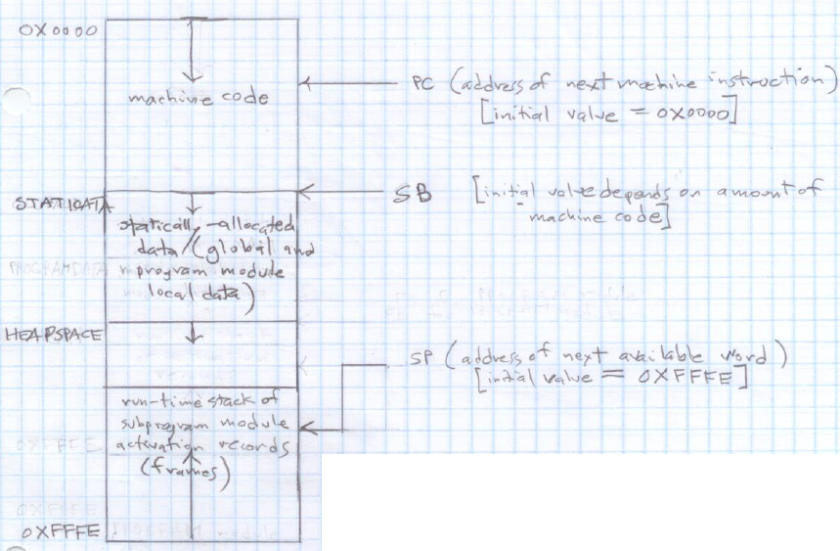
Hint By design, every SPL compiler-generated assembly language program has the same outline (see figure at right that Dr. Hanna copied from STM.doc).

*FYI #6* Study the CODE class data members and the CODE class member functions.

private:
ofstream STM;
char codeFileName[80+1];
vector<DATARECORD> staticdata;
int SBOffset;
int labelsuffix;

public:
CODE();
~CODE();
void OpenFile(const char sourceFileName[]);
void EmitBeginningCode(const char sourceFileName[]);
void EmitEndingCode();
void AddRWToStaticData(int operand,const char comment[],char reference[]);
void AddDWToStaticData(const char operand[],const char comment[],char reference[]);
void AddDSToStaticData(const char operand[],const char comment[],char reference[]);
void EmitStaticData();
int LabelSuffix();
void EmitFormattedLine(const char label[],const char mnemonic[],const char operand[] = "",const char comment[] = "");
void EmitUnformattedLine(const char line[]);

You must be able to answer questions like these (1) When data member labelsuffix is 10, what does the member function LabelSuffix() return? ______ (2) How is the data member labelsuffix side-effected by each call to LabelSuffix()? (3) How is EmitFormattedLine() similar to EmitUnformattedLine() and how is it different? (4) AddRWToStaticData() is useful for allocating one or more 16-bit words in the static data region of memory: How is it planned to be used because it isn’t used in SPL1Compiler.cpp? (5) AddDWToStaticData() is useful for allocating and initializing one 16-bit word in the static data region of memory: How is it planned to be used because it isn’t used in SPL1Compiler.cpp? (6) What does EmitStaticData() do and when is it called and where is the code it emits in the ?

Sample SPL1-to-STM Program Dialogs

;------------------------------------------------------------
; Dr. Art Hanna
; Program #1
; P1.spl
;------------------------------------------------------------

PROGRAM
END

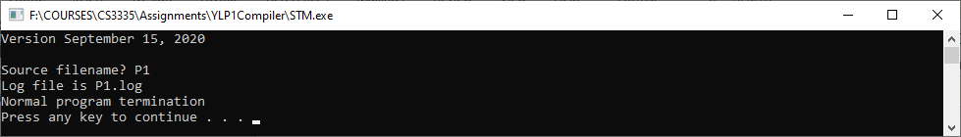

;------------------------------------------------------------
; Dr. Art Hanna
; Program #2
; P2.spl
/*---------------------------------------------------------*/

PROGRAM
PRINT "\"Howdy, world!\"\n".
PRINT "\"Howdy, world!\"",ENDL.
END

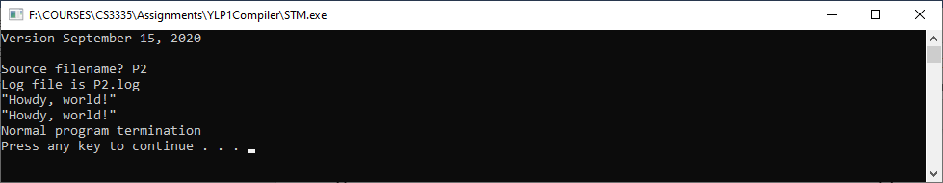

;------------------------------------------------------------
; Dr. Art Hanna
; Program #3
; P3.spl
;------------------------------------------------------------

PROGRAM
PRINT "Howdy".
PRINT ","," ","world","!",ENDL.
END

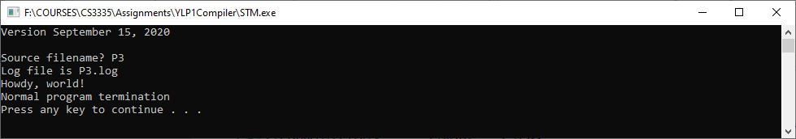
P3.log
LC Object Line Source Line
------ -------- ---- -------------------------------------------------------------
0X0000 1 ;--------------------------------------------------------------
0X0000 2 ; P3.stm
0X0000 3 ;--------------------------------------------------------------
0X0000 4 ; SVC numbers
0X0000 5 SVC_DONOTHING EQU 0D0 ; force context switch
0X0000 6 SVC_TERMINATE EQU 0D1
0X0000 7 SVC_READ_INTEGER EQU 0D10
0X0000 8 SVC_WRITE_INTEGER EQU 0D11
0X0000 9 SVC_READ_FLOAT EQU 0D20
0X0000 10 SVC_WRITE_FLOAT EQU 0D21
0X0000 11 SVC_READ_BOOLEAN EQU 0D30
0X0000 12 SVC_WRITE_BOOLEAN EQU 0D31
0X0000 13 SVC_READ_CHARACTER EQU 0D40
0X0000 14 SVC_WRITE_CHARACTER EQU 0D41
0X0000 15 SVC_WRITE_ENDL EQU 0D42
0X0000 16 SVC_READ_STRING EQU 0D50
0X0000 17 SVC_WRITE_STRING EQU 0D51
0X0000 18 SVC_INITIALIZE_HEAP EQU 0D90
0X0000 19 SVC_ALLOCATE_BLOCK EQU 0D91
0X0000 20 SVC_DEALLOCATE_BLOCK EQU 0D92
0X0000 21
0X0000 22 ORG 0X0000
0X0000 23
0X0000 800003 24 JMP PROGRAMMAIN
0X0003 25 ; 1 ;------------------------------------------------------------
0X0003 26 ; 2 ; Dr. Art Hanna
0X0003 27 ; 3 ; Program #3
0X0003 28 ; 4 ; P3.spl
0X0003 29 ; 5 ;------------------------------------------------------------
0X0003 30 ; 6 PROGRAM
0X0003 31 ; 7 PRINT "Howdy".
0X0003 32 ; 8 PRINT ","," ","world","!",ENDL.
0X0003 33 ; **** =========
0X0003 34 ; **** PROGRAM module ( 6)
0X0003 35 ; **** =========
0X0003 36 PROGRAMMAIN EQU *
0X0003 0100FFFE 37 PUSH #RUNTIMESTACK ; set SP
0X0007 0A 38 POPSP
0X0008 02010074 39 PUSHA STATICDATA ; set SB
0X000C 0C 40 POPSB
0X000D 0100011A 41 PUSH #HEAPBASE ; initialize heap
0X0011 01001000 42 PUSH #HEAPSIZE
0X0015 FF005A 43 SVC #SVC_INITIALIZE_HEAP
0X0018 A0002C 44 CALL PROGRAMBODY0010
0X001B 020A0000 45 PUSHA SB:0D0
0X001F FF0033 46 SVC #SVC_WRITE_STRING
0X0022 FF002A 47 SVC #SVC_WRITE_ENDL
0X0025 01000000 48 PUSH #0D0 ; terminate with status = 0
0X0029 FF0001 49 SVC #SVC_TERMINATE
0X002C 50
0X002C 51 PROGRAMBODY0010 EQU *
0X002C 52 ; **** PRINT statement ( 7)
0X002C 020A001C 53 PUSHA SB:0D28
0X0030 FF0033 54 SVC #SVC_WRITE_STRING
0X0033 55 ; **** PRINT statement ( 8)
0X0033 020A0023 56 PUSHA SB:0D35
0X0037 FF0033 57 SVC #SVC_WRITE_STRING
0X003A 020A0026 58 PUSHA SB:0D38
0X003E FF0033 59 SVC #SVC_WRITE_STRING
0X0041 020A0029 60 PUSHA SB:0D41
0X0045 FF0033 61 SVC #SVC_WRITE_STRING
0X0048 62 ; 9 END
0X0048 020A0030 63 PUSHA SB:0D48
0X004C FF0033 64 SVC #SVC_WRITE_STRING
0X004F 65 ; 10
0X004F FF002A 66 SVC #SVC_WRITE_ENDL
0X0052 A1 67 RETURN
0X0053 68 ; **** =========
0X0053 69 ; **** END ( 9)
0X0053 70 ; **** =========
0X0053 71
0X0053 72 ;------------------------------------------------------------
0X0053 73 ; Issue "Run-time error #X..X near line #X..X" to handle run-time errors
0X0053 74 ;------------------------------------------------------------
0X0053 75 HANDLERUNTIMEERROR EQU *
0X0053 FF002A 76 SVC #SVC_WRITE_ENDL
0X0056 020A0033 77 PUSHA SB:0D51
0X005A FF0033 78 SVC #SVC_WRITE_STRING
0X005D FF000B 79 SVC #SVC_WRITE_INTEGER
0X0060 020A0045 80 PUSHA SB:0D69
0X0064 FF0033 81 SVC #SVC_WRITE_STRING
0X0067 FF000B 82 SVC #SVC_WRITE_INTEGER
0X006A FF002A 83 SVC #SVC_WRITE_ENDL
0X006D 01000001 84 PUSH #0D1
0X0071 FF0001 85 SVC #SVC_TERMINATE
0X0074 86
0X0074 87 ;------------------------------------------------------------
0X0074 88 ; Static allocation of global data and PROGRAM module data
0X0074 89 ;------------------------------------------------------------
0X0074 90 STATICDATA EQU *
0X0074 001A001A 91 DS "Normal program termination"
0X0078 004E006F
0X007C 0072006D
0X0080 0061006C
0X0084 00200070
0X0088 0072006F
0X008C 00670072
0X0090 0061006D
0X0094 00200074
0X0098 00650072
0X009C 006D0069
0X00A0 006E0061
0X00A4 00740069
0X00A8 006F006E
0X00AC 00050005 92 DS "Howdy"
0X00B0 0048006F
0X00B4 00770064
0X00B8 0079
0X00BA 00010001 93 DS ","
0X00BE 002C
0X00C0 00010001 94 DS " "
0X00C4 0020
0X00C6 00050005 95 DS "world"
0X00CA 0077006F
0X00CE 0072006C
0X00D2 0064
0X00D4 00010001 96 DS "!"
0X00D8 0021
0X00DA 00100010 97 DS "Run-time error #"
0X00DE 00520075
0X00E2 006E002D
0X00E6 00740069
0X00EA 006D0065
0X00EE 00200065
0X00F2 00720072
0X00F6 006F0072
0X00FA 00200023
0X00FE 000C000C 98 DS " near line #"
0X0102 0020006E
0X0106 00650061
0X010A 00720020
0X010E 006C0069
0X0112 006E0065
0X0116 00200023
0X011A 99
0X011A 100 ;------------------------------------------------------------
0X011A 101 ; Heap space for dynamic memory allocation (to support future SPL syntax)
0X011A 102 ;------------------------------------------------------------
0X011A 103 HEAPBASE EQU *
0X011A 104 HEAPSIZE EQU 0B0001000000000000 ; 8K bytes = 4K words
0X011A 105
0X011A 106 ;------------------------------------------------------------
0X011A 107 ; Run-time stack
0X011A 108 ;------------------------------------------------------------
0X011A 109 RUNTIMESTACK EQU 0XFFFE

PC SP TOS0 TOS1 TOS2 mnemonic information
---- ---- ---- ---- ---- --------- ----------------------------------------------
0000 FFFE JMP 0X0003
0003 FFFE PUSH #memory[EA = 0X0005] = 0XFFFE
0007 FFFC FFFE POPSP SP = 0XFFFE
0008 FFFE PUSHA memory[EA = 0X0074]
000C FFFC 0074 POPSB SB = 0X0074
000D FFFE PUSH #memory[EA = 0X000F] = 0X011A
0011 FFFC 011A PUSH #memory[EA = 0X0013] = 0X1000
-------------------------------------------------------------
FREE nodes list
0X011A:0X1119(0X0FFC)
-------------------------------------------------------------
0015 FFFA 1000 011A SVC #90 initialize heap, heapBase = 0X011A, heapSize = 0X1000 words
0018 FFFE CALL 0X002C return to 0X001B
002C FFFC 001B PUSHA SB( 28) memory[EA = 0X00AC]
0030 FFFA 00AC 001B SVC #51 write string
0033 FFFC 001B PUSHA SB( 35) memory[EA = 0X00BA]
0037 FFFA 00BA 001B SVC #51 write string
003A FFFC 001B PUSHA SB( 38) memory[EA = 0X00C0]
003E FFFA 00C0 001B SVC #51 write string
0041 FFFC 001B PUSHA SB( 41) memory[EA = 0X00C6]
0045 FFFA 00C6 001B SVC #51 write string
0048 FFFC 001B PUSHA SB( 48) memory[EA = 0X00D4]
004C FFFA 00D4 001B SVC #51 write string
Howdy, world!
004F FFFC 001B SVC #42 write ENDL
0052 FFFC 001B RETURN to 0X001B
001B FFFE PUSHA SB( 0) memory[EA = 0X0074]
001F FFFC 0074 SVC #51 write string
Normal program termination
0022 FFFE SVC #42 write ENDL
0025 FFFE PUSH #memory[EA = 0X0027] = 0X0000
0029 FFFC 0000 SVC #1 terminate program with status 0, SP = 0XFFFE

