CST-239-Activity2-Project-Report.docx

Cover Page

CST-239 Activity 2: Inheritance
Batossa Bakouma
May 2025
Grand Canyon University
CST-239: Object-Oriented Programming
Instructor: Komal Chhibber

Part 1: Super Hero Battle
Description:
This part demonstrates class inheritance and polymorphism. The SuperHero class is extended by Batman and Superman. Each hero attacks the other using random damage until one is declared dead.
Theory of Operation:
- Uses inheritance and method calls
- Includes a loop for turn-based battle logic
Screenshot:
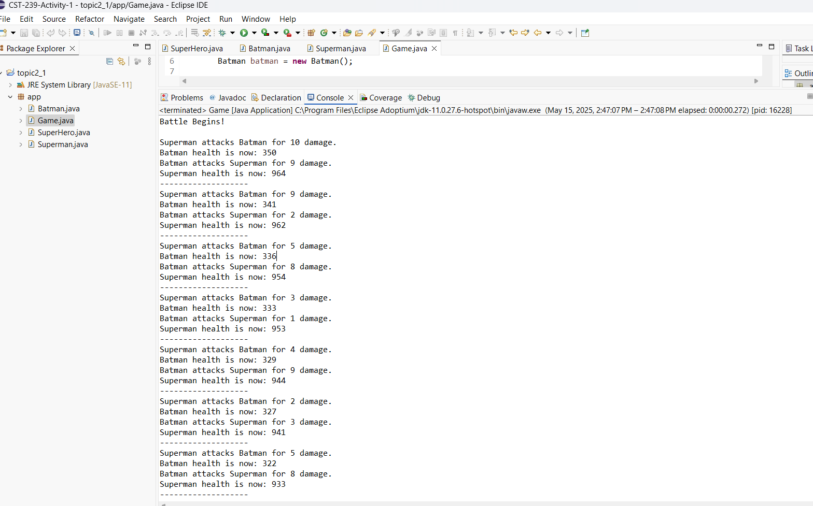
- Initial Game Launch and Battle Setup
Shows the Eclipse environment with Game.java loaded and the start of the battle printed in the console.
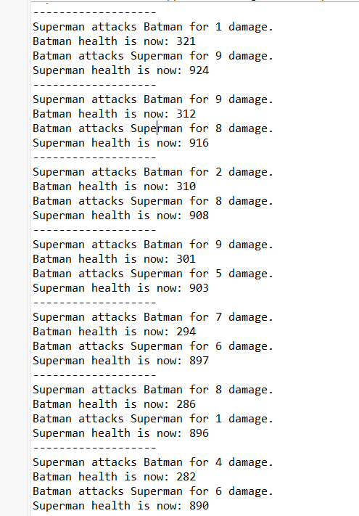
- Battle Progress - Early Rounds
Displays output where both heroes begin attacking, showing turn-by-turn health changes.
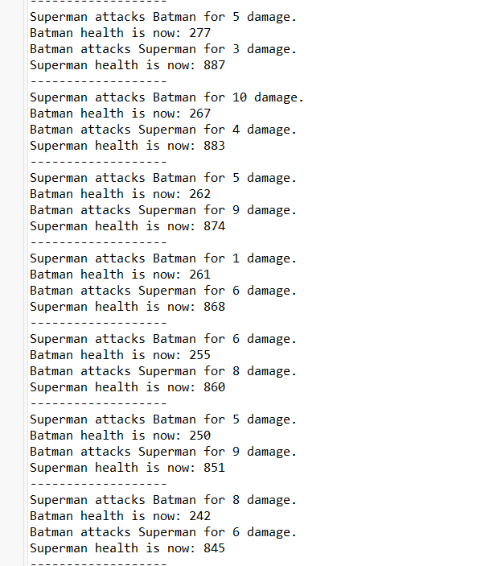
- Battle Progress - Mid Rounds
Continued combat with moderate health drop in both Batman and Superman.

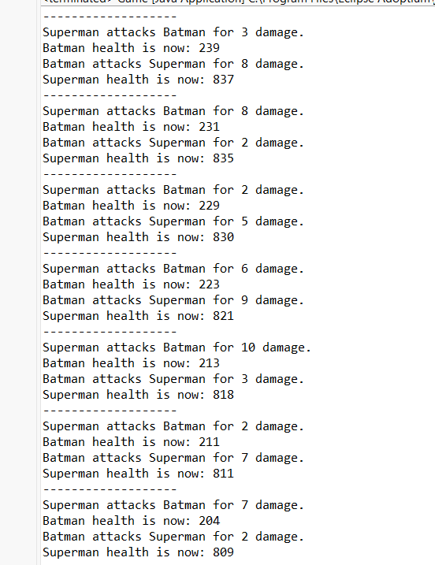
- Battle Progress - More Rounds and Damage Exchange
Multiple turn-based damage events showing sustained damage.
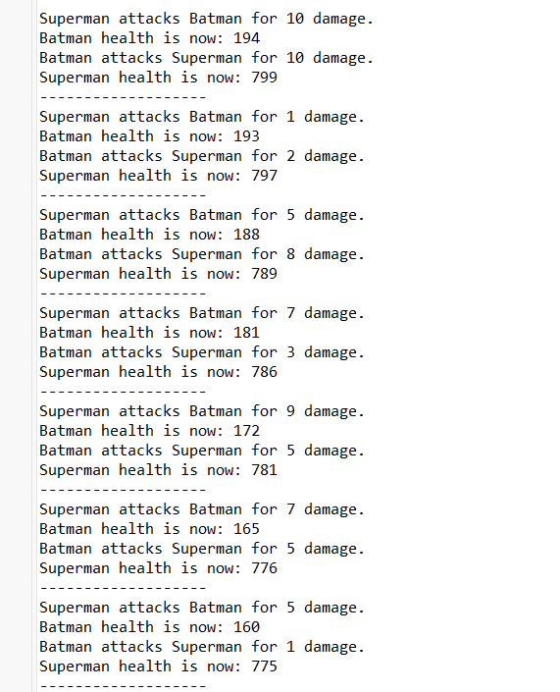
- Battle Progress - Critical Damage Zone
Both heroes enter the lower-health zone; damage becomes more intense.
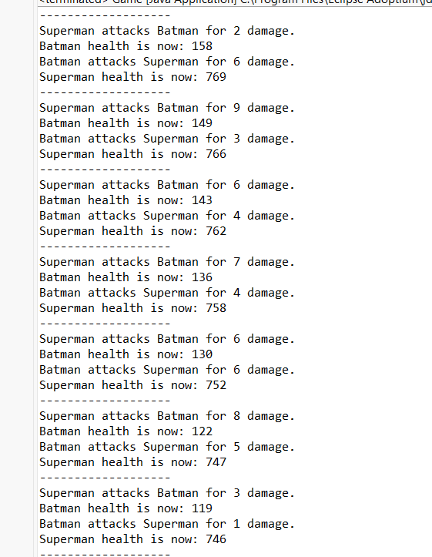
- Battle Progress - Approaching Endgame
Batman’s health continues decreasing sharply; battle nearing conclusion.
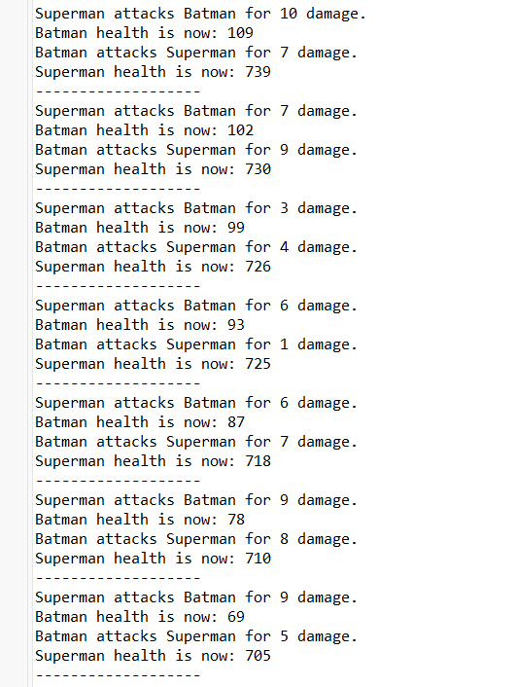
- Battle Progress - Final Stretch
The damage output increases and Batman’s health hits double digits.
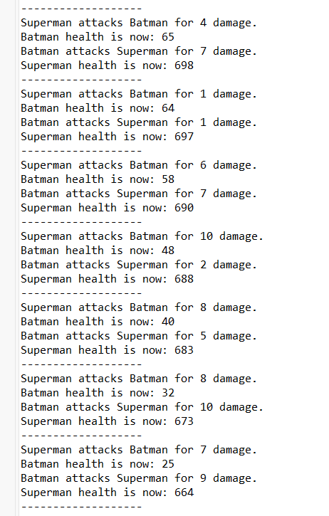
- Battle Progress - Final Stretch
The damage output increases and Batman almost lost.
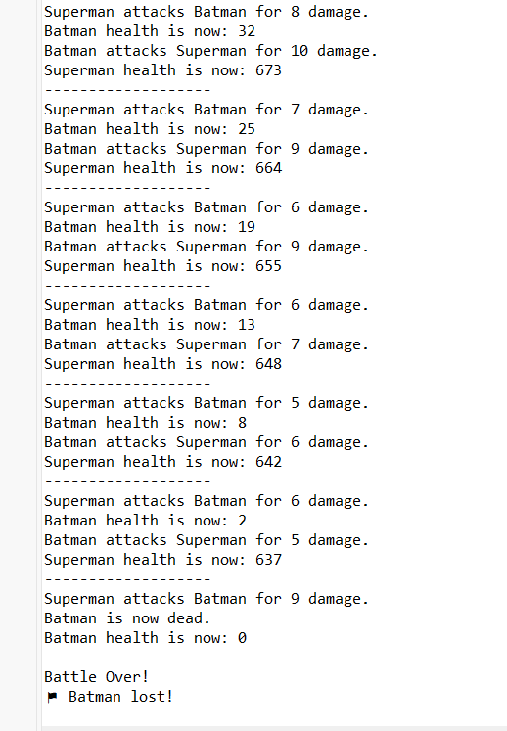
- Battle Conclusion - Batman is Defeated
Final sequence where Batman’s health reaches 0 and the console prints “Batman lost!”

Part 2: Weapons, Bombs, and Guns
Description:
This part demonstrates abstraction and method overloading/overriding. The abstract class Weapon is extended by Bomb and Gun.

Theory of Operation:
- activate() is abstract and implemented in subclasses
- fireWeapon() is both overridden and overloaded
- Screenshot:
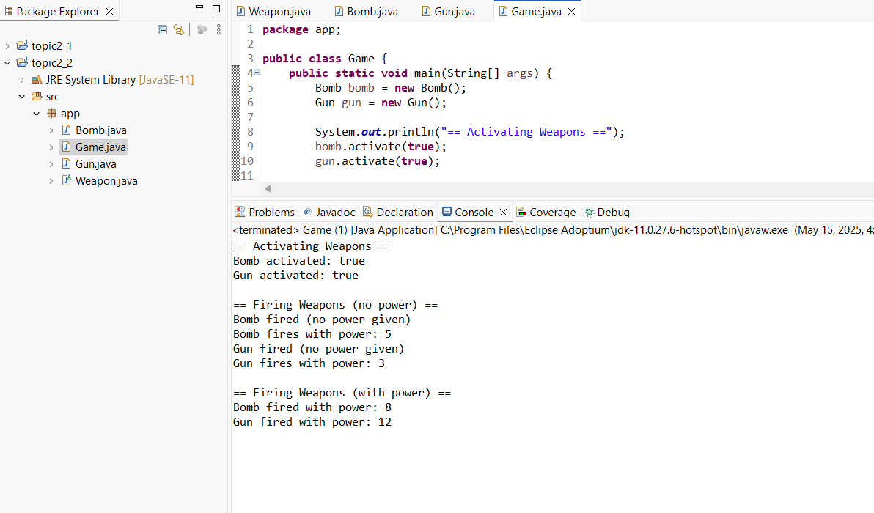
Game.java with Bomb and Gun Objects – Screenshot of Full Output

Part 3: Comparing Person Objects
Description:
This part focuses on object comparison using the overridden equals() and toString() methods in the Person class.
Theory of Operation:
- Checks object equality based on name and age
- Demonstrates string output and logical comparison

Screenshot:
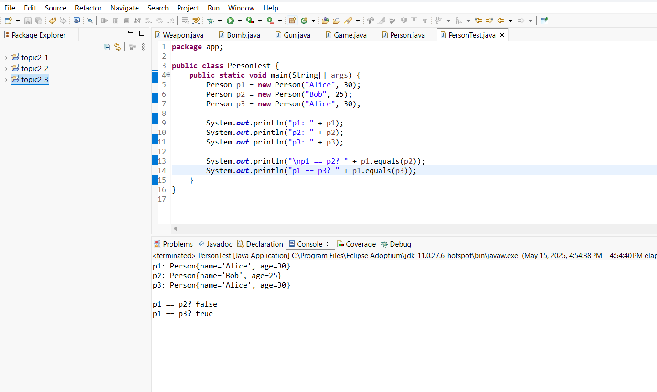
Object Comparison Using equals() and toString() in PersonTest.java

Part 4: Debugging Practice
Description:
This part demonstrates the use of Eclipse’s debugger. Breakpoints were set in the PersonTest class and values were stepped through.
Theory of Operation:
- Shows how to step into, over, and inspect variable values
- Verifies internal state of Person objects

Screenshot:
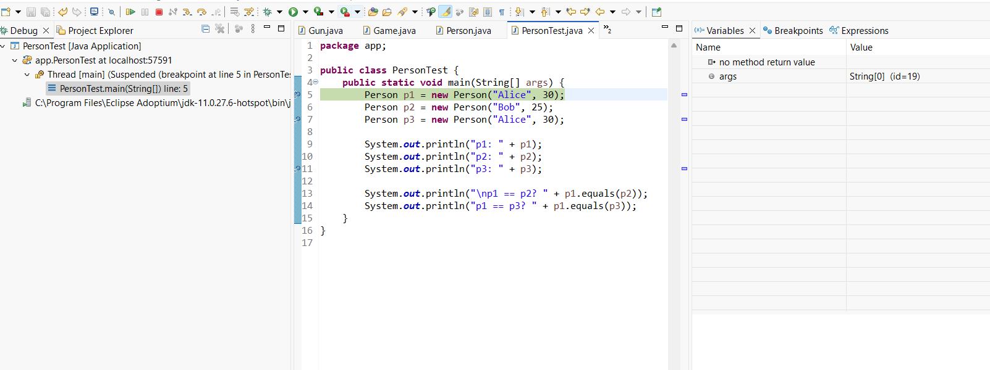
Debugger Breakpoint Hit: Shows Eclipse debugger paused at line 5 in PersonTest.java with initial variable args.

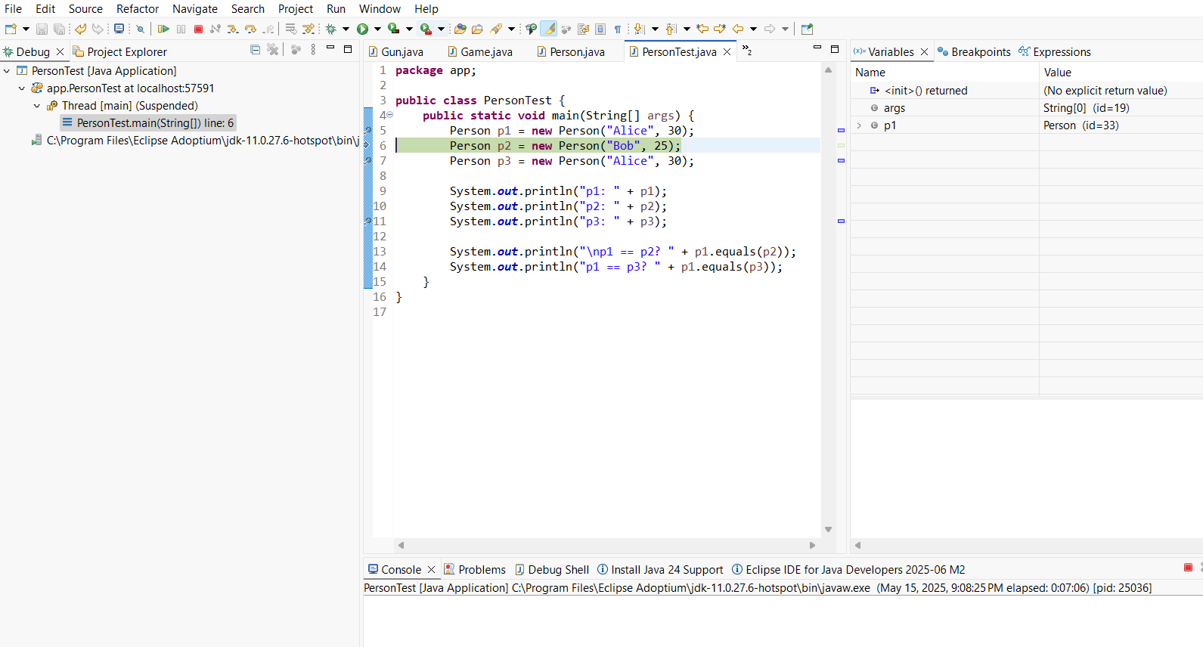
Step Over Execution: Demonstrates stepping over line 5 and initialization of p1, showing p1 details in Variables view. Also shows variables args and p1 populated in the debug window after stepping into the constructor.

