DVWA: Brute Force Vulnerability Exploitation Lab
By: Belizaire Bassette II
School: Syracuse University
Major: Information Management & Technology (Information Security Concentration)
Minor: Computer Science

Overview & Professional Relevance
This lab was conducted in a controlled environment using the Damn Vulnerable Web Application (DVWA) to simulate a real-world brute force attack scenario. The goal was to gain hands-on experience with the tools, techniques, and workflows commonly used in penetration testing engagements and security operations.
Key outcomes of this exercise include:
- Identifying and exploiting authentication weaknesses.
- Leveraging automated tools for password cracking.
- Understanding attacker workflows for improved defense strategies.
In practice, these skills translate to real-world cybersecurity roles by:
- Strengthening offensive capabilities to identify weaknesses before attackers do.
- Enhancing defensive readiness through recognition of brute force indicators.
- Developing professional reporting skills for both technical and executive audiences.

Lab Environment & Tools Used
- Operating Systems: Kali Linux, Ubuntu Linux
- Web Application Target: DVWA (Damn Vulnerable Web Application)
- Tools & Utilities:
- Nmap: Network scanning and service enumeration.
- Burp Suite: HTTP traffic interception and analysis.
- Hydra: Automated password cracking for brute force testing.
- rockyou.txt: Common password wordlist from the 2009 RockYou breach.

Step 1 — Target Identification
Confirmed DVWA was hosted locally at 127.0.0.1 (localhost). Accessed the application and navigated to the Brute Force module.

Step 2 — Manual Reconnaissance
Attempted a manual login to observe the server’s response to invalid credentials. Identified the error message: 'Username and/or password incorrect'. This provided the failure condition for Hydra’s automated attack.
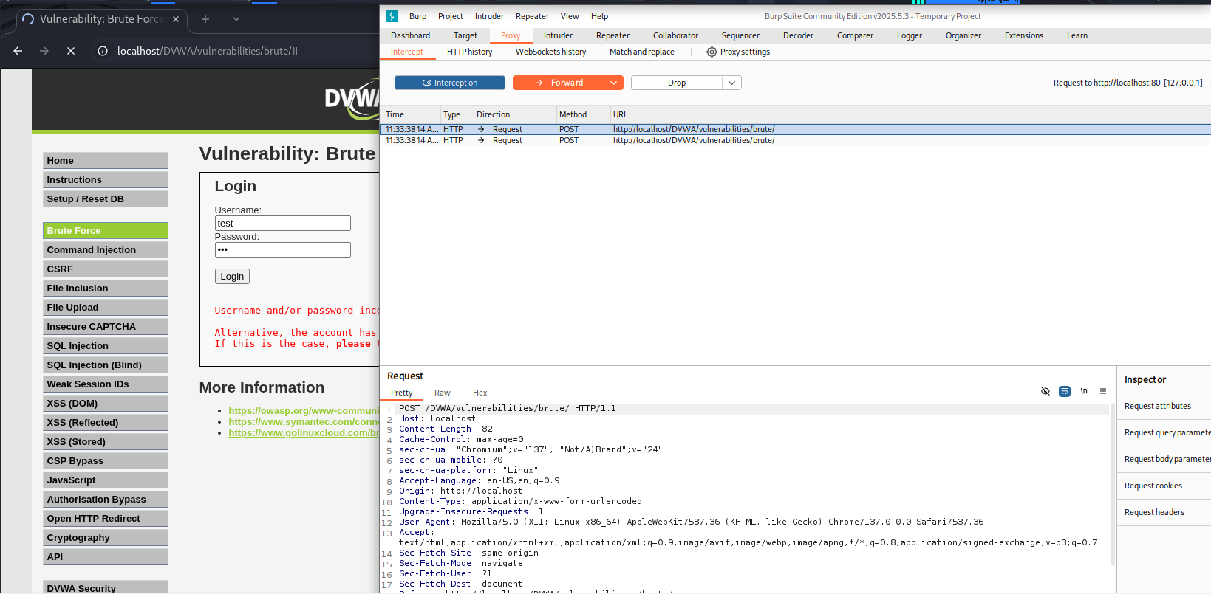

Step 3 — Traffic Interception & Parameter Discovery
Using Burp Suite, intercepted the login request to identify POST parameters and the exact form structure.
Parameters Identified:
- username
- password
- Login (submit field)
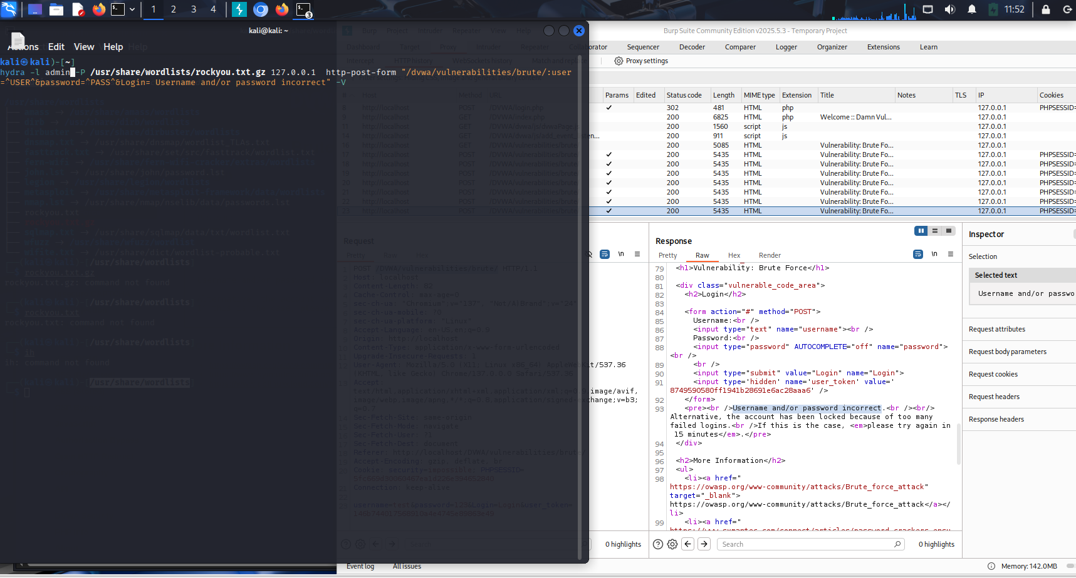

Step 4 — Wordlist Preparation

Selected rockyou.txt as the password list due to its large dataset of real-world passwords from the 2009 RockYou breach.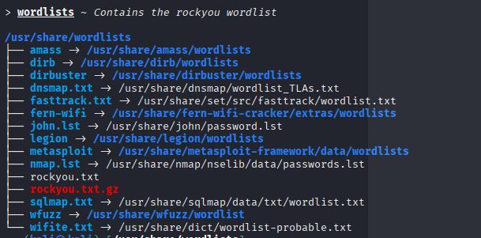

Step 5 — Hydra Execution
The following command was executed to perform the brute force attack:
hydra -l admin \
-P /usr/share/wordlists/rockyou.txt \
127.0.0.1 \
http-post-form \
"/DVWA/vulnerabilities/brute/:username=^USER^&password=^PASS^&Login=Login:Username and/or password incorrect" \
-V
Command Breakdown:
- `-l admin`: Specifies the username to test.
- `-P /usr/share/wordlists/rockyou.txt`: Path to the wordlist.
- `127.0.0.1`: Target IP (localhost).
- `http-post-form`: Specifies the attack type (form-based login).
- `"/DVWA/...incorrect"`: Login form path, parameters, and failure message.
- `-V`: Verbose mode for detailed output.
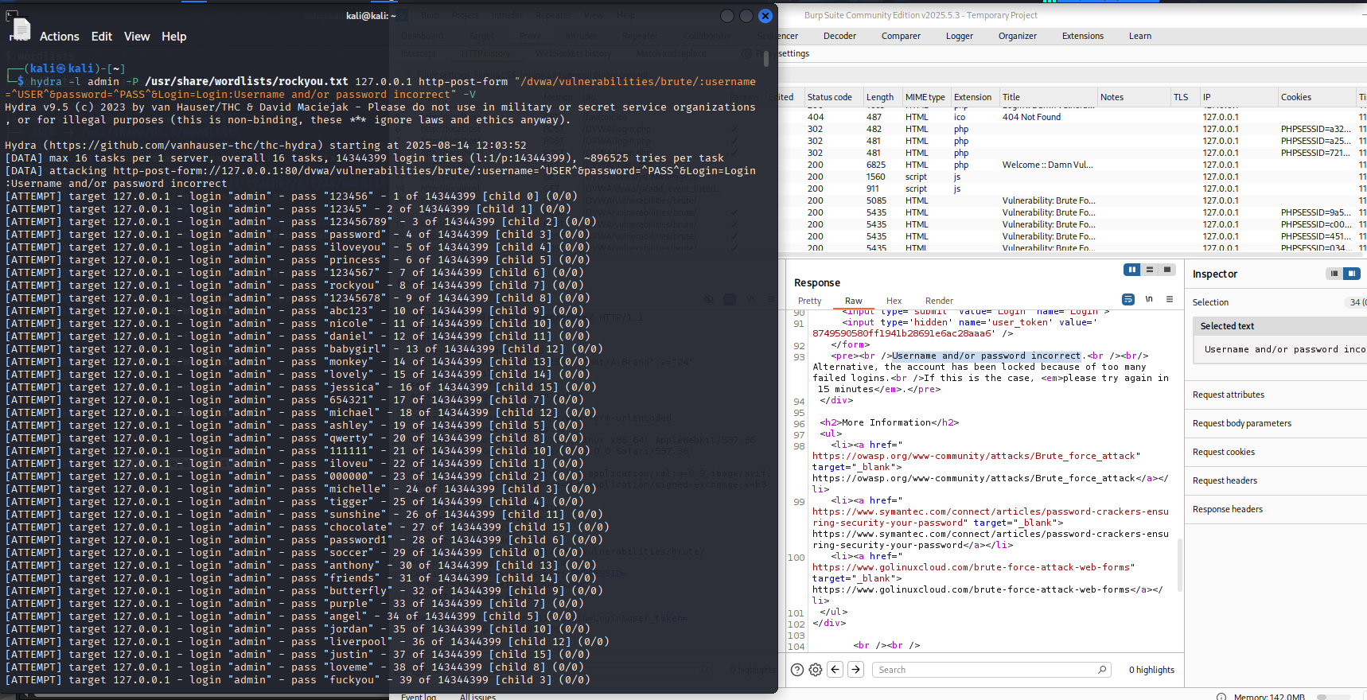

Step 6 — Results & Findings
The correct password was found after 4 attempts, successfully logging into the application and capturing the flag.
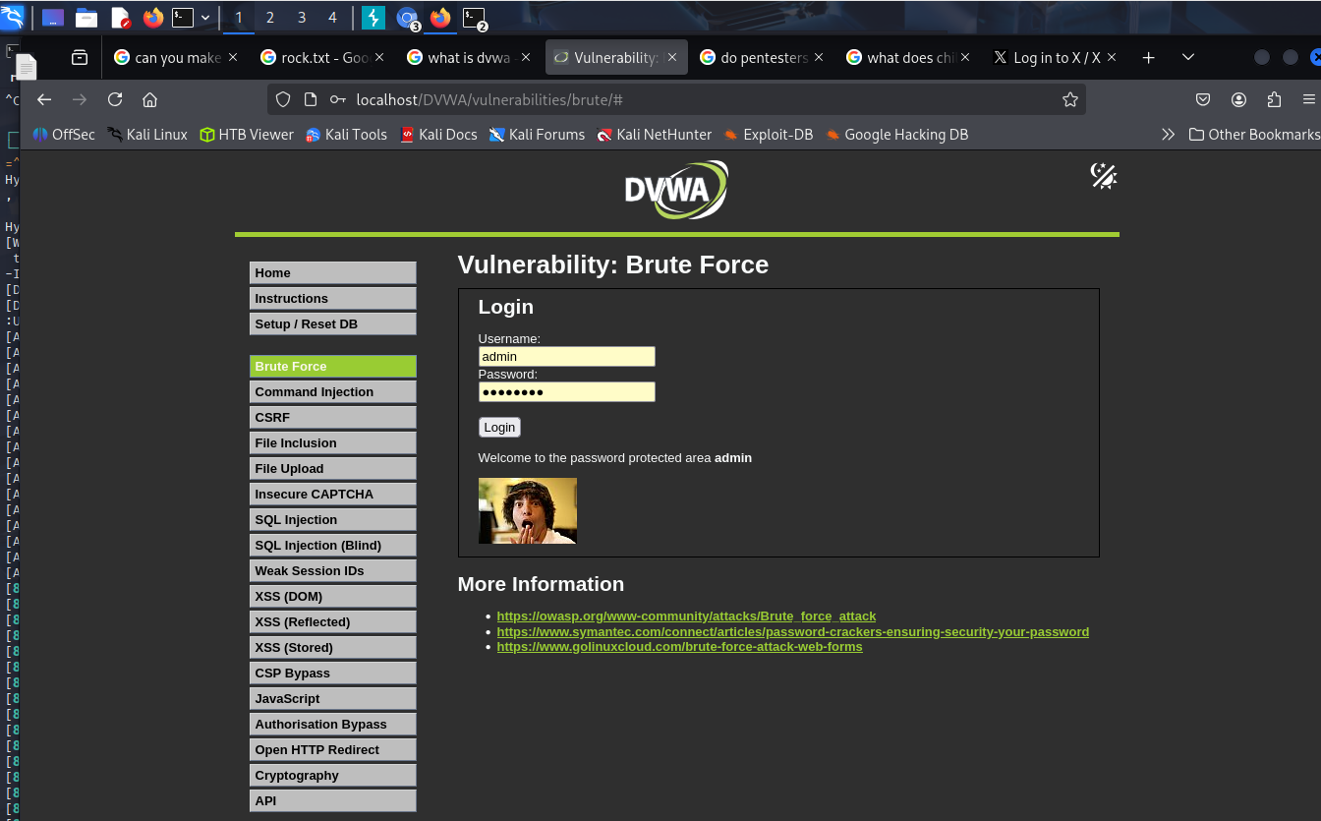

Step 7 — Security Recommendations
- Implement account lockout policies after a set number of failed attempts.
- Enforce strong password complexity requirements.
- Enable multi-factor authentication (MFA).
- Monitor for repeated failed login attempts using SIEM alerts.

