HW6_EFA

0859605陳冠景

1. EFA with ‘Maximum Likelihood’, factor rotation: ‘Varimax’ with 2 factors.

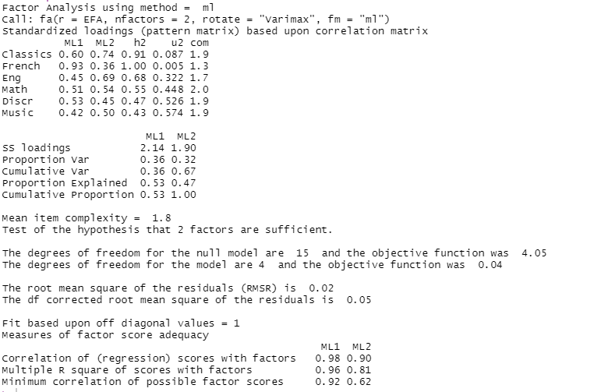

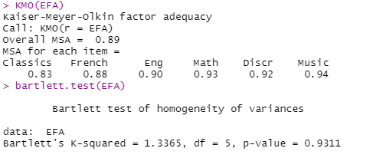

KMO of six variables are all higher 0.8 and they are factor well. It has common variances among these variables.

The Bartlett’s test of Sphericity isn’t significant( Bartlett’s K- squared = 1.33, *p*=.93).

The relationship among the variables isn’t strong enough to identify their underlying factors.

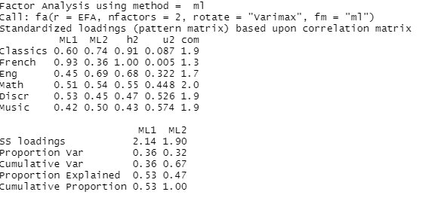

Total variance explained : 67 %

Community:



Community represent sum of squared factor loadings for that item(response variables).

Eigenvalue:



Eigenvalues of 6 response variables from common factors.

Scree plot:

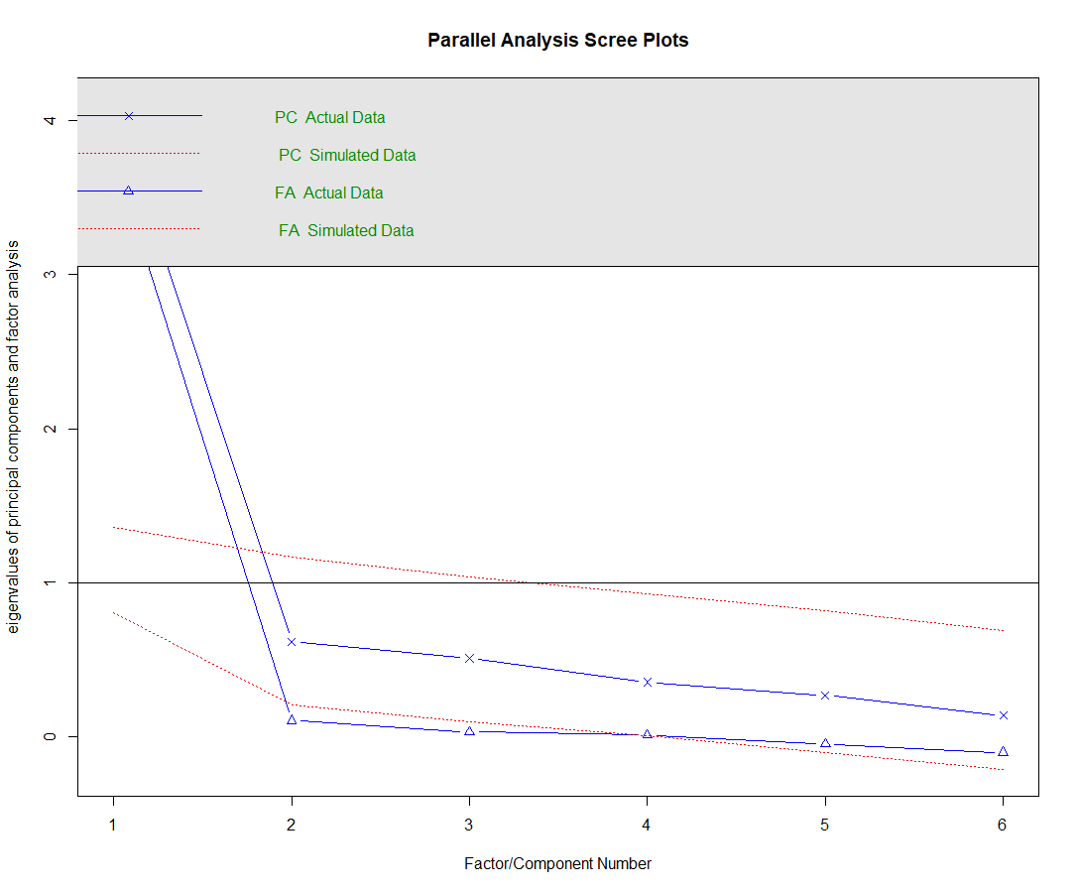

Factor matrix: This table contains the unrotated factor loadings, which are the correlations between the variable and the factor.

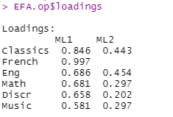

Goodness- of – fit



Reproduced correlation matrix : (the communality is the diagonal of the reproduced correlation matrix )

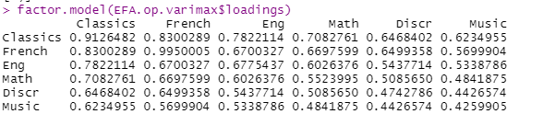

Rotated factor matrix:This table contains the rotated factor loadings, which represent both how the variables are weighted for each factor but also the correlation between the variables and the factor.

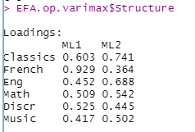

Factor score coefficient matrix : This is the factor weight matrix and is used to compute the factor scores.

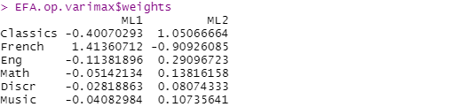

Factor score covariance matrix: The correlations of the factor score estimates using the specified model.



Because we used an orthogonal rotation, this should be a diagonal matrix.

Factor plot in rotated factor space:

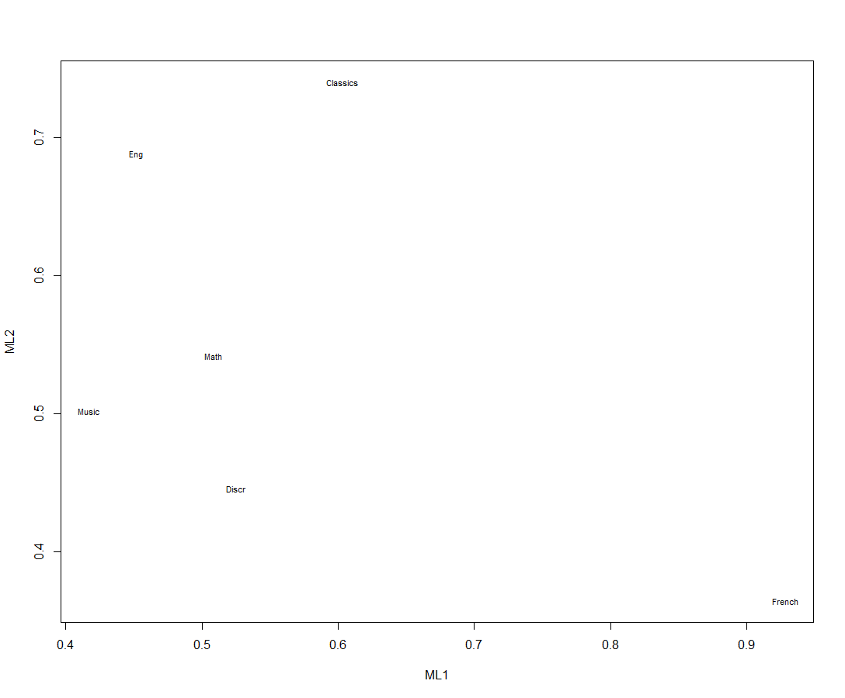

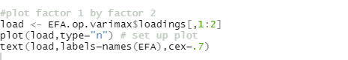

3.

Because only six variables in the data, it’s possible that the factor analysis could only create a new set of uncorrelated variables, called underlying factors to better understanding the data.

4.

|  |  |  |
| --- | --- | --- |
| Variables | Community | Uniquenss |
| X1 | 24.3% | 75.7% |
| X2 | 22.8% | 77.2% |
| X3 | 21.3% | 78.7% |
| X4 | 19.7% | 80.3% |
| X5 | 18.2% | 81.8% |
| X6 | 16.7% | 83.3% |

