1. The full reference of the paper including title, authors, source (i.e., the journal title)

Kallio, H., Virta, K., & Kallio, M. (2018). Modelling the components of metacognitive awareness. *International Journal of Educational Psychology*, *7*(2), 94-122.

2. How large is the sample size?

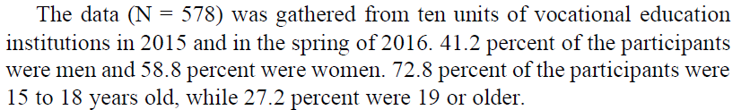

學生年紀範圍比較廣  
3. Is it a single-group study or multiple-group study (e.g., different ethnic groups)?

This research is single-group study, the aim of the study is: Using self-report instruments can help learners to incorporate strategies that will improve their metacognitive awareness

4. What is the number of observed variables in the model?

Only contains 2 components :

“knowledge of cognition” component consisted of 13 items and

“regulation of cognition” component consisted of 24 items

5. Did the authors include the correlation or covariance matrix in the paper?

Path aanlysis圖中回報了變項間的相關係數

descriptive analysis : both skewness and kurtosis had values between -1 to 1 revealing the normality of the items.

6. Did the authors present the theoretical model?

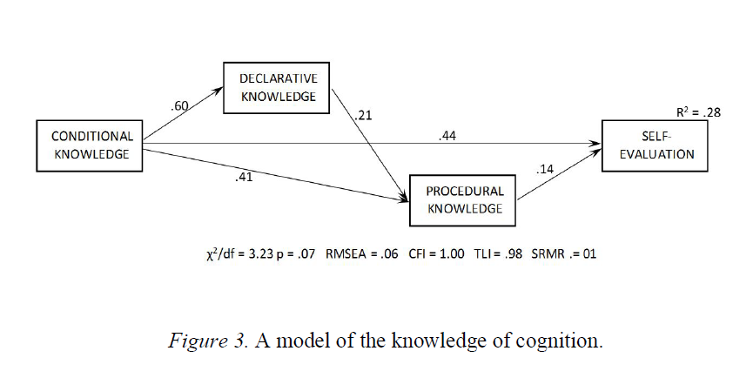

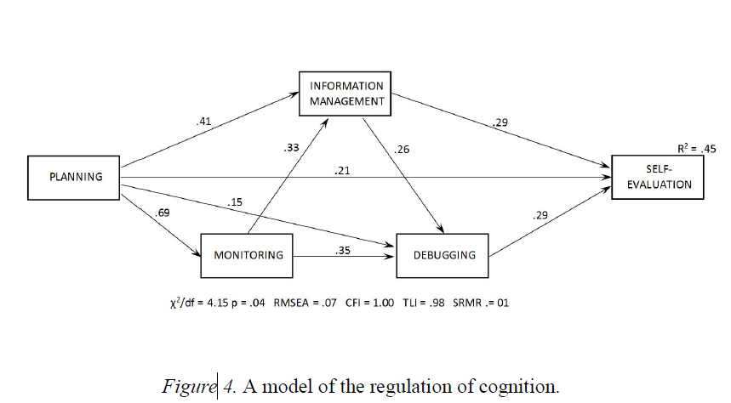

由於metacognitive awareness 分為knowledge of cognition and regulation of cognition

講這兩個構念分別先利用測量模型再利用路徑分析得到兩個路徑結構圖。

7. What kind of estimation method the authors used to estimate their model?

No 嗚嗚..  
8. Did the authors report the overall model test (or chi-square test statistic) and other model fit indices  
(e.g., CFI, RMSEA, and SRMR)?

“In the methods of structural equation modeling, the fit of the model and the data can be verified with several indexes. Chi Square (χ2) describes the difference between the theoretical and measured covariance matrix. The interpretation of the χ2 value is ambiguous and depends on sample size.”

主要採卡方檢定chi-square理論模型跟測量模型的適配程度，由於 “since the significance levels (*p* values) of the test remained low.” 所以需要參考其他指標

* “The Comparative Fit Index (CFI) and Tucker–Lewis Indexes (TLI) compare model fit with the

independence model.”

還有CFI, TLI等指標。

* “Root Mean Square Error of Approximation (RMSEA) indicates model fit in comparison with the

degree of freedom of the model”  
 加上RMSEA 指標，以0.5為好的標準

* “Standardized Root Mean Square Residual (SRMR) indicates the model fit by comparing the averages of standardized residuals of the observed and predicted covariance matrixes.”

以及 SRMR 指標，標準為.8為好的 (A cut-off value of close to .08 indicates good

model fit (Hu & Bentler, 1999).?? 好奇怪，不是越小越好嗎?

9. Did the authors modify the theoretical model? If yes, how did they modify their model (e.g., used modification index)?

有說明模型修改的過程

* “high modification index (79.88), a path from conditional knowledge also to procedural knowledge was

added into the model.”

* “the fit of the model was tested within genders. The fit indexes revealed an excellent model fit for women