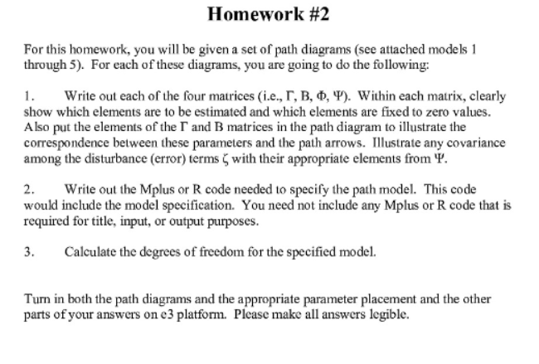

Degree of freedom = [(p+q)(p+q+1)]/2 -total r (r=parameter of model)

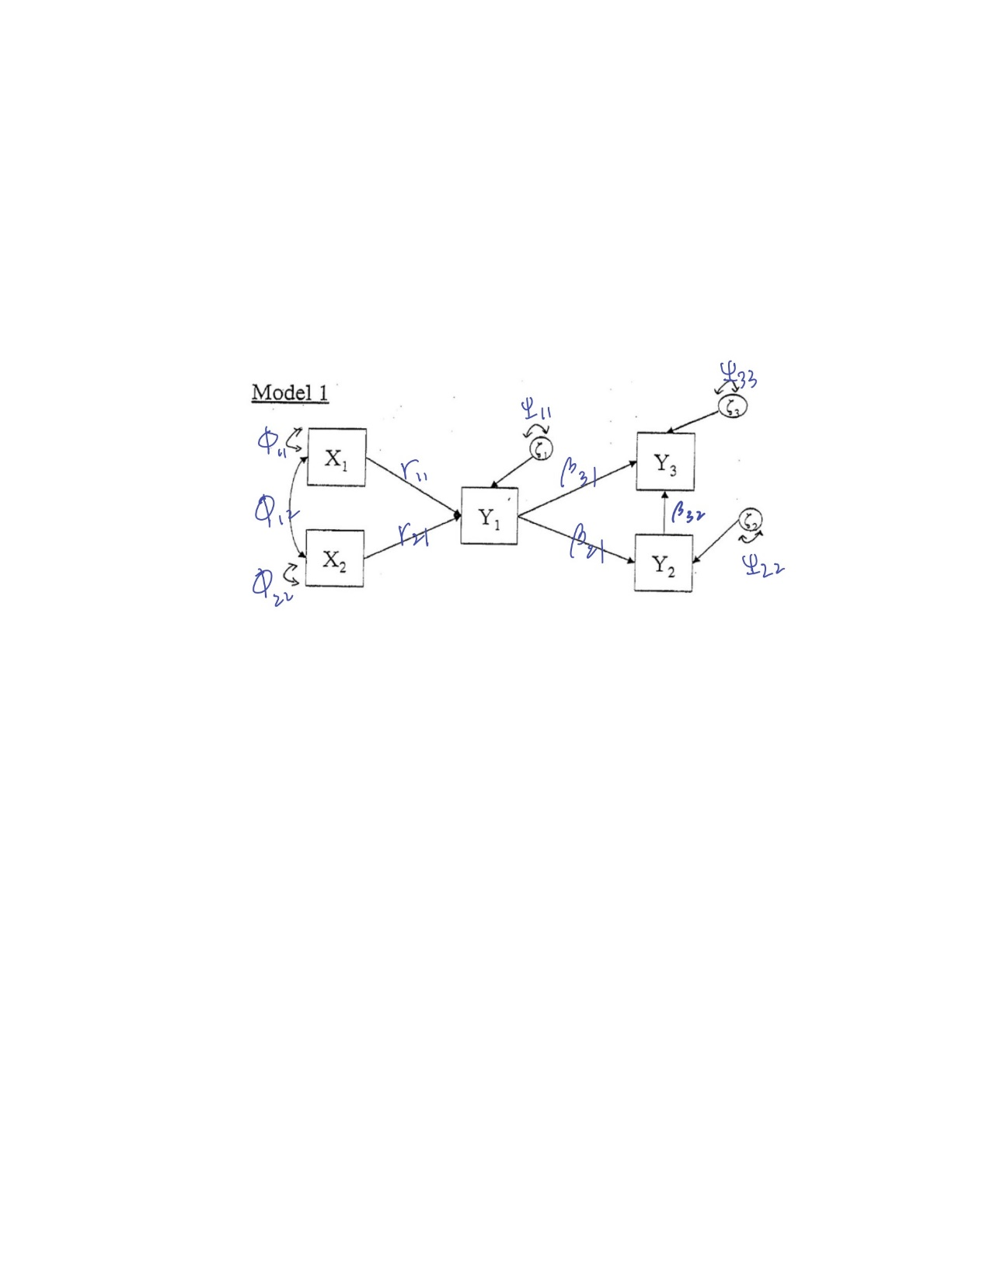

Degree of freedom =15-11=4

$\begin{matrix}X_{1} & X_{2}\end{matrix}$ $\begin{matrix}Y_{1} & Y_{2} & Y_{3}\end{matrix}$ $\begin{matrix}ζ_{1} & ζ_{2} & ζ_{3}\end{matrix}$

$Γ=\begin{matrix}Y_{1} \\ Y_{2} \\ Y_{3}\end{matrix}\left[\begin{matrix}Γ_{11} & Γ_{21} \\ 0 & 0 \\ 0 & 0\end{matrix}\right]$ $β=\begin{matrix}Y_{1} \\ Y_{2} \\ Y_{3}\end{matrix}\left[\begin{matrix}0 & 0 & 0 \\ β_{21} & 0 & 0 \\ β_{31} & β_{32} & 0\end{matrix}\right]$ $ψ=\begin{matrix}ζ_{1} \\ ζ_{2} \\ ζ_{3}\end{matrix}\left[\begin{matrix}Ψ_{11} & 0 & 0 \\ 0 & ψ_{22} & 0 \\ 0 & 0 & ψ_{33}\end{matrix}\right]$

$\begin{matrix}X_{1} & X_{2}\end{matrix}$

$ϕ$ = $\begin{matrix}X_{1} \\ X_{2}\end{matrix}\left[\begin{matrix}ϕ_{11} & ϕ_{12} \\ 0 & ϕ_{22}\end{matrix}\right]$

Y1 on X1 X2;

Y2 on Y1;

Y3 on Y1 Y2;

X1 with X2;

X1;X2;Y1;Y2;Y3;

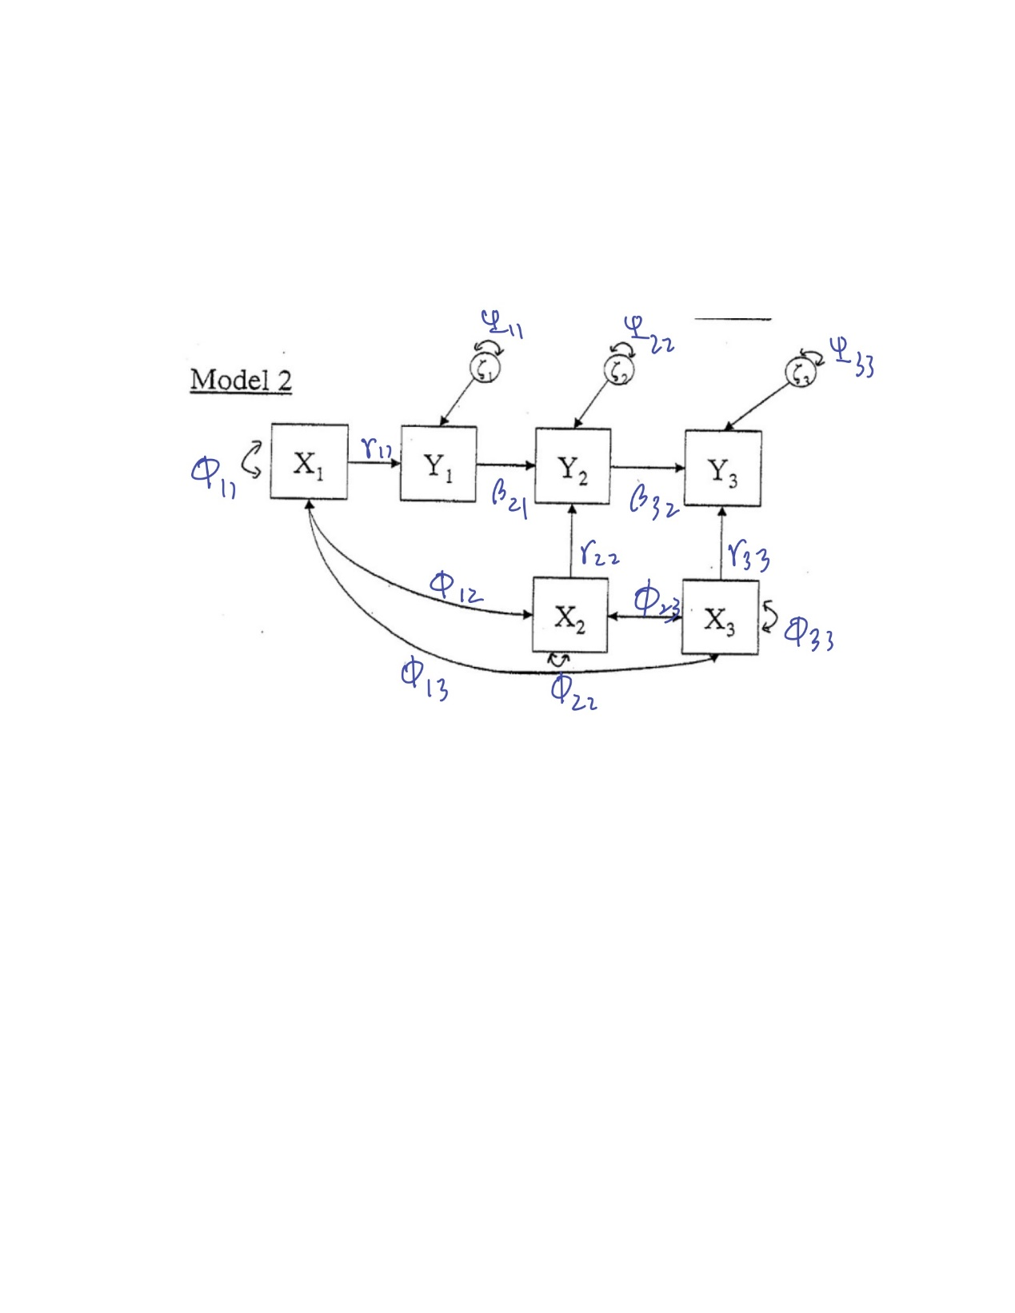

$$\begin{matrix}X_{1} & X_{2} & X_{3}\end{matrix} \begin{matrix}X_{1} & X_{2} & X_{3}\end{matrix} \begin{matrix}ζ_{1} & ζ_{2} & ζ_{3}\end{matrix}$$

$Γ=\begin{matrix}Y_{1} \\ Y_{2} \\ Y_{3}\end{matrix}\left[\begin{matrix}Γ_{11} & 0 & 0 \\ 0 & Γ_{22} & 0 \\ 0 & 0 & Γ_{33}\end{matrix}\right]$ $β=\begin{matrix}Y_{1} \\ Y_{2} \\ Y_{3}\end{matrix}\left[\begin{matrix}0 & 0 & 0 \\ β_{21} & 0 & 0 \\ 0 & β_{32} & 0\end{matrix}\right]$ $ψ=\begin{matrix}ζ_{1} \\ ζ_{2} \\ ζ_{3}\end{matrix}\left[\begin{matrix}Ψ_{11} & 0 & 0 \\ 0 & ψ_{22} & 0 \\ 0 & 0 & ψ_{33}\end{matrix}\right]$

$\begin{matrix}X_{1} & X_{2} & X_{3}\end{matrix}$

$$ϕ= \begin{matrix}X_{1} \\ X_{2} \\ X_{3}\end{matrix} \left[\begin{matrix}ϕ_{11} & ϕ_{12} & ϕ_{13} \\ 0 & ϕ_{22} & 0 \\ 0 & 0 & ϕ_{33}\end{matrix}\right]$$

Degree of freedom = 7

Y1 on X1;

Y2 on Y1 X2;

Y3 on X3;

X1 with X2

X2 with X3

X1 with X3

X1;X2;X3;Y1;Y2;Y3;

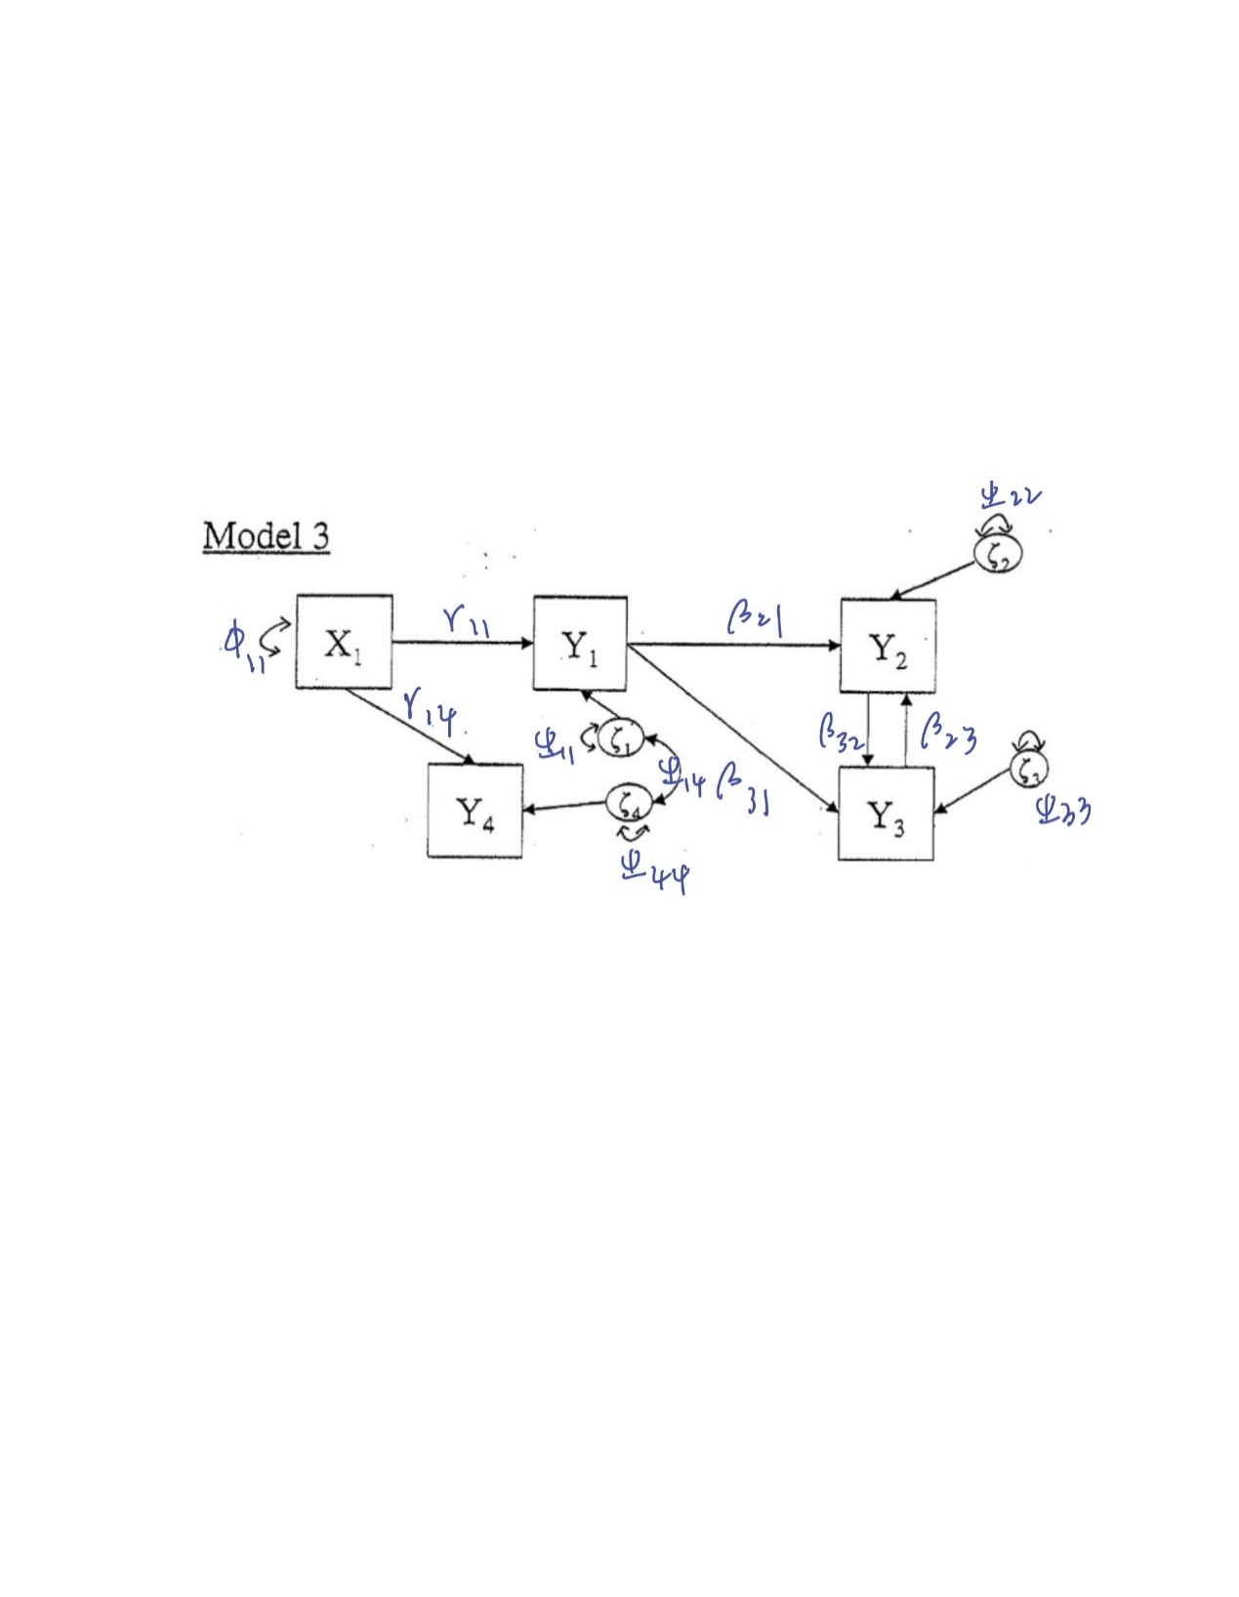

$X_{1} \begin{matrix}{ Y}_{1} & \begin{matrix}{ Y}_{2} & \begin{matrix}{ Y}_{3} & Y_{4}\end{matrix}\end{matrix}\end{matrix} \begin{matrix}{ ζ}_{1} & \begin{matrix}ζ_{2} & \begin{matrix}{ ζ}_{3} & ζ_{4}\end{matrix}\end{matrix}\end{matrix}$

$Γ=\begin{matrix}\begin{matrix}Y_{1} \\ Y_{2} \\ Y_{3}\end{matrix} \\ Y_{4}\end{matrix}\left[\begin{matrix}Γ_{11} \\ \begin{matrix}Γ_{12} \\ \begin{matrix}Γ_{13} \\ Γ_{14}\end{matrix}\end{matrix}\end{matrix}\right]$ $β=\begin{matrix}Y_{1} \\ \begin{matrix}Y_{2} \\ \begin{matrix}Y_{3} \\ Y_{4}\end{matrix}\end{matrix}\end{matrix}\left[\begin{matrix}\begin{matrix}0 \\ \begin{matrix}β_{21} \\ \begin{matrix}β_{31} \\ 0\end{matrix}\end{matrix}\end{matrix} & \begin{matrix}0 \\ \begin{matrix}0 \\ \begin{matrix}β_{32} \\ 0\end{matrix}\end{matrix}\end{matrix} & \begin{matrix}\begin{matrix}0 \\ \begin{matrix}β_{23} \\ \begin{matrix}0 \\ 0\end{matrix}\end{matrix}\end{matrix} & \begin{matrix}0 \\ \begin{matrix}0 \\ \begin{matrix}0 \\ 0\end{matrix}\end{matrix}\end{matrix}\end{matrix}\end{matrix}\right]$ $Ψ=\begin{matrix}ζ_{1} \\ \begin{matrix}ζ_{2} \\ \begin{matrix}ζ_{3} \\ ζ_{4}\end{matrix}\end{matrix}\end{matrix}\left[\begin{matrix}\begin{matrix}ψ_{11} \\ \begin{matrix}0 \\ \begin{matrix}0 \\ ψ_{41}\end{matrix}\end{matrix}\end{matrix} & \begin{matrix}\begin{matrix}0 \\ \begin{matrix}Ψ_{22} \\ \begin{matrix}0 \\ 0\end{matrix}\end{matrix}\end{matrix} & \begin{matrix}\begin{matrix}0 \\ \begin{matrix}0 \\ \begin{matrix}ψ_{33} \\ 0\end{matrix}\end{matrix}\end{matrix} & \begin{matrix}0 \\ \begin{matrix}0 \\ \begin{matrix}0 \\ ψ_{44}\end{matrix}\end{matrix}\end{matrix}\end{matrix}\end{matrix}\end{matrix}\right]$

$X_{1}$

$$ϕ=X_{1}\left[ϕ_{11}\right]$$

Y1 on X1;

Y2 on Y1 Y3;

Y3 on Y1 Y2;

Y4 on X1

X1;Y1;Y2;Y3;Y4;

Degree of freedom = 3

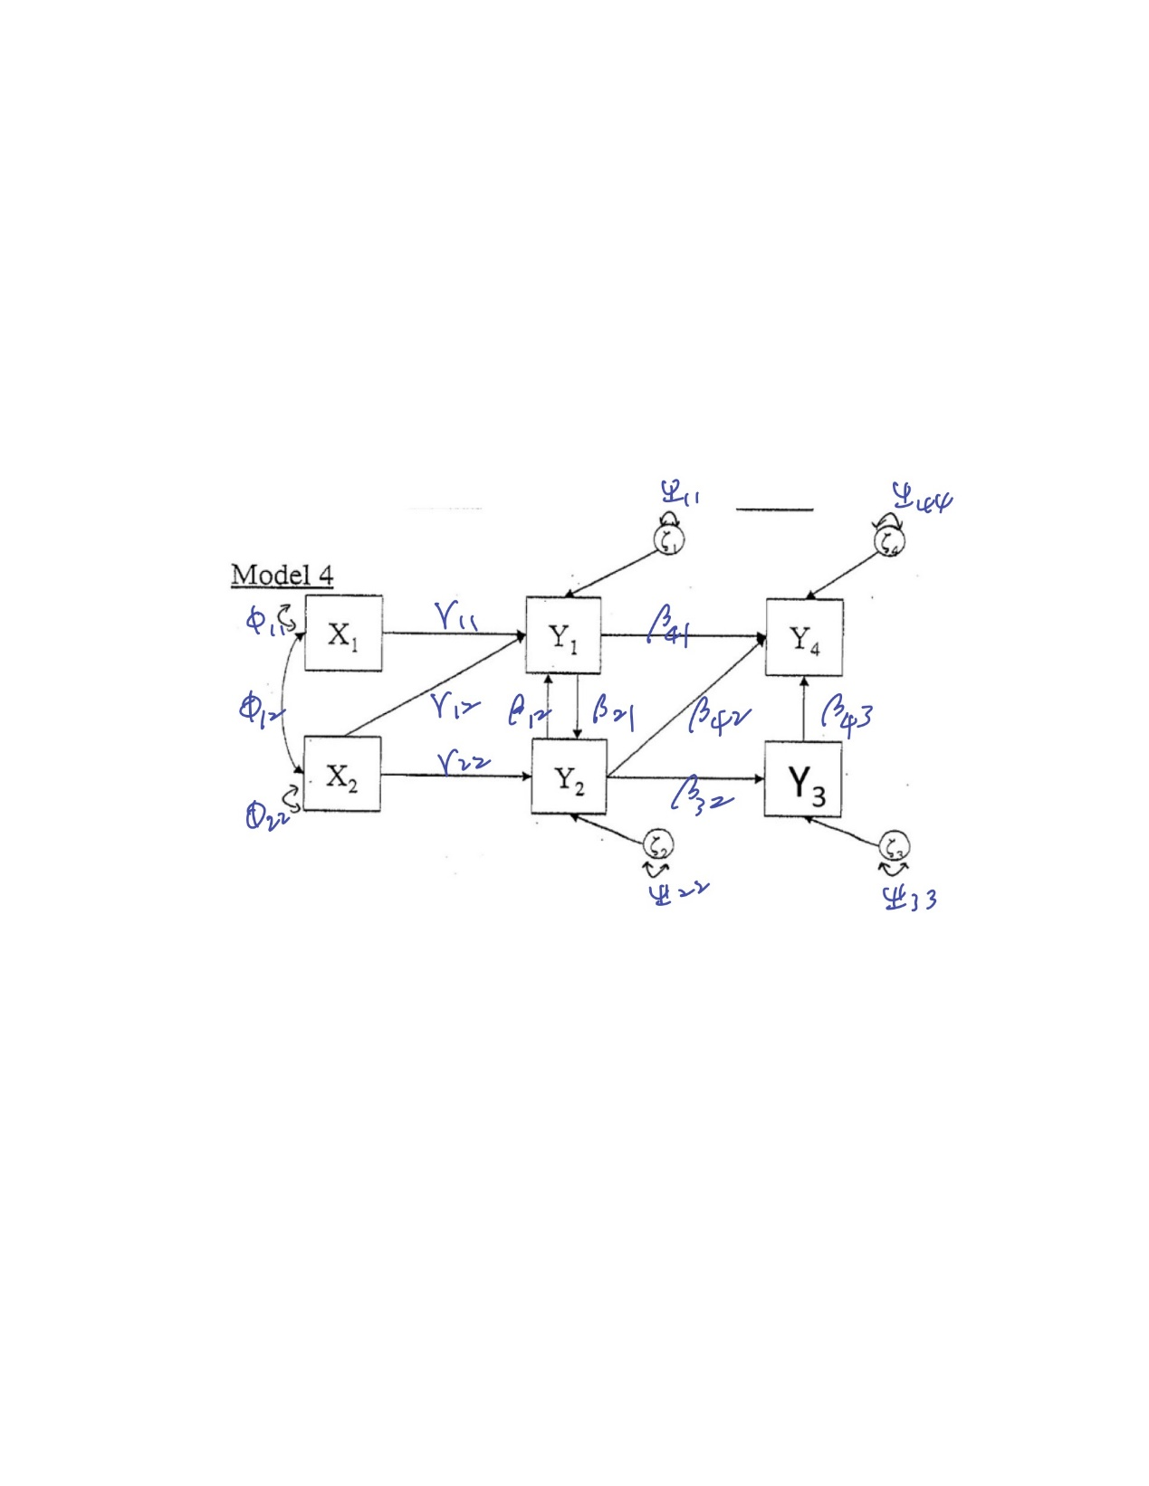

$\begin{matrix}X_{1} & X_{2}\end{matrix}$ $\begin{matrix}{ Y}_{1} & \begin{matrix}Y_{2} & \begin{matrix}Y_{3} & Y_{4}\end{matrix}\end{matrix}\end{matrix}$ $\begin{matrix}ζ_{1} & \begin{matrix}{ ζ}_{2} & \begin{matrix}ζ_{3} & { ζ}_{4}\end{matrix}\end{matrix}\end{matrix}$

$Γ=\begin{matrix}\begin{matrix}Y_{1} \\ Y_{2} \\ Y_{3}\end{matrix} \\ Y_{4}\end{matrix}\left[\begin{matrix}\begin{matrix}Γ_{11} \\ \begin{matrix}0 \\ \begin{matrix}0 \\ 0\end{matrix}\end{matrix}\end{matrix} & \begin{matrix}Γ_{12} \\ \begin{matrix}Γ_{22} \\ \begin{matrix}0 \\ 0\end{matrix}\end{matrix}\end{matrix}\end{matrix}\right]$ $β=\begin{matrix}Y_{1} \\ \begin{matrix}Y_{2} \\ \begin{matrix}Y_{3} \\ Y_{4}\end{matrix}\end{matrix}\end{matrix}\left[\begin{matrix}\begin{matrix}0 \\ \begin{matrix}β_{21} \\ \begin{matrix}0 \\ β_{41}\end{matrix}\end{matrix}\end{matrix} & \begin{matrix}β_{12} \\ \begin{matrix}0 \\ \begin{matrix}β_{32} \\ β_{42}\end{matrix}\end{matrix}\end{matrix} & \begin{matrix}\begin{matrix}0 \\ \begin{matrix}0 \\ \begin{matrix}0 \\ β_{43}\end{matrix}\end{matrix}\end{matrix} & \begin{matrix}0 \\ \begin{matrix}0 \\ \begin{matrix}0 \\ 0\end{matrix}\end{matrix}\end{matrix}\end{matrix}\end{matrix}\right]$ $Ψ=\begin{matrix}ζ_{1} \\ \begin{matrix}ζ_{2} \\ \begin{matrix}ζ_{3} \\ ζ_{4}\end{matrix}\end{matrix}\end{matrix}\left[\begin{matrix}\begin{matrix}ψ_{11} \\ \begin{matrix}0 \\ \begin{matrix}0 \\ 0\end{matrix}\end{matrix}\end{matrix} & \begin{matrix}\begin{matrix}0 \\ \begin{matrix}Ψ_{22} \\ \begin{matrix}0 \\ 0\end{matrix}\end{matrix}\end{matrix} & \begin{matrix}\begin{matrix}0 \\ \begin{matrix}0 \\ \begin{matrix}ψ_{33} \\ 0\end{matrix}\end{matrix}\end{matrix} & \begin{matrix}0 \\ \begin{matrix}0 \\ \begin{matrix}0 \\ ψ_{44}\end{matrix}\end{matrix}\end{matrix}\end{matrix}\end{matrix}\end{matrix}\right]$

$\begin{matrix}{ X}_{1} & X_{2}\end{matrix}$

$$ϕ=\begin{matrix}X_{1} \\ X_{2}\end{matrix}\left[\begin{matrix}ϕ_{11} & ϕ_{12} \\ 0 & ϕ_{22}\end{matrix}\right]$$

Y1 on X1 X2 Y2 ;

Y2 on X2 Y1 ;

Y3 on Y2;

Y4 on Y1 Y2 Y3;

X1 with X2;

X1;X2;Y1;Y2;Y3;Y4;

Degree of freedom = 5

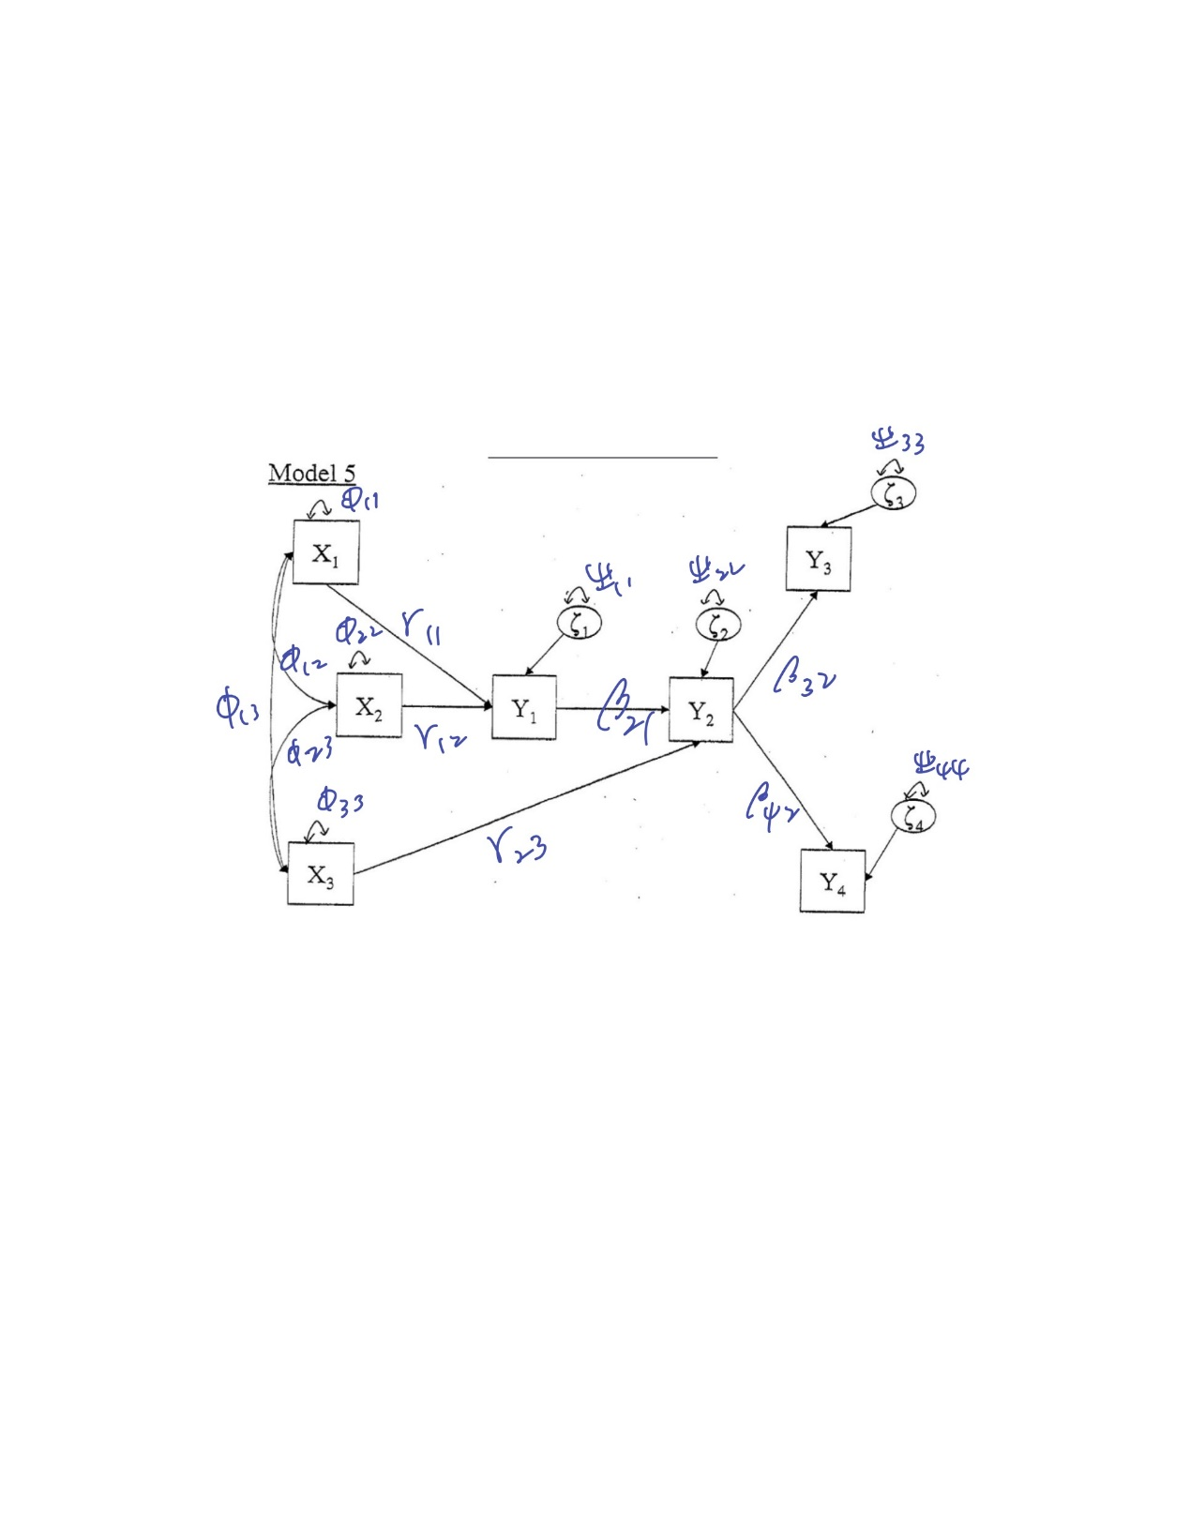

$\begin{matrix}X_{1} & X_{2} & X_{3}\end{matrix}$ $\begin{matrix}Y_{1} & Y_{2} & { Y}_{3} \end{matrix}Y_{4}$ $\begin{matrix}ζ_{1} & { ζ}_{2} & \begin{matrix}ζ_{3} & ζ_{4}\end{matrix}\end{matrix}$

$Γ=\begin{matrix}\begin{matrix}Y_{1} \\ Y_{2} \\ Y_{3}\end{matrix} \\ Y_{4}\end{matrix}\left[\begin{matrix}\begin{matrix}Γ_{11} \\ \begin{matrix}0 \\ \begin{matrix}0 \\ 0\end{matrix}\end{matrix}\end{matrix} & \begin{matrix}\begin{matrix}Γ_{12} \\ \begin{matrix}0 \\ \begin{matrix}0 \\ 0\end{matrix}\end{matrix}\end{matrix} & \begin{matrix}0 \\ \begin{matrix}Γ_{23} \\ \begin{matrix}0 \\ 0\end{matrix}\end{matrix}\end{matrix}\end{matrix}\end{matrix}\right]$ $β=\begin{matrix}Y_{1} \\ \begin{matrix}Y_{2} \\ \begin{matrix}Y_{3} \\ Y_{4}\end{matrix}\end{matrix}\end{matrix}\left[\begin{matrix}\begin{matrix}0 \\ \begin{matrix}β_{21} \\ \begin{matrix}0 \\ 0\end{matrix}\end{matrix}\end{matrix} & \begin{matrix}0 \\ \begin{matrix}0 \\ \begin{matrix}β_{32} \\ β_{42}\end{matrix}\end{matrix}\end{matrix} & \begin{matrix}\begin{matrix}0 \\ \begin{matrix}0 \\ \begin{matrix}0 \\ 0\end{matrix}\end{matrix}\end{matrix} & \begin{matrix}0 \\ \begin{matrix}0 \\ \begin{matrix}0 \\ 0\end{matrix}\end{matrix}\end{matrix}\end{matrix}\end{matrix}\right]$ $Ψ=\begin{matrix}ζ_{1} \\ \begin{matrix}ζ_{2} \\ \begin{matrix}ζ_{3} \\ ζ_{4}\end{matrix}\end{matrix}\end{matrix}\left[\begin{matrix}\begin{matrix}ψ_{11} \\ \begin{matrix}0 \\ \begin{matrix}0 \\ 0\end{matrix}\end{matrix}\end{matrix} & \begin{matrix}\begin{matrix}0 \\ \begin{matrix}Ψ_{22} \\ \begin{matrix}0 \\ 0\end{matrix}\end{matrix}\end{matrix} & \begin{matrix}\begin{matrix}0 \\ \begin{matrix}0 \\ \begin{matrix}ψ_{33} \\ 0\end{matrix}\end{matrix}\end{matrix} & \begin{matrix}0 \\ \begin{matrix}0 \\ \begin{matrix}0 \\ ψ_{44}\end{matrix}\end{matrix}\end{matrix}\end{matrix}\end{matrix}\end{matrix}\right]$

$\begin{matrix}X_{1} & X_{2} & X_{3}\end{matrix}$

$$ϕ= \begin{matrix}X_{1} \\ X_{2} \\ X_{3}\end{matrix} \left[\begin{matrix}ϕ_{11} & ϕ_{12} & ϕ_{13} \\ 0 & ϕ_{22} & ϕ_{23} \\ 0 & 0 & ϕ_{33}\end{matrix}\right]$$

Y1 on X1 X2;

Y2 on Y1 X3;

Y3 on Y2;

Y4 on Y2;

X1 with X2;

X2 with X3;

X1 with X3;

X1;X2;X3;Y1;Y2;Y3;Y4;

Degree of freedom = 12