A)

Path diagram with the standardized model coefficient

Model 1

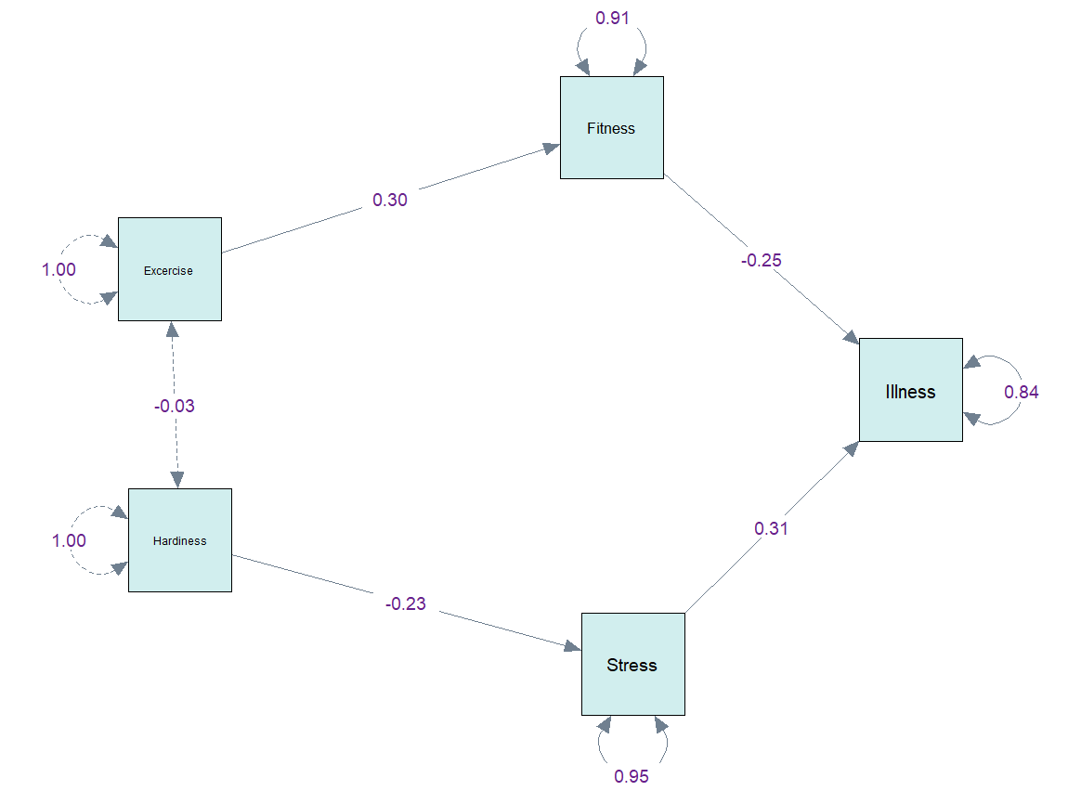

Model 2

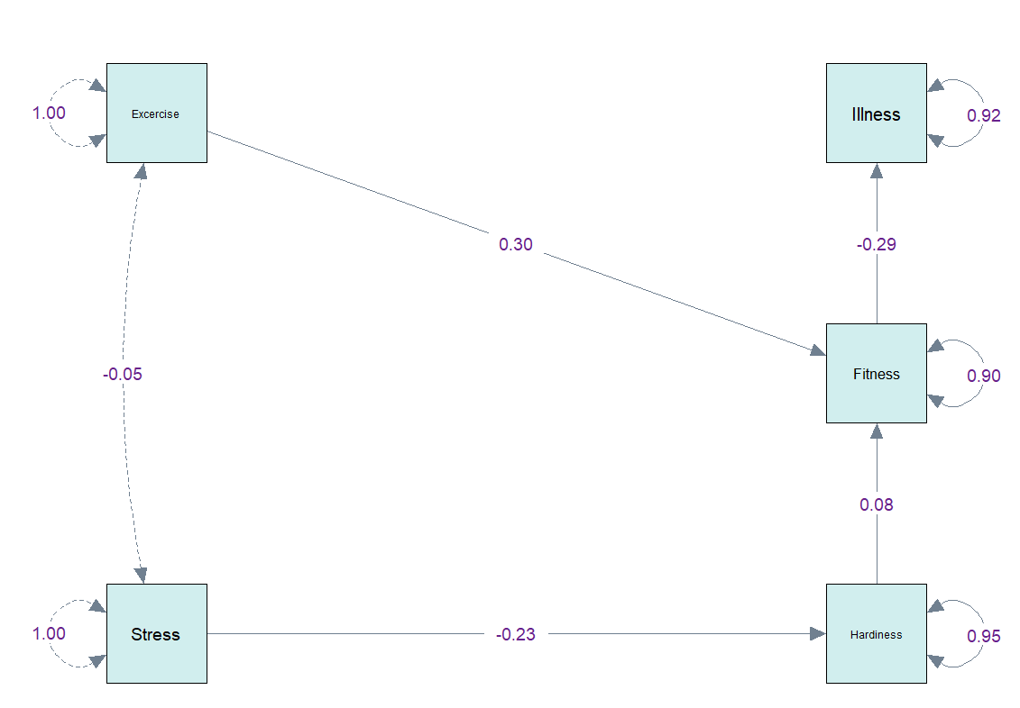

HW3

Square multiple correlations for each endogenous variable.

Model 1:

|  |  |
| --- | --- |
| R-Square: | |
| Fitness | 0.09 |
| Stress | 0.053 |
| Illness | 0.16 |

Model 2:

|  |  |
| --- | --- |
| R-Square: | |
| Fitness | 0.098 |
| Hardiness | 0.053 |
| Illness | 0.084 |

CFI,RMSEA,SRMR

Model 1

|  |  |  |
| --- | --- | --- |
| CFI | RMSEA | SRMR |
| 0.958 | 0.054 | 0.051 |

CFI 值 接近1，且RMSEA　接近.05，SRMR小於.08，所以是個好模型。

Model2

|  |  |  |
| --- | --- | --- |
| CFI | RMSEA | SRMR |
| 0.673 | 0.15 | 0.096 |

CFI 值遠離1，且RMSEA　大於.05，SRMR大於.08，所以不太算好模型。

C) 兩者不是巢套模型，所以無法進行chi-square differentiated test

D) model 1 已經是一個良好的模型，基於簡效性不需要再增加參數估計

Model 2 不是一個表現良好的模型，可以增加參數估計