A). Create under identified model

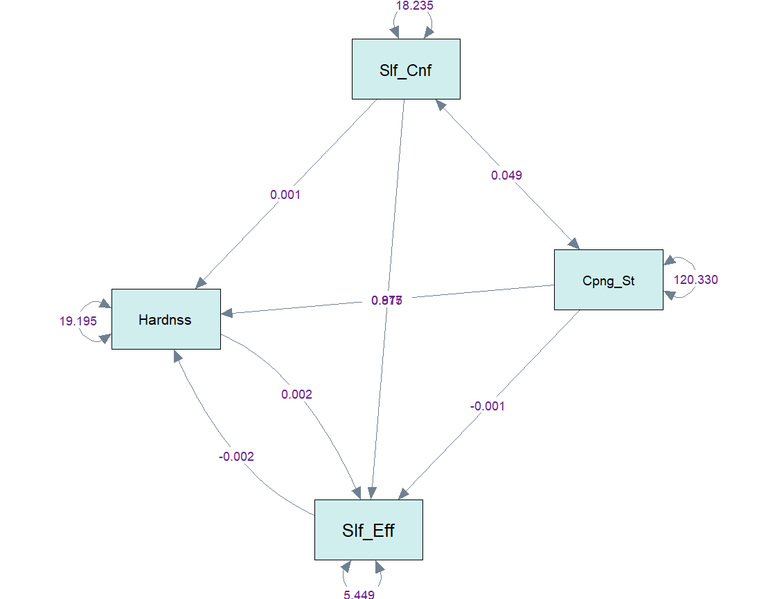

Parameter:11

t rule and null B rule are violated.

B). Create overidentified model

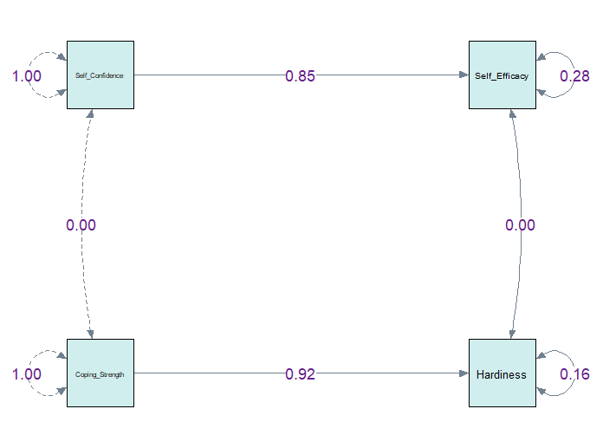

Parameter:6

都符合t rule and null B rule

C). Create just identified model

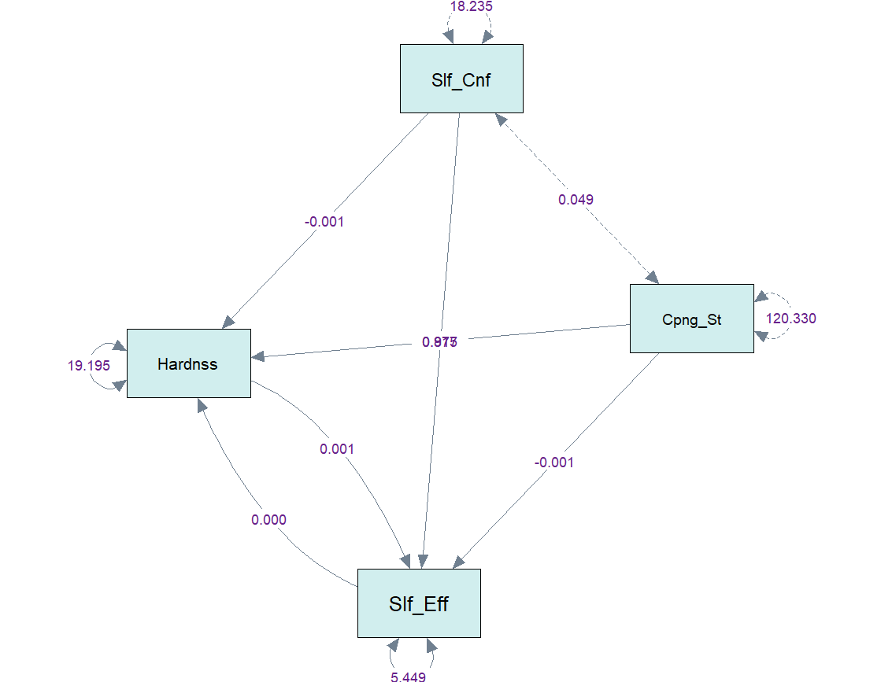

Parameters: 10

都符合t rule and null B rule

Bonus:

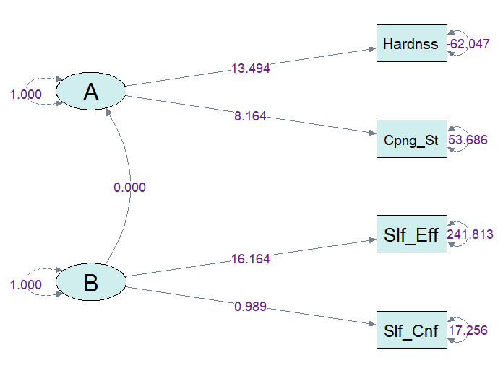

Hardiness殘差項為負值，可以考慮將該因子與其他三個因子分開。