**Megan Hoeksema**

**COMP4433**

**Assignment 1 Run Results**

**Assignment 1, Part 1:**

1. Results from creation of CSV:

1. Results from reading that into a pandas DataFrame

1. Results from adding the 9th and 10th elements to the dataframe

1. Results from adding a column with the atomic weights rounded to the nearest integer

**Assignment 1, Part 2:**

1. Results from creating a dataframe from dictionary

1. Dataframe after sorting on greekLetters

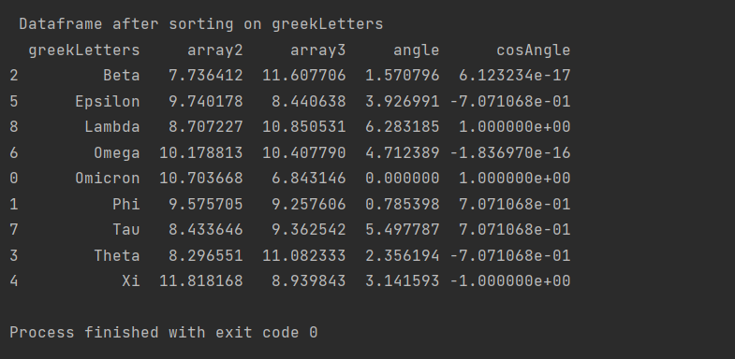

1. Dataframe after sorting on greekLetters, dropping two columns, and removing 1 row

**Assignment 1, Part 3:**

1. Code

1. Write a program in Python to create and print out the first 12 Fibonacci numbers.

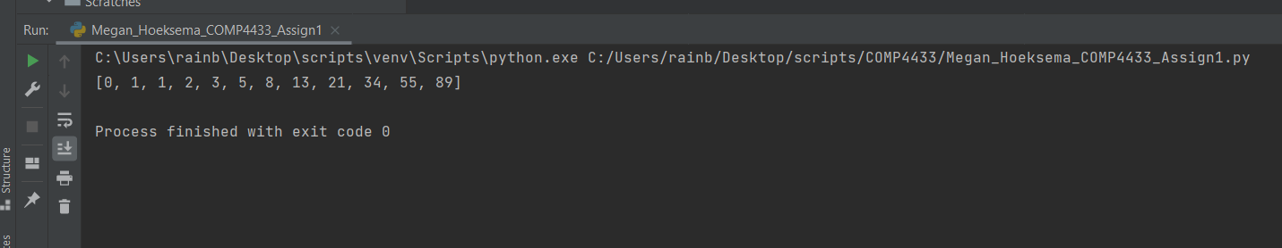

1. Iterate over the last five numbers to build another list with the ratio of each number to its predecessor. What do you observe about this latter list?

You will notice that the difference between two numbers in a Fibonacci sequence is equal to the previous value in the Fibonacci sequence.

For example, the 11th number in the sequence is 55. The difference between the 11th number and the 12th number (|55 - 89|) is equal to the value in the 10th position (34).

**Assignment 1, Part 4:**

1. Code

1. Results

