Megan Hoeksema

COMP4433 Assignment 2 Results

**Assignment 2, Part 1**

**Dataframe:**

**Graph:**

**Assignment 2, Part 2**

**Dataframe:**

**Graph:**

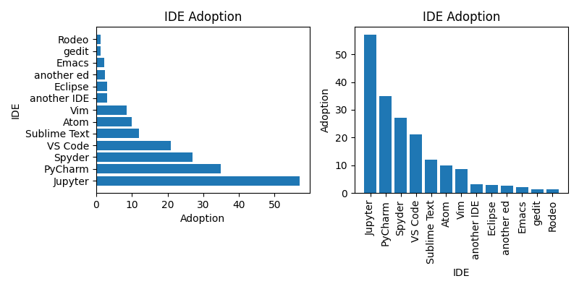

**Assignment 2, Part 3**

**Dataframe:**

**Graphs:**

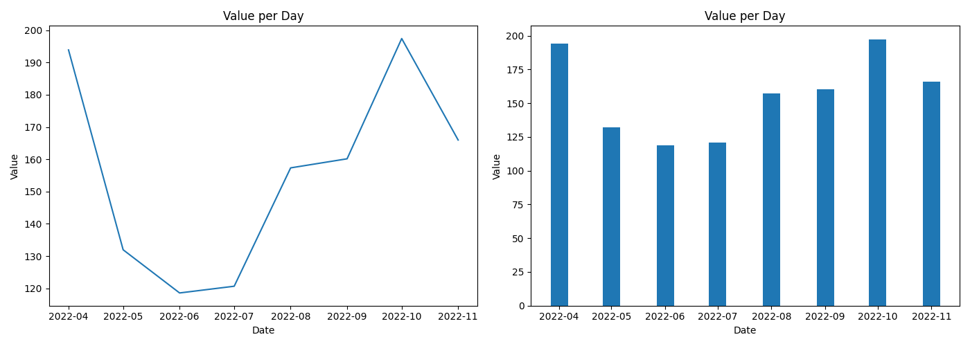

**Assignment 2, Part 4**

**Dataframe:**

**Graph:**

