Problem Set 3, Winter 2022

Wendy Christensen

# Load any packages, if any, that you use as part of your answers here  
# For example:   
  
library(MASS)

CONTEXT: Factorial experiment with doughnuts

Donna is the owner of a boutique doughnut shop. Because many of her customers are conscious of their fat intake but want the flavor of fried doughnuts, she decided to develop a doughnut recipe that minimizes the amount of fat that the doughnuts absorb from the fat in which the doughnuts are fried.

She conducted a factorial experiment that had a similar procedures as Lowe (1935). Like Lowe, she used four types of fats (fat_type). She also used three types of flour (flour_type): all-purpose flour, whole wheat flour, and gluten-free flour. For each combination of fat type and flour type, she cooked six identical batches of doughnuts. Each batch contained 24 doughnuts, and the total fat (in grams) absorbed by the doughnuts in each batch was recorded (sim_tot_fat).

## Question 1 - 5 points

You may need to process your data before you begin your analysis. Specifically, you will need to make sure that the variable type is set to ‘factor’ for both of your grouping variables and ‘num’ for your outcome variable.

doughnuts.factorial <- read.csv("doughnutsfactorial.csv", header=TRUE, sep=",") # Loads the CSV file into memory. You may need to adapt this line to work on your computer

Like in Problem Set 1, please create two new variables in the doughnuts.factorial data set. The first new variable will be called fat_type_factor and will contain the same values as in the fat_type variable but will have a variable type of factor. The second new variable will be called flour_type_factor and will contain the same values as in the flour_type variable but will also have a variable type of factor.

# Complete the lines to properly create the two new variables  
  
doughnuts.factorial$fat_type_factor <- as.factor(doughnuts.factorial$fat_type) # Complete this line  
  
doughnuts.factorial$flour_type_factor <- as.factor(doughnuts.factorial$flour_type) # Complete this line

Check your work by running the following code chunk. Be sure that fat_type_factor and flour_type_factor are factor-type variables before you complete the rest of the problem set.

str(doughnuts.factorial)

## 'data.frame': 72 obs. of 5 variables:  
## $ fat_type : chr "Canola" "Canola" "Canola" "Canola" ...  
## $ flour_type : chr "ap" "ap" "ap" "ap" ...  
## $ sim_tot_fat : int 78 71 80 88 62 72 78 75 89 74 ...  
## $ fat_type_factor : Factor w/ 4 levels "Canola","Peanut",..: 1 1 1 1 1 1 3 3 3 3 ...  
## $ flour_type_factor: Factor w/ 3 levels "ap","gf","ww": 1 1 1 1 1 1 1 1 1 1 ...

# Question 2 - 10 points

Using the code in the code chunk below, I fitted a regression model that has a specification equivalent to a one-way ANOVA. Specifically, I used the doughnuts.factorial data set to re-create the one-way ANOVA with sim_tot_fat as the outcome variable and fat_type_factor as the grouping variable. This is the same model as the first model you estimated in Problem Set 2, Question 4. Run this code before continuing with this question.

doughnuts.reg = lm(sim_tot_fat ~ fat_type_factor, data=doughnuts.factorial) # You may need to change the variable names depending on how you named the variables in Question 1  
  
summary(doughnuts.reg)

##   
## Call:  
## lm(formula = sim_tot_fat ~ fat_type_factor, data = doughnuts.factorial)  
##   
## Residuals:  
## Min 1Q Median 3Q Max   
## -35.944 -4.736 -0.167 5.514 21.056   
##   
## Coefficients:  
## Estimate Std. Error t value Pr(>|t|)   
## (Intercept) 66.944 2.529 26.467 < 2e-16 ***  
## fat_type_factorPeanut 8.722 3.577 2.438 0.017372 *   
## fat_type_factorShortening 11.722 3.577 3.277 0.001654 **   
## fat_type_factorSunflower -13.611 3.577 -3.805 0.000306 ***  
## ---  
## Signif. codes: 0 '***' 0.001 '**' 0.01 '*' 0.05 '.' 0.1 ' ' 1  
##   
## Residual standard error: 10.73 on 68 degrees of freedom  
## Multiple R-squared: 0.4708, Adjusted R-squared: 0.4475   
## F-statistic: 20.17 on 3 and 68 DF, p-value: 1.856e-09

You will now use the output of this regression model to answer the following four questions. Note that the lm() function dummy coded the fat type variable for you.

Question A: If you plug in the appropriate zeros and ones into the estimated regression equation to obtain the mean of the *Canola oil* group, which of the four terms shown in the regression output remain (i.e., would not be multiplied by zero)?

Your answer here: 66.944

Question B: If you plug in the appropriate zeros and ones into the estimated regression equation to obtain the mean of the *Peanut oil* group, which of the four terms shown in the regression output remain (i.e., would not be multiplied by zero)?

Your answer here: 66.944 + 8.722

Question C: Based on the output, which fat type had a *lower* mean than that of Canola oil?

Your answer here: Sunflower

Question D: Based on the output, which of the three other fat types - Peanut oil Shortening, and Sunflower oil - was significantly different from Canola oil? For full credit, list the names of the fat types (if any) that are significantly different from Canola oil.

Your answer here: Peanut, Shortening, Sunflower

# Question 3 - 10 points

In Problem Set 2, Question 5, you conducted a two-way factorial ANOVA with an interaction. First, copy the code you wrote for Problem Set 2, Question 5 into the code chunk below and display the results using the summary() function. You won’t answer any questions about the two-way ANOVA model directly, but you should notice some similarities between the two-way ANOVA with interaction output and your equivalently-specified regression model that may help you answer the questions about the regression model.

# Your two-way ANOVA code from Problem Set 2, Question 5 copied and pasted here.  
  
fat_flour_int.aov <- aov(sim_tot_fat~fat_type_factor*flour_type_factor,data=doughnuts.factorial)  
  
# Don't forget to display the results with the summary() function!  
  
summary(fat_flour_int.aov)

## Df Sum Sq Mean Sq F value Pr(>F)   
## fat_type_factor 3 6967 2322.5 21.976 1.01e-09 ***  
## flour_type_factor 2 1063 531.3 5.028 0.00958 **   
## fat_type_factor:flour_type_factor 6 427 71.2 0.674 0.67095   
## Residuals 60 6341 105.7   
## ---  
## Signif. codes: 0 '***' 0.001 '**' 0.01 '*' 0.05 '.' 0.1 ' ' 1

Next, conduct a regression analysis that is equivalently-specified; that is, it should have sim_tot_fat as the outcome and fat_type_factor, flour_type_factor, and their interaction as predictors. (Hint: much like in the aov() function, interactions are specified in lm() by using * between the two variables that interact). Display the summary of this model using the summary() function. Once you have done this, answer the five questions below based on the regression model output.

# Your code for an equivalently-specified regression model.   
  
doughnuts.reg <- lm(sim_tot_fat~fat_type_factor*flour_type_factor,data=doughnuts.factorial) # Complete this line  
  
# Don't forget to display the results with the summary() function!  
  
summary(doughnuts.reg)

##   
## Call:  
## lm(formula = sim_tot_fat ~ fat_type_factor * flour_type_factor,   
## data = doughnuts.factorial)  
##   
## Residuals:  
## Min 1Q Median 3Q Max   
## -28.333 -5.958 -0.250 6.667 21.667   
##   
## Coefficients:  
## Estimate Std. Error t value  
## (Intercept) 75.167 4.197 17.910  
## fat_type_factorPeanut 3.667 5.935 0.618  
## fat_type_factorShortening 7.167 5.935 1.207  
## fat_type_factorSunflower -15.167 5.935 -2.555  
## flour_type_factorgf -8.833 5.935 -1.488  
## flour_type_factorww -15.833 5.935 -2.668  
## fat_type_factorPeanut:flour_type_factorgf 2.333 8.394 0.278  
## fat_type_factorShortening:flour_type_factorgf 3.667 8.394 0.437  
## fat_type_factorSunflower:flour_type_factorgf -3.833 8.394 -0.457  
## fat_type_factorPeanut:flour_type_factorww 12.833 8.394 1.529  
## fat_type_factorShortening:flour_type_factorww 10.000 8.394 1.191  
## fat_type_factorSunflower:flour_type_factorww 8.500 8.394 1.013  
## Pr(>|t|)   
## (Intercept) < 2e-16 ***  
## fat_type_factorPeanut 0.53906   
## fat_type_factorShortening 0.23199   
## fat_type_factorSunflower 0.01316 *   
## flour_type_factorgf 0.14191   
## flour_type_factorww 0.00981 **   
## fat_type_factorPeanut:flour_type_factorgf 0.78198   
## fat_type_factorShortening:flour_type_factorgf 0.66380   
## fat_type_factorSunflower:flour_type_factorgf 0.64954   
## fat_type_factorPeanut:flour_type_factorww 0.13154   
## fat_type_factorShortening:flour_type_factorww 0.23820   
## fat_type_factorSunflower:flour_type_factorww 0.31529   
## ---  
## Signif. codes: 0 '***' 0.001 '**' 0.01 '*' 0.05 '.' 0.1 ' ' 1  
##   
## Residual standard error: 10.28 on 60 degrees of freedom  
## Multiple R-squared: 0.5715, Adjusted R-squared: 0.493   
## F-statistic: 7.275 on 11 and 60 DF, p-value: 1.026e-07

Question A: Not counting the intercept, how many coefficients were estimated in this model?

Your answer here: 11

Question B: Not counting the intercept, how many coefficients in this model are associated with the *main effect* of fat type? Hint: ANOVA is a special case of regression and will not contradict the results of an equivalently-specified regression model.

Your answer here: 3

Question C: Not counting the intercept, how many coefficients in this model are associated with the *main effect* of flour type? Hint: ANOVA is a special case of regression and will not contradict the results of an equivalently-specified regression model.

Your answer here: 3

Question D: Not counting the intercept, how many coefficients in this model are associated with the *interaction* between fat type and flour type? Hint: ANOVA is a special case of regression and will not contradict the results of an equivalently-specified regression model.

Your answer here: 6

Question E: What is the predicted amount of fat absorbed by a doughnut made from gluten-free flour and cooked in Sunflower oil? For full credit, you may use any valid method of finding this value (e.g., manually inputting values into an equation, using the predict() function, etc.), but you must show how you obtained it.

# Show how you obtained your answer here.  
  
75.167 - 15.167 * (1) - 8.833 * (1) - 3.833 * (1)

## [1] 47.334

Your answer here: 47.334

CONTEXT - FISHERMAN DATA (many thanks to Dr. Durso for obtaining this data set)

Data Source: N.B. Al-Majed and M.R. Preston (2000). “Factors Influencing the Total Mercury and Methyl Mercury in the Hair of Fishermen in Kuwait,” Environmental Pollution, Vol. 109, pp. 239-250.

<http://users.stat.ufl.edu/~winner/datasets.html>, downloaded on 4/23/2019

Description: Factors related to mercury levels among fishermen and a control group of non-fishermen.

Variables (names of variables in the data set)

Fisherman indicator (“fisherman”), categorical 0 = No 1 = Yes

Age in years (“age”), continuous

Residence Time in years (“restime”), continuous

Height in cm (“height”), continuous

Weight in kg (“weight”), continuous

Fish meals per week (“fishmlwk”), continuous

Parts of fish consumed (“fishpart”), categorical 0 = none 1 = muscle tissue only 2 = muscle tissue and sometimes whole fish 3 = whole fish

Methyl Mercury in mg/g (“MeHg”), continuous

Total Mercury in mg/g (“TotHg”), continuous

## Preamble to Questions 4-5 - do this part before starting these questions!

Before moving on, set the variables you’ll use to the proper data types by completing the lines in the code chunk below.

fish <- read.csv("fishermen_mercury.csv", header=TRUE, sep=",") # Loads the CSV file into memory. You may need to adapt this line to work on your computer  
  
fish$fishpart_factor <- as.factor(fish$fishpart) # Complete this line

Check your work by running the following code chunk. Be sure that fishmlwk and weight are integer-type or numeric variables (R should type these two appropriately automatically) and fishpart_factor is a factor-type variable before you complete the rest of the problem set.

str(fish)

## 'data.frame': 135 obs. of 10 variables:  
## $ fisherman : int 1 1 1 1 1 1 1 1 1 1 ...  
## $ age : int 45 38 24 41 43 58 45 46 46 46 ...  
## $ restime : int 6 13 2 2 11 2 6 0 14 5 ...  
## $ height : int 175 173 168 183 175 176 184 170 175 175 ...  
## $ weight : int 70 73 66 80 78 75 85 68 80 75 ...  
## $ fishmlwk : int 14 7 7 7 21 21 21 7 21 7 ...  
## $ fishpart : int 2 1 2 1 1 1 1 2 1 1 ...  
## $ MeHg : num 4.01 4.03 3.58 10.99 10.52 ...  
## $ TotHg : num 4.48 4.79 3.86 11.44 10.85 ...  
## $ fishpart_factor: Factor w/ 4 levels "0","1","2","3": 3 2 3 2 2 2 2 3 2 2 ...

## Question 4 - 10 points

Fit a regression model with “TotHg” as the outcome variable and “fishmlwk”, “weight”, and “fishpart_factor” as predictor variables. Do not include interaction terms or polynomial terms in this model. Please display the model output using the summary() function.

TotHg.reg <- lm(TotHg~fishmlwk+weight+fishpart_factor,data=fish) # Complete this line  
  
# Don't forget to display your output in the knitted document using the summary() function  
   
summary(TotHg.reg)

##   
## Call:  
## lm(formula = TotHg ~ fishmlwk + weight + fishpart_factor, data = fish)  
##   
## Residuals:  
## Min 1Q Median 3Q Max   
## -5.1298 -1.2455 -0.3262 0.6778 11.0020   
##   
## Coefficients:  
## Estimate Std. Error t value Pr(>|t|)   
## (Intercept) -10.02782 2.54490 -3.940 0.000133 ***  
## fishmlwk 0.12320 0.04440 2.775 0.006347 **   
## weight 0.15604 0.03431 4.549 1.23e-05 ***  
## fishpart_factor1 2.18255 1.02701 2.125 0.035480 *   
## fishpart_factor2 1.47379 0.89973 1.638 0.103854   
## fishpart_factor3 2.55652 1.22244 2.091 0.038461 *   
## ---  
## Signif. codes: 0 '***' 0.001 '**' 0.01 '*' 0.05 '.' 0.1 ' ' 1  
##   
## Residual standard error: 2.537 on 129 degrees of freedom  
## Multiple R-squared: 0.2822, Adjusted R-squared: 0.2543   
## F-statistic: 10.14 on 5 and 129 DF, p-value: 3.296e-08

Next, generate the diagnostic plots for this model. Be sure that these are visible in your knitted document. Once you’ve done so, answer the questions below

# Code to produce diagnostic plots  
plot(TotHg.reg)

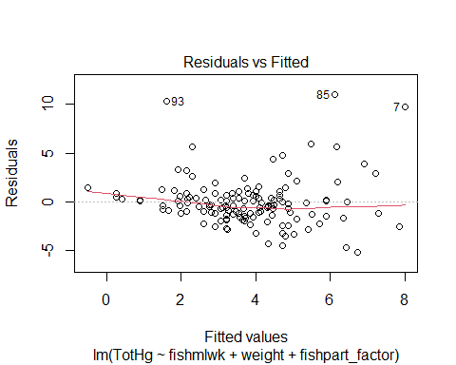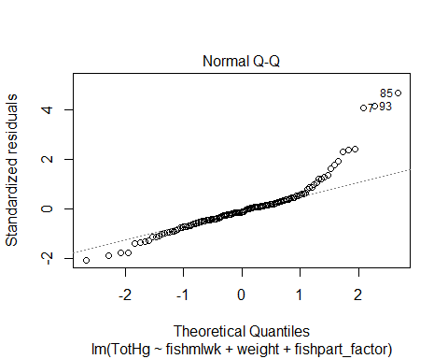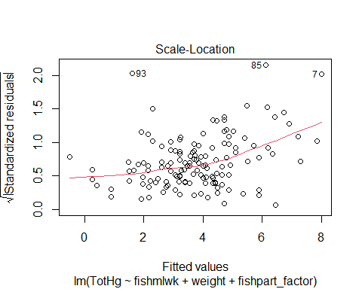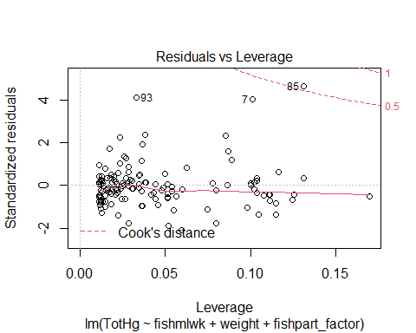

Question A: The Residuals vs Fitted plot (the first plot) allows you to assess the assumptions of linearity and equality of residual variance across the range of the fitted values. What specific part of this plot should be examined to evaluate the *linearity* assumption?

Your answer here: The red line should be examined. The better it fits to the dotted line the better the linearity is.

Question B: The Normal Q-Q plot (the second plot) allows you to assess the assumption of normality across the range of the fitted values, and is interpreted similarly to plots you’ve seen previously. With regard to the assumption of *normality*, is the left side of the QQ plot more concerning or is the right side more concerning?

Your answer here (left or right): Right

Question C: The Scale-Location plot (the third plot) allows you to assess the assumption of equality of residual variance across the range of the fitted values, and we discussed three shapes that indicate potential violations of this assumption (bowtie, bullhorns, and diamond). Are any of these shapes obviously present in this plot?

Your answer here (yes or no): No

Question D: The Residuals vs Leverage plot (the four plot) helps you identify potentially influential points. If you use the Cook’s D guideline of 0.5, which point/s would you identify as being influential? Please list the observation number/s of any point/s you would consider removing based on this guideline.

Your answer here: 35, 65, and 85

# Question 5 - 5 points

If we follow a Cook’s D guideline of 0.05, we may want to remove this potentially influential point. We can remove the point and see how the point’s removal changes the model estimates and diagnostic plots.

First, remove observation 85 from the fish data set. Save the data set with the removed point into a data set called “fish.remove”

fish.remove <- fish[-85, ] # Complete this line

Next, re-fit the *same* model as you fitted in Question 4 and save it as a model object called “fish.reg.remove”. This time, use the fish.remove data set.

fish.reg.remove <- lm(TotHg~fishmlwk+weight+fishpart_factor,data=fish.remove)# Complete this line  
   
# Showing the coefficients using the summary() function   
   
summary(fish.reg.remove)

##   
## Call:  
## lm(formula = TotHg ~ fishmlwk + weight + fishpart_factor, data = fish.remove)  
##   
## Residuals:  
## Min 1Q Median 3Q Max   
## -4.8667 -1.1706 -0.0931 0.6257 10.1226   
##   
## Coefficients:  
## Estimate Std. Error t value Pr(>|t|)   
## (Intercept) -8.49716 2.35016 -3.616 0.00043 ***  
## fishmlwk 0.13599 0.04074 3.338 0.00111 **   
## weight 0.13430 0.03171 4.235 4.32e-05 ***  
## fishpart_factor1 2.21262 0.94061 2.352 0.02018 *   
## fishpart_factor2 1.42901 0.82407 1.734 0.08531 .   
## fishpart_factor3 1.14095 1.15375 0.989 0.32458   
## ---  
## Signif. codes: 0 '***' 0.001 '**' 0.01 '*' 0.05 '.' 0.1 ' ' 1  
##   
## Residual standard error: 2.324 on 128 degrees of freedom  
## Multiple R-squared: 0.2927, Adjusted R-squared: 0.2651   
## F-statistic: 10.59 on 5 and 128 DF, p-value: 1.572e-08

Finally, display the diagnostic plots of the re-fitted model.

# Code to produce diagnostic plots here  
  
plot(fish.reg.remove)

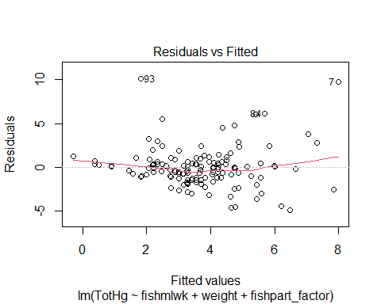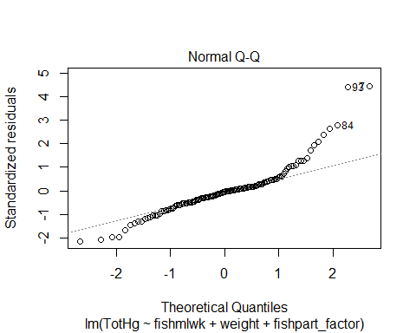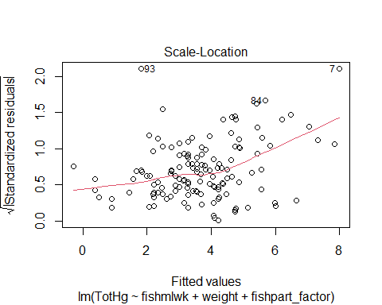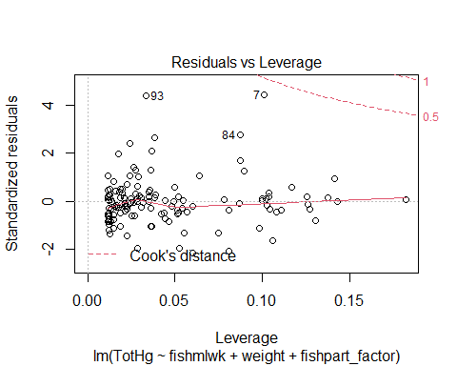

Have a look at both the model coefficients and the diagnostic plots and compare them to the coefficients and plots of the original model in Question 4. Once you’ve done that, answer the questions below:

1. Look at the p-values associated with fishmlwk, weight, fishpart_factor1, fishpart_factor2, and fishpart_factor3 in both models. Using an alpha level of 0.05, would your conclusion about any of the coefficients be different for any of them? That is, would your conclusion switch from reject -> fail to reject or from fail to reject -> reject for any of the coefficients?

Your answer here (yes/no): Yes

1. If you answered ‘yes’ to the previous question, which coefficient/s would your conclusion change between models and how would the conclusion change? Be sure to name the coefficient explicitly (i.e., fishmlwk/weight/fishpart_factor1/fishpart_factor2/fishpart_factor3) and state how the decisions would differ (reject in first model -> fail to reject in second model or from fail to reject in first model -> reject in second model)

Your answer here: fishpart_factor2 (reject in first model -> fail to reject in second model)  
fishpart_factor3 (fail to reject in first model -> reject in second model)

# Question 6 - 10 points

There are several reasons to transform variables, one of which we will explore in this question. If the diagnostic plots indicate that the residuals are not normally distributed across the range of fitted values, one can apply a nonlinear transformation to the outcome variable to change the shape of the distribution of the residuals. A common method for doing this is the Box-Cox transformation. Dr. Cathy Durso offered the following explanation of this approach:

“The Box-Cox transformations are a parametrized family of power transformations designed to be applied to the outcome variable to improve the Normality of residuals of a linear model. For $λ≠0$, the transformation maps $y$ to $\frac{y^{λ}−1}{λ}$ while for $λ=0$, the tranformation maps $y$ to $\text{ln}y$.

For each value of $λ$ in the range of the argument “lambda”, the “boxcox” function in the “MASS” package fits the linear model it is given as an argument but with the Box-Cox transformation applied to the outcome variable, assumed to be positive. The function “boxcox” computes the log likelihood of the residuals under the assumption of Normality. This is plotted against the $λ$’s and the $λ$’s and the corresponding log likelihoods are returned. In typical use, a value of $λ$ close to maximizing the log likelihood is chosen and regression performed with this transformation applied to the outcome variable.”

In this problem, you will walk through the steps of conducting a Box-Cox transformation.

#### Fitting the base model

You start the process by fitting the model and examining the diagnostic plots to determine if there is non-normality in the model residuals. This time, the model contains fishmlwk, weight, fishpart_factor, age, and height.

Run the code chunk below and examine the output. You do not need to modify anything (except maybe the very first line; see the comment). Once you’ve done that, continue onto the next section.

fish.demo <- read.csv("fishermen_mercury.csv", header=TRUE, sep=",") # You may need to change the file path on this line  
  
fish.demo$fishpart_factor <- as.factor(fish$fishpart)  
  
fish.reg.demo = lm(TotHg ~ fishmlwk + weight + fishpart_factor + age + height, data=fish.demo)  
  
summary(fish.reg.demo)

##   
## Call:  
## lm(formula = TotHg ~ fishmlwk + weight + fishpart_factor + age +   
## height, data = fish.demo)  
##   
## Residuals:  
## Min 1Q Median 3Q Max   
## -5.1645 -1.2147 -0.3064 0.7235 11.0284   
##   
## Coefficients:  
## Estimate Std. Error t value Pr(>|t|)   
## (Intercept) -15.85401 5.95019 -2.664 0.00871 **   
## fishmlwk 0.12113 0.04555 2.659 0.00883 **   
## weight 0.14693 0.03574 4.112 7.01e-05 ***  
## fishpart_factor1 2.05185 1.04238 1.968 0.05120 .   
## fishpart_factor2 1.47024 0.90256 1.629 0.10580   
## fishpart_factor3 2.40495 1.23425 1.949 0.05356 .   
## age 0.01657 0.02916 0.568 0.57075   
## height 0.03432 0.03416 1.005 0.31701   
## ---  
## Signif. codes: 0 '***' 0.001 '**' 0.01 '*' 0.05 '.' 0.1 ' ' 1  
##   
## Residual standard error: 2.544 on 127 degrees of freedom  
## Multiple R-squared: 0.2894, Adjusted R-squared: 0.2503   
## F-statistic: 7.39 on 7 and 127 DF, p-value: 1.938e-07

plot(fish.reg.demo)

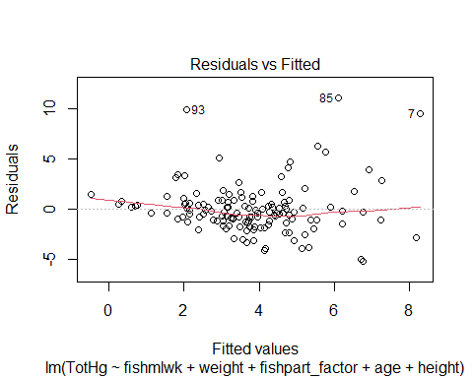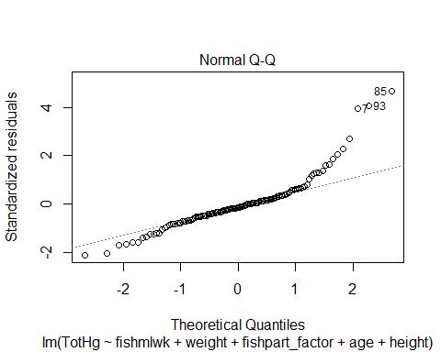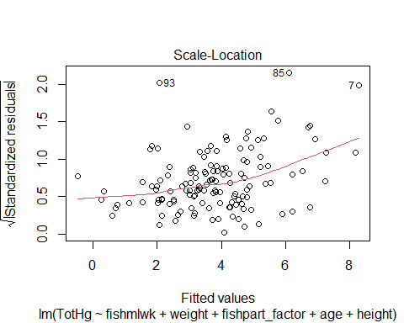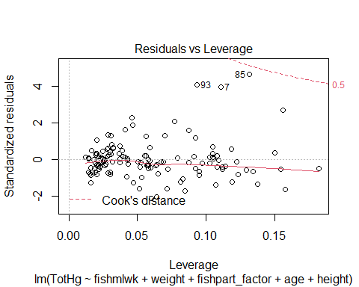

#### Apply the boxcox() function from the MASS package (loaded at the beginning of this document) to your fitted model

Run the code below and examine what it produces before moving on to the next part. You do not need to modify anything in this code chunk.

lambda<-boxcox(fish.reg.demo)

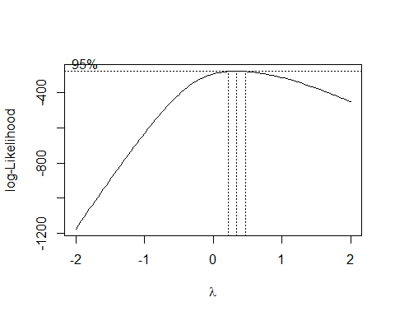

lambda

## $x  
## [1] -2.00000000 -1.95959596 -1.91919192 -1.87878788 -1.83838384 -1.79797980  
## [7] -1.75757576 -1.71717172 -1.67676768 -1.63636364 -1.59595960 -1.55555556  
## [13] -1.51515152 -1.47474747 -1.43434343 -1.39393939 -1.35353535 -1.31313131  
## [19] -1.27272727 -1.23232323 -1.19191919 -1.15151515 -1.11111111 -1.07070707  
## [25] -1.03030303 -0.98989899 -0.94949495 -0.90909091 -0.86868687 -0.82828283  
## [31] -0.78787879 -0.74747475 -0.70707071 -0.66666667 -0.62626263 -0.58585859  
## [37] -0.54545455 -0.50505051 -0.46464646 -0.42424242 -0.38383838 -0.34343434  
## [43] -0.30303030 -0.26262626 -0.22222222 -0.18181818 -0.14141414 -0.10101010  
## [49] -0.06060606 -0.02020202 0.02020202 0.06060606 0.10101010 0.14141414  
## [55] 0.18181818 0.22222222 0.26262626 0.30303030 0.34343434 0.38383838  
## [61] 0.42424242 0.46464646 0.50505051 0.54545455 0.58585859 0.62626263  
## [67] 0.66666667 0.70707071 0.74747475 0.78787879 0.82828283 0.86868687  
## [73] 0.90909091 0.94949495 0.98989899 1.03030303 1.07070707 1.11111111  
## [79] 1.15151515 1.19191919 1.23232323 1.27272727 1.31313131 1.35353535  
## [85] 1.39393939 1.43434343 1.47474747 1.51515152 1.55555556 1.59595960  
## [91] 1.63636364 1.67676768 1.71717172 1.75757576 1.79797980 1.83838384  
## [97] 1.87878788 1.91919192 1.95959596 2.00000000  
##   
## $y  
## [1] -1175.7102 -1152.6920 -1129.7300 -1106.8269 -1083.9854 -1061.2081  
## [7] -1038.4978 -1015.8577 -993.2910 -970.8015 -948.3930 -926.0697  
## [13] -903.8363 -881.6978 -859.6596 -837.7280 -815.9093 -794.2112  
## [19] -772.6417 -751.2100 -729.9264 -708.8020 -687.8502 -667.0849  
## [25] -646.5230 -626.1830 -606.0856 -586.2554 -566.7183 -547.5054  
## [31] -528.6507 -510.1913 -492.1705 -474.6325 -457.6274 -441.2073  
## [37] -425.4252 -410.3351 -395.9903 -382.4373 -369.7198 -357.8718  
## [43] -346.9144 -336.8635 -327.7150 -319.4583 -312.0715 -305.5199  
## [49] -299.7666 -294.7669 -290.4741 -286.8416 -283.8230 -281.3735  
## [55] -279.4523 -278.0204 -277.0428 -276.4881 -276.3269 -276.5344  
## [61] -277.0869 -277.9640 -279.1474 -280.6198 -282.3667 -284.3739  
## [67] -286.6292 -289.1210 -291.8386 -294.7725 -297.9133 -301.2527  
## [73] -304.7826 -308.4955 -312.3844 -316.4424 -320.6632 -325.0408  
## [79] -329.5692 -334.2431 -339.0569 -344.0058 -349.0848 -354.2892  
## [85] -359.6145 -365.0564 -370.6109 -376.2738 -382.0413 -387.9099  
## [91] -393.8759 -399.9360 -406.0869 -412.3255 -418.6487 -425.0536  
## [97] -431.5376 -438.0979 -444.7320 -451.4372

#### Obtain the $λ$ corresponding to the maximum profile log likelihood

The code below pulls the lambda for which the log likelihood is maximized. You do not need to modify anything in this chunk. Run this code and examine what it produces, then answer the two questions before moving onto the next section.

ll.best<-which(lambda[[2]]==max(lambda[[2]]))  
  
ll.best

## [1] 59

lambda.best<-lambda[[1]][ll.best]  
  
lambda.best

## [1] 0.3434343

Question A: What is the *number* of the lambda that corresponds to the maximum profile likelihood?

Your answer here: 59

Question B: What is the *value* of the lambda that corresponds to the maximum profile likelihood?

Your answer here: 0.3434343

#### Apply the transformation to the output variable and re-fit the model.

Now that you have the value of the lambda that corresponds to the maximum profile likelihood, you can now apply the Box-Cox transformation to your model.

# Transforming the outcome variable

First, use lambda.best to transform the outcome variable. Recall from Dr. Durso’s overview that the formula is $\frac{y^{λ}−1}{λ}$. Complete the line in the code chunk to compute and save the transformed variable as a new variable (“TotHg.BC”) in the fish data set, then answer the question below to check that you applied the transformation correctly.

# Your code for creating and saving the transformed outcome variable   
  
fish.demo$TotHg.BC <- (fish.demo$TotHg ^ lambda.best - 1)/lambda.best # Complete this line

Question C: Look at the first observation in the fish.demo data set. The TotHg value for this observation is 4.484. What is the value of TotHg.BC (i.e., the transformed value) for this same observation?

Your answer here: 1.963

# Re-fitting the regression model using the transformed outcome

Be sure to have completed the previous section before starting this one.

Next, re-fit the regression model that was originally fitted. Keep the predictors the same - fishmlwk, weight, fishpart_factor, age, and height - but use the transformed outcome (TotHg.BC) instead of the original outcome (TotHg). Display the output for this model.

# Your code for refitting the regression model here  
  
fish.reg.BC <- lm(TotHg.BC ~ fishmlwk + weight + fishpart_factor + age + height, data=fish.demo) # Complete this line  
  
# Be sure to display the results using the summary() function!  
  
summary(fish.reg.BC)

##   
## Call:  
## lm(formula = TotHg.BC ~ fishmlwk + weight + fishpart_factor +   
## age + height, data = fish.demo)  
##   
## Residuals:  
## Min 1Q Median 3Q Max   
## -3.4276 -0.4156 0.0023 0.4627 3.0815   
##   
## Coefficients:  
## Estimate Std. Error t value Pr(>|t|)   
## (Intercept) -5.877885 2.292472 -2.564 0.01151 *   
## fishmlwk 0.027332 0.017548 1.558 0.12184   
## weight 0.056810 0.013769 4.126 6.63e-05 ***  
## fishpart_factor1 1.345115 0.401604 3.349 0.00107 **   
## fishpart_factor2 1.125900 0.347738 3.238 0.00154 **   
## fishpart_factor3 1.444877 0.475530 3.038 0.00289 **   
## age 0.003221 0.011233 0.287 0.77477   
## height 0.009951 0.013163 0.756 0.45103   
## ---  
## Signif. codes: 0 '***' 0.001 '**' 0.01 '*' 0.05 '.' 0.1 ' ' 1  
##   
## Residual standard error: 0.9803 on 127 degrees of freedom  
## Multiple R-squared: 0.3012, Adjusted R-squared: 0.2627   
## F-statistic: 7.82 on 7 and 127 DF, p-value: 7.369e-08

# Display diagnostic plots for model with transformed outcome

For your convenience, I’ve included code to produce the plots from the original model. Run this chunk (no modifications needed) and continue.

plot(fish.reg.demo) # Original model diagnostic plots



Now, generate the diagnostic plots of the re-fitted model that used the transformed outcome.

# Display your diagnostic plots for the transformed model here. Make sure they are visible in the knitted document  
  
plot(fish.reg.BC)

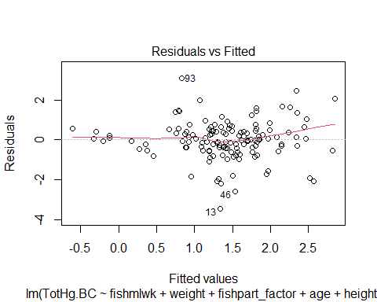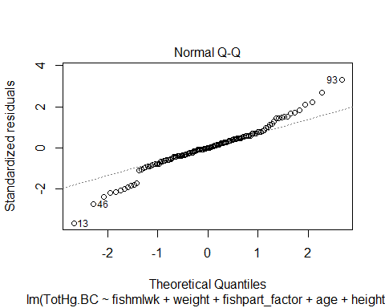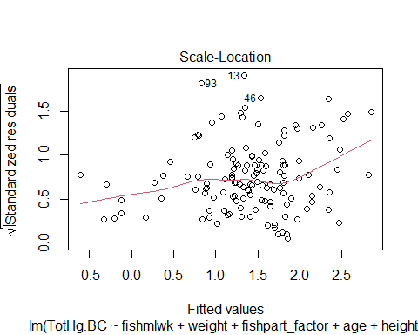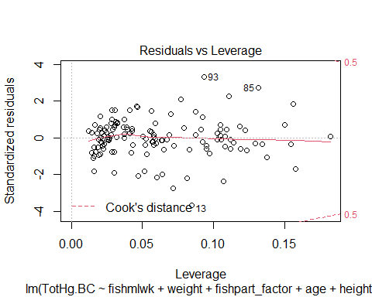

Look at both of the QQ plots and answer the two questions below.

Question 4: In the regression model using the original outcome variable, was the most concerning side of the QQ plot the left side or the right side?

Your answer here (left or right): Right

Question 5: Is the QQ plot of the model that used the transformed outcome different than the one from the model with the original outcome?

Your answer here (yes or no): Yes