PHASE 1 — Create Your Azure Environment

Step 1 — Create Azure Account

PHASE 2 — Create Resource Group

Step 2 — Create Resource Group
In Azure Portal:
- Search: “Resource Groups”
- Click Create
- Name:
RG-BlackHawkData-NOC-1
- Region:
  - East US (cheap and common)
- Click Review + Create
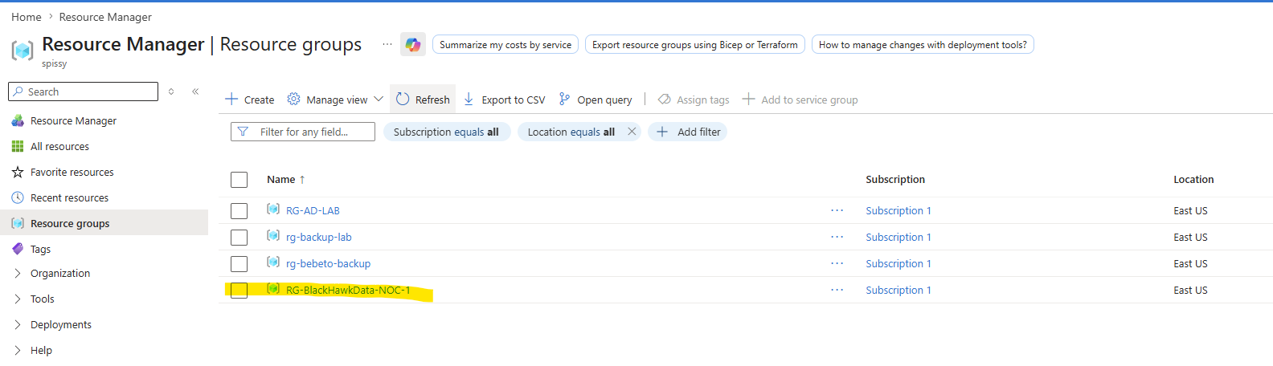

PHASE 3 — Create Network

Step 3 — Create Virtual Network (VNet)
Search:
- “Virtual Networks”
Create:
Setting | Value
Name | NOC_Vnet_01_BlackHawkData
Address Space | 10.0.0.0/16
Create 2 subnets:
Subnet | Range
Servers | 10.0.1.0/24
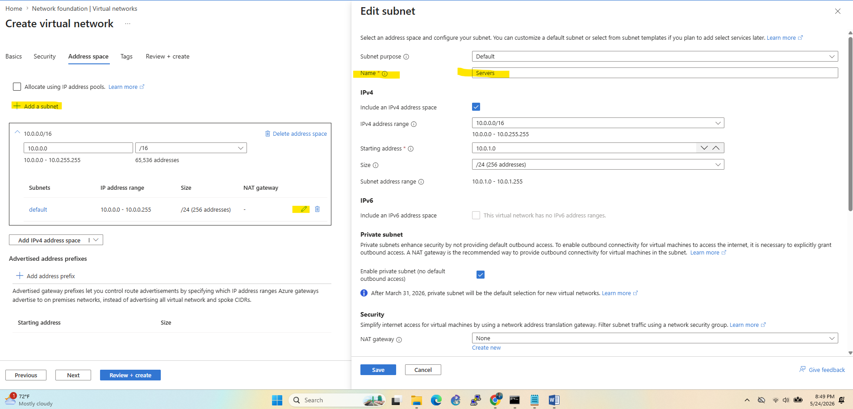

Clients | 10.0.2.0/24
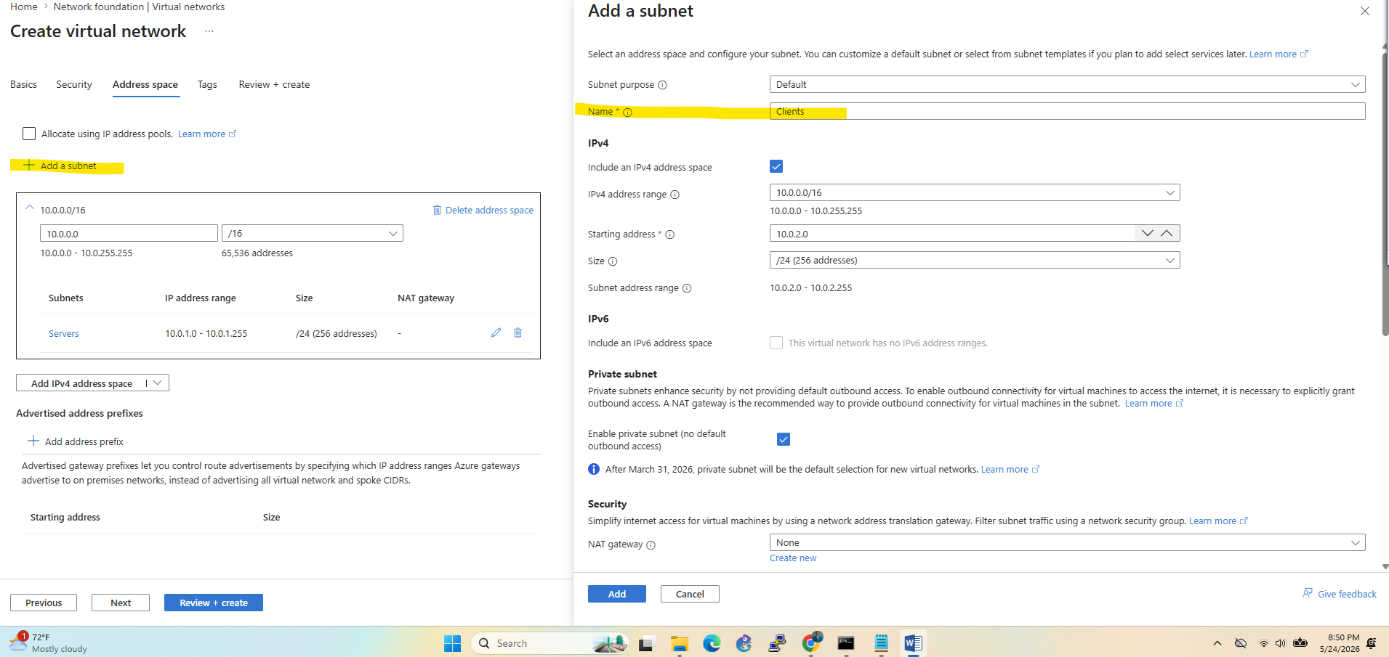
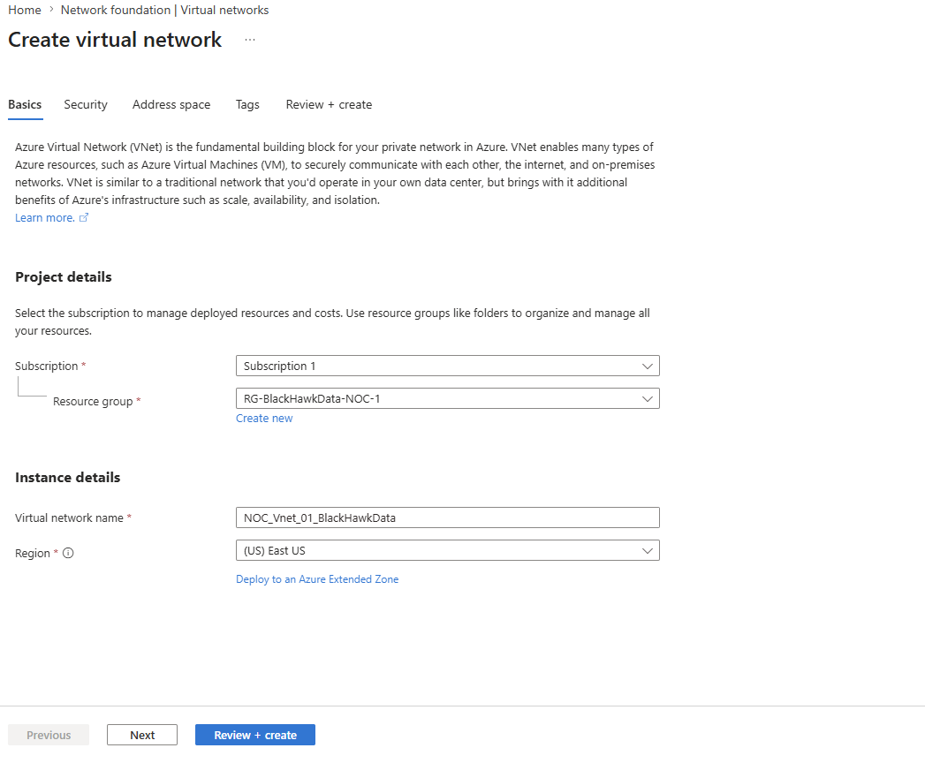
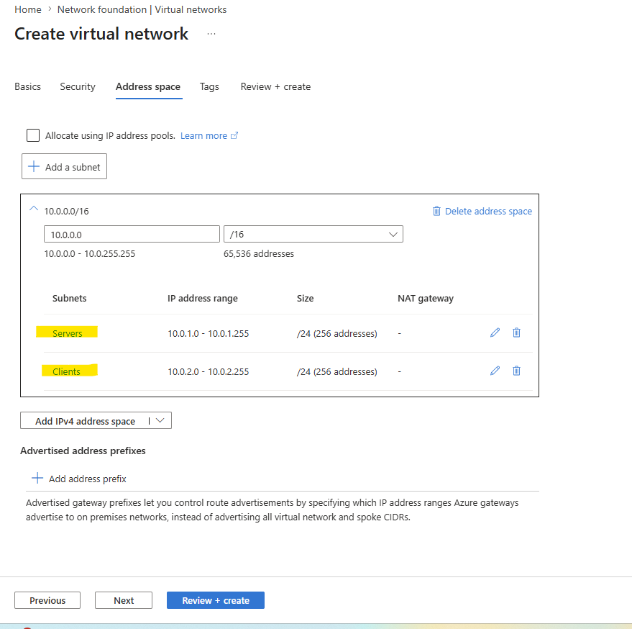

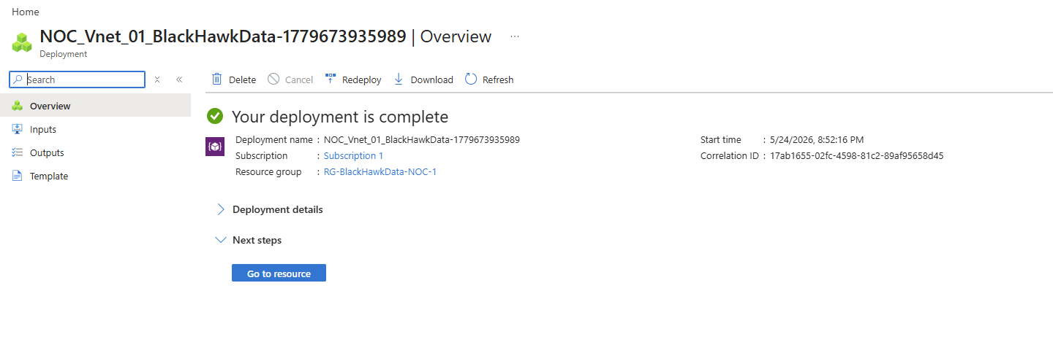

PHASE 4 — Create Domain Controller
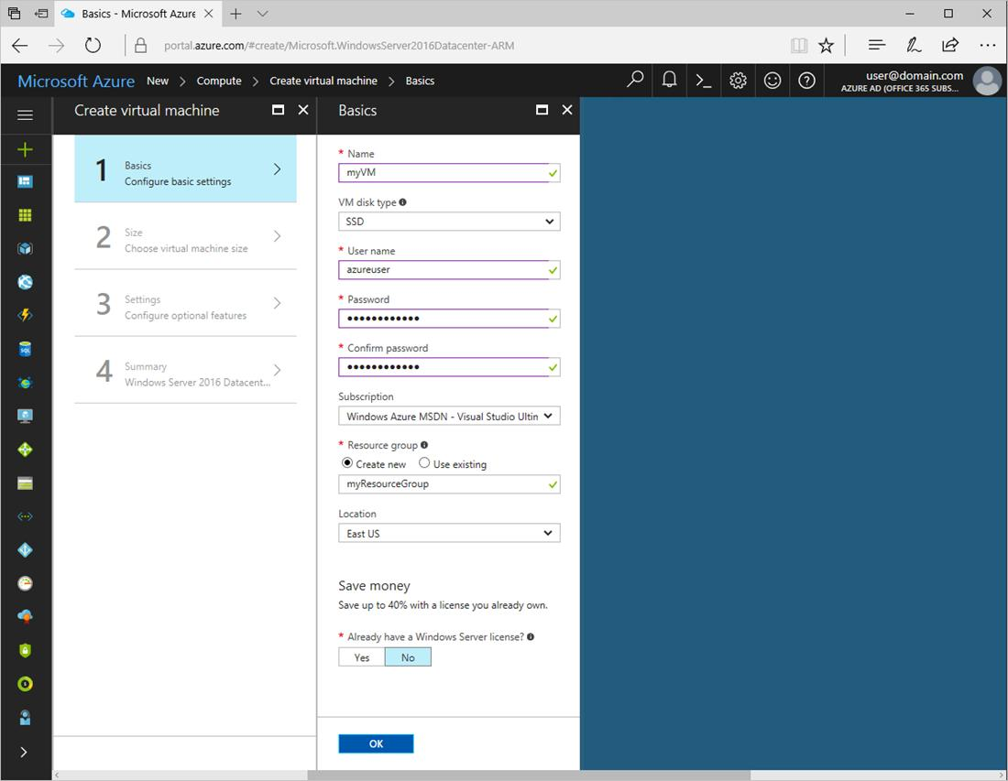
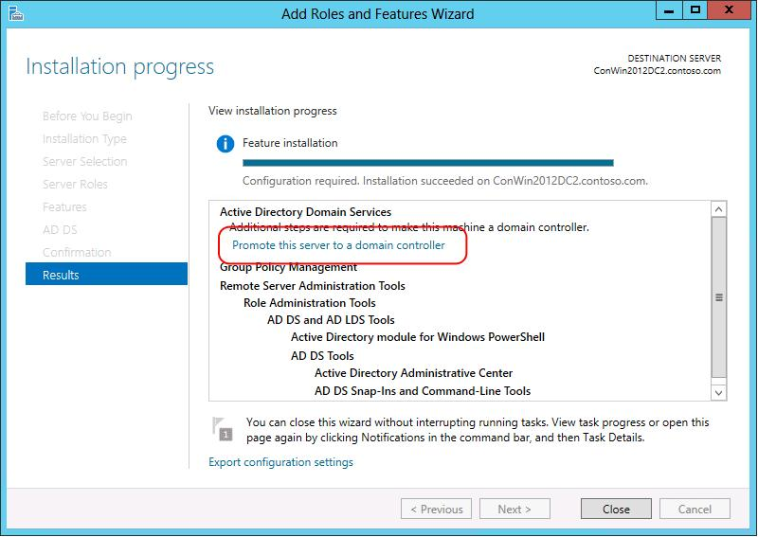
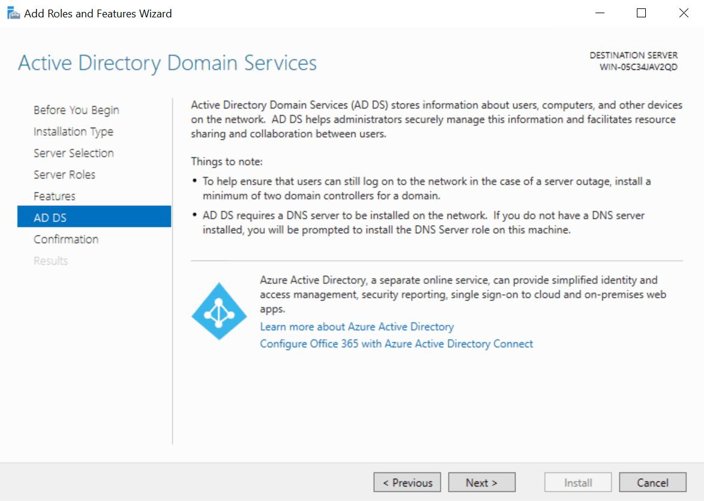
4

Step 4 — Create Windows Server VM
Search:
- “Virtual Machines”
- Click Create

VM Settings
Setting | Value
VM Name | DC01
Image | Windows Server 2022
Size | B2s
Username | azureadmin
Password | Create strong password
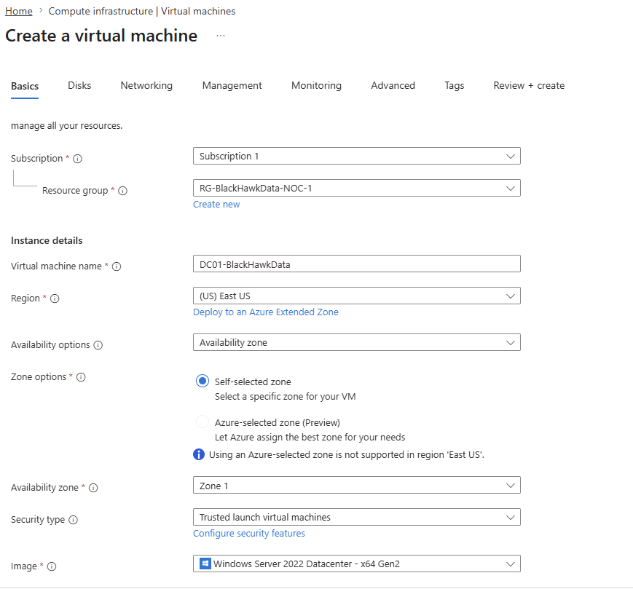

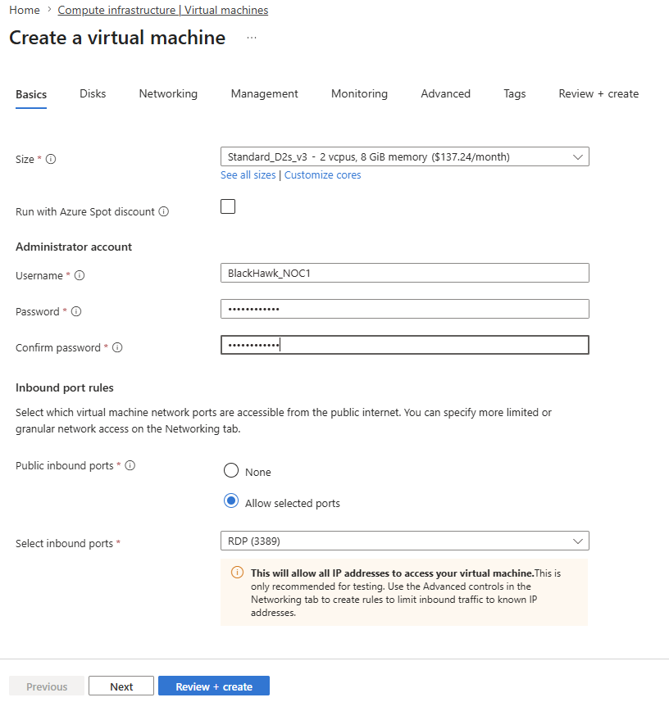

Networking:
- VNet: NOC-VNET
- Subnet: Servers

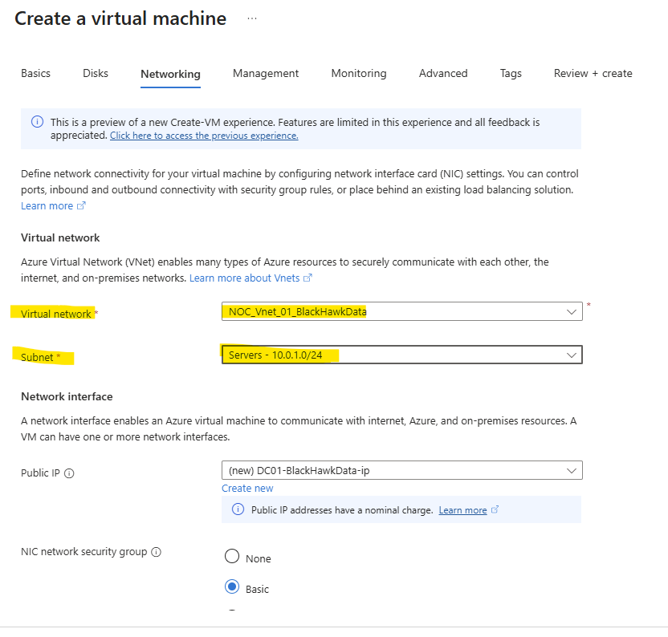
Enable:
- RDP

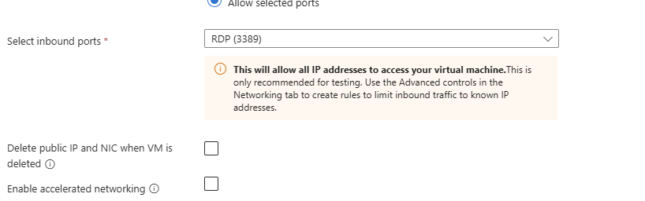
Create VM.

By deploying the VM Azure also create a NSG group
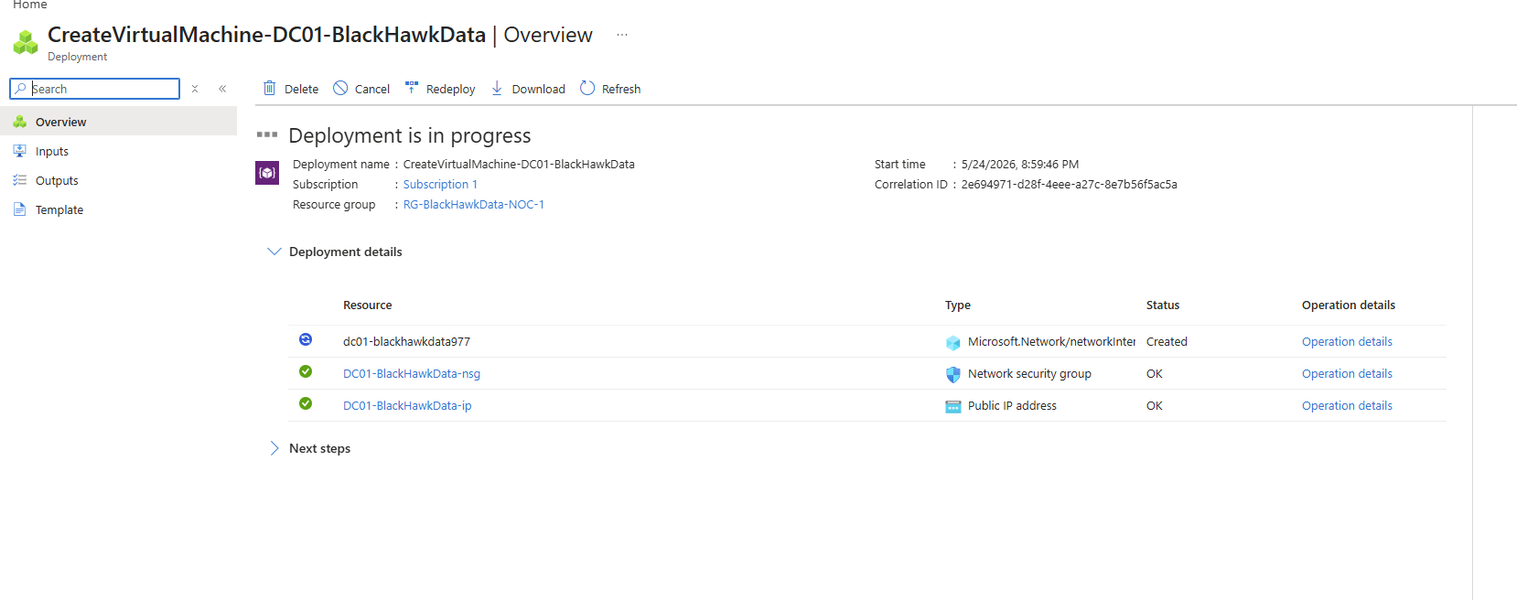
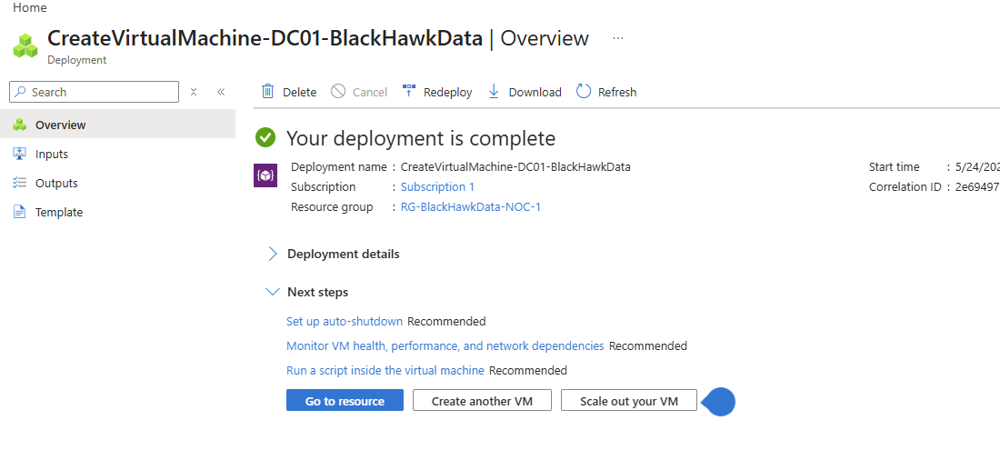

PHASE 5 — Install Active Directory

Step 5 — Connect via RDP
From VM page:
- Click Connect
- Download RDP file
- Login
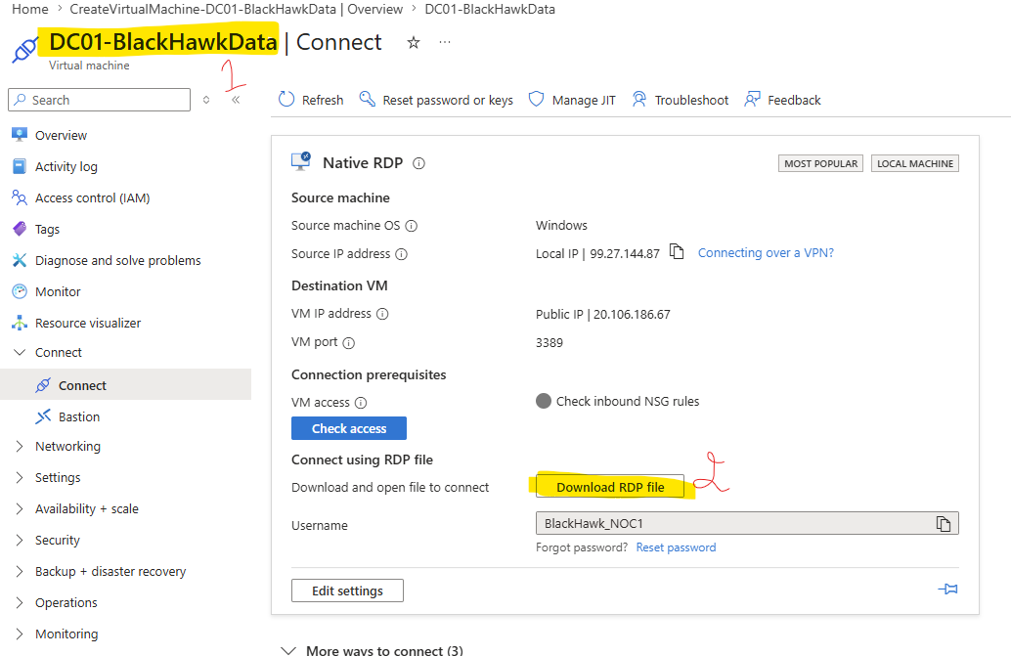
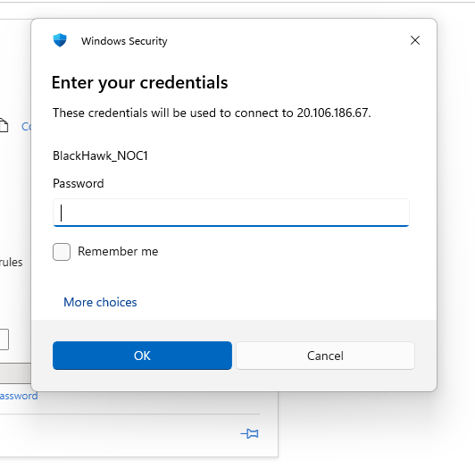

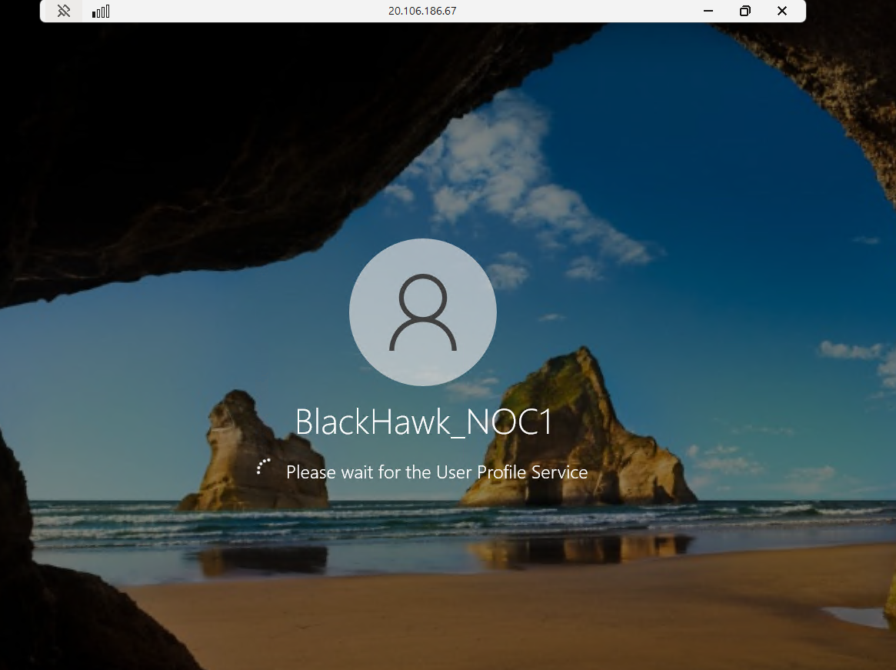

Step 6 — Install AD DS
Once The server is up and running
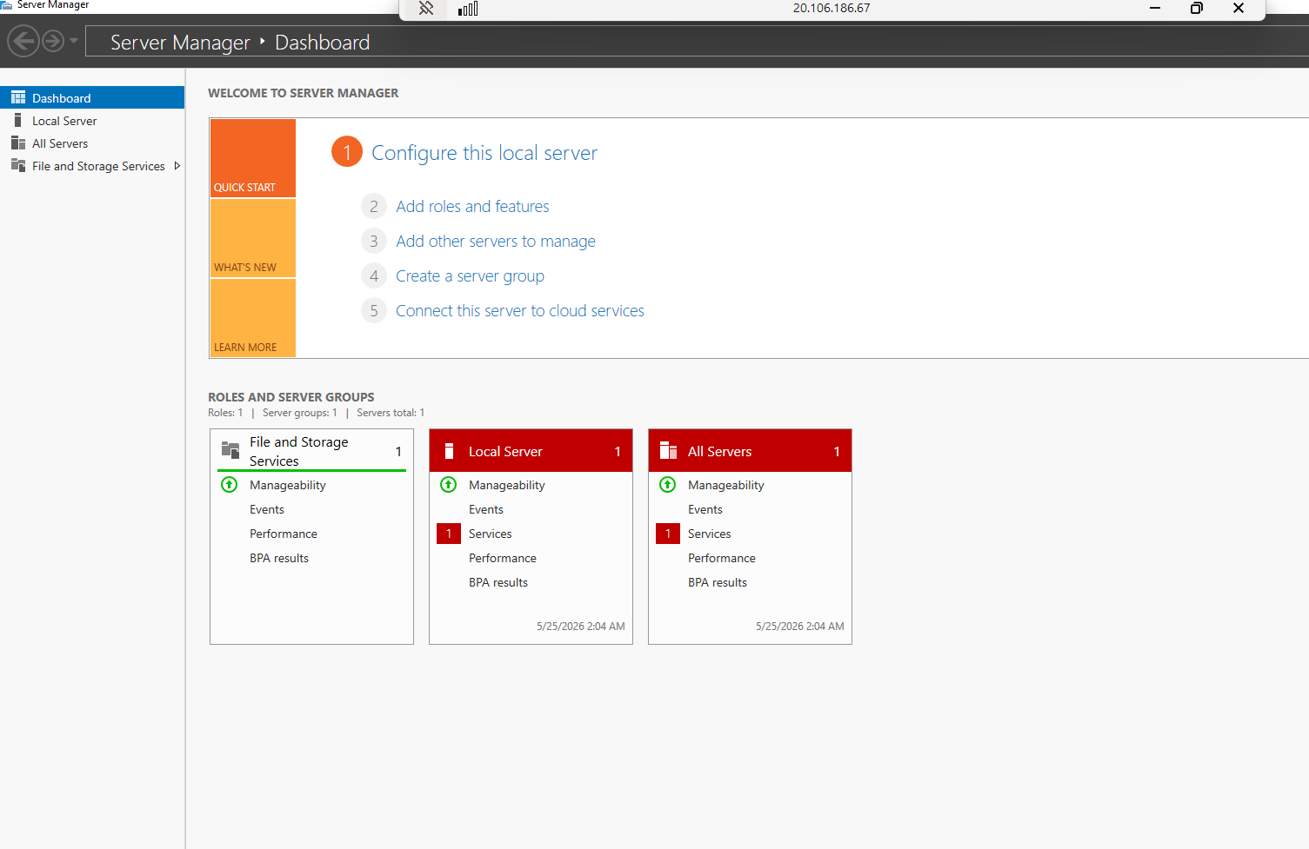

Open:
Server Manager → Add Roles and Features
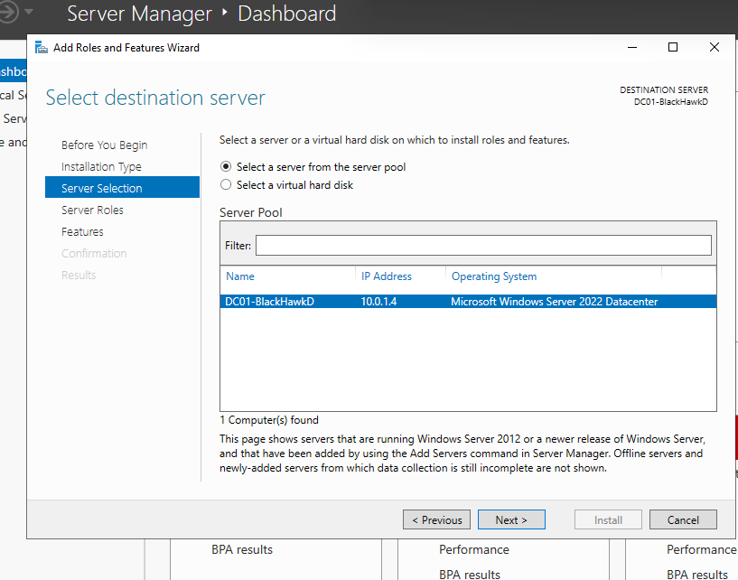

Install:
- Active Directory Domain Services
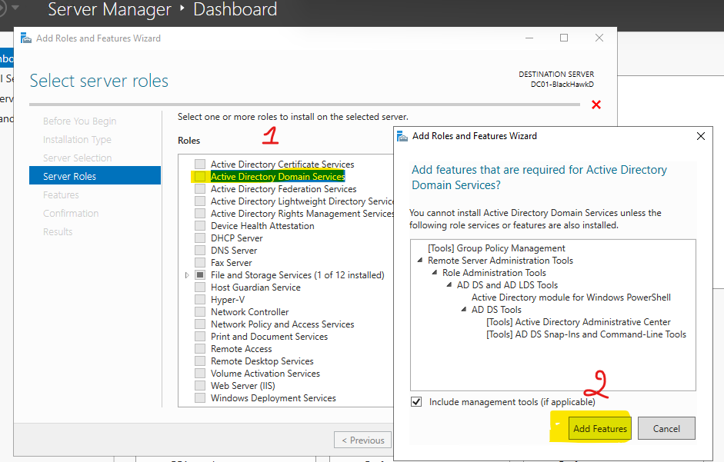
- DNS Server
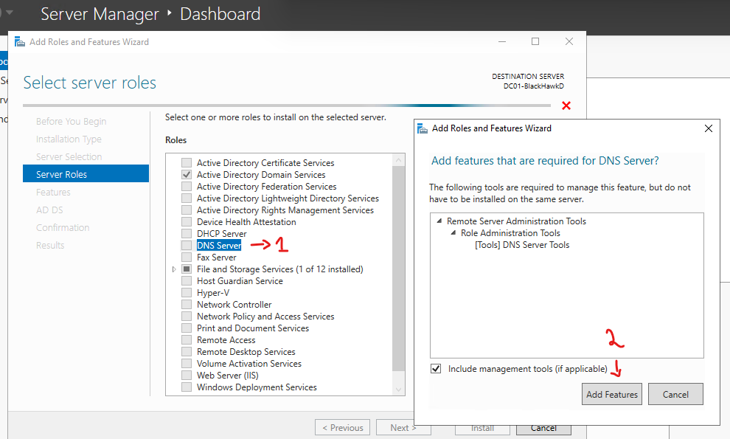

Issue : No Static IP
Troubleshoot
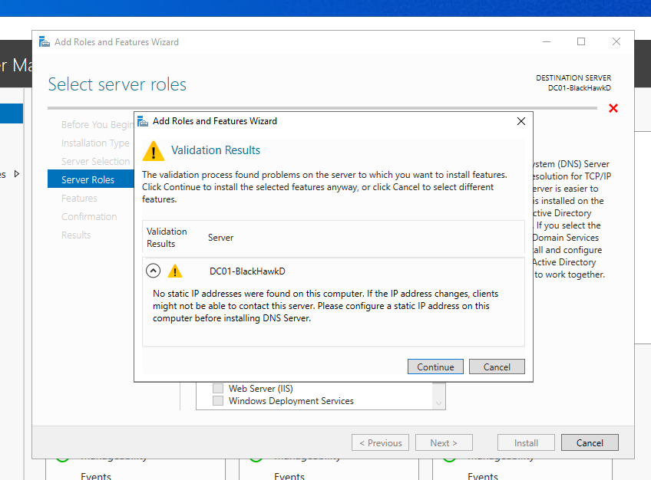
Log in back to Azure
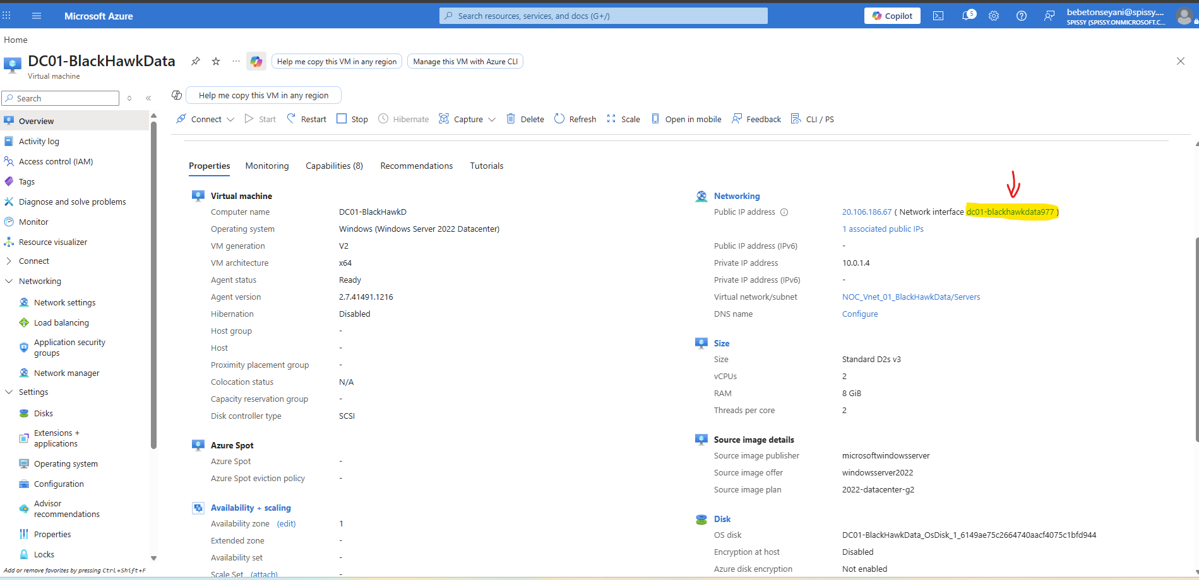

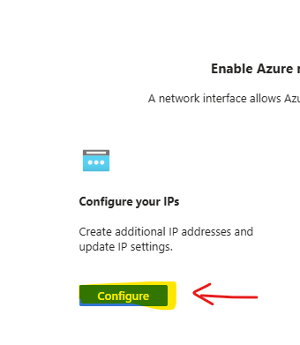

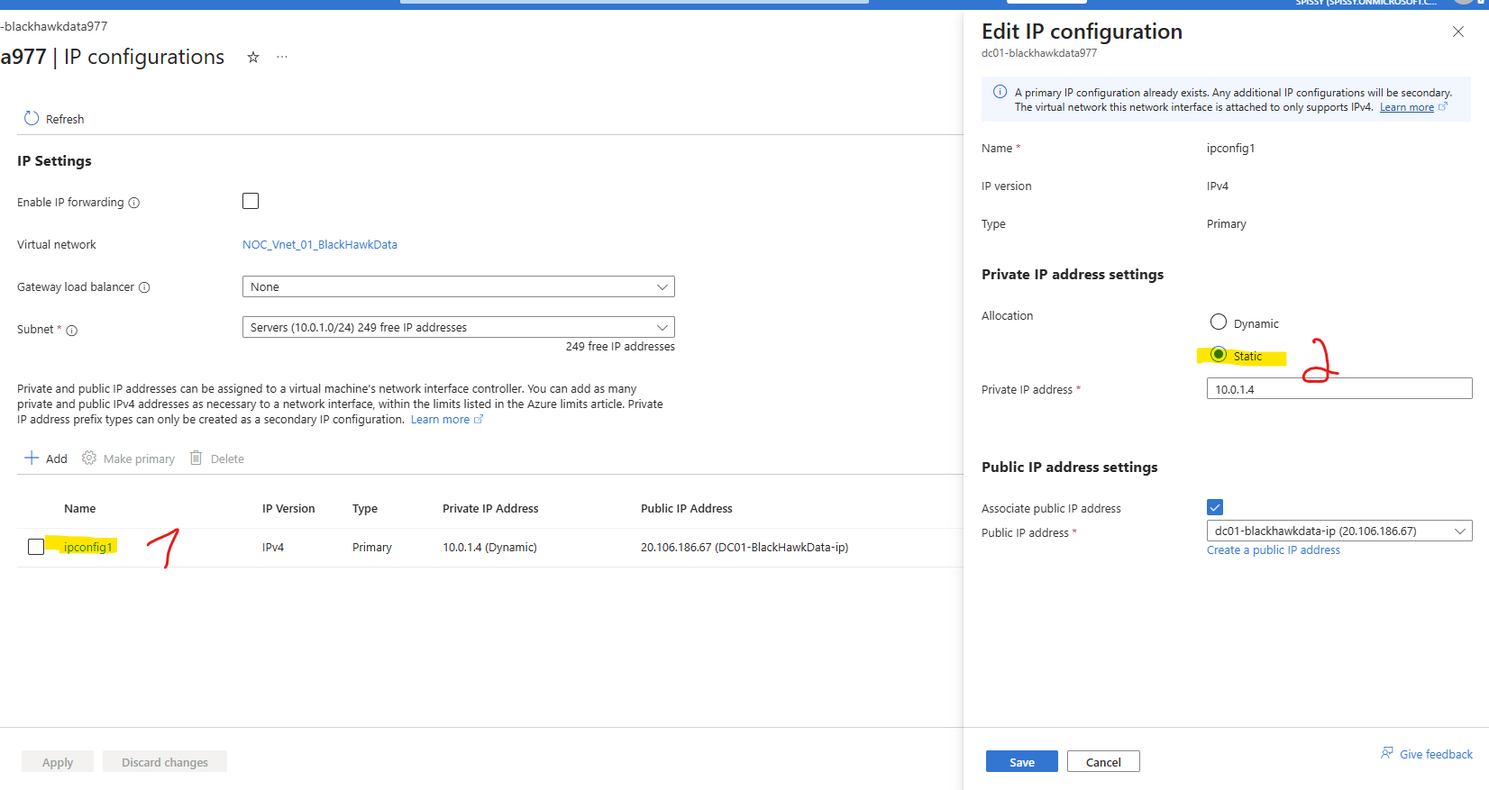
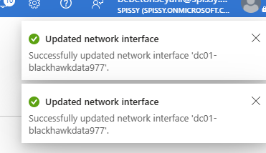

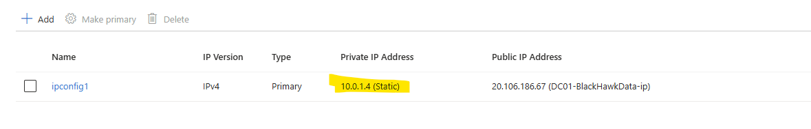
Let install
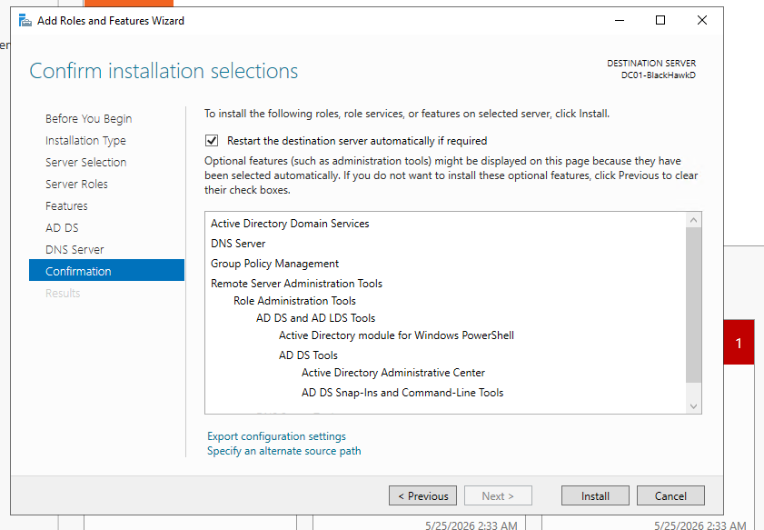

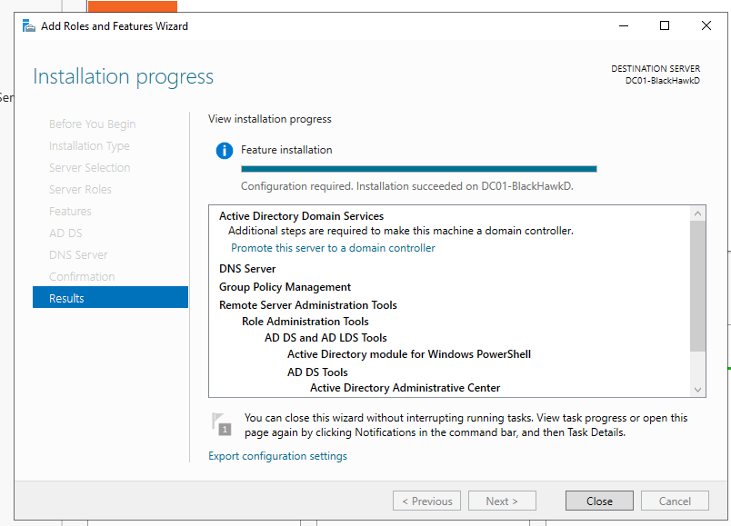
After install:
- Click notification flag
- “Promote this server to a domain controller”
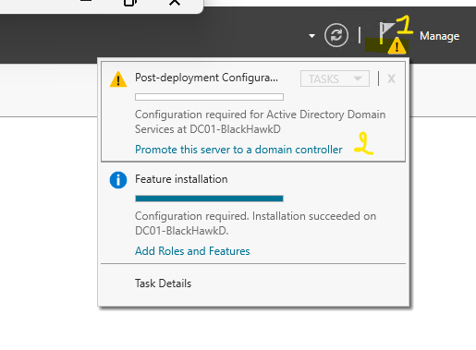

Step 7 — Create Domain
Choose:
- Add new forest
Domain:
Blackhawkdata.local

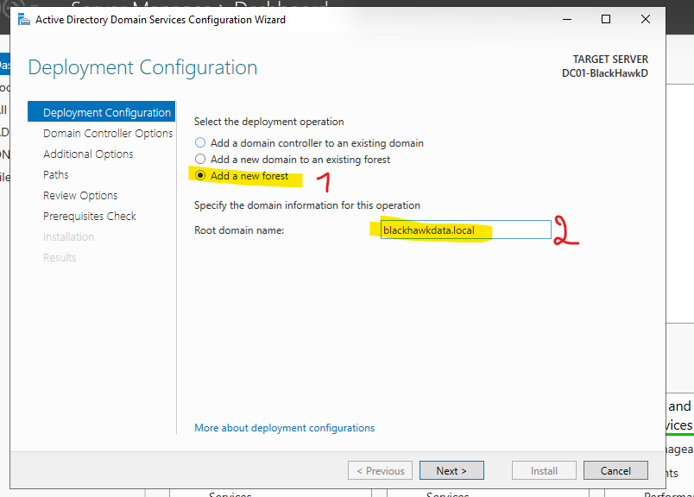
Reboot after installation.

PHASE 6 — Create Windows Client

Step 8 — Create Windows 11 VM
Create another VM:
Setting | Value
Name | CLIENT01
Image | Windows 11 Pro
Size | B2s
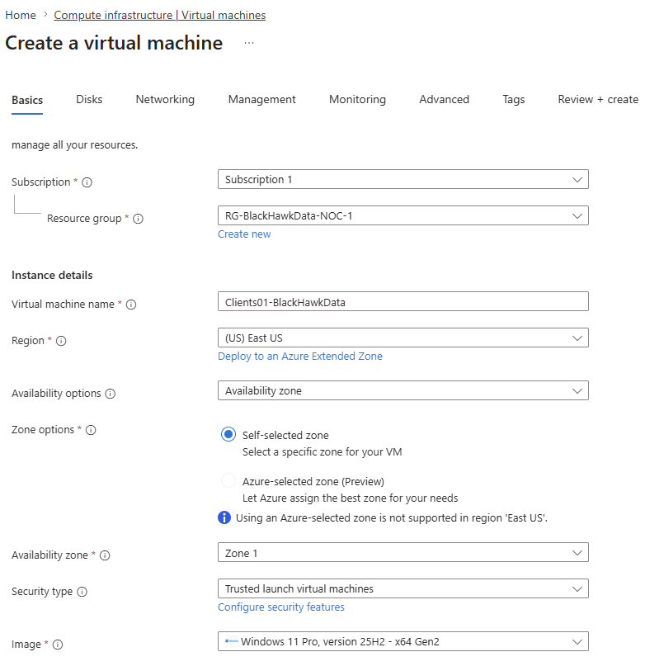

Networking:
- Subnet: Clients
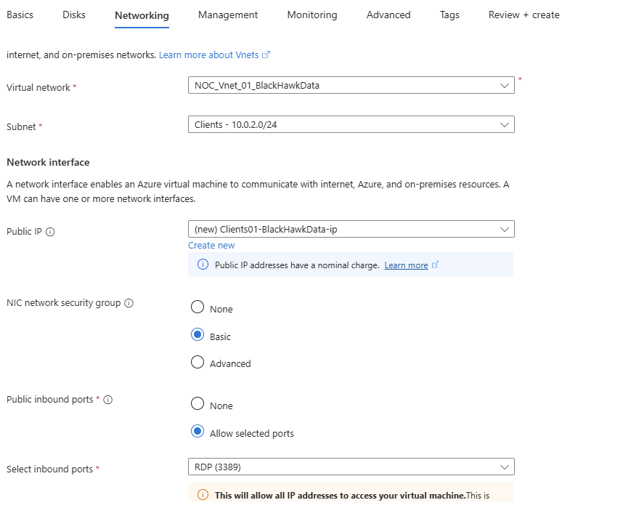

PHASE 7 — Configure DNS

Step 9 — Point Client to Domain Controller DNS
Go to:
- CLIENT01 NIC
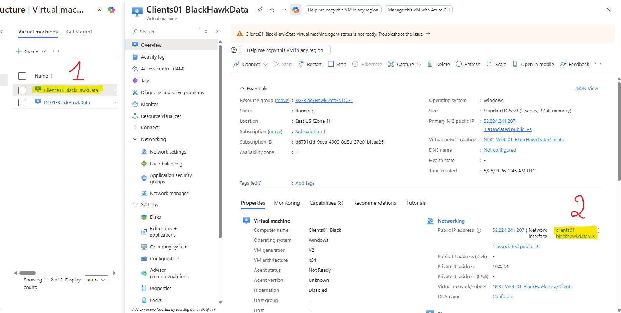
- DNS settings
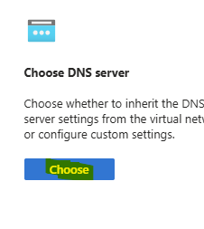
Set custom DNS:
10.0.1.4
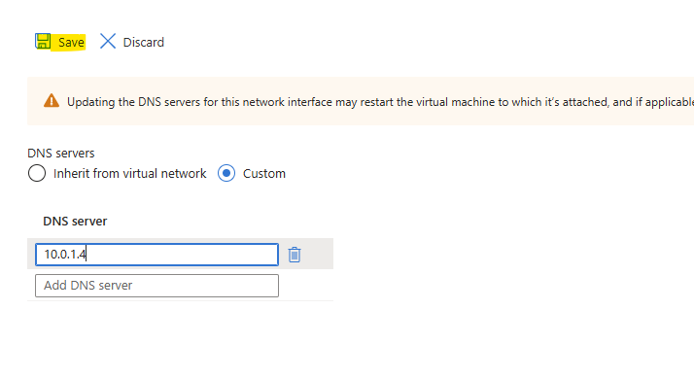
(Use your DC private IP)
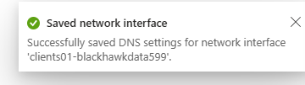
Restart VM.

PHASE 8 — Join Domain

Step 10 — Join CLIENT01 to Domain
Inside CLIENT01:

Go to:
System → About → Rename this PC (Advanced)
Join domain:
blackhawkdata.local
Login using:
CS-BlackHawkData
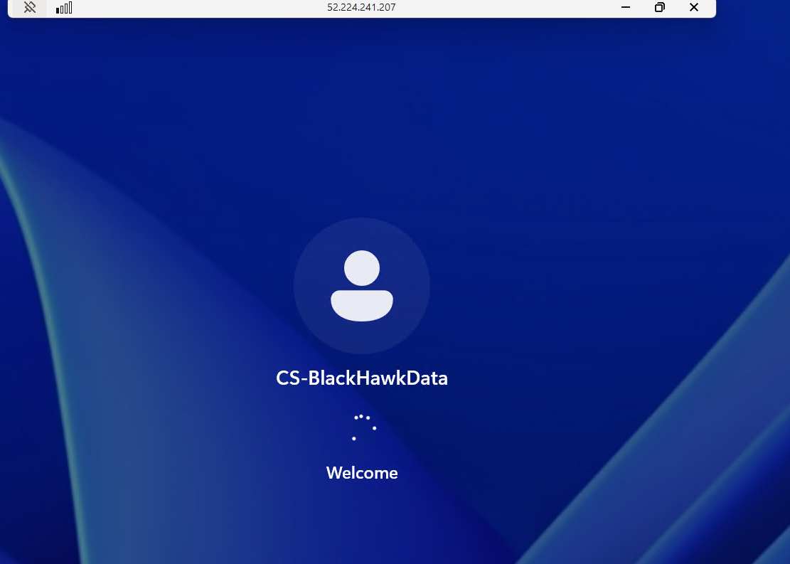

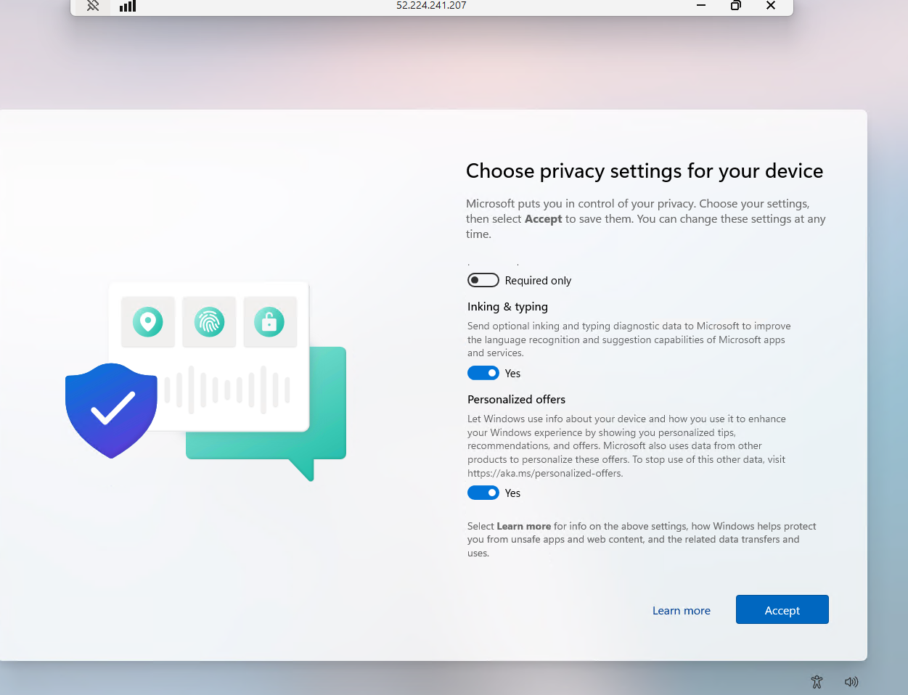

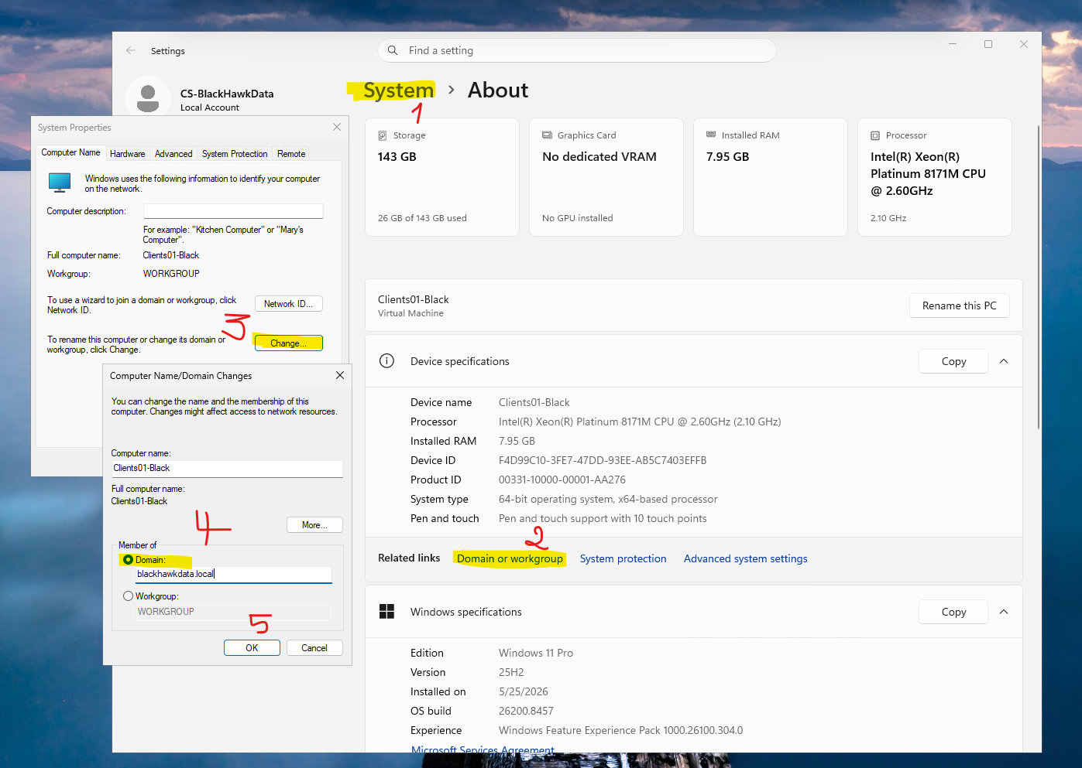

Use the DC01 admin username and PASSWORD
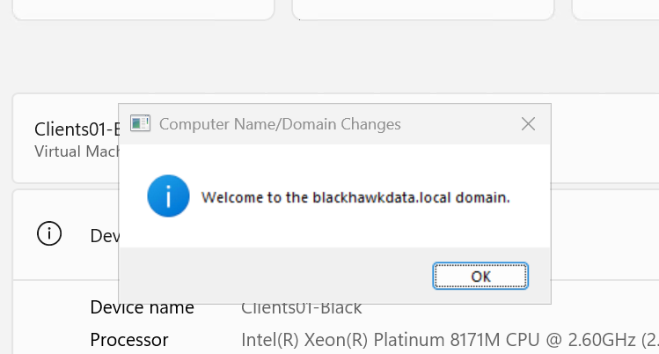

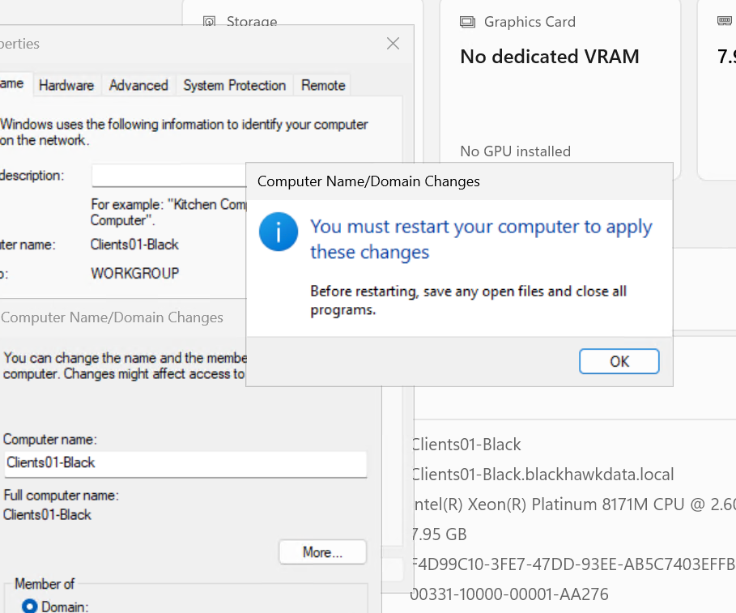

Click on Restart Now

PHASE 9 — Create Users & Groups

Step 11 — Create AD Users
On DC01:
Open:
Active Directory Users and Computers

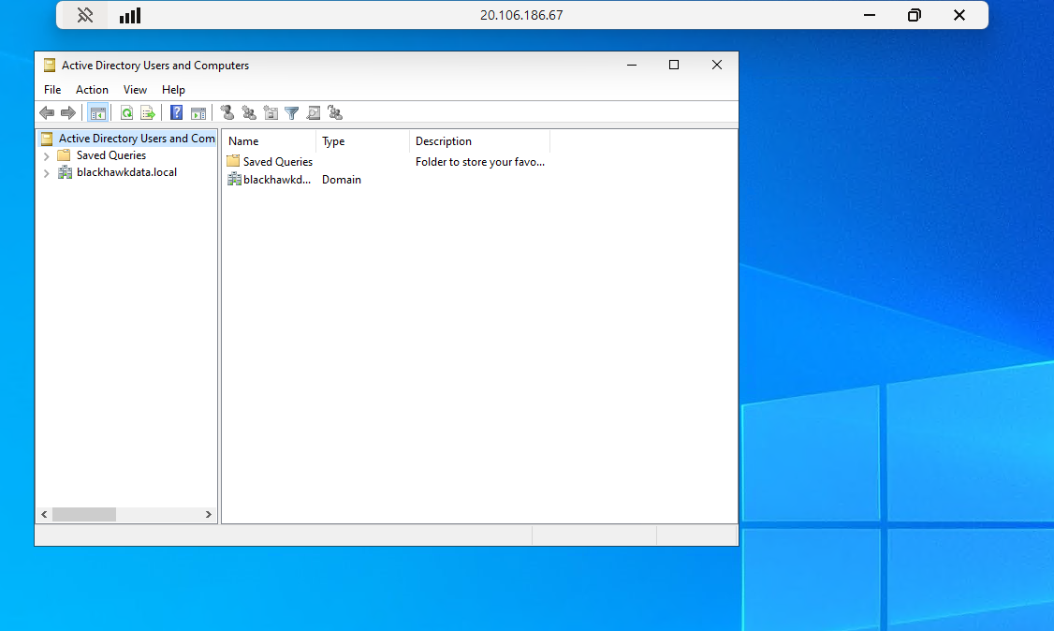
Create:
- NOCEngineer_sa
- Christel dikola
- NetworkAdmin

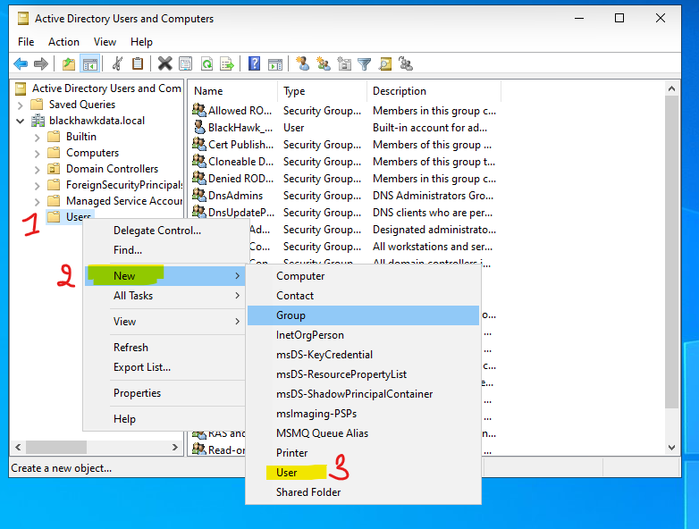

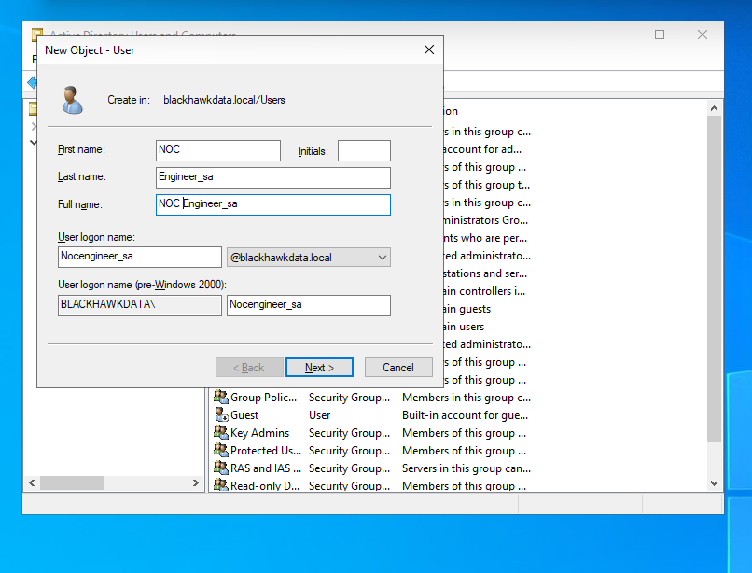

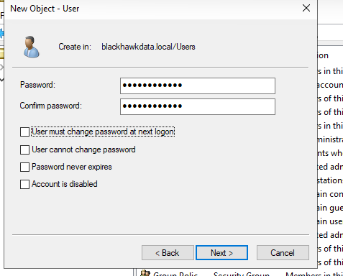

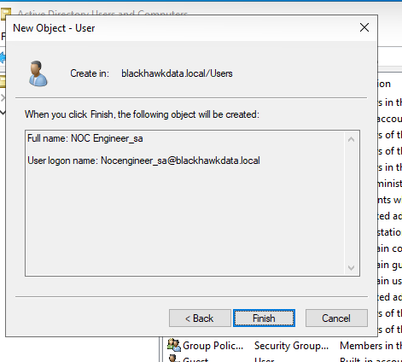
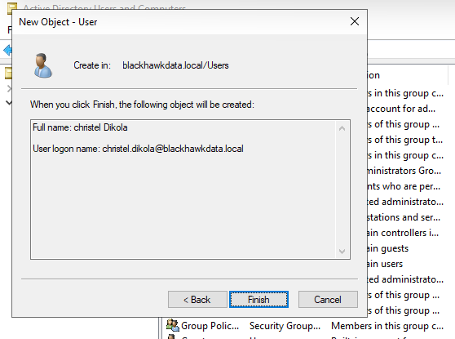
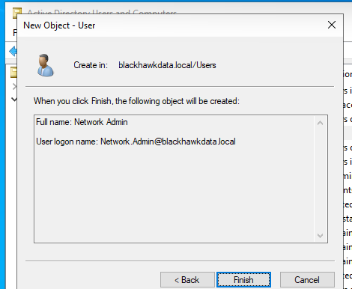

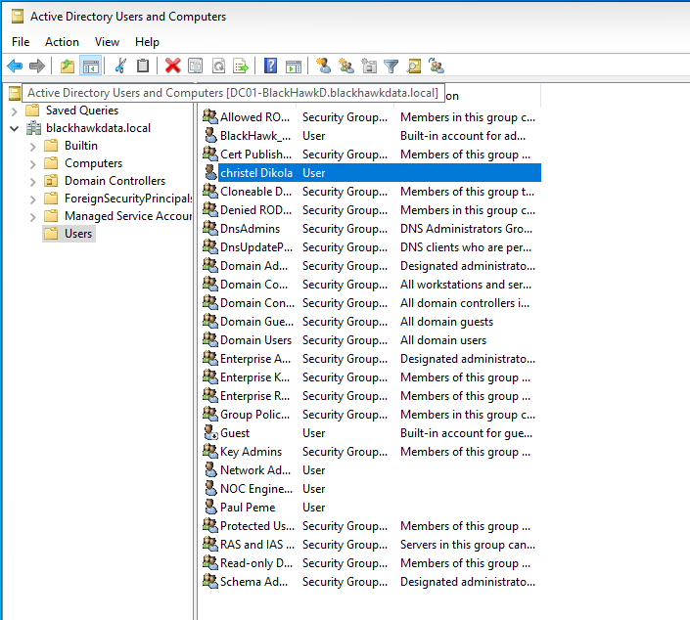

Create groups:
- HelpDesk
- NOC Admins
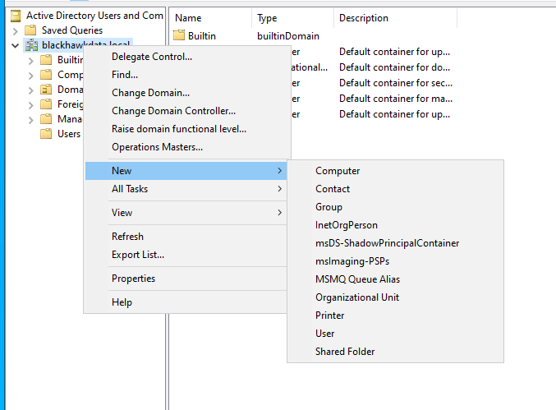

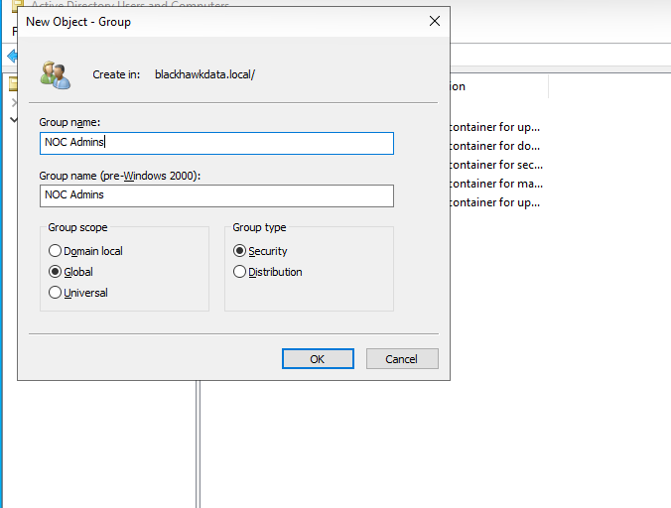

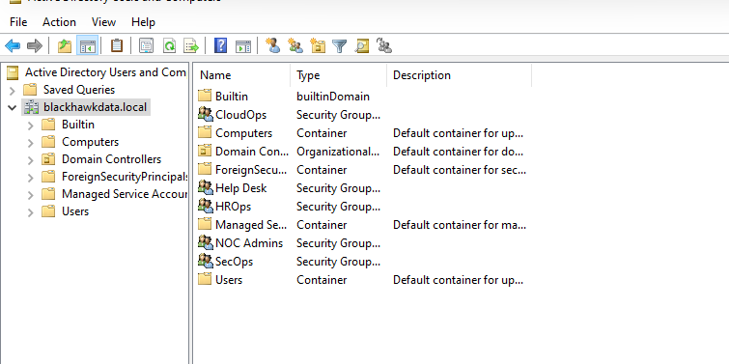

PHASE 10 — Install Monitoring
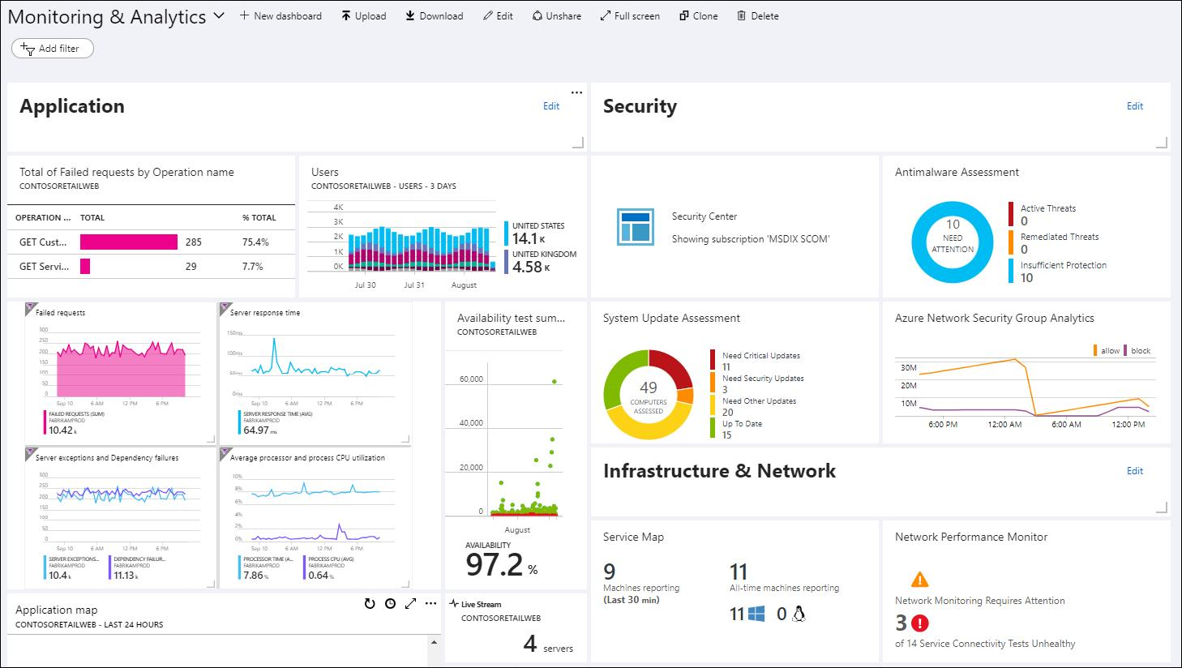
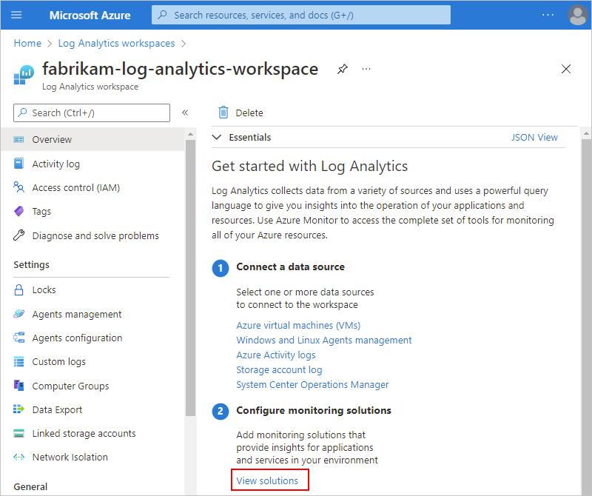
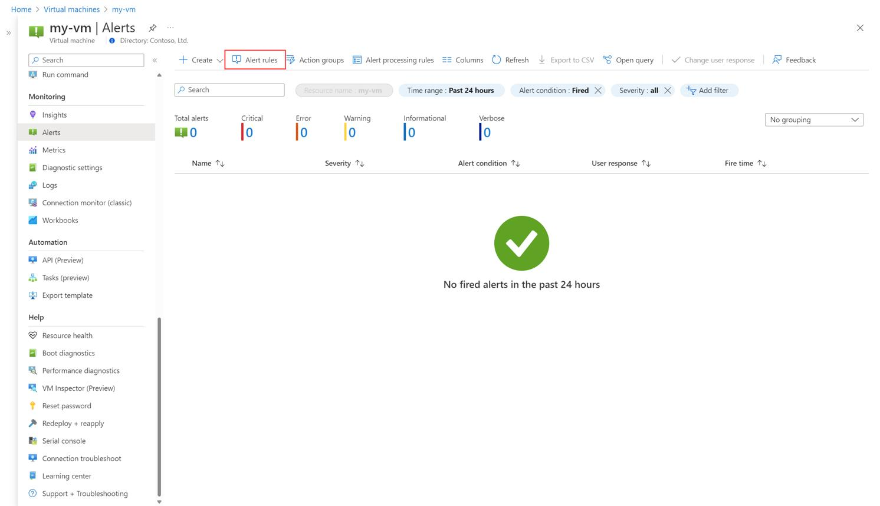
4

Step 12 — Create Log Analytics Workspace
Search:
- Log Analytics Workspace

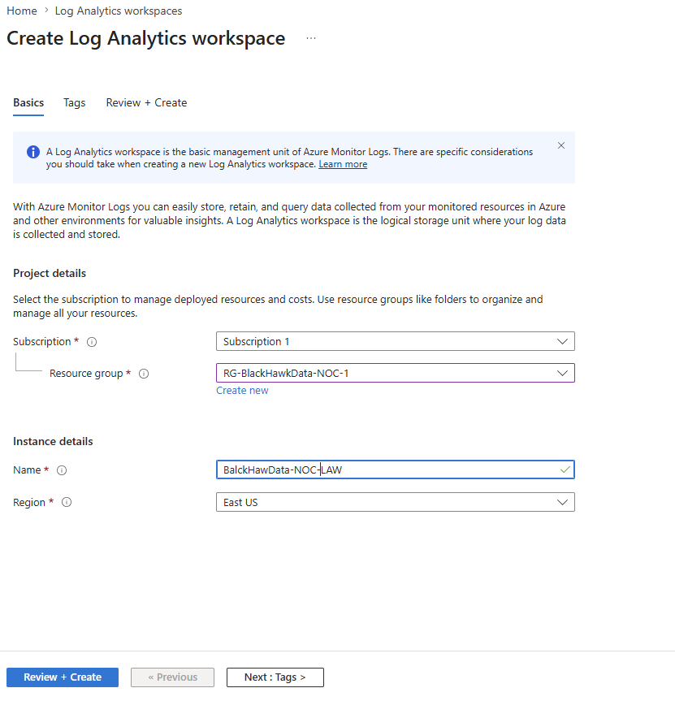
Create:
BalckHawData-NOC-LAW

Step 13 — Enable VM Monitoring
Go to:
- DC01
- Insights
- Enable monitoring

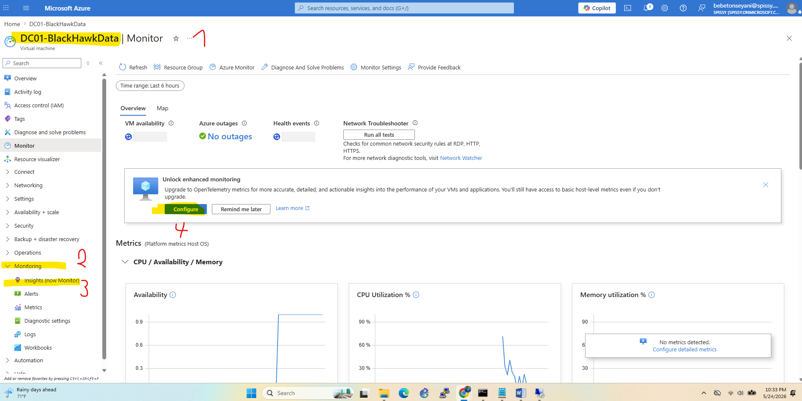

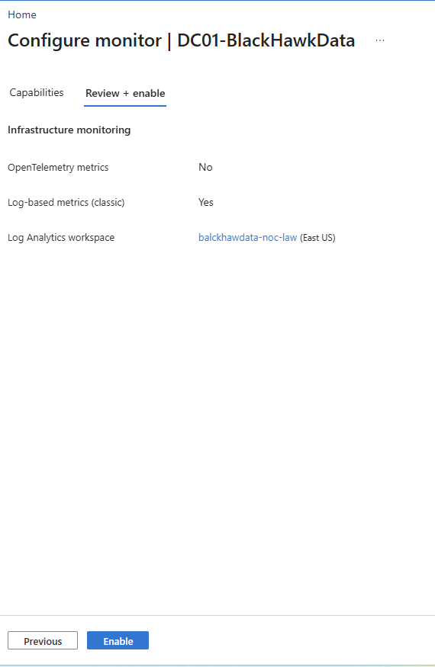
Do same for:
- CLIENT01
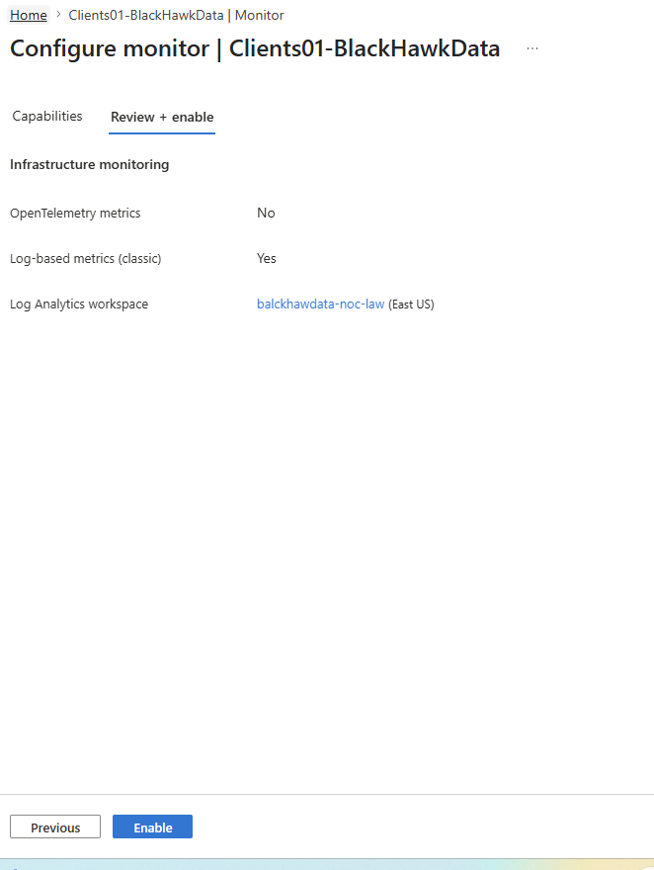

PHASE 11 — Create Alerts

Step 14 — Create CPU Alert
Go to:
- Azure Monitor
- Alerts
- Create Alert Rule
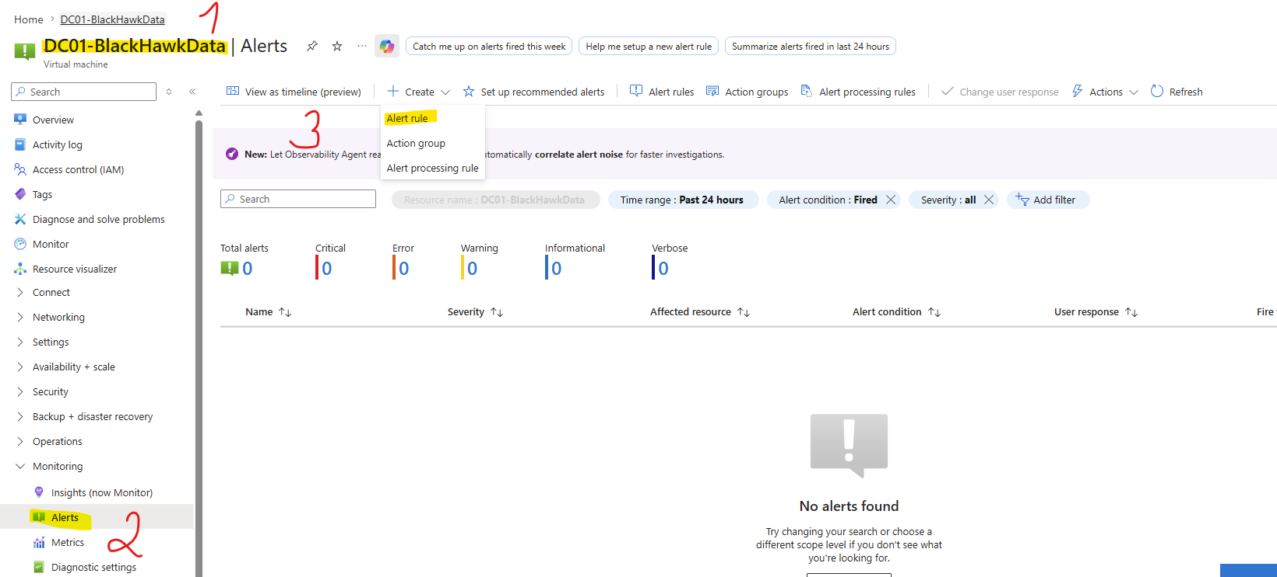

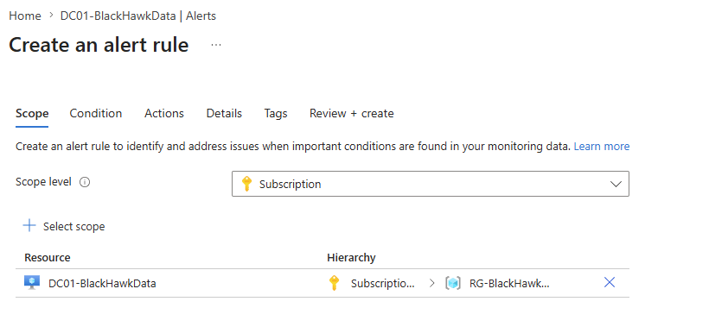

Condition:
CPU > 80%

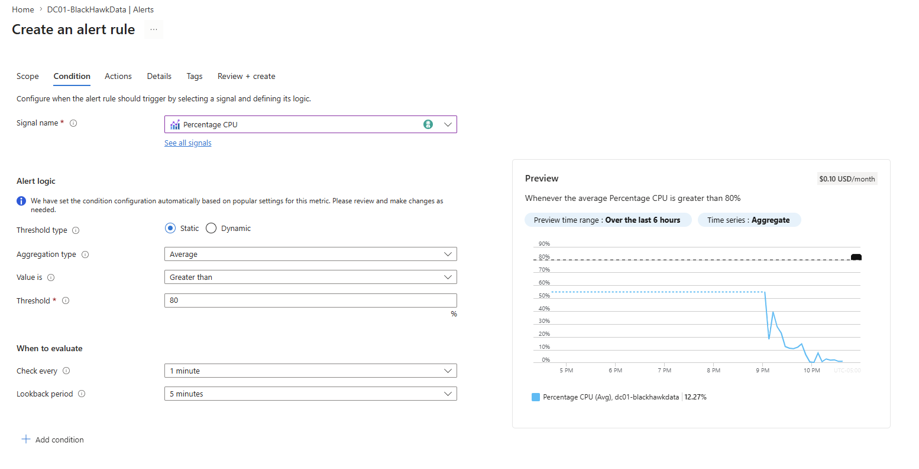
Action:
- Email notification
- 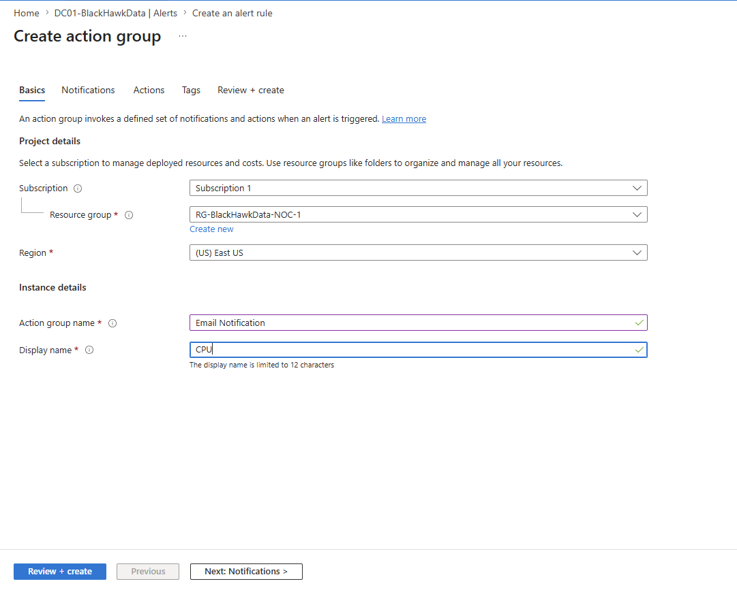
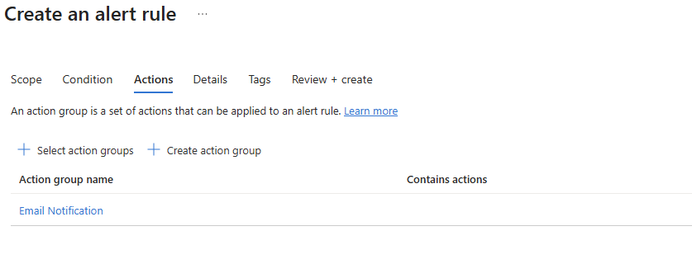

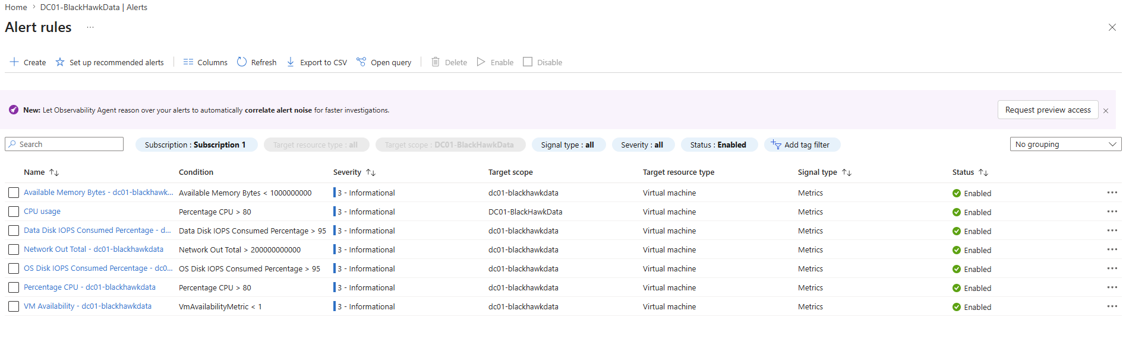

PHASE 12 — Create Linux Server

Step 15 — Create Ubuntu VM
Create VM:
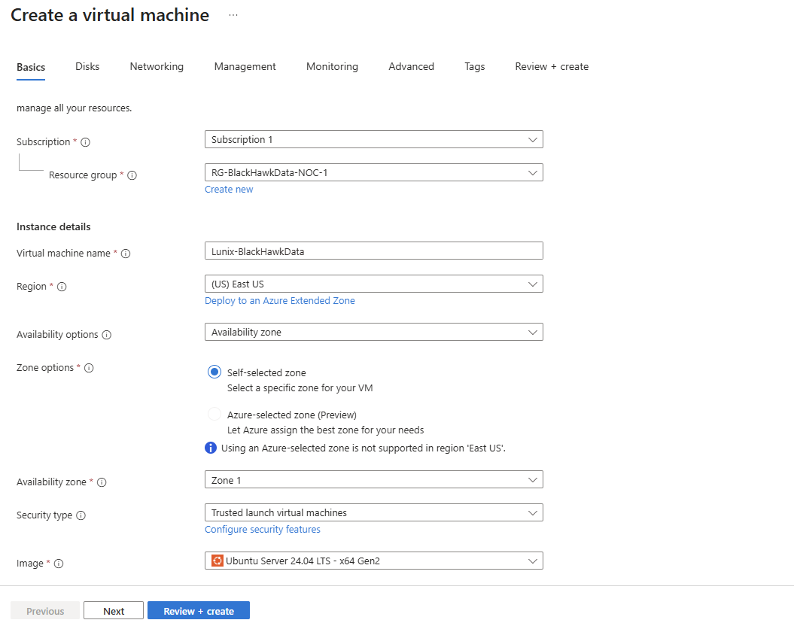
Setting | Value
Name | LINUX01
Image | Ubuntu 24.04
Enable:
- SSH
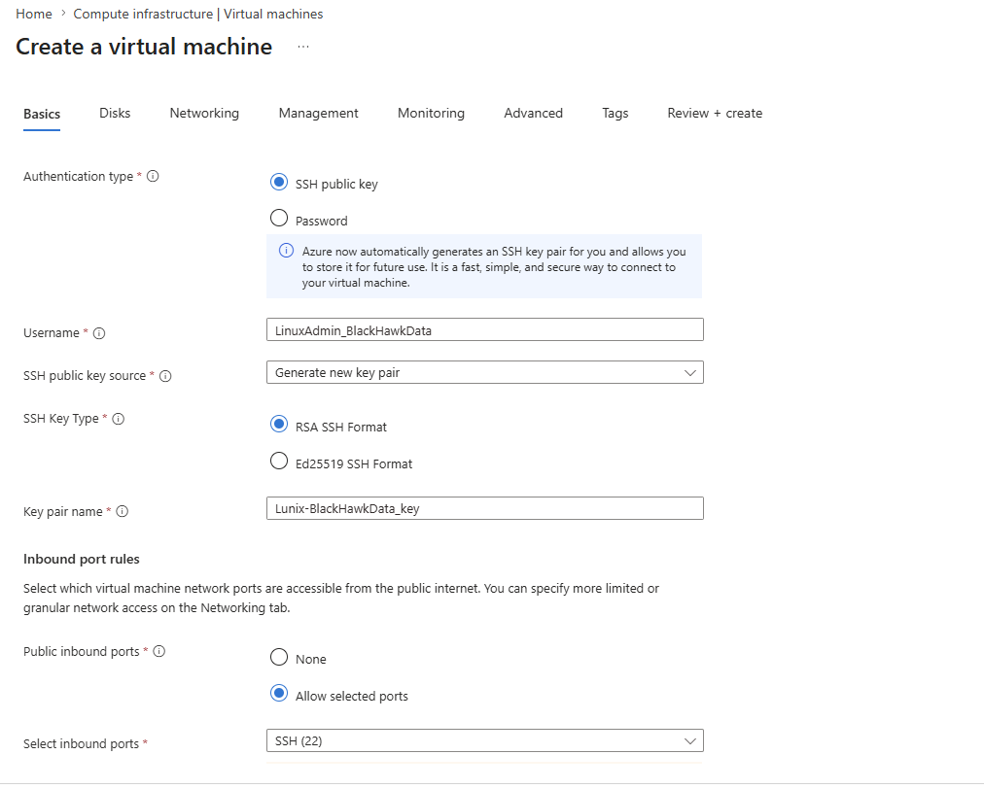
Activated SSH using the key pair
Create and downloaded the Key pair

Run cmd as an admin
C:\Users\Mr. Bebeto\Documents\Azure Lab>ssh -i LinuxAdmin_BlackHawkData2.pem LinuxAdmin_BlackHawkData@74.235.96.221
Welcome to Ubuntu 24.04.4 LTS (GNU/Linux 6.17.0-1015-azure x86_64)

* Documentation: https://help.ubuntu.com
* Management: https://landscape.canonical.com
* Support: https://ubuntu.com/pro

System information as of Mon May 25 04:32:12 UTC 2026

System load: 0.0 Processes: 121
Usage of /: 5.8% of 28.02GB Users logged in: 0
Memory usage: 3% IPv4 address for eth0: 10.0.0.4
Swap usage: 0%

Expanded Security Maintenance for Applications is not enabled.

0 updates can be applied immediately.

Enable ESM Apps to receive additional future security updates.
See https://ubuntu.com/esm or run: sudo pro status

The programs included with the Ubuntu system are free software;
the exact distribution terms for each program are described in the
individual files in /usr/share/doc/*/copyright.

Ubuntu comes with ABSOLUTELY NO WARRANTY, to the extent permitted by
applicable law.

To run a command as administrator (user "root"), use "sudo <command>".
See "man sudo_root" for details.

LinuxAdmin_BlackHawkData@Lunix-BlackHawkData:~$

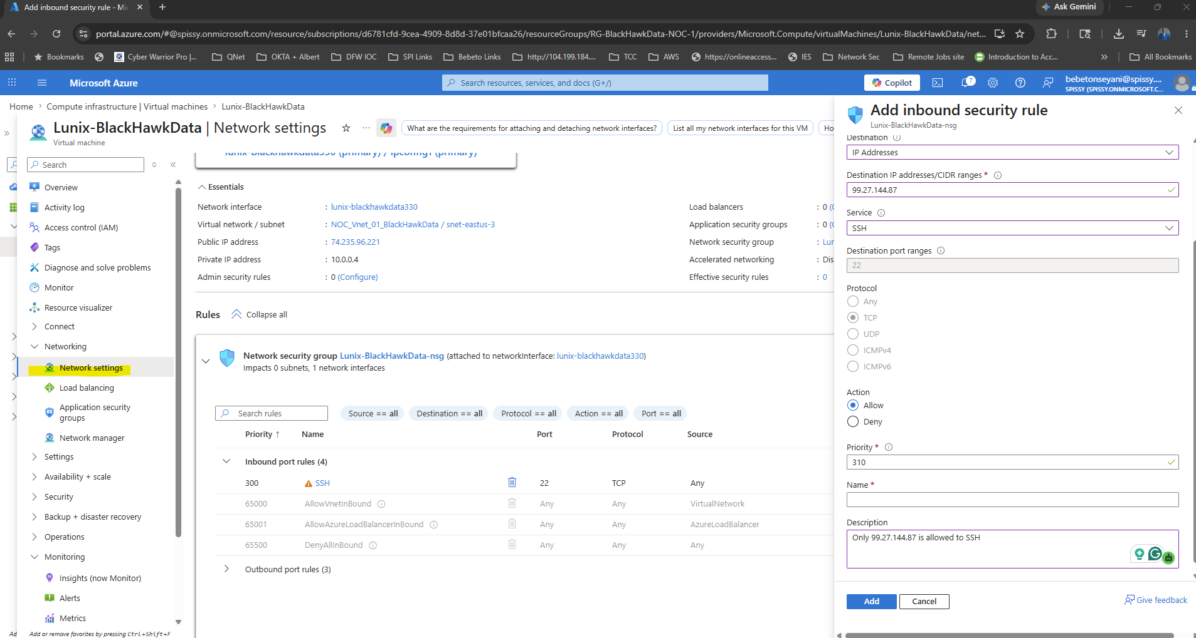

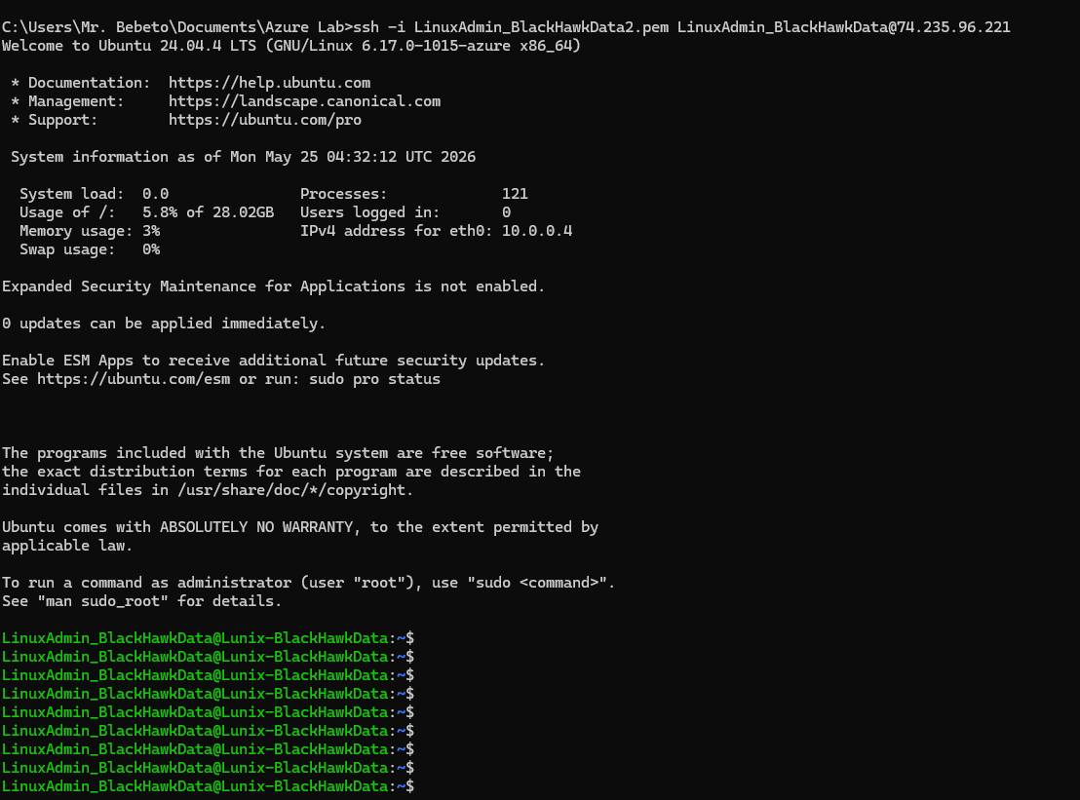

PHASE 13 — Practice NOC Tasks

Step 16 — Simulate Real NOC Issues

DNS Failure
Stop DNS service on DC01.
Practice:
nslookup
ping
ipconfig /flushdns

Account Lockout
Lock a user account.
Unlock in:
Active Directory Users and Computers

High CPU Alert
Run:
while ($true) {}
Watch Azure alert trigger.

RDP Failure
Disable RDP firewall rule.
Troubleshoot connectivity.

PHASE 14 — Add Ticketing System

Step 17 — Create Free ServiceNow Lab
Use:
ServiceNow Developer Instance
Create tickets for:
- VM down
- DNS outage
- Password reset
- CPU alert

PHASE 15 — Add Security

Step 18 — Configure MFA
Use:
- Microsoft Entra ID
Enable:
- MFA
- Conditional Access

PHASE 16 — Build Portfolio Documentation

Step 19 — Document Everything
Create:
- Network diagram
- Screenshots
- Incident reports
- Troubleshooting notes

