**Design Pattern Project**

Julie Higelin

Romain Girodet

Rémi Lombard

# 1. Introduction

# Objective of the project is to simulate a simplified version of the Monopoly™ game. A set of players is given, each with name and initial position. Dice are rolled and players’ positions on the game board will change.

## 2. Design Hypotheses

### INITIALIZATION:

Initailize a gameBord with 40 positions (index from 0 to 39)

Initialize a set of players (choose number and name)

If a player exceed the last position (index 39) he return to the position 0.

End the game when a certain number of lap have been made by one player.

### ACCESS INFORMATION:

Get access to players position at any time of the game.

Get access to players’ number of lap at any time of the game.

### DICE:

Roll two dice (from 0 to 6) and move a player using the sum obtain by the to dice.

Make a player move again if he obtained a double on his last roll.

Count the number of double a player made during his turn.

Send him to Jail (index 9) if the counter exceed 3.

### JAIL:

If player lands on If player lands on Go TO jail (index 29) he goes to In Jail (Index 9).

If player lands on If player lands on Visit Only / In Jail, (index 9) he visit the jail but will not stay in it. His turn end, even if he made a double he won’t be able to roll the dice again.

If player in jail make a double he can leave the prison.

Count number of turn a player stay in Jail.

If this counter exceed 3, the player can leave the prison.

If the player leave of prison, even if he made a double he wont be able to roll the dice again to move second time.

## 3. UML diagrams

## a. Class diagram of the solution

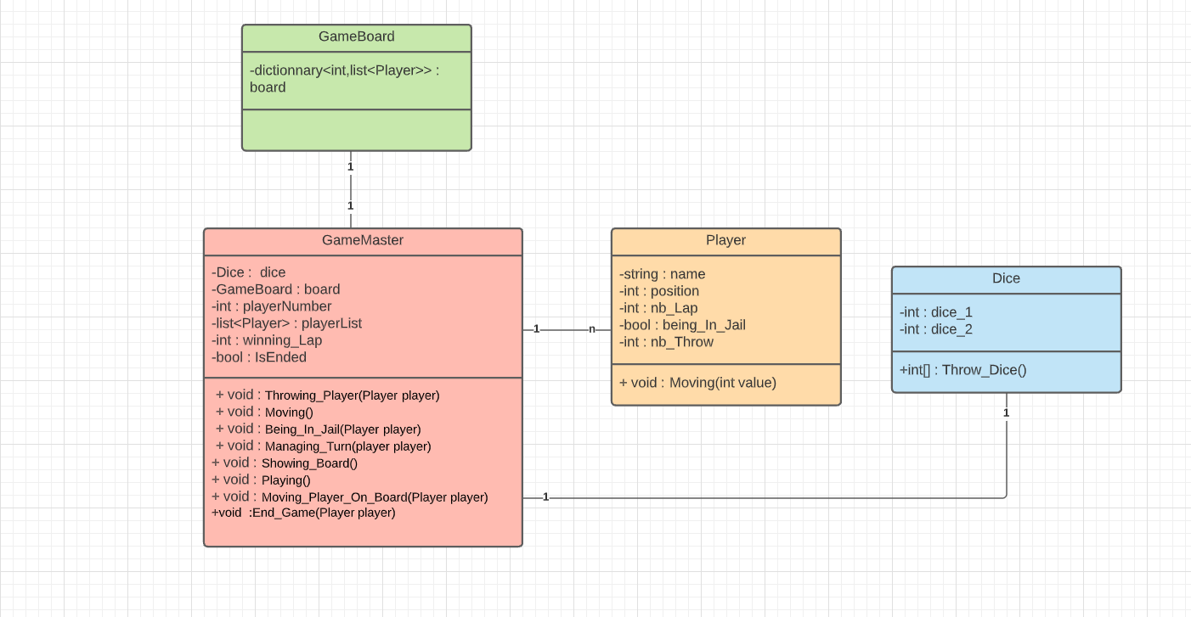

## b. Sequence diagrams

# 4. Test cases