**CS673S16 Software Engineering** 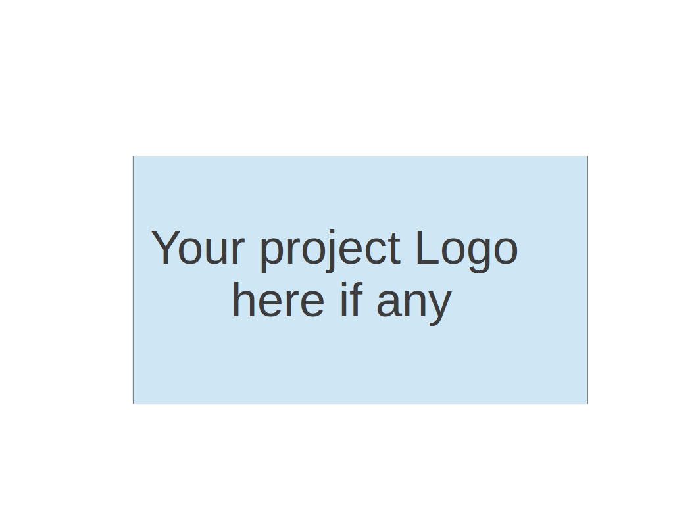

**Team 1 - Issue Tracker REST API**

**Tests Report**

|  |  |  |  |
| --- | --- | --- | --- |
| Team Member | Role(s) | Signature | Date |
| Steve Black | Team Leader, Design Lead | *Steve Black* | 12/12/2016 |
| Anthony Valencia | Configuration Lead | *Anthony Valencia* | 12/12/2016 |
| Demetrius Glover | Environment and Integration Lead | *Demetrus Glover* | 12/12/2016 |
| Yash Bavishi | Requirement Lead | *Yash Bavishi* | 12/12/2016 |
| Kevin Ding | Implementation Leader | *Kevin Ding* | 12/12/2016 |
| Kevin Sperling | QA Lead | *Kevin Sperling* | 12/12/2016 |
| Bakyt Bakayeva | Security Lead | *Bakyt Bakayeva* | 12/12/2016 |
|  |  |  |  |

**Revision history**

|  |  |  |  |
| --- | --- | --- | --- |
| **Version** | **Author** | **Date** | **Change** |
| 1 | Kevin Sperling | 10/3/2016 | Intro/Proposal |
| 2 | Kevin Sperling | 10/24/2016 | Test Summary |
| 3 | Kevin Sperling | 11/14/2016 | Test Case Spreadsheet |
| 4 | Kevin Sperling | 12/12/2016 | Final Metrics |

Introduction

Test Summary

Tests Reports

Testing Metrics

References

Glossary

# Introduction

The goal of our testing efforts is to combine Unit, UI Automation and Systems Tests to get as much test coverage as possible in order to detect bugs early or eliminate them completely. This is a living document and changes will be made throughout the term.

# Test Summary

In this section, you will summarize what was tested and what happened, based on each test type.

* + **Unit Test** - The version of the app that our team forked has no unit tests around the issue tracker. We will be adding them to cover existing code and to any new code during iteration 2.
  + **System Tests** - We are planning on using TravisCI as a means of integration testing, however, with 0 unit tests, spending time to set up Travis was not a high priority.
  + **UI Automation** - There is currently an issue with the Firefox driver as a result of Firefox browser being updated since the previous classes work on the application

# Tests Reports

The current test cases are provided in the attached spreadsheet:

[Test Cases Spreadsheet](https://docs.google.com/spreadsheets/d/1APmHFP_sgFEae4dVfLkNVMjh0oQ52GcGxHFAYYcoXOU/edit#gid=0)

# Testing Metrics

|  |  |
| --- | --- |
| **Iteration 1** | |
| Unit Tests | UI Automation Tests |
| 0 | 6 (Currently inoperable) |

|  |  |  |  |
| --- | --- | --- | --- |
| **Iteration 2** | | | |
| Unit Tests | UI Automation Tests | Manual testing | Bugs |
| -0 | -4 inoperable  -2 Passing | -5 Passing -1 Failing | -1 Edit Issue Description (Fixed) |

|  |  |  |  |  |
| --- | --- | --- | --- | --- |
| **Iteration 3** | | | | |
| Unit Tests | UI Automation Tests | Manual testing | API Tests | Bugs |
| -0 | -5 Passing | -15 Passing | -13 Passing | -1 Unable to Messages in chat(Fixed) |

# References

# Glossary